**Task**:-Build a two node diskless HPC-Cluster using Open HPC with xCAT , OpenLDAP, Slurm, HPL Benchmark, Ganglia and document the results.

**Steps performed:**

**xCAT**

[root@localhost~]#hostnamectl set-hostname master

[root@localhost~]#su

[root@master~]#systemctl stop firewalld

[root@master~]systemctl disable firewalld

[root@master~]#systemctl status firewalld

[root@master~]#vim /etc/selinux/config

SELINUX=disabled

[root@master~]#reboot

[root@master ~]# sestatus

SELinux status: disabled

[root@master ~]# systemctl status firewalld

● firewalld.service - firewalld - dynamic firewall daemon

Loaded: loaded (/usr/lib/systemd/system/firewalld.service; disabled; vendor preset: enabled)

Active: inactive (dead)

Docs: man:firewalld(1)

[root@master ~]# yum install yum-utils

root@master ~]# wget -P /etc/yum.repos.d <https://xcat.org/files/xcat/repos/yum/latest/xcat-core/xcat-core.repo> --no-check-certificate

[root@master~]# wget -P /etc/yum.repos.d <https://xcat.org/files/xcat/repos/yum/xcat-dep/rh7/x86_64/xcat-dep.repo> --no-check-certificate

[root@master~]# yum install xCAT -y

[root@master~]# ll /etc/profile.d/xcat.sh

-rwxr-xr-x 1 root root 174 Jan 25 00:37 /etc/profile.d/xcat.sh

[root@master ~]# . /etc/profile.d/xcat.sh

[root@master ~]# lsxcatd -a

Version 2.16.4 (git commit bb7a4bbbc8bde7e6613558d8d039fe43d49d2079, built Mon Jun 13 08:53:10 EDT 2022)

This is a Management Node

dbengine=SQLite

[root@master~]# tabdump site

[root@localhost ~]# chdef -t site dhcpinterfaces="ens36"

1 object definitions have been created or modified.

[root@master ~]# chdef -t site master='192.168.233.10'

1 object definitions have been created or modified.

[root@master ~]# tabdump site | grep master

"master","192.168.233.10"

[root@master ~]# tabdump site | grep dhcp

"dhcplease","43200",,

"dhcpinterfaces","ens36"

[root@master ~]# lsblk

NAME MAJ:MIN RM SIZE RO TYPE MOUNTPOINT

sda 8:0 0 40G 0 disk

├─sda1 8:1 0 1G 0 part /boot

└─sda2 8:2 0 39G 0 part

├─centos-root 253:0 0 35.1G 0 lvm /

└─centos-swap 253:1 0 3.9G 0 lvm [SWAP]

sr0 11:0 1 1024M 0 rom

[root@master ~]# dd if= /dev/sr0 of= /root/centos7.6.iso

9203712+0 records in

9203712+0 records out

4712300544 bytes (4.7 GB) copied, 725.842 s, 6.5 MB/s

[root@master ~]# ll -h

total 4.4G

-rw-------. 1 root root 1.4K Jan 24 23:51 anaconda-ks.cfg

-rw-r--r-- 1 root root 4.4G Jan 25 01:09 centos7.6.iso

[root@master ~]# copycds centos7.6.iso

Copying media to /install/centos7.9/x86_64

Media copy operation successful

[root@master ~]# lsdef -t osimage

centos7.9-x86_64-install-compute (osimage)

centos7.9-x86_64-netboot-compute (osimage)

centos7.9-x86_64-statelite-compute (osimage)

[root@master ~]# lsdef -t osimage centos7.9-x86_64-install-compute

Object name: centos7.9-x86_64-install-compute

imagetype=linux

osarch=x86_64

osdistroname=centos7.9-x86_64

osname=Linux

osvers=centos7.9

otherpkgdir=/install/post/otherpkgs/centos7.9/x86_64

pkgdir=/install/centos7.9/x86_64

pkglist=/opt/xcat/share/xcat/install/centos/compute.centos7.pkglist

profile=compute

provmethod=install

template=/opt/xcat/share/xcat/install/centos/compute.centos7.tmpl

[root@master ~]# genimage centos7.9-x86_64-netboot-compute

[root@master ~]# mkdir -p /install/custom/netboot

[root@master ~]# chdef -t osimage centos7.9-x86_64-netboot-compute

synclists="/install/custom/netboot/compute.synclist"

1 object definitions have been created or modified.

[root@master ~]# echo "/etc/passwd -> /etc/passwd" > /install/custom/netboot/compute.synclist

[root@master ~]# echo "/etc/shadow -> /etc/shadow" >> /install/custom/netboot/compute.synclist

[root@master ~]# echo "/etc/group -> /etc/group" >> /install/custom/netboot/compute.synclist

[root@master ~]# echo "/etc/hosts -> /etc/hosts" >> /install/custom/netboot/compute.synclist

[root@master ~]# packimage centos7.9-x86_64-netboot-compute

Packing contents of /install/netboot/centos7.9/x86_64/compute/rootimg

archive method:cpio

compress method:gzip

[root@master ~]# mkdef -t node cn00 groups=compute,all ip=192.168.233.15 mac=00:0C:29:06:25:01 netboot=xnba

1 object definitions have been created or modified.

[root@master ~]# lsdef cn00

Object name: cn00

groups=compute,all

ip=192.168.127.135

mac=00:0C:29:DC:A1:01

netboot=xnba

postbootscripts=otherpkgs

postscripts=syslog,remoteshell,syncfiles

[root@master ~]# chdef -t group compute provmethod=centos7.9-x86_64-netboot-compute

1 object definitions have been created or modified.

[root@master ~]# chdef -t site domain=xcat.in

1 object definitions have been created or modified.

[root@master ~]# lsdef cn00

Object name: cn00

groups=compute,all

ip=192.168.127.135

mac=00:0C:29:DC:A1:01

netboot=xnba

postbootscripts=otherpkgs

postscripts=syslog,remoteshell,syncfiles

provmethod=centos7.9-x86_64-netboot-compute

[root@master ~]# cat /etc/hosts

127.0.0.1 localhost localhost.localdomain localhost4 localhost4.localdomain4

::1 localhost localhost.localdomain localhost6 localhost6.localdomain6

[root@master ~]# makehosts

[root@master ~]# cat /etc/hosts

127.0.0.1 localhost localhost.localdomain localhost4 localhost4.localdomain4

::1 localhost localhost.localdomain localhost6 localhost6.localdomain6

192.168.233.15 cn00 cn00.xcat.in

[root@master ~]# makenetworks

Warning: [master]: The network entry '192_168_122_0-255_255_255_0' already exists in xCAT networks table. Cannot create a definition for '192_168_122_0-255_255_255_0'

Warning: [master]: The network entry '192_168_226_0-255_255_255_0' already exists in xCAT networks table. Cannot create a definition for '192_168_226_0-255_255_255_0'

[root@master ~]# makedhcp -n

Renamed existing dhcp configuration file to /etc/dhcp/dhcpd.conf.xcatbak

[root@master ~]# makedns -n

[root@master ~]# vi /etc/resolv.conf

# Generated by NetworkManager

search localdomain xcat.in

nameserver 192.168.233.10

[root@master ~]# nslookup cn00

Server: 192.168.233.10

Address: 192.168.233.10#53

Name: cn00.xcat.in

Address: 192.168.233.15

[root@master ~]# nodeset compute osimage=centos7.9-x86_64-netboot-compute

cn00: netboot centos7.9-x86_64-compute

[root@master ~]# systemctl restart dhcpd

[root@master ~]# systemctl status dhcpd

● dhcpd.service - DHCPv4 Server Daemon

Loaded: loaded (/usr/lib/systemd/system/dhcpd.service; enabled; vendor preset: disabled)

Active: active (running) since Wed 2023-01-25 01:57:22 IST; 8s ago

**Screenshots:**

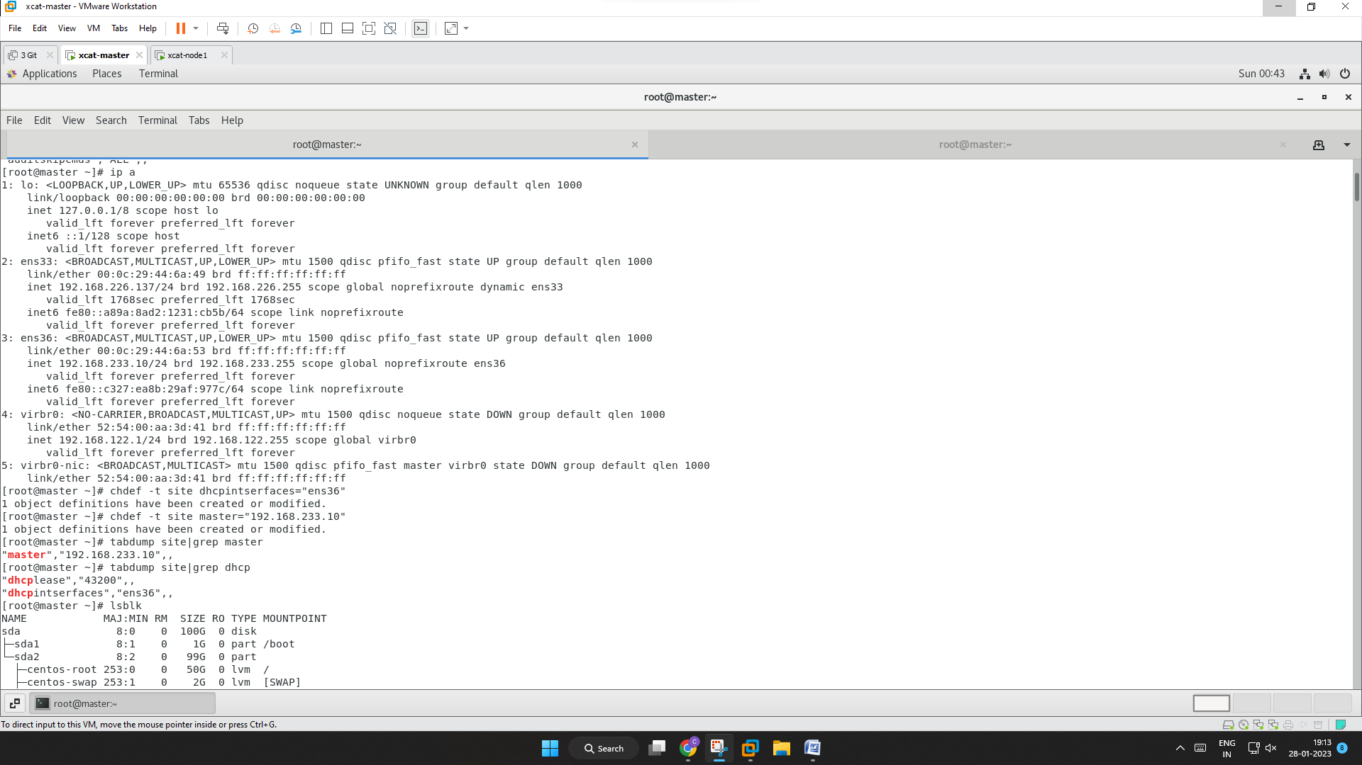

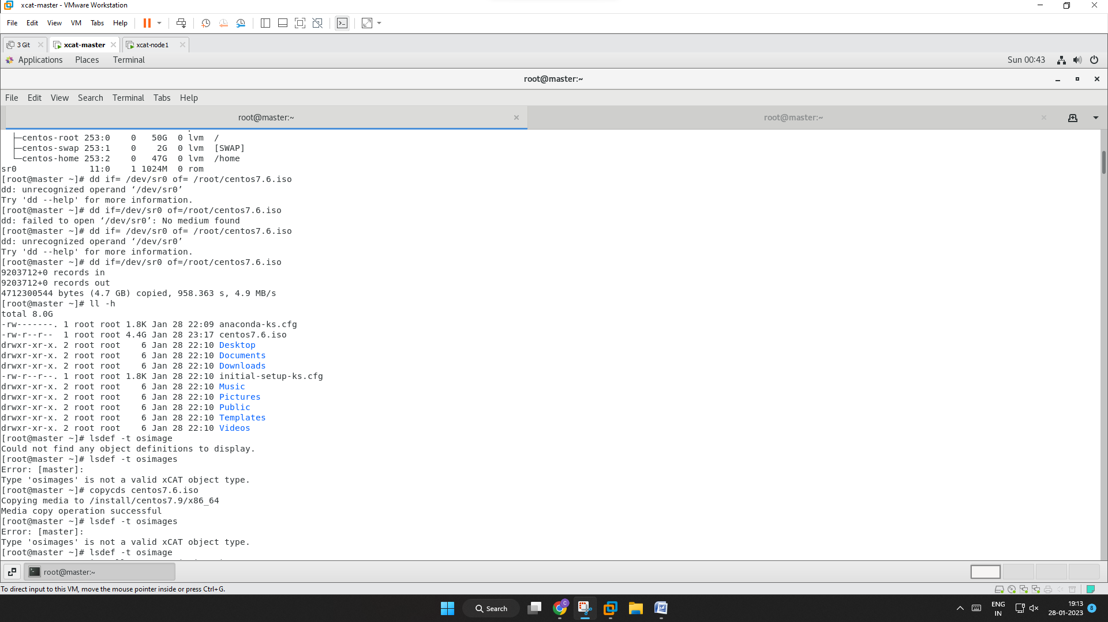

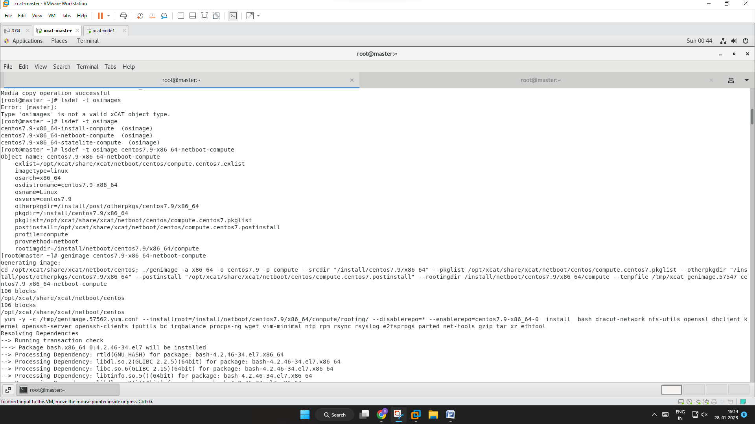

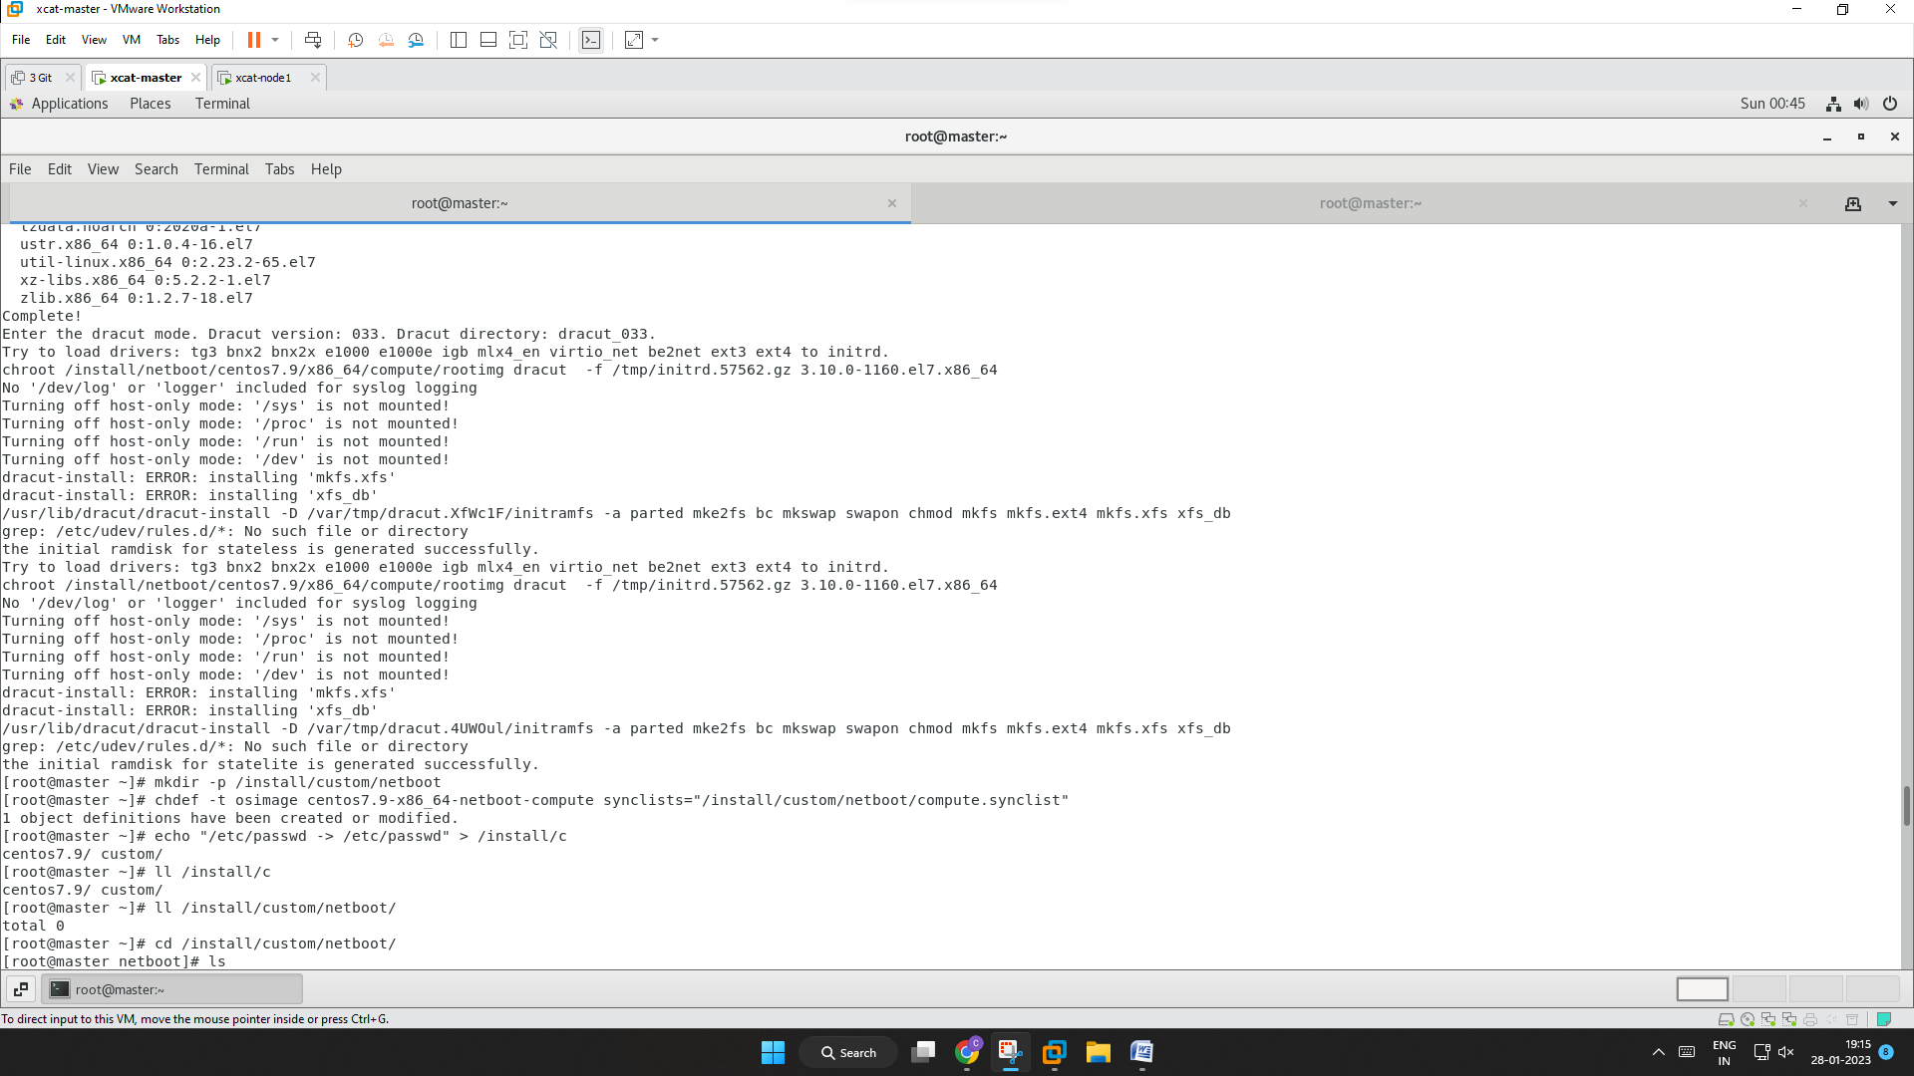

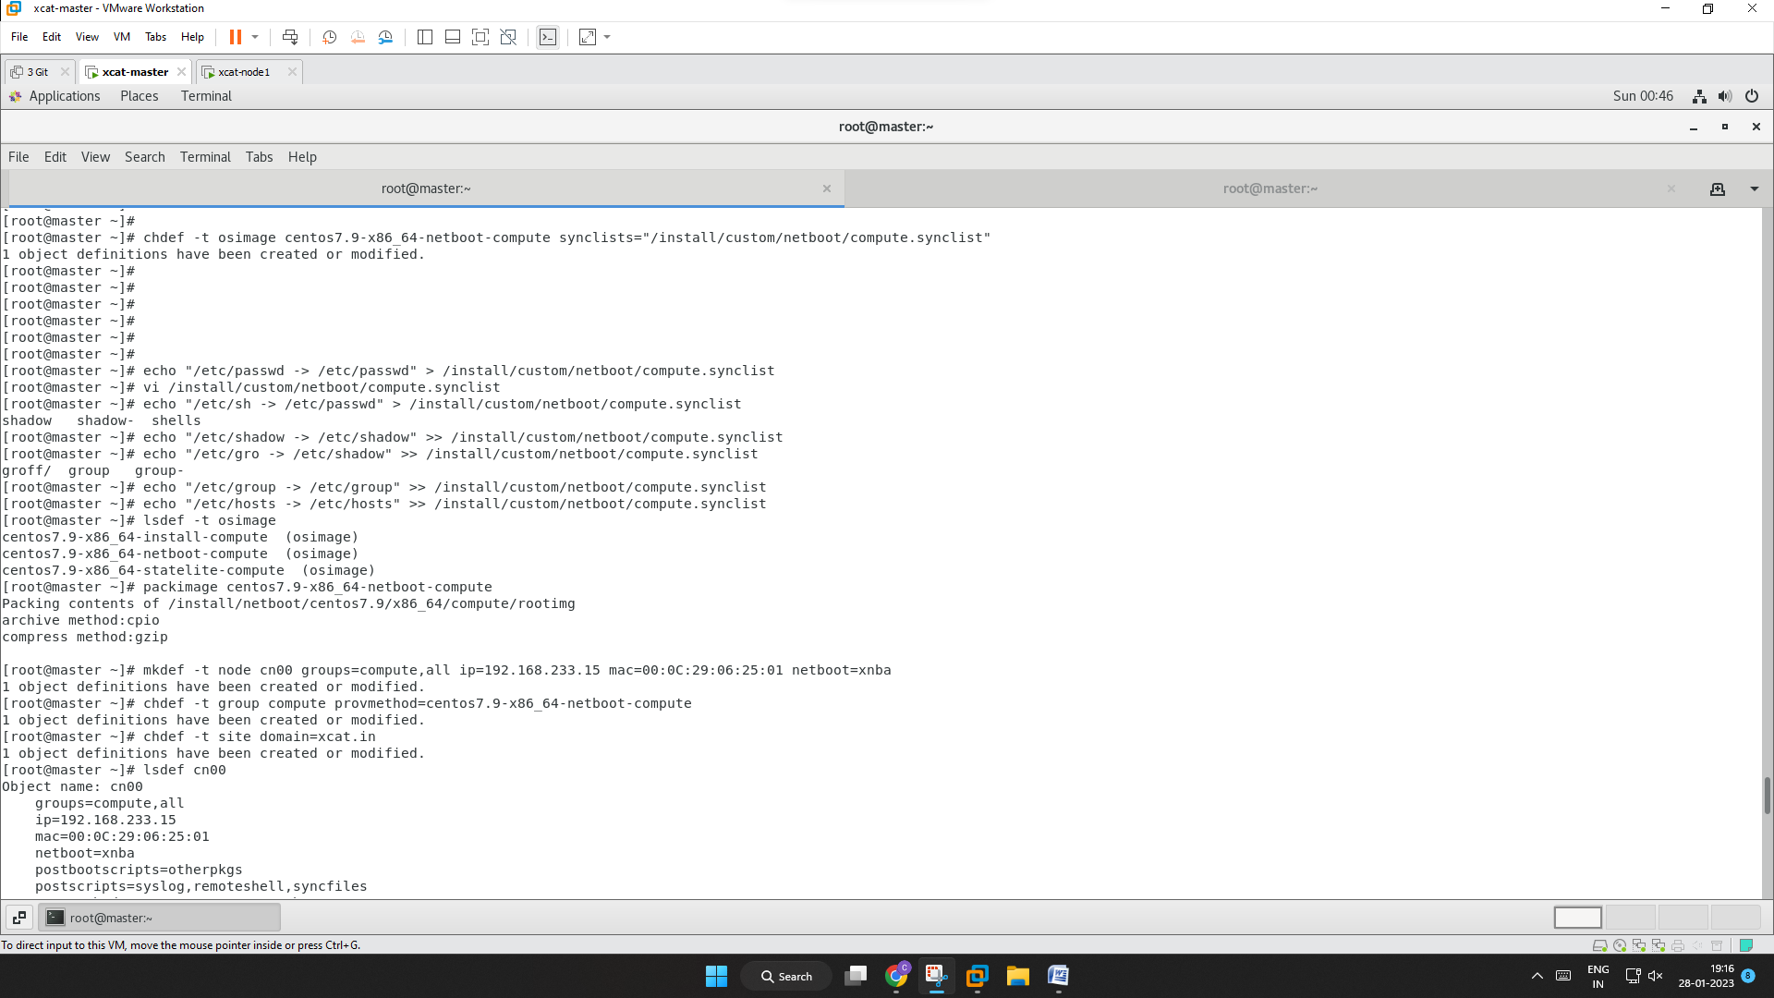

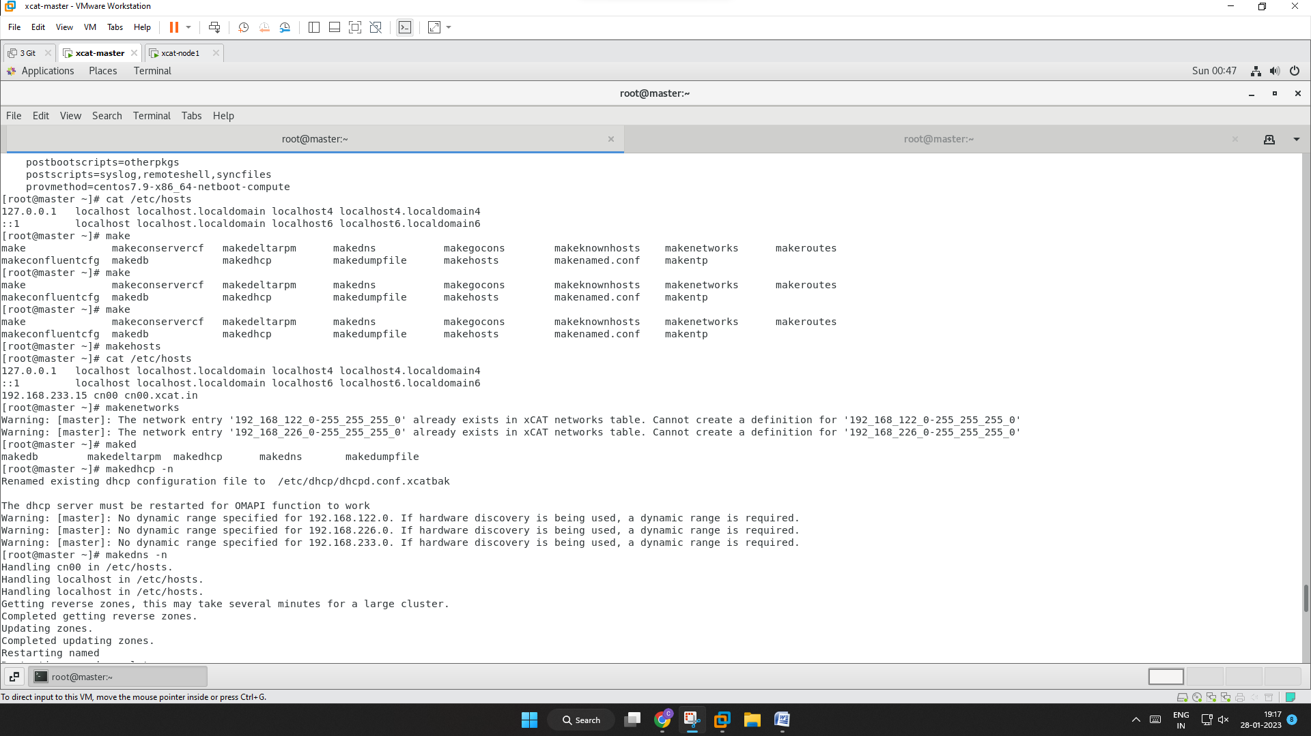

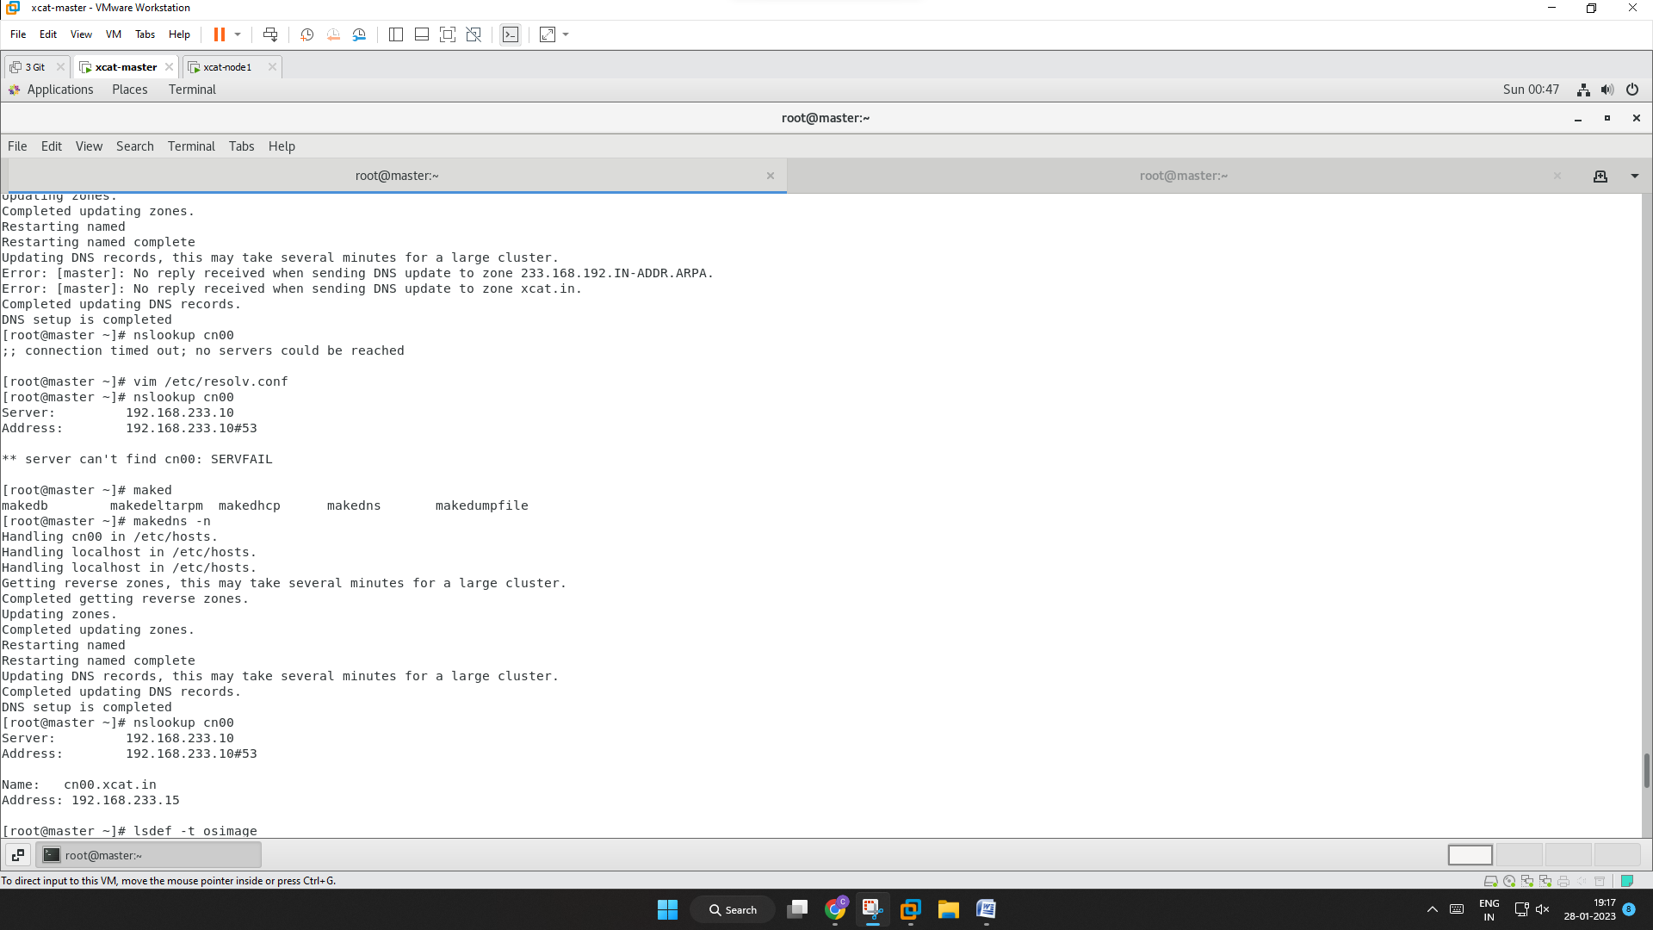

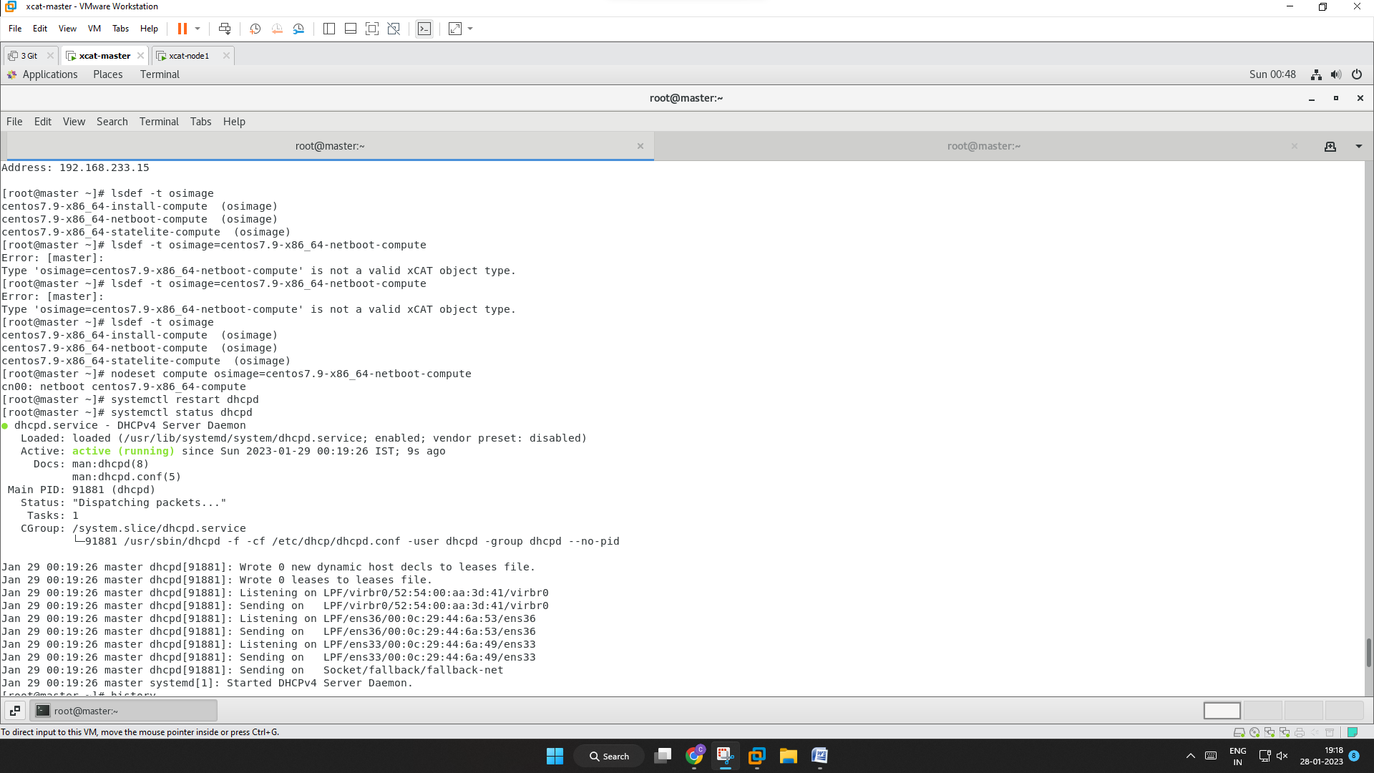

**Output**

