Week 4 Task
Comprehensive Data Science Report & Insights Presentation Plan
Virtual Data Science Explorer Internship — YuvaIntern
Prepared for: Executive Leadership Review

1. Executive Summary
This report presents the findings of a customer-retention analysis conducted for a subscription-based telecom business, undertaken to answer a single business question: which customers are at the greatest risk of cancelling their subscription, and what should the business do about it? Using account, usage, and billing data for 3,000 customers, a predictive model was built and evaluated, and the resulting patterns were translated into concrete, actionable recommendations.
Key finding: Contract structure and account tenure are the two strongest predictors of churn. Customers on month-to-month contracts churn at roughly 6-7 times the rate of customers on two-year contracts, and churn risk is highest in a customer's first year, peaking between months 7 and 12.
Business impact: The final model identifies at-risk customers with high reliability (87.5% F1-score, 98.6% ROC-AUC on held-out data), giving the retention team a practical, rankable list of customers to prioritize for proactive outreach rather than relying on guesswork or reacting only after a cancellation request is submitted.
The remainder of this report walks through the methodology used, the insights uncovered, the visualizations chosen to communicate them, a strategy for presenting these results to a non-technical executive audience, and recommended next steps.

2. Methodology Overview
The analysis followed a structured, end-to-end data science workflow:
- Data preparation: account, billing, usage, and support-interaction data were cleaned, missing values were imputed, and derived features (such as average monthly spend) were engineered.
- Exploratory analysis: churn rates were broken down by contract type, tenure, and service usage to surface early patterns before any model was built.
- Predictive modeling: three classification approaches (Logistic Regression, Decision Tree, and Random Forest) were trained and compared; the Random Forest model was selected and fine-tuned using cross-validated hyperparameter search.
- Validation: the tuned model was evaluated on a held-out set of customers it had never seen, using multiple metrics (accuracy, precision, recall, F1-score, ROC-AUC) rather than a single number, to ensure the reported performance is trustworthy rather than an artifact of one lucky split of the data.
This methodology mirrors standard industry practice for churn analytics and was chosen to balance predictive strength with interpretability, so the results can be explained confidently to a non-technical audience rather than treated as a “black box.”

3. Insights and Analysis

3.1 Contract type is the single biggest churn driver
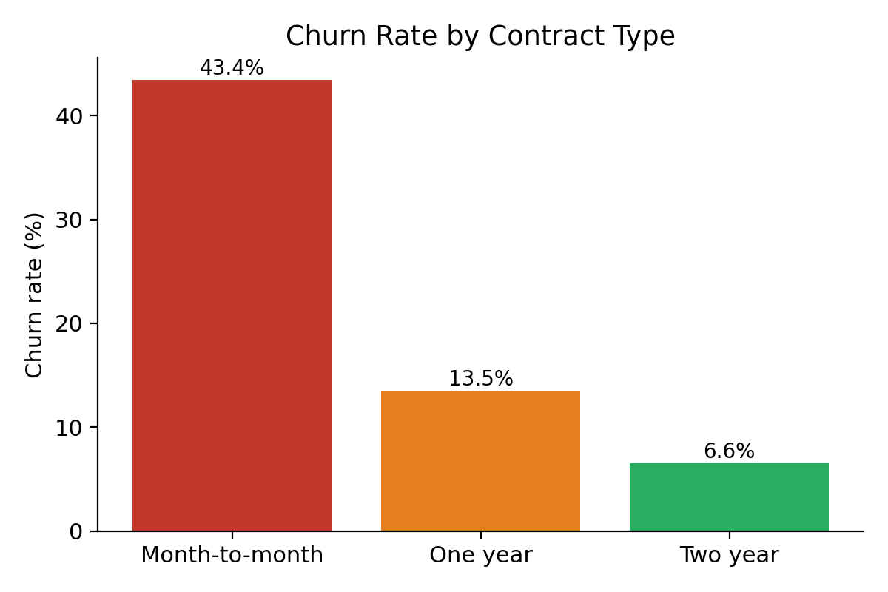
Figure 1 — Churn rate by contract type.
Customers on month-to-month contracts churn at 43.4%, compared with 13.5% for one-year contracts and just 6.6% for two-year contracts. This is the clearest and most actionable signal in the data: contract length functions as a natural retention mechanism, and the business currently under-incentivizes customers to move off flexible, high-churn plans.

3.2 Churn risk peaks early in the customer lifecycle
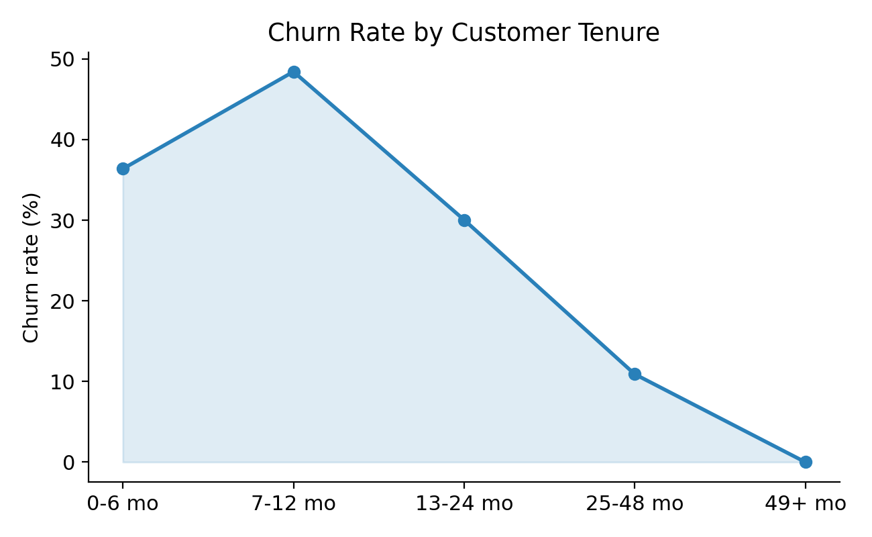
Figure 2 — Churn rate by customer tenure bucket.
Churn risk rises through the first year, peaking at 48% for customers in months 7-12, before declining steadily for longer-tenured customers. Customers who make it past their first year become substantially more loyal — making the 6-12 month window the highest-priority period for retention intervention.

3.3 What the model learned matches business intuition
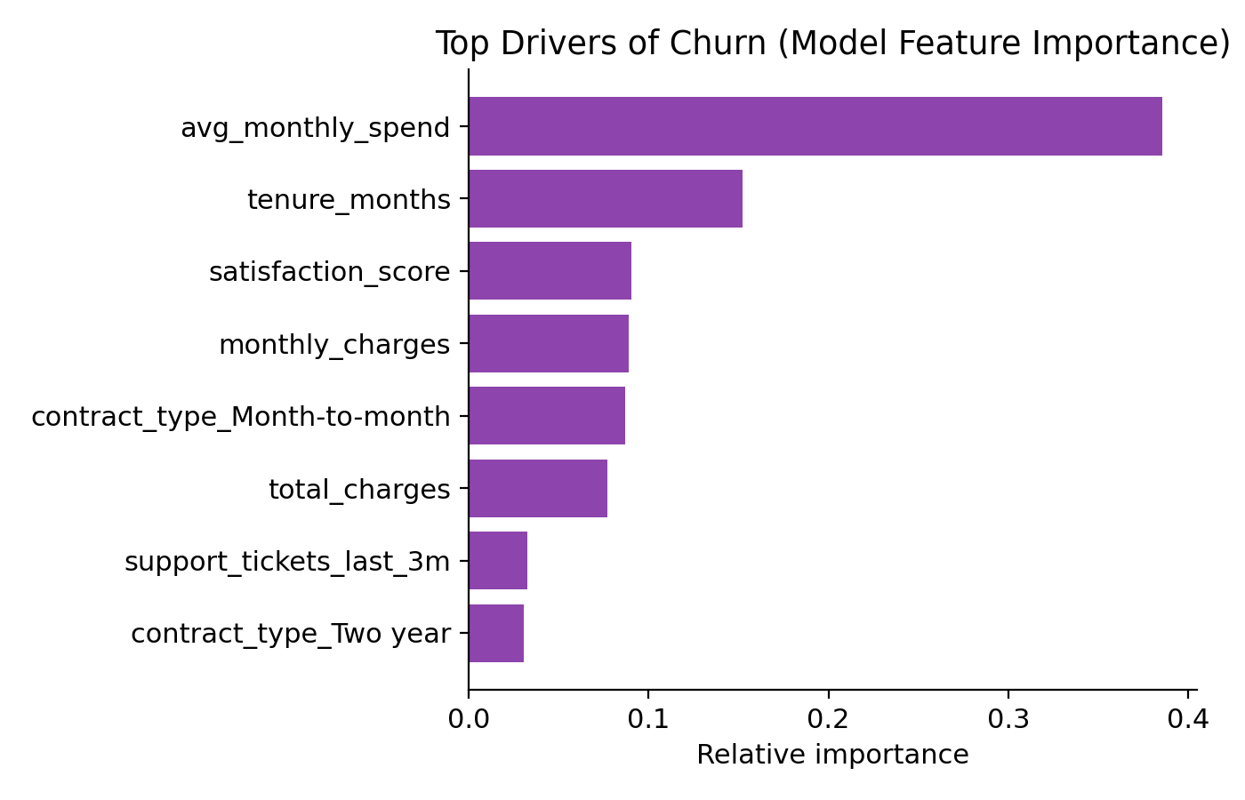
Figure 3 — Top features driving the model's churn predictions.
The model's own feature-importance ranking reinforces the manual analysis above: average monthly spend, tenure, satisfaction score, and month-to-month contract status are the leading predictors, giving confidence that the model is learning genuine business signal rather than noise.

3.4 The model reliably separates at-risk from loyal customers
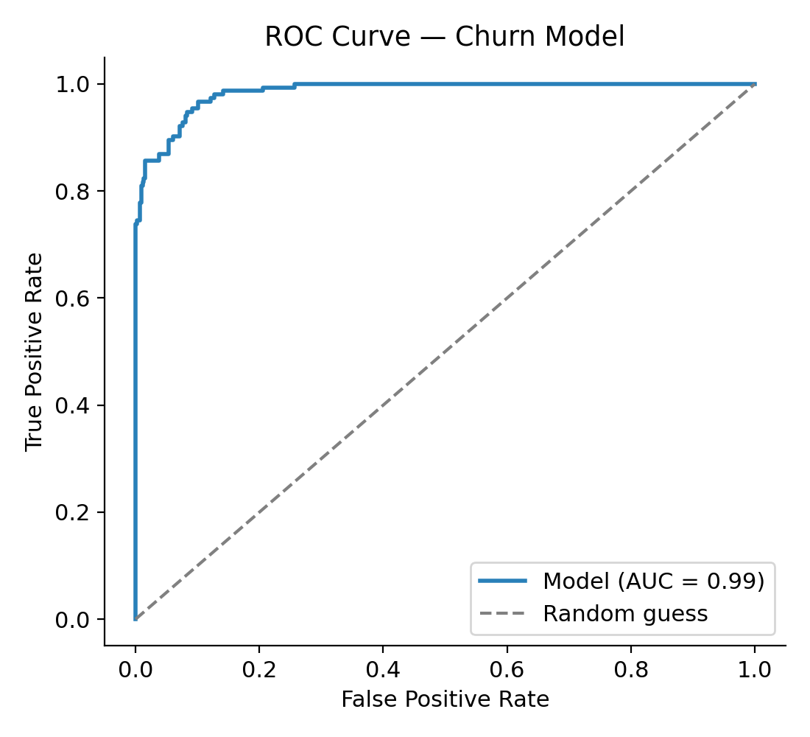
Figure 4 — ROC curve for the final tuned model (AUC = 0.99).
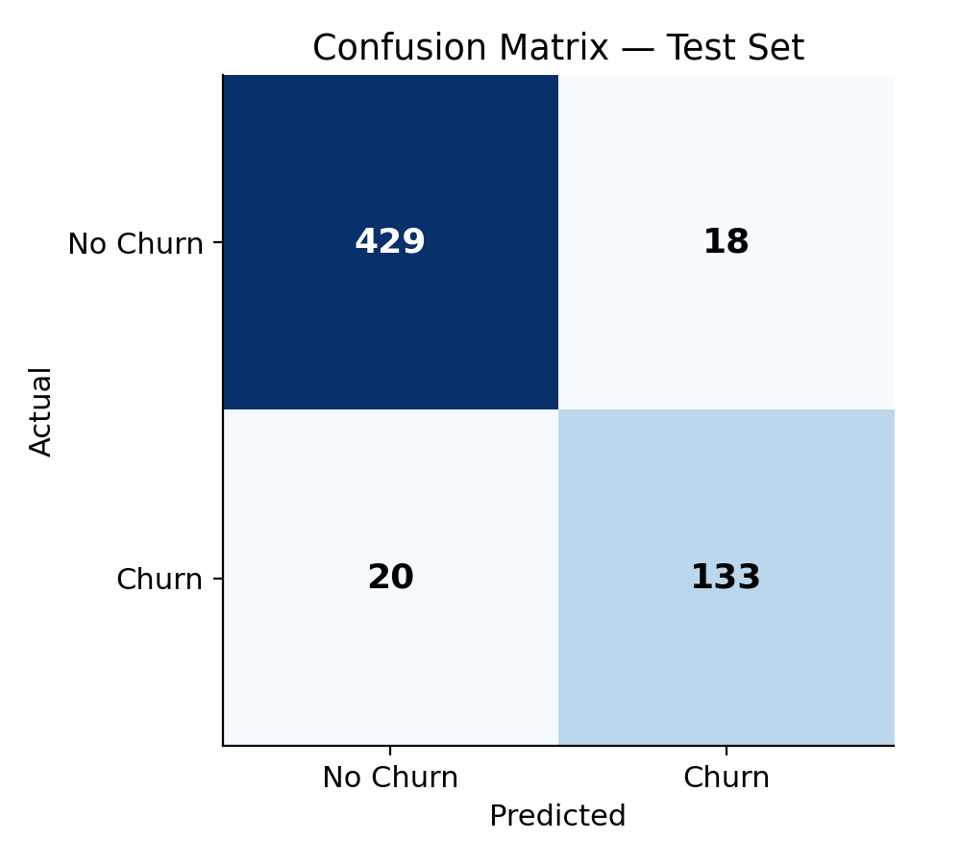
Figure 5 — Confusion matrix on the held-out test set.
On 600 held-out test customers, the model correctly flagged 133 of 153 actual churners (87% recall) while raising only 18 false alarms among 447 loyal customers. This level of precision and recall means the retention team can act on the model's output with confidence that most flagged customers are genuinely at risk.

4. Planned Visualizations & Rationale
Each visualization in this report was chosen deliberately, matching chart type to the nature of the underlying data and to what a non-technical reviewer needs to take away from it:
Visualization | What It Shows | Why This Chart Type
Bar chart — churn by contract type | Categorical comparison of churn rate across the 3 contract types | Bars make discrete categories easy to rank at a glance — ideal for the single most persuasive statistic in the report
Line/area chart — churn by tenure | Trend in churn risk across the customer lifecycle | A line chart best conveys a trend over an ordered variable (tenure), making the mid-lifecycle risk peak immediately visible
Horizontal bar chart — feature importance | Which customer attributes most influence the model's predictions | Horizontal bars accommodate longer feature labels cleanly and rank importance top-to-bottom, matching how executives scan a list
ROC curve | Overall discriminative power of the model across all decision thresholds | Standard, credible way to demonstrate model quality to technical stakeholders reviewing the analysis alongside the executive summary
Confusion matrix (heatmap) | Concrete counts of correct and incorrect predictions on real customers | Translates abstract accuracy into tangible numbers (“how many did we get right/wrong”) that build trust with non-technical reviewers

5. Presentation Strategy for a Non-Technical Audience
Communicating this analysis to executives and other non-technical stakeholders requires translating statistical results into business language and a clear narrative arc, rather than walking through the modeling process step by step. The planned approach:
- Lead with the business question and the headline number, not the method: open with “1 in 4 customers churns, and it is predictable” rather than “we trained a Random Forest classifier.”
- Use a story arc of Problem → Discovery → Evidence → Action: state the retention problem, reveal the contract/tenure pattern as the “discovery,” support it with the visual evidence in Section 3, then close on recommended actions.
- Favor one clear takeaway per slide/visual, with the supporting chart doing the explanatory work instead of dense text or statistical jargon (no p-values, coefficients, or hyperparameter names in the executive-facing material).
- Translate model-quality metrics into business terms: instead of “87.5% F1-score,” say “the model correctly flags about 9 in 10 at-risk customers, while rarely raising a false alarm.”
- Anchor every insight to a concrete, relatable customer example (e.g., “a customer on a month-to-month plan in their 8th month is nearly 7 times more likely to leave than a two-year customer”) rather than only abstract percentages.
- Close with a short, prioritized action list (Section 6) so the audience leaves with clear next steps rather than just findings.

6. Recommendations
- Launch a targeted contract-conversion incentive (e.g., a modest discount or perk) aimed at month-to-month customers between months 6 and 12, the highest-risk window identified in Section 3.2.
- Integrate the churn model's risk scores into the retention team's workflow so at-risk customers can be proactively contacted before they initiate a cancellation, rather than only offered retention deals reactively.
- Investigate the drivers behind the avg_monthly_spend signal (the model's top predictor) with a focused follow-up analysis, to determine whether pricing tiers or billing changes are contributing to churn.
- Pilot the retention program on a small customer segment first, measuring actual retention lift against a held-out control group, before rolling it out company-wide.
- Establish a recurring (e.g., quarterly) refresh of the churn model as new customer data accumulates, to keep predictions accurate as customer behaviour evolves over time.

7. Conclusion
This analysis demonstrates that customer churn, while it may appear unpredictable at the individual level, follows clear, actionable patterns at the portfolio level — driven primarily by contract structure and account tenure. The predictive model built on these patterns performs reliably on unseen data and is ready to support a proactive, targeted retention strategy. Framed through the lens of business impact rather than technical process, these findings and recommendations are intended to give leadership a confident, evidence-based basis for the next phase of the customer-retention program.

