Week 1 Task
Data Science Project Planning and Strategy Design
Project: Customer Churn Prediction for a Telecom Company
Virtual Data Science Explorer Internship – YuvaIntern

1. Introduction & Background
Customer churn — the loss of subscribers to a competitor or service cancellation — is one of the most expensive problems in the telecom industry, where acquiring a new customer typically costs far more than retaining an existing one. For this hypothetical project, I take on the role of a data scientist at a mid-sized telecom operator, “ConnectSphere Telecom,” which has noticed a rising churn rate over the last two quarters but has no systematic way to predict which customers are at risk before they leave.
The business problem is: Connect Sphere's retention team currently reacts to churn only after a customer has already cancelled, relying on manual review of complaint tickets. This is slow, inconsistent, and expensive. A predictive, data-driven early-warning system would let the retention team intervene proactively — for example, by offering a loyalty discount or resolving a service issue — before the customer decides to leave. This project applies the end-to-end Python data science workflow (collection → cleaning → exploration → modeling → evaluation) to design a plan for solving this problem.

2. Project Objectives & Scope

2.1 Objectives
- Build a predictive model that estimates the probability that a given customer will churn within the next billing cycle.
- Identify the top behavioral and account-level drivers of churn (e.g., contract type, tenure, monthly charges, support tickets).
- Produce a ranked “at-risk customer” list that the retention team can act on.
- Establish baseline evaluation metrics so future model iterations can be benchmarked.

2.2 In-Scope
- Analysis and modeling using structured, tabular customer account data (demographics, billing, usage, support history).
- Binary classification: churn vs. no-churn within the next 30-day cycle.
- A single, well-documented baseline pipeline built with scikit-learn.

2.3 Out-of-Scope
- Real-time streaming prediction or production deployment (this task is planning-level only).
- Unstructured data sources such as call-center audio or free-text chat logs.
- Multi-class churn-reason classification (why they churned) — reserved for a future phase.

3. Methodology & Strategy
The project follows a standard six-stage data science lifecycle, illustrated below, moving from raw data to an evaluated, reportable model.
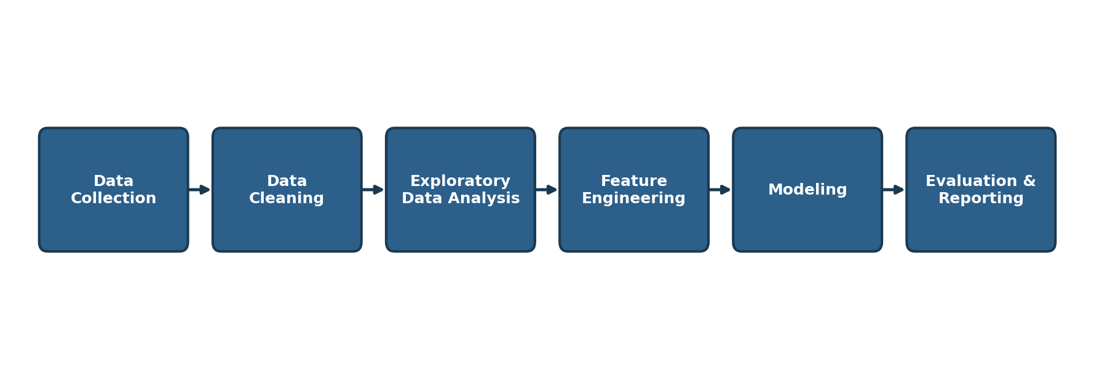
Figure 1: End-to-end data science process flow for the churn prediction project

3.1 Data Collection
Hypothetical data would be assembled from three internal sources: (1) the billing system — monthly charges, contract type, payment method, tenure; (2) the CRM — demographics and support-ticket history; and (3) the usage platform — call minutes, data usage, and service downtime events. These would be joined on a unique customer ID into a single analysis table, targeting roughly 5,000–7,000 customer records for a representative sample.

3.2 Data Cleaning
- Handle missing values: impute numeric fields (e.g., tenure) with median values; flag and review missing categorical fields rather than dropping rows outright.
- Standardize categorical labels (e.g., “Month-to-month” vs “month to month”) and correct data types (dates, currency, booleans).
- Detect and treat outliers in continuous fields such as MonthlyCharges using IQR-based capping.
- Remove exact duplicate customer records and resolve conflicting entries.

3.3 Exploratory Data Analysis (EDA)
- Univariate analysis: distribution of tenure, monthly charges, and churn rate overall.
- Bivariate analysis: churn rate broken down by contract type, payment method, and internet service.
- Correlation heatmap across numeric features to spot multicollinearity before modeling.
- Segment analysis: compare churned vs. retained customers on tenure and support-ticket volume.

3.4 Feature Engineering & Modeling
- Engineer features such as tenure buckets, average monthly spend, and a support-ticket-per-month ratio.
- Encode categorical variables (one-hot encoding) and scale numeric features for distance-sensitive models.
- Train and compare baseline models: Logistic Regression (interpretable baseline), Random Forest, and XGBoost (higher accuracy, feature importance).
- Apply SMOTE oversampling to address the expected class imbalance (churners are typically a minority class).

3.5 Evaluation
- Use an 80/20 stratified train-test split, plus 5-fold cross-validation for robustness.
- Primary metrics: Precision, Recall, F1-score, and ROC-AUC — chosen over raw accuracy because churn classes are imbalanced and false negatives (missed churners) are costly.
- Use a confusion matrix and SHAP feature-importance plot to interpret and communicate model behavior to non-technical stakeholders.

4. Timeline & Tools
The plan below allocates 33 hours of work across the week, spread over the planning, design, and documentation activities for this task.
Day | Focus Area | Key Activities | Hours
Day 1 | Introduction & Background | Research the hypothetical business context; define the data science problem | 3
Day 1 | Objectives & Scope | List project objectives; define what is in-scope and out-of-scope | 2
Day 2 | Data Collection Strategy | Identify data sources, collection methods, and data schema | 4
Day 2–3 | Data Cleaning Strategy | Plan handling of missing values, duplicates, outliers, and type conversions | 4
Day 3–4 | EDA Planning | Plan univariate/bivariate analysis, visualizations, and correlation checks | 5
Day 4–5 | Feature Engineering & Modeling | Plan feature creation, model selection, and training approach | 6
Day 5–6 | Evaluation Strategy | Define metrics, validation approach, and success criteria | 3
Day 6 | Diagrams & Flowcharts | Create process flowchart and timeline chart for the report | 3
Day 7 | Report Writing & Review | Compile the DOC file, proofread, and finalize submission | 3
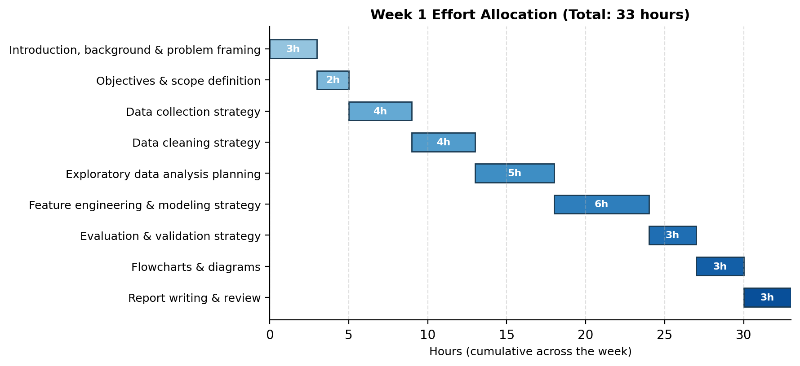
Figure 2: Week 1 effort allocation across planning activities (33 hours total)

4.1 Python Libraries & Tools
Category | Tools / Libraries | Purpose
Data Handling | pandas, numpy | Loading, cleaning, and transforming tabular data
Visualization | matplotlib, seaborn, plotly | Exploratory charts and dashboard-style visuals
Modeling | scikit-learn, xgboost | Classification models and evaluation utilities
Imbalanced Data | imbalanced-learn (SMOTE) | Handling class imbalance in churn labels
Model Interpretation | SHAP | Explaining feature contributions to predictions
Environment | Jupyter Notebook, Git/GitHub | Iterative development and version control
Diagramming | draw.io / PowerPoint (free-form) | Creating the flowcharts and timeline diagrams

5. Expected Outcomes & Challenges

5.1 Expected Outcomes
- A baseline classification model achieving an estimated ROC-AUC of 0.80+ on held-out data, based on typical results for similar telecom churn datasets.
- A ranked list of the top 5–10 churn drivers (e.g., month-to-month contracts, high monthly charges, low tenure, frequent support tickets).
- A reusable, documented pipeline (notebook + scripts) that the retention team's analysts can rerun monthly.
- Clear, non-technical visual summaries (charts, SHAP plots) that translate model output into actionable retention recommendations.

5.2 Anticipated Challenges & Mitigation Strategies
Challenge | Mitigation Strategy
Class imbalance (few churners vs. many retained customers) | Apply SMOTE/class-weighting and evaluate with F1/ROC-AUC instead of raw accuracy
Missing or inconsistent hypothetical data fields | Define clear imputation rules upfront and document every assumption in the report
Risk of overfitting on a moderately small sample | Use k-fold cross-validation and keep model complexity (tree depth, regularization) in check
Explaining model results to non-technical stakeholders | Use SHAP plots and plain-language summaries rather than raw coefficients
Time constraint of ~33 hours for a full planning cycle | Time-box each phase per the schedule in Section 4 and timebox EDA to avoid scope creep

6. Conclusion
This plan lays out a structured, end-to-end strategy for tackling the Customer Churn Prediction problem: a clearly scoped objective, a defined methodology across data collection through evaluation, a realistic 33-hour timeline, and an honest accounting of the risks involved. Following this plan provides a solid foundation for the technical implementation tasks in the coming weeks of the internship, while building the strategic planning skills central to real-world data science work.

