Week 2 Task
Exploratory Data Analysis (EDA) and Visualization Framework Design
Project: Customer Churn Prediction for a Telecom Company
Virtual Data Science Explorer Internship – YuvaIntern

1. Introduction to Exploratory Data Analysis
Exploratory Data Analysis (EDA) is the process of investigating a dataset to summarize its main characteristics, uncover patterns, spot anomalies, and test underlying assumptions — primarily through summary statistics and visualizations, before any formal modeling begins. In a data science project such as this one (predicting customer churn for a telecom company), EDA is the bridge between raw, messy data and a trustworthy predictive model: it reveals which features actually relate to churn, exposes data-quality issues that would otherwise silently corrupt a model, and builds the analyst's intuition for the business problem.
This report outlines the full EDA and visualization framework I would apply to the (not-yet-provided) churn dataset — covering the data types expected, the exploration techniques for each, the visualization strategy with concrete chart choices, the tools involved, and how findings would be documented and reported.
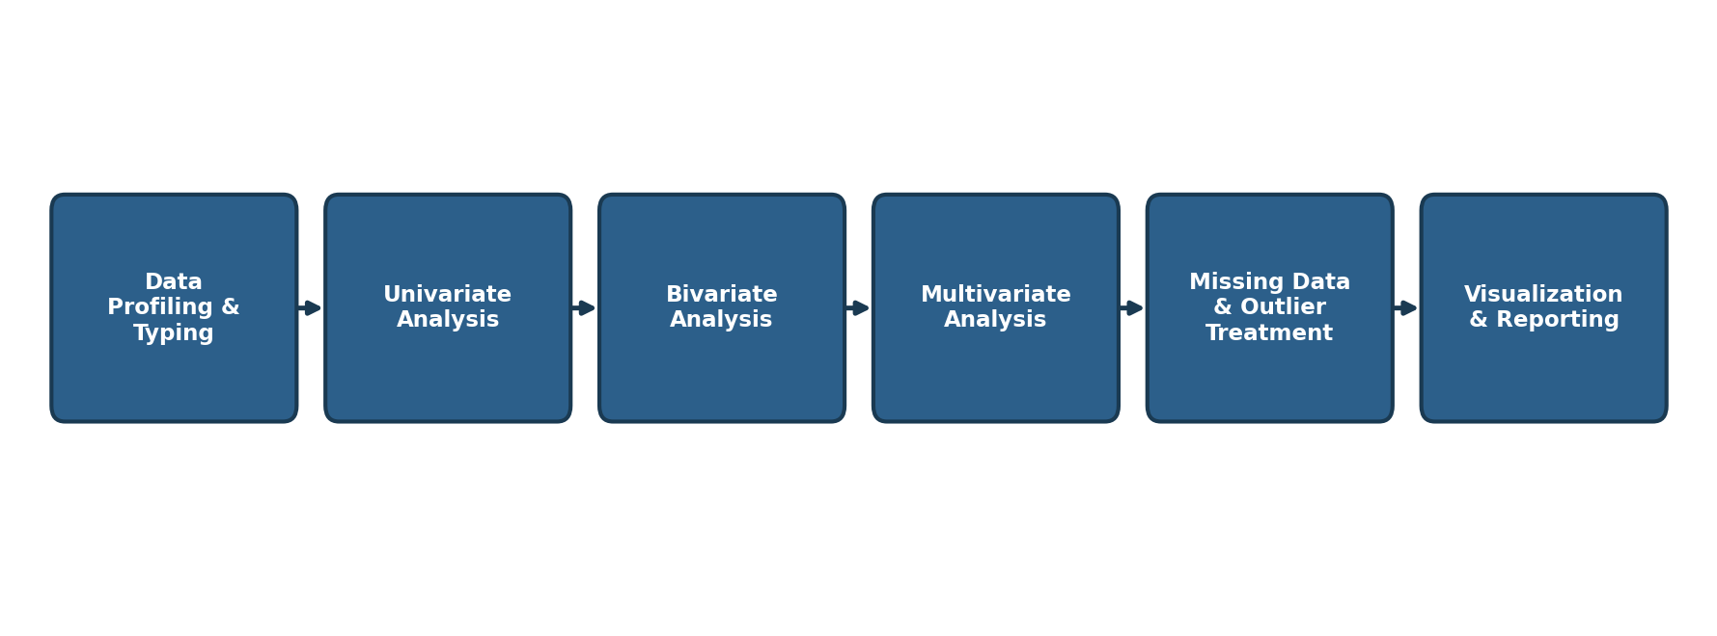
Figure 1: The EDA framework applied in this project, from data profiling to reporting

2. Potential Data Types
Before analysis begins, every column is profiled and typed correctly — mis-typed data (e.g., a numeric field stored as text) is one of the most common causes of broken EDA. For a telecom churn dataset, the expected data types are:
Data Type | Examples in the Churn Dataset | Typical pandas dtype
Numerical – Continuous | MonthlyCharges, TotalCharges, TenureMonths | float64
Numerical – Discrete | NumSupportTickets, NumServices | int64
Categorical – Nominal | ContractType, PaymentMethod, InternetService | object / category
Categorical – Ordinal | SatisfactionRating (Low/Medium/High) | category (ordered)
Binary / Boolean | Churned (Yes/No), SeniorCitizen, Partner | bool / object
Datetime | SignupDate, LastBillingDate | datetime64

3. Data Exploration Techniques
Exploration proceeds in increasing order of complexity — from single variables, to pairs of variables, to the full multivariate picture — alongside dedicated checks for data-quality issues.
Technique | What It Examines | Example Methods
Univariate Analysis | Distribution and spread of a single variable | Histograms, box plots, value_counts(), describe()
Bivariate Analysis | Relationship between two variables (often vs. churn) | Grouped bar charts, scatter plots, crosstabs, correlation
Multivariate Analysis | Interactions among 3+ variables simultaneously | Pair plots, heatmaps, PCA, faceted plots
Missing Data Handling | Identify and treat null/blank values | isnull().sum(), heatmap of missingness, imputation
Outlier Detection | Identify extreme or anomalous values | Box plots, Z-score, IQR method

3.1 Univariate Analysis
- Compute summary statistics (mean, median, std, min/max, quartiles) for every numeric column using describe().
- Plot histograms and KDE curves for continuous variables (TenureMonths, MonthlyCharges) to check skewness.
- Use value_counts() and bar charts for categorical variables (ContractType, PaymentMethod).

3.2 Bivariate Analysis
- Compare each feature against the target variable (Churned) — e.g., churn rate by contract type.
- Use grouped box plots to compare MonthlyCharges distributions between churned and retained customers.
- Build a correlation matrix between numeric features and a point-biserial correlation against the binary churn label.

3.3 Multivariate Analysis
- Use a seaborn pair plot across key numeric features (tenure, charges, tickets), colored by churn status.
- Use a correlation heatmap across all numeric features to check for multicollinearity before modeling.
- Optionally apply PCA for a 2D visual summary of how churned vs. retained customers cluster.

3.4 Missing Data & Outlier Treatment
- Quantify missingness per column with isnull().sum() and visualize patterns with a missingno matrix.
- Decide a treatment per column: median/mode imputation for low-missingness numeric/categorical fields; flag-and-review for high-missingness fields.
- Detect outliers using the IQR method and box plots; cap or review extreme values in MonthlyCharges and TotalCharges rather than dropping them outright.

4. Proposed Visualization Strategies
Each exploration step is paired with a specific chart type chosen for what it best reveals, rather than using one chart style everywhere:
Chart Type | Best Used For | Application in This Project
Histogram | Distribution of a single continuous variable | Distribution of TenureMonths and MonthlyCharges
Box Plot | Spread, median, and outliers across categories | MonthlyCharges across ContractType, split by churn
Bar Chart | Comparing counts/averages across categories | Churn rate by ContractType and PaymentMethod
Scatter Plot | Relationship between two continuous variables | TenureMonths vs. TotalCharges, colored by churn
Heatmap | Correlation strength across numeric features | Correlation matrix of all numeric churn features
Pair Plot | Pairwise relationships across multiple variables at once | Multivariate view of tenure, charges, and tickets
Line Chart | Trends over time or ordered categories | Average monthly charges trend across tenure buckets
Pie / Donut Chart | Simple proportion of a categorical variable | Overall churn vs. retained customer split
Together, these charts move from “what does one variable look like” (histograms, bar charts) to “how do two variables relate” (box plots, scatter plots) to “what is the full picture” (heatmaps, pair plots) — mirroring the univariate → bivariate → multivariate progression in Section 3.

5. Tools and Libraries
Library | Role in This Project
pandas | Load, profile, and manipulate the dataset — dtype checks, groupby summaries, missing-value counts, and crosstabs that feed every other step.
numpy | Underlying numerical operations — array math, percentile/IQR calculations for outlier detection.
matplotlib | Base plotting engine for histograms, box plots, scatter plots, and fine-grained custom chart formatting.
seaborn | Statistical visualizations built on matplotlib — heatmaps, pair plots, and grouped box/violin plots with far less code.
plotly | Interactive charts (hoverable scatter plots, dashboards) useful for exploring data live and for the final presentation.
missingno | Quick visual matrix/heatmap of missing-data patterns across the dataset.
scipy.stats | Statistical tests (e.g., chi-square for categorical association with churn) to support visual findings numerically.

6. Reporting and Documentation Plan
Findings would be compiled into a single EDA report, organized so a reader can follow the same univariate → bivariate → multivariate → conclusions flow used during analysis. The proposed sections for the final report or presentation are:
- Executive Summary – 3–4 sentence overview of the dataset and the most important churn drivers found.
- Dataset Overview – shape, data dictionary, and data-type summary (Section 2 of this document).
- Data Quality Notes – missing-value summary, outliers found, and how each was treated.
- Univariate Findings – key distributions, with histograms/bar charts and 1–2 sentence takeaways each.
- Bivariate Findings – each feature's relationship to churn, with the supporting chart and takeaway.
- Multivariate Findings – correlation heatmap and pair plot, with any multicollinearity or clustering notes.
- Key Insights & Recommendations – a short, plain-language list of what the retention team should act on.
- Appendix – full code snippets and any charts not included in the main body.
The report would be delivered as a single DOC file, with headings for each section above, embedded charts placed directly beside the text that discusses them, and short captions under every figure — the same format used throughout this document — so a non-technical evaluator can follow the logic without reading code.

7. Timeline
The plan below allocates 33 hours across the week for designing this EDA and visualization framework.
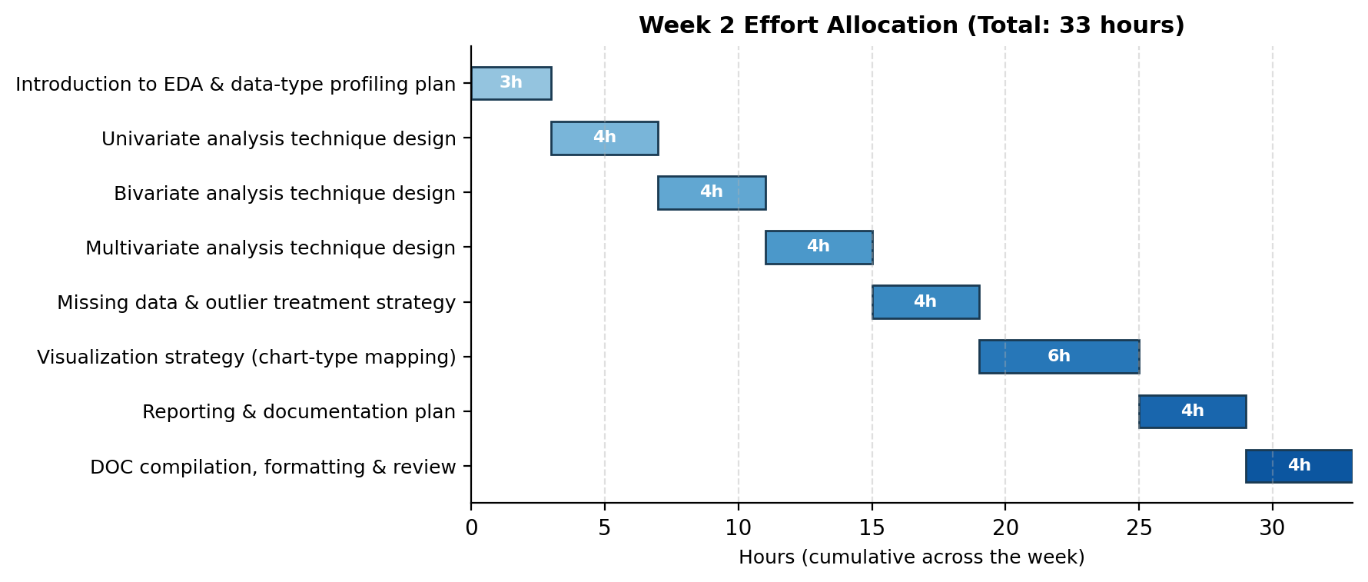
Figure 2: Week 2 effort allocation across EDA framework design activities (33 hours total)

8. Conclusion
This framework lays out a complete, dataset-agnostic EDA and visualization strategy — spanning data typing, univariate through multivariate exploration, missing-data and outlier handling, a deliberate chart-type selection for each question being asked, and a clear reporting structure. Because it is designed around techniques and reasoning rather than a specific file, this plan is directly reusable the moment a real churn dataset (or any similarly structured tabular dataset) becomes available, fulfilling the goal of deepening practical, adaptable data-analysis skills.

