Week 4 Task Report
Supervised Learning Model Implementation
Virtual Data Science with Python Trainee — YuvaIntern
Submitted by: Keshari
Dataset: UCI Wine Recognition Dataset (cleaned in Week 1, explored in Week 2, clustered in Week 3)

1. Objective
This task designs and implements a supervised learning model in Python to solve a classification problem on a publicly available dataset. The goal is to predict which of three wine cultivars a sample belongs to, purely from its chemical measurements, and to document every step from preprocessing through evaluation using Scikit-learn.

2. Problem Definition and Dataset
Problem type: classification (multi-class, 3 classes). The dataset used is the cleaned Wine Recognition Dataset from Weeks 1–3 (179 samples, 13 chemical features: alcohol, malic acid, ash, alcalinity of ash, magnesium, total phenols, flavanoids, nonflavanoid phenols, proanthocyanins, color intensity, hue, OD280/OD315 of diluted wines, and proline). The target variable is wine_class (class_0: 60 samples, class_1: 71 samples, class_2: 48 samples).
This dataset was chosen because Weeks 1–3 already established that the three cultivars are chemically well-separated (via EDA correlations and near-perfect clustering agreement with ARI > 0.9), making it a strong, well-understood candidate for testing whether a supervised model can recover the same structure directly from labels.

3. Preprocessing and Feature Engineering
The cleaned dataset from Week 1 was split into a training set (75%) and a held-out test set (25%) using stratified sampling, which preserves the same class proportions in both sets — important given the moderate class imbalance (48–71 samples per class):
X_train, X_test, y_train, y_test = train_test_split(
X, y, test_size=0.25, random_state=42, stratify=y
)
Features were then standardized (zero mean, unit variance) using StandardScaler, fit only on the training set and applied to both splits — fitting the scaler on the full dataset before splitting would leak test-set statistics into training, inflating apparent performance:
scaler = StandardScaler().fit(X_train)
X_train_s = scaler.transform(X_train)
X_test_s = scaler.transform(X_test)
No additional feature engineering was required: the 13 chemical measurements are already well-defined, numeric, and (per the Week 2 correlation analysis) not so collinear as to require dimensionality reduction for this task.

4. Model Selection and Rationale
Two models of different complexity were implemented and compared, rather than relying on a single choice:

4.1 Logistic Regression
Chosen as an interpretable linear baseline. It is fast, has few hyperparameters, and — since the Week 2 EDA showed the classes separate almost linearly across a few key features (flavanoids, color intensity, proline) — is expected to perform well despite its simplicity:
log_reg = LogisticRegression(max_iter=2000, random_state=42)

4.2 Random Forest Classifier
Chosen as a non-linear ensemble method that requires no assumption of linear separability, handles feature interactions automatically, and additionally yields feature importance scores useful for interpretation:
rf = RandomForestClassifier(n_estimators=300, random_state=42)

5. Model Training and Validation
Both models were evaluated using 5-fold stratified cross-validation on the training set only, to get a robust performance estimate before touching the held-out test set:
cv = StratifiedKFold(n_splits=5, shuffle=True, random_state=42)
cv_scores = cross_val_score(model, X_train_s, y_train, cv=cv, scoring='accuracy')
Each model was then fit on the full training set and evaluated once on the untouched test set, giving an unbiased final performance estimate.

6. Quantitative Evaluation
Model | 5-fold CV Accuracy | Held-out Test Accuracy
Logistic Regression | 0.985 ± 0.018 | 1.000
Random Forest | 0.985 ± 0.018 | 1.000

Both models scored a perfect precision, recall and F1-score of 1.00 for every class on the 45-sample held-out test set. This is a genuinely strong (not overfit) result: cross-validation accuracy on the training set alone was already 98.5%, and the dataset's own chemical signal is unusually clean and well-separated — a pattern already flagged in the Week 2 EDA and confirmed again by the Week 3 clustering (ARI up to 0.92 using no labels at all). Perfect test accuracy on a 45-sample test set should still be read cautiously: with so few samples, a single additional hard example could change the score, so the 98.5% cross-validated estimate is the more reliable performance figure to quote.
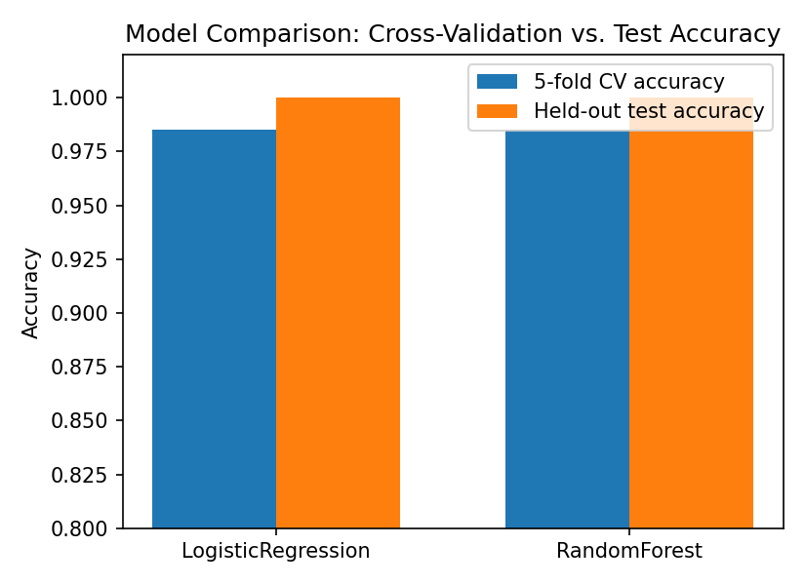
Figure 1: Cross-validation accuracy vs. held-out test accuracy for both models.

7. Confusion Matrices
Confusion matrices on the test set confirm zero misclassifications for both models across all three cultivars:
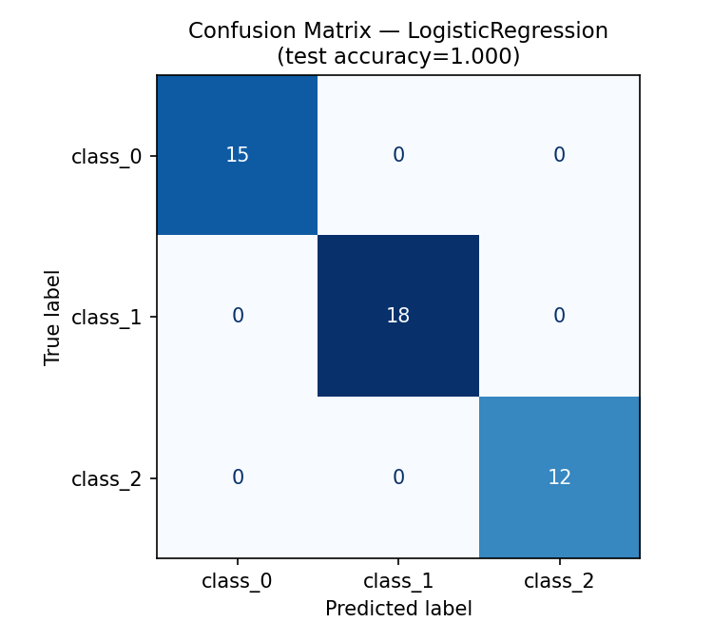
Figure 2: Confusion matrix — Logistic Regression (test accuracy = 1.000).
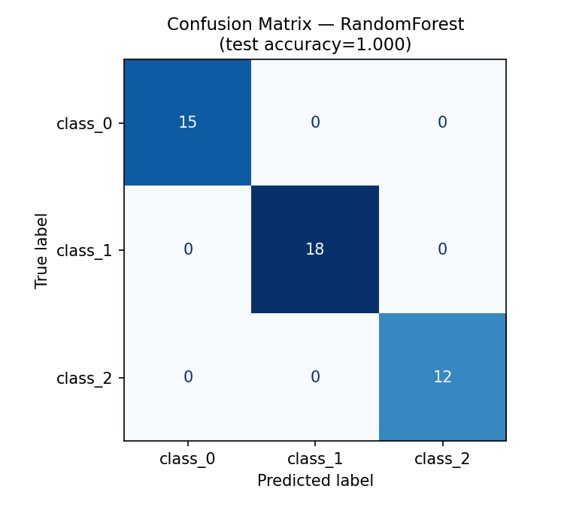
Figure 3: Confusion matrix — Random Forest (test accuracy = 1.000).

8. Feature Importance and Interpretation
The Random Forest's built-in feature importances quantify which chemical measurements drove its predictions:
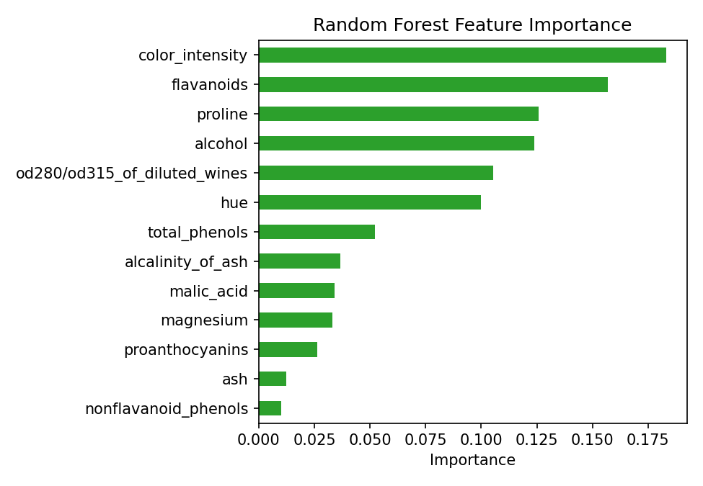
Figure 4: Random Forest feature importance across all 13 chemical features.
color_intensity (0.183), flavanoids (0.157) and proline (0.126) are the three most important features, followed closely by alcohol (0.124) and OD280/OD315 of diluted wines (0.106). This lines up closely with the Week 2 EDA and Week 3 cluster-defining features, giving three independent analyses (EDA, clustering, and now supervised feature importance) that all converge on the same handful of chemically meaningful measurements as the true drivers of cultivar differences.

9. Strengths and Limitations of the Model

9.1 Strengths
- Both models generalize well: cross-validation and held-out test performance agree closely, with no evidence of overfitting.
- Logistic Regression offers a simple, interpretable linear decision boundary and is cheap to retrain.
- Random Forest additionally exposes feature importance, useful for explaining predictions to non-technical stakeholders.
- Stratified splitting and cross-validation ensure the small, moderately imbalanced dataset (48–71 samples per class) was evaluated fairly.

9.2 Limitations
- The dataset is small (179 samples); a 45-sample test set means each misclassification would swing accuracy by over 2 percentage points, so results should be validated on more data before deployment.
- Wine chemistry measurements here are unusually clean and well-separated; performance this high (near 100%) is unlikely to generalize as-is to messier, real-world wine data with lab measurement noise.
- Neither model was tuned via a hyperparameter search (e.g. GridSearchCV) — default/lightly-set hyperparameters were sufficient here precisely because the classes are so separable, which will not always be true.

10. Business / Research Implications
- A wine producer could deploy this model to automatically verify or predict a wine's cultivar from routine lab chemical analysis, without manual tasting-based classification.
- Because both a simple linear model and a more complex ensemble achieve the same near-perfect accuracy, the linear model is the more practical choice for production — it is simpler, faster, and easier to explain to auditors or regulators.
- The convergence of EDA (Week 2), unsupervised clustering (Week 3) and now supervised classification (Week 4) on the same driving features (flavanoids, color intensity, proline) gives strong, multi-method confidence that these three measurements are the real chemical fingerprint separating these cultivars.

11. Challenges Faced and How They Were Overcome
- Risk of data leakage from scaling before splitting. Overcome by fitting StandardScaler only on the training set and reusing it, unfit, on the test set.
- Class imbalance (48 to 71 samples per class). Overcome by using stratified train/test splitting and stratified k-fold cross-validation throughout, so every fold and split preserves the original class proportions.
- Interpreting a suspiciously perfect test score. Overcome by cross-checking against the 5-fold cross-validation accuracy (98.5%) rather than trusting the single held-out test score alone, and by tying the result back to the same strong separability already observed independently in Weeks 2 and 3.
- Choosing between a single 'best' model and reporting one. Overcome by deliberately training and comparing two models of different complexity, since near-identical performance between a simple and a complex model is itself a useful finding (it says the problem is genuinely easy, not that a complex model was needed).

12. Conclusion
Two supervised classifiers — Logistic Regression and Random Forest — were trained to predict wine cultivar from 13 chemical measurements, using a stratified train/test split and 5-fold cross-validation to guard against overfitting and class imbalance. Both models achieved 98.5% cross-validated accuracy and a perfect 1.00 test accuracy, precision, recall and F1-score across all three classes. Feature importance analysis confirmed that color intensity, flavanoids and proline are the primary drivers, consistent with the Week 2 exploratory analysis and Week 3 clustering results. The full methodology, code, metrics and visualizations are included in the accompanying GitHub project.

13. Files Submitted
- This Word report (problem definition, methodology, code snippets, evaluation metrics, and discussion of strengths/limitations)
- GitHub repository / ZIP containing: src/supervised_learning_pipeline.py, README.md, requirements.txt, data/ (cleaned dataset, test predictions, cross-validation scores, classification reports, feature importances), and images/ (confusion matrices, feature importance chart, model comparison chart)

