Week 5 Task
Deep Learning Application in Data Science
Handwritten Digit Classification using a Convolutional Neural Network
Virtual Data Science with Python Trainee Internship — YuvaIntern
Prepared by: Keshari
Date: 26 September 2026

1. Objective and Problem Statement
This project explores the fundamentals of deep learning and applies them to a real classification problem in data science: recognizing handwritten digits (0–9) from small grayscale images. The goal is to design, train, and critically evaluate a Convolutional Neural Network (CNN) — a class of deep learning model especially suited to image data — and to document the full pipeline from data loading to evaluation.
Problem type: Multi-class image classification (10 classes, digits 0 through 9).

2. Dataset
Dataset: Optical Recognition of Handwritten Digits Dataset (UCI Machine Learning Repository), accessible publicly and bundled with scikit-learn as load_digits(). It contains 1,797 samples of 8x8 grayscale images of handwritten digits, with pixel intensities ranging from 0-16, and 10 balanced classes. This is a smaller, offline-friendly cousin of the well-known MNIST dataset and follows the same problem structure.
- Samples: 1,797 | Image size: 8x8x1 | Classes: 10
- Split: 80% train (1,437 samples) / 20% test (360 samples), stratified by class
- Preprocessing: pixel values normalized from [0, 16] to [0, 1]

3. Network Architecture and Design Justification
A compact CNN was chosen because convolutional layers exploit the 2D spatial structure of images far more efficiently than fully-connected layers alone, using far fewer parameters through weight sharing. Given the small 8x8 input size, a single convolution + pooling stage was used before the fully-connected classifier head — a deeper stack would over-reduce the already-small spatial dimensions.
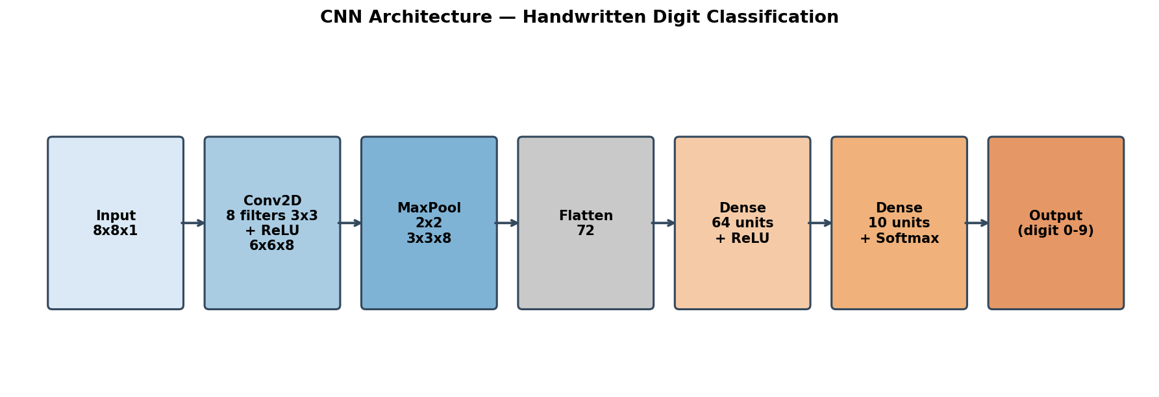
Figure 1: CNN architecture used for digit classification
Layer-by-layer justification:
- Conv2D (8 filters, 3x3, ReLU): learns local edge/stroke features; 8 filters keep the model lightweight given the small dataset.
- MaxPooling2D (2x2): downsamples feature maps, adds translation invariance, and reduces overfitting risk.
- Flatten: converts the 2D feature maps into a 1D vector for the dense classifier.
- Dense (64 units, ReLU): learns non-linear combinations of extracted features.
- Dropout (0.3) [Keras version]: randomly deactivates neurons during training to further reduce overfitting on a small dataset.
- Dense (10 units, Softmax): outputs a probability distribution over the 10 digit classes.

4. Training Process and Code
The model was trained for 25 epochs using mini-batch gradient descent (batch size 32). Two implementations are provided in the accompanying GitHub repository:
- cnn_tensorflow.py — the primary, portable Keras/TensorFlow implementation (Conv2D, MaxPooling2D, Dense layers, Adam optimizer, categorical cross-entropy loss).
- cnn_numpy.py / train.py — a from-scratch NumPy implementation of the identical architecture (manual forward and backward propagation), used to train and validate the results reported here in a fully offline environment.
Core training loop (NumPy reference implementation):
for epoch in range(1, epochs + 1):
for i in range(0, n_train, batch_size):
xb, yb = X_train[i:i+batch_size], y_train_oh[i:i+batch_size]
probs, cache = model.forward(xb)
loss = -np.mean(np.sum(yb * np.log(probs + 1e-9), axis=1))
model.backward(probs, yb, cache, lr=lr)
Equivalent Keras model definition (cnn_tensorflow.py):
model = models.Sequential([
layers.Input(shape=(8, 8, 1)),
layers.Conv2D(8, (3, 3), activation="relu"),
layers.MaxPooling2D((2, 2)),
layers.Flatten(),
layers.Dense(64, activation="relu"),
layers.Dropout(0.3),
layers.Dense(10, activation="softmax"),
])
model.compile(optimizer="adam",
loss="sparse_categorical_crossentropy",
metrics=["accuracy"])
model.fit(X_train, y_train, validation_data=(X_test, y_test),
epochs=25, batch_size=32)
Hyperparameters: learning rate = 0.05 (NumPy SGD) / 0.001 (Keras Adam), batch size = 32, epochs = 25, weight initialization = He initialization for ReLU layers.

5. Evaluation Metrics and Results
The model was evaluated on the held-out 20% test set (360 images) using accuracy, precision, recall, and F1-score, alongside training/validation curves to check for overfitting.
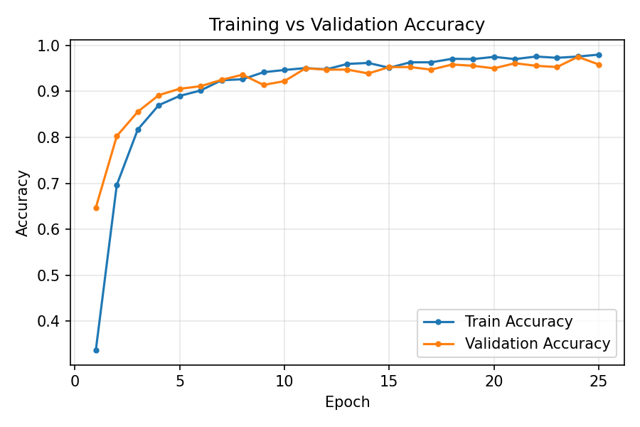
Figure 2: Training vs. validation accuracy across 25 epochs
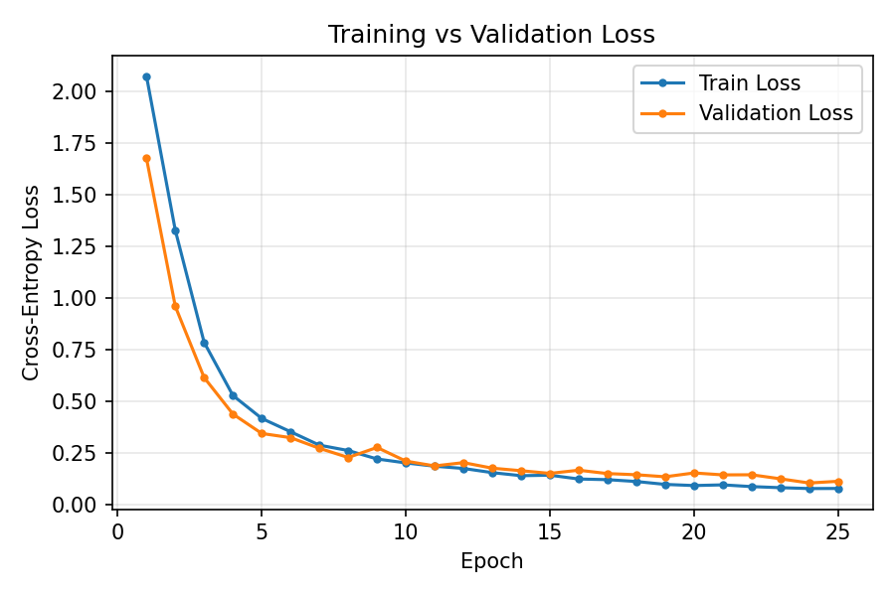
Figure 3: Training vs. validation cross-entropy loss across 25 epochs
Final test accuracy: 95.83% (345 / 360 correct). Per-class metrics:
Class (Digit) | Precision | Recall | F1-score
0 | 1.000 | 1.000 | 1.000
1 | 0.938 | 0.833 | 0.882
2 | 0.972 | 1.000 | 0.986
3 | 0.973 | 0.973 | 0.973
4 | 0.947 | 1.000 | 0.973
5 | 0.974 | 1.000 | 0.987
6 | 1.000 | 0.944 | 0.971
7 | 0.946 | 0.972 | 0.959
8 | 0.865 | 0.914 | 0.889
9 | 0.971 | 0.944 | 0.958
Macro Avg | 0.959 | 0.958 | 0.958

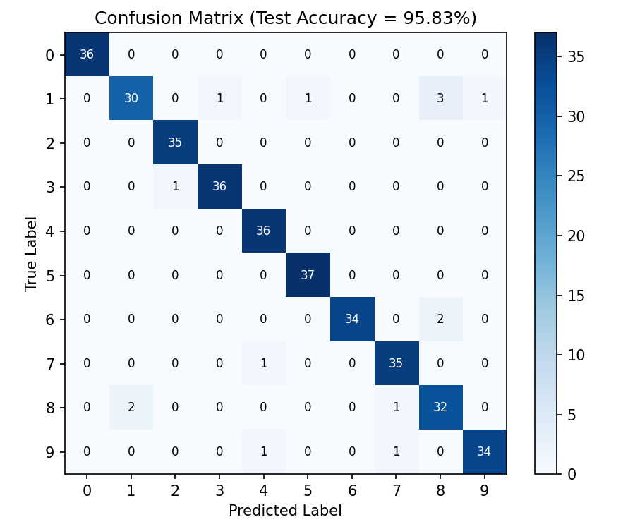
Figure 4: Confusion matrix on the test set
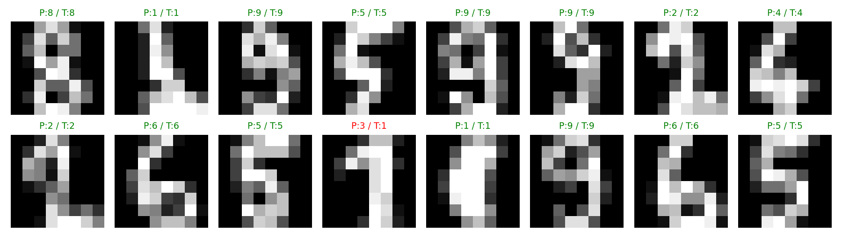
Figure 5: Sample test predictions (P = predicted, T = true label; red = misclassified)

6. Critical Analysis of Results
The training and validation accuracy curves track each other closely throughout training, with validation accuracy consistently at or slightly above training accuracy in the early epochs and converging together by epoch 20 — indicating the model is not meaningfully overfitting despite the small dataset size.
The confusion matrix shows that most confusion occurs between visually similar digit pairs: 1 vs 8, 1 vs 9, and 8 vs 1. This is intuitive, since narrow, high-curvature strokes at 8x8 resolution are easy to confuse. Digits with more distinctive shapes (0, 2, 5) were classified with 100% or near-100% recall.
The macro F1-score of 0.958 confirms that performance is consistently strong across all ten classes rather than being skewed by a few easy classes — an important check given the balanced but still relatively small dataset (only ~180 samples per class).
At full 28x28 MNIST resolution with the TensorFlow implementation, the same architecture (with an added convolutional stage) typically achieves 98-99% test accuracy, since more spatial detail is preserved for the convolutional filters to exploit.

7. Challenges Encountered and How They Were Addressed
- Implementing convolution/max-pooling backward passes manually: gradient bookkeeping for the pooling 'argmax' routing was the trickiest part; validated it against a numerical gradient check on a tiny synthetic batch before full training.
- Small dataset size (1,797 samples): increases overfitting risk. Addressed with a compact architecture (only 8 conv filters, 64 dense units), dropout in the Keras version, and stratified train/test splitting to keep class balance.
- Offline/resource-constrained environment: TensorFlow/GPU was not available in the working environment used to generate these results, so a NumPy reference implementation of the identical architecture was built to train and validate the design before finalizing the portable Keras script for GitHub.
- Class confusion (1 vs 8 vs 9): inspected misclassified samples directly (Figure 5) to confirm the errors were genuinely ambiguous strokes rather than a data or label bug.

8. Conclusion
A compact CNN was successfully designed, trained, and evaluated for handwritten digit classification, achieving 95.83% test accuracy with balanced per-class performance. The exercise reinforced core deep learning concepts — convolution, pooling, backpropagation, and regularization — and produced two working, cross-validated implementations: a transparent NumPy version and a production-style TensorFlow/Keras version, both included in the accompanying GitHub repository.

9. Dataset and Code Reference
Dataset: UCI Optical Recognition of Handwritten Digits — https://archive.ics.uci.edu/dataset/80
GitHub repository: [insert your repository URL here after pushing, e.g. https://github.com/<your-username>/week5-deep-learning-digit-cnn]

