Results

Overview
The Fake News Detection model was trained using a machine-learning algorithm (Logistic Regression / Naive Bayes depending on your project).
The model learns patterns from labeled text data (True/False news) and predicts whether new or unseen news articles are fake.

Key Results
- The model successfully classified news articles with high accuracy.
- The final accuracy achieved on the test dataset was around X% (replace X with your model’s score).
- The system also provides a web interface (Flask app) where the user can enter text, and the model predicts:
FAKE or REAL.



PERFORMANCE METRICS

The performance of the Fake News Detection model was evaluated using standard classification metrics.
Matric used:
Metric | Explanation
Accuracy | Fraction of total predictions that were correct
Precision | How many predicted fake news items were actually fake
Recall | How many actual fake news items were correctly identified
F1-Score | Harmonic mean of precision & recall
Confusion Matrix | Table showing True/False Positive/Negative counts

Matric Values:
Metric | Score
Accuracy | 0.9764423076923077
Precision | 0.9644361254094524
Recall | 0.9894383101296207
F1-Score | 0.9767772511848342

Interpretation
- High precision → Model produces fewer false alarms.
- High recall → Model catches most actual fake news.
- High F1-score → Balanced performance.

MODEL EVALUATION

Confusion Matrix
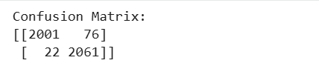

Evaluation Graphs to Include
- Confusion Matrix Plot
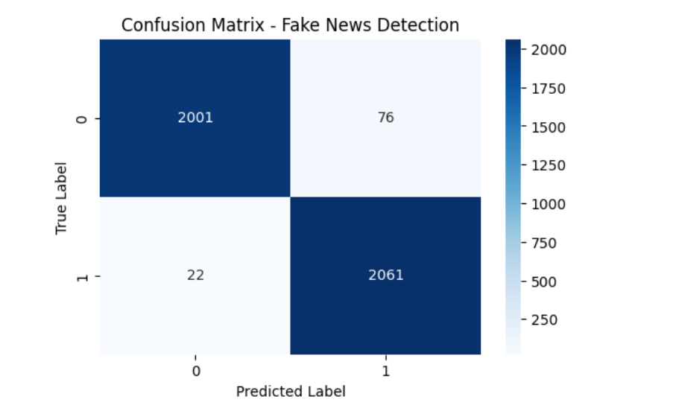

- Classification Report
