Outcome
- Minor Project Research Paper Acceptance
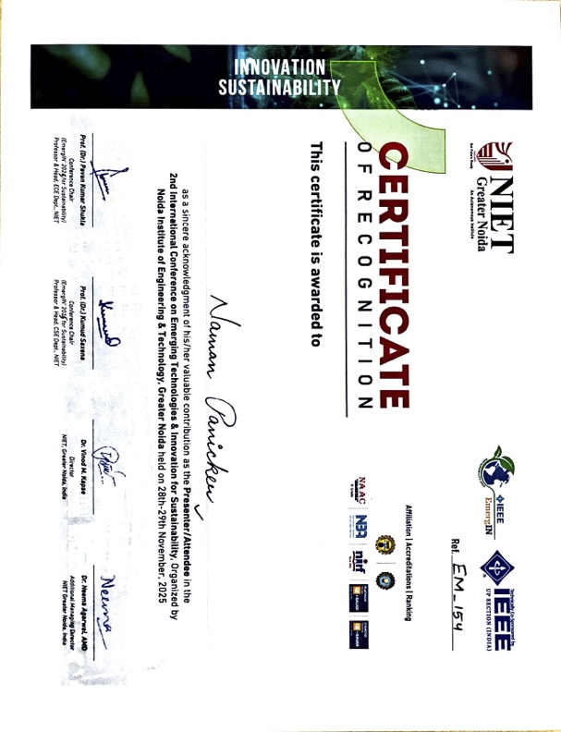
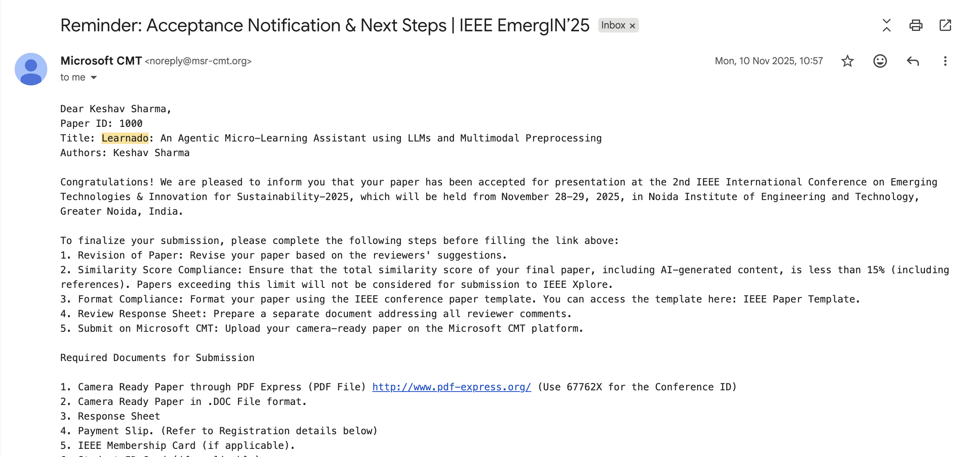
- Minor Project Research Paper Presentation Certificate

- Minor Project Research Paper Publication Link:
https://ieeexplore.ieee.org/document/11450714

