# What is Tableau?

Tableau is the fastly growing and powerful data visualization tool. Tableau is a business intelligence tool which helps us to analyze the raw data in the form of the visual manner; it may be a graph, report, etc.

****Example:**** - If you have any data like ****Big Data, Hadoop, SQL,**** or any cloud data and if you want to analyze that given data in the form of pictorial representation of data, you can use Tableau.

Data analysis is very fast with Tableau, and the visualizations created are in the form of worksheets and dashboards. Any professional can understand the data created using Tableau.

Tableau software doesn't require any technical or any programming skills to operate. Tableau is easy and fast for creating visual dashboards.

## Why use Tableau?

Here are some reasons to use Tableau:

* Ultimate skill for Data Science
* User-Friendly
* Apply to any Business
* Fast and Easy
* You don't need to do any Coding
* Community is Huge
* Hold the power of data
* It makes it easier to understand and explain the Data Reports

## Features of Tableau

* ****Data Blending:**** Data blending is the most important feature in Tableau. It is used when we combine related data from multiple data sources, which you want to analyze together in a single view, and represent in the form of a graph.

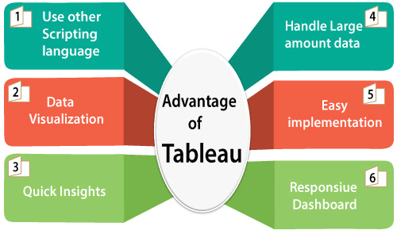

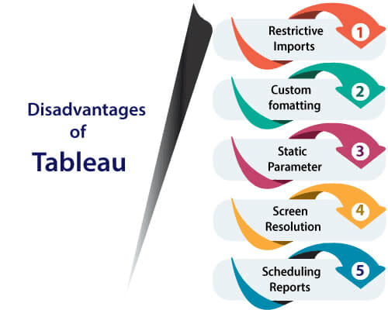

# Tools of Tableau

A list of Tableau tools:

* Tableau Desktop
* Tableau Public
* Tableau Online
* Tableau Server
* Tableau Reader

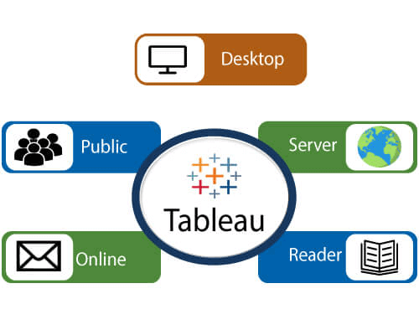

****Data analytics in Tableau is classified into two parts:-****

1. ****Developer Tools:-**** The Tableau tools which are used for development such as the creation of charts, dashboards, report generation and visualization are known as developer's tools. Tableau Desktop and the Tableau Public, are the example of this type.
2. ****Sharing Tools:-**** The role of these tools are sharing the reports, visualizations, and dashboards that were created using the developer tools. The Tableau tools that fall into this category are Tableau Server, Tableau Online, and Tableau Reader.

****Let's see all the Tools one by one:****

## Tableau Desktop

Tableau Desktop has a rich feature set and allows us to code and customize reports. Right from creating the reports, charts to blending them all to form a dashboard, all the necessary work is created in Tableau Desktop.

For live data analysis, Tableau Desktop establish connectivity between the Data Warehouse and other various types of files. The dashboards and the workbooks created here can be either shared locally or publicly.

Based on the connectivity to the publishing option and data sources, Tableau Desktop is also classified into two parts-

* ****Tableau Desktop Personal:-**** The personal version of the Tableau desktop keeps the workbook private, and the access is limited. The workbooks can't be published online. So, it should be distributed either offline or in Tableau public.
* ****Tableau Desktop Professional:-**** It is similar to Tableau desktop. The main difference is that the workbooks created in the Tableau desktop can be published online or in Tableau server. In the professional version, there is full access to all sorts datatypes. It is best for those who want to publish their workbook in Tableau server.

## Tableau Public

This Tableau version is specially built for cost-effective users. The word '****Public****' means that the created workbooks cannot be saved locally. They should be kept on the Tableau's public cloud, which can be accessed and viewed by anyone.

There is no privacy of the files saved on the cloud, so anyone can access and download the same data. This version is the best for them who want to share their data with the general public and for the individuals who want to learn Tableau.

## Tableau Online

Its functionality is similar to the tableau server, but data is stored on the servers that hosted on the cloud, which is maintained by the Tableau group.

There is no storage limit on the data which is published in the Tableau Online. Tableau Online creates a direct link over 40 data sources who are hosted in the cloud such as the ****Hive, MySQL, Spark SQL, Amazon Aurora****, and many more.

To be published, both Tableau Server and Tableau online require the workbooks that are created by Tableau Desktop. Data that flow from the web applications say Tableau Server and Tableau Online also support ****Google Analytics**** and ****Salesforce.com****.

## Tableau Server

The software is correctly used to share the workbooks, visualizations, which is created in the Tableau Desktop application over the organization. To share dashboards in the Tableau Server, you should first publish your workbook in the Tableau Desktop. Once the workbook has been uploaded to the server, it will be accessible only to the authorized users.

It's not necessary that the authorized users have the Tableau Server installed on their machine. They only require the login credentials by which they can check reports by the web browser. The security is very high in Tableau server, and it is beneficial for quick and effective sharing of data.

The admin of the organization has full control over the server. The organization maintains the hardware and the software.

## Tableau Reader

Tableau Reader is a free tool which allows us to view the visualizations and workbooks, which is created using Tableau Desktop or Tableau Public. The data can be filtered, but modifications and editing are restricted. There is no security in Tableau Reader as anyone can view workbook using Tableau Reader.

If you want to share the dashboards which are created by you, the receiver should have Tableau Reader to view the document.