Protein Data Analysis

The project focuses on trying to use disorder and amino acid residue to predict physical features of a protein structure, namely the PH, temperature, and PI (isoelectric point). This would be helpful in quickly identifying diseases in patients to administer the best form of treatment.

The first model trained on is the following uses a variation of the structure below which represents the traditional fully connected layers.

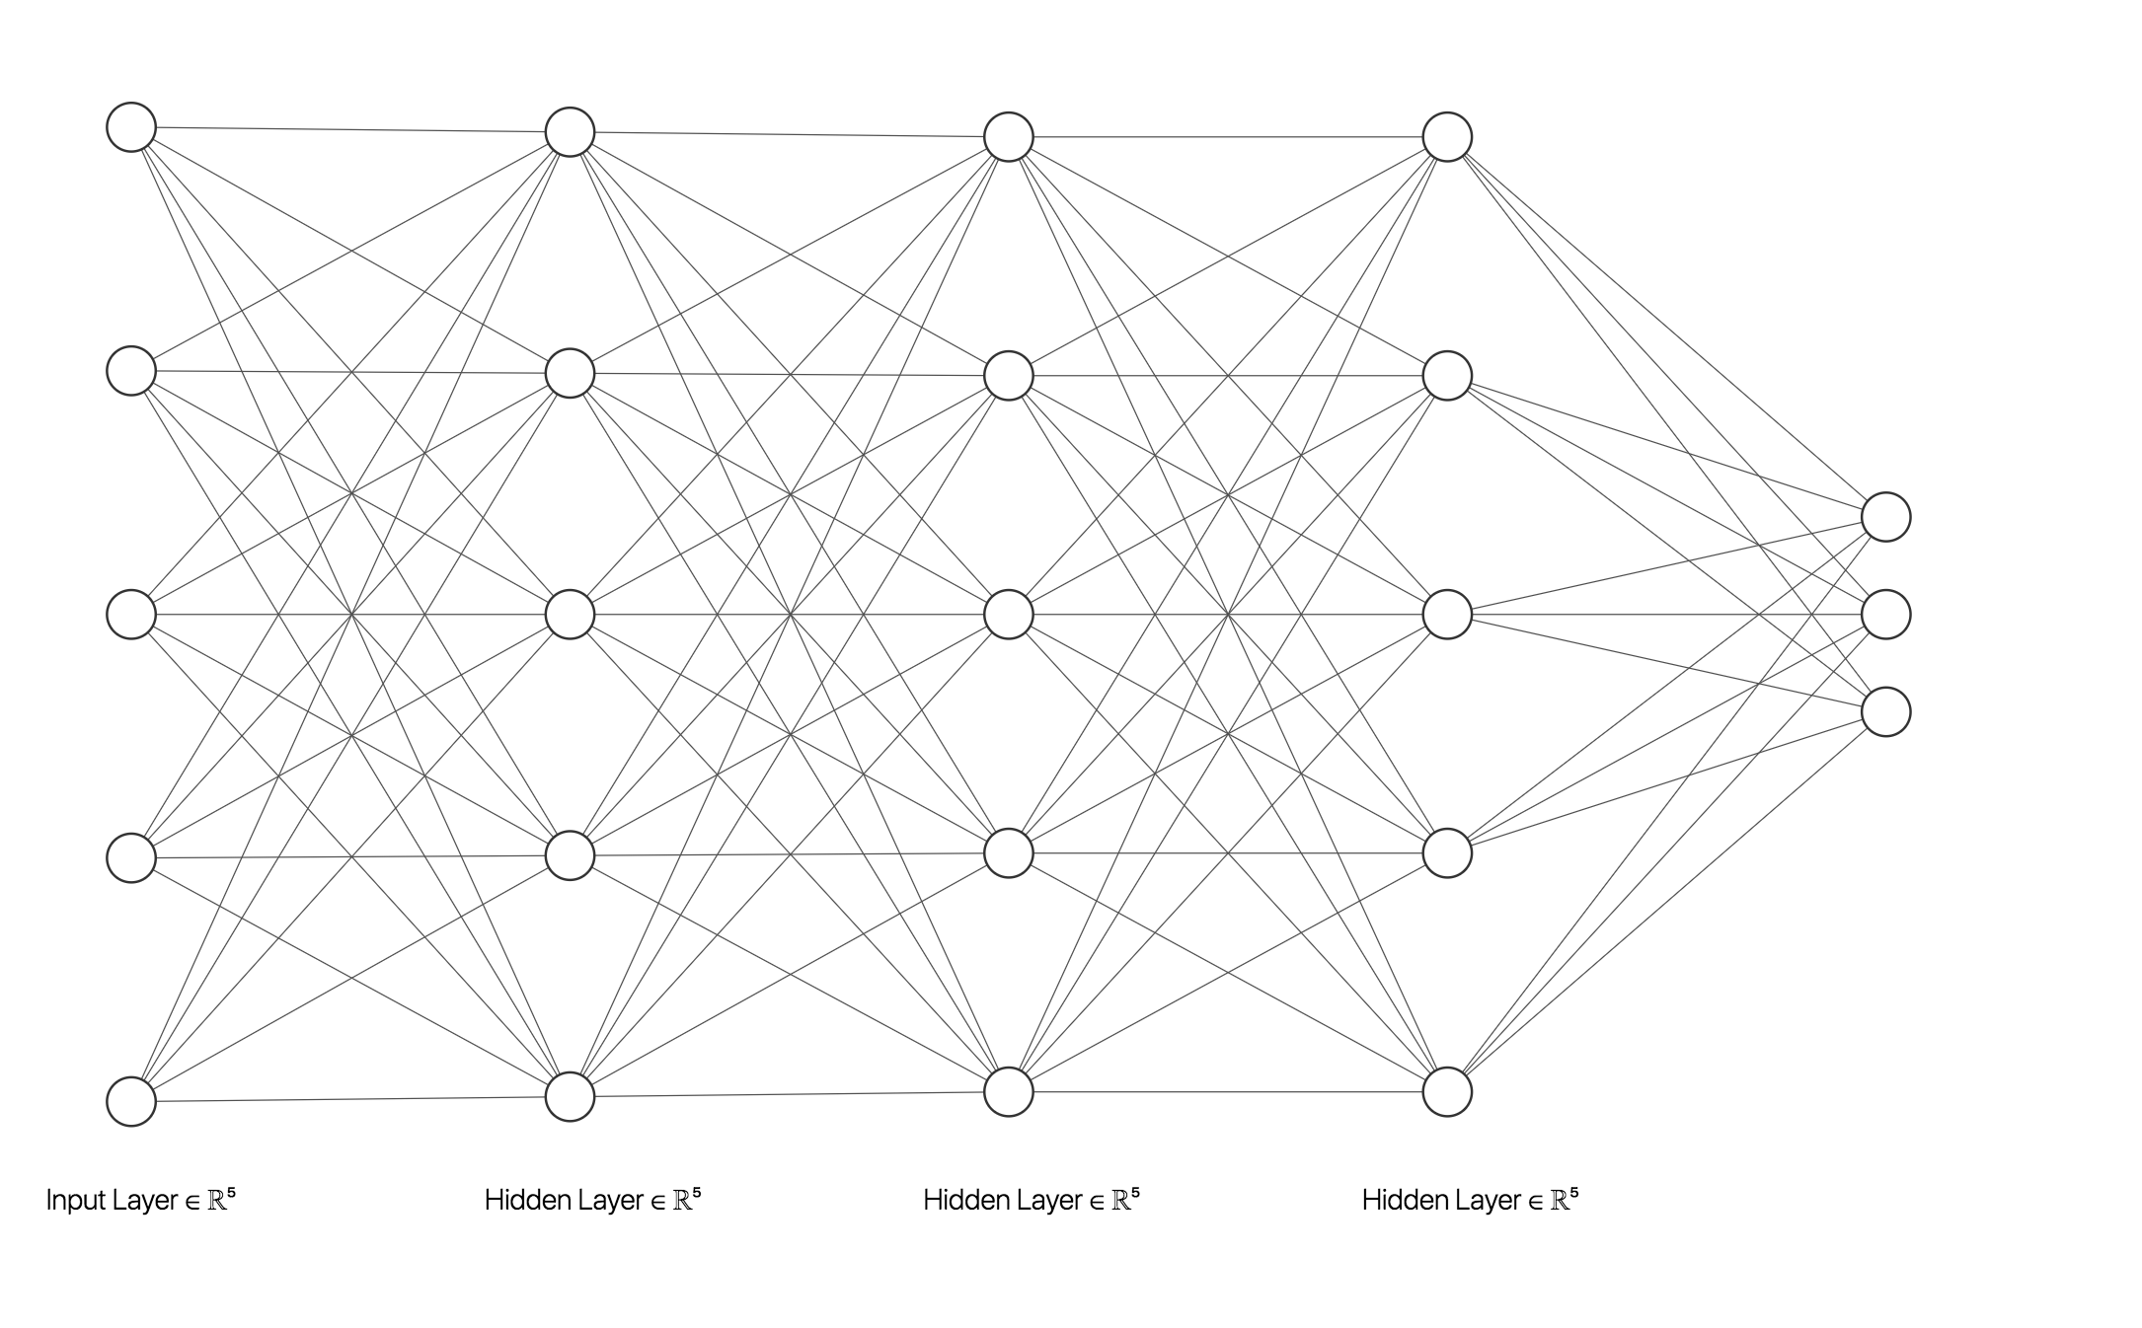

This structure unfortunately fails at deeper layers due to various complications which end up reducing accuracy hence the structure below, which is inspired from ResNet was used. This structure allows the models to learn faster due to the outputs influencing deeper layers and reduces the problem of cost functions increasing on long iterations.

