Part1

Outputs of the following commands:

1. pwd:-

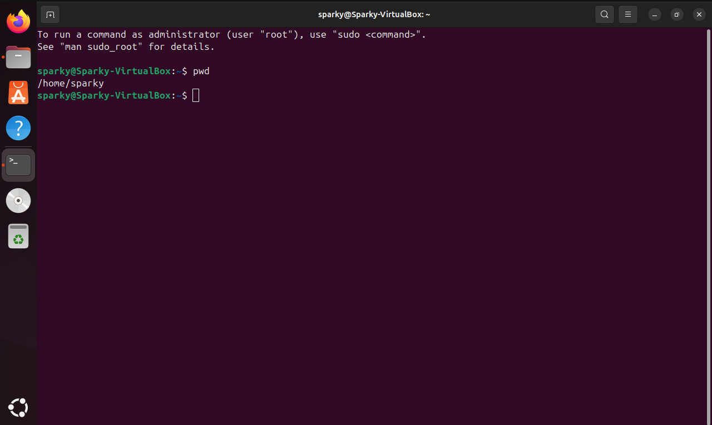

1. cd:-

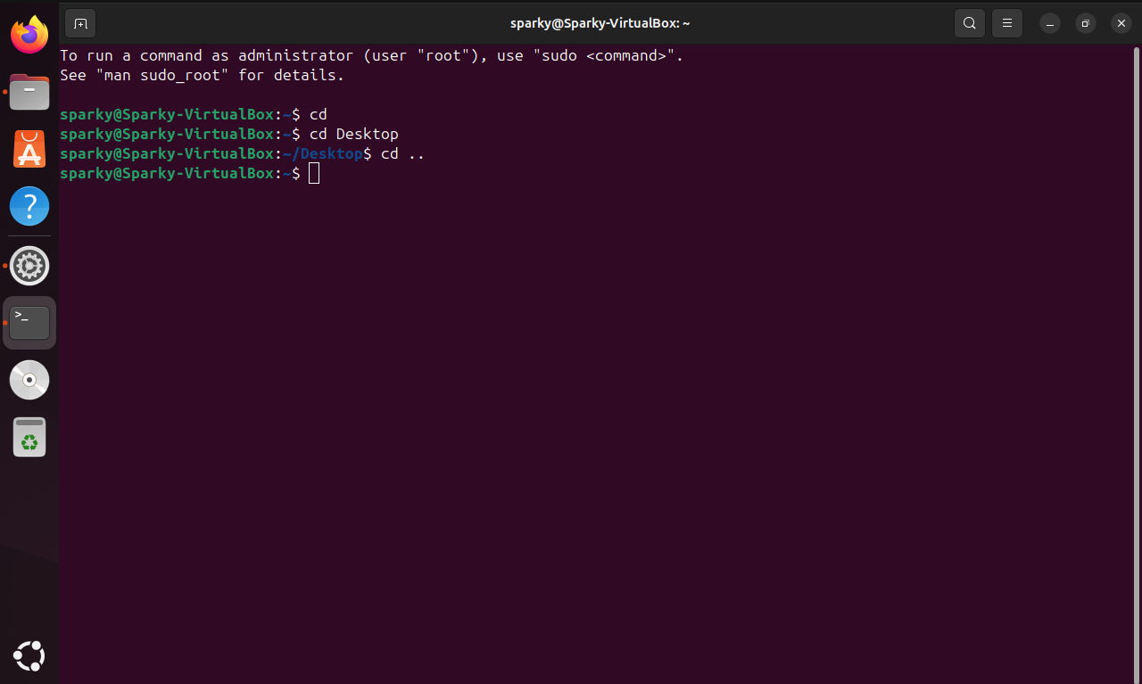

1. ls:-

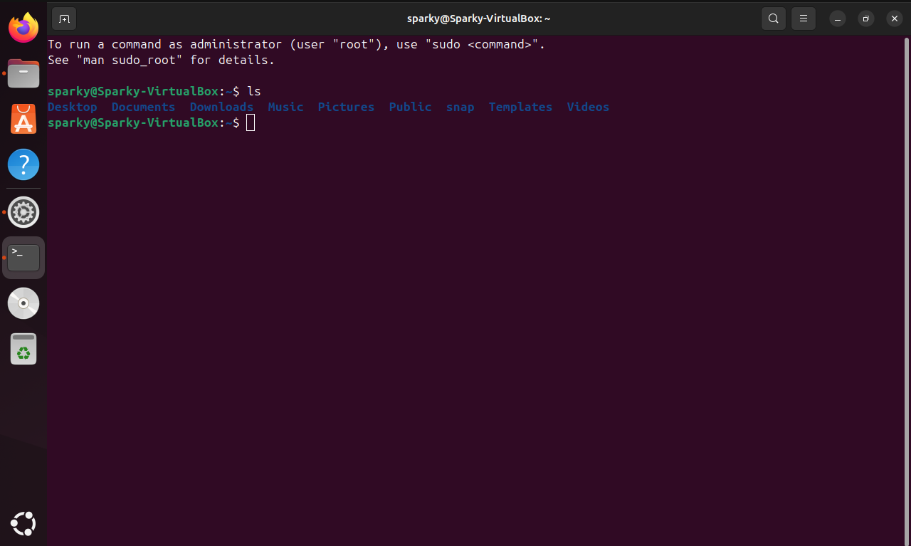

1. mkdir:-

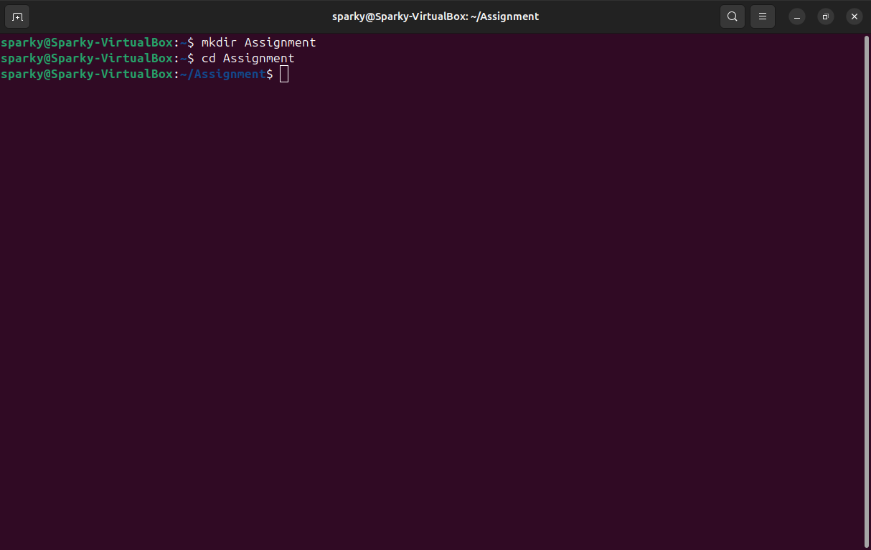

1. rm:-

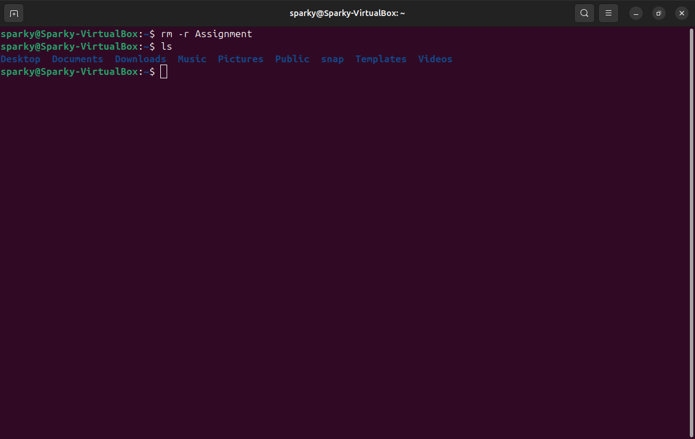

1. touch:-

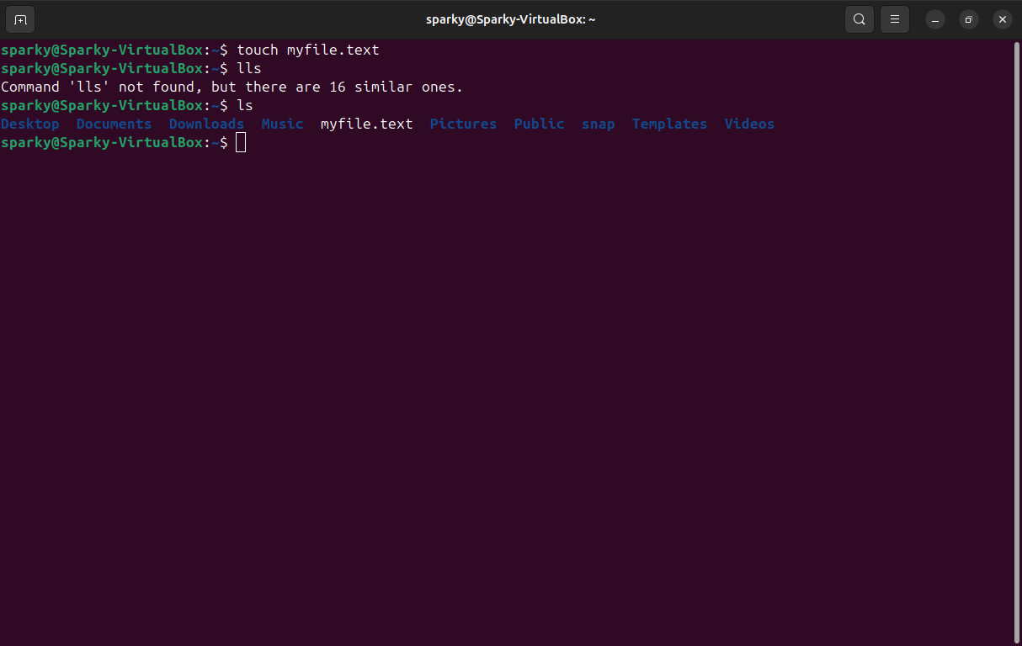

1. hostname:-

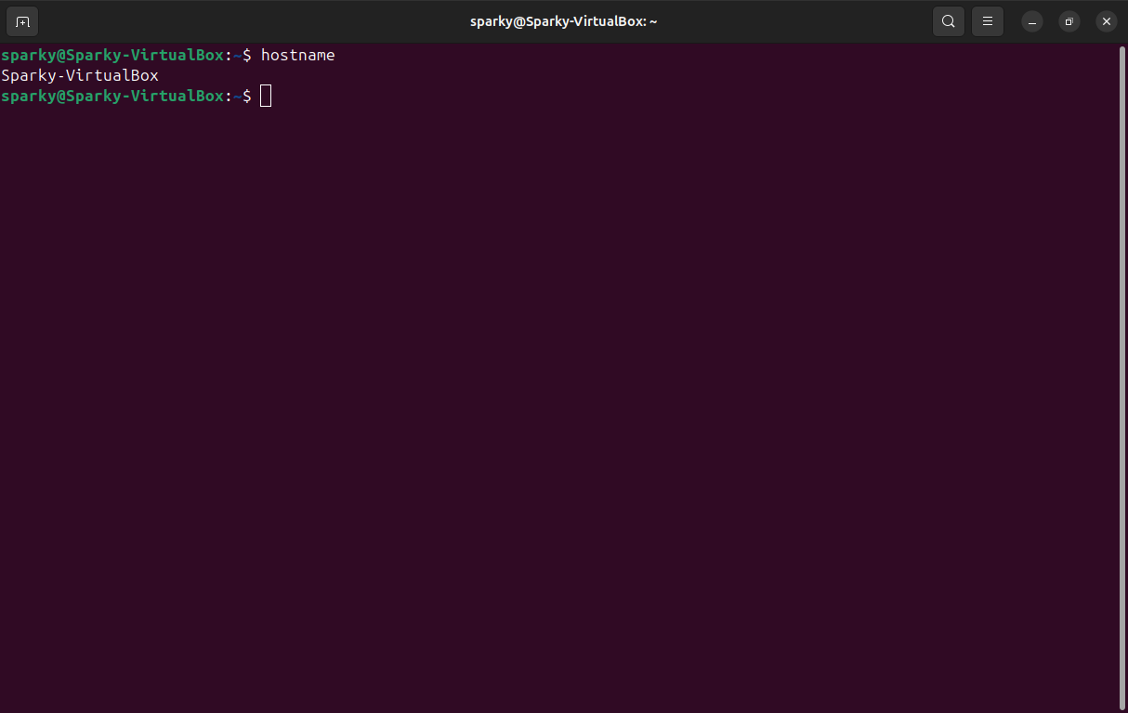

1. cat:-

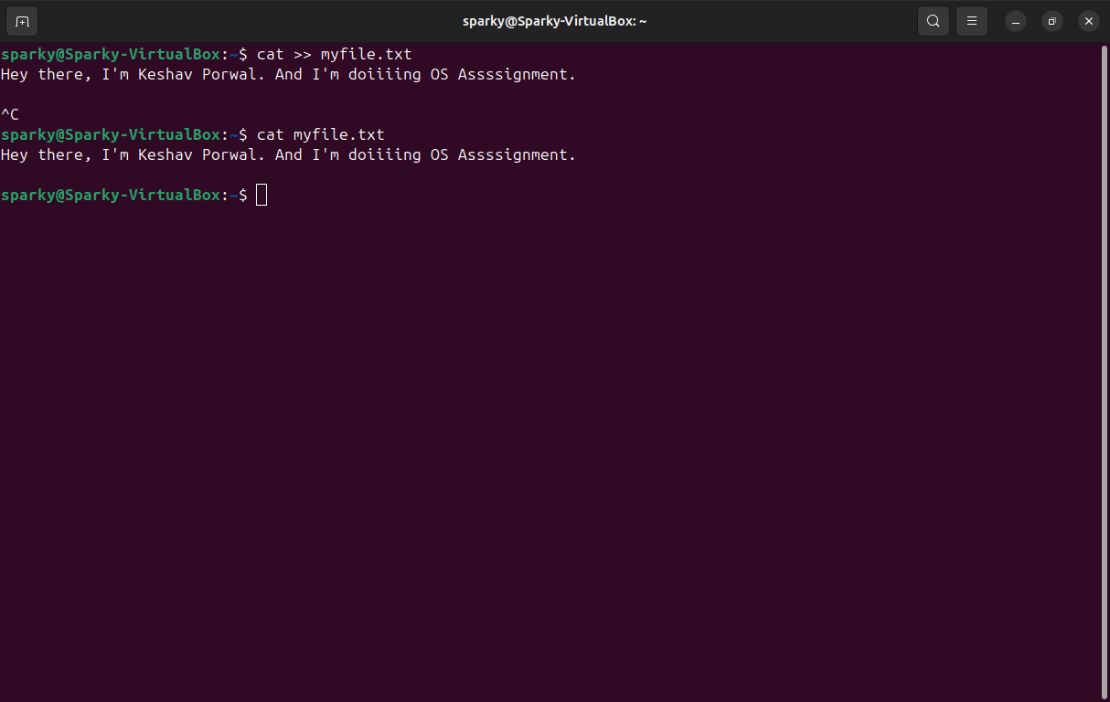

1. chmod:-

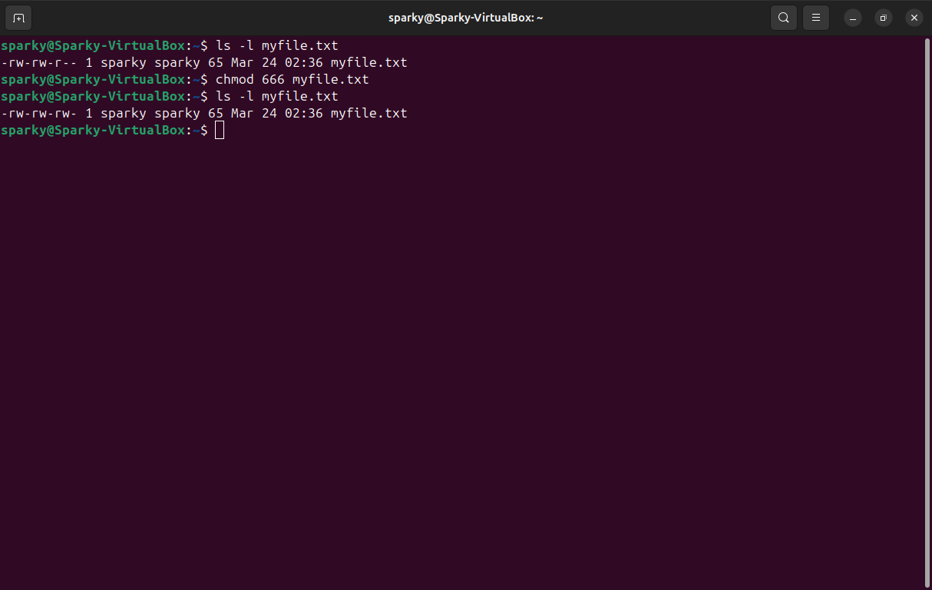

1. echo:-

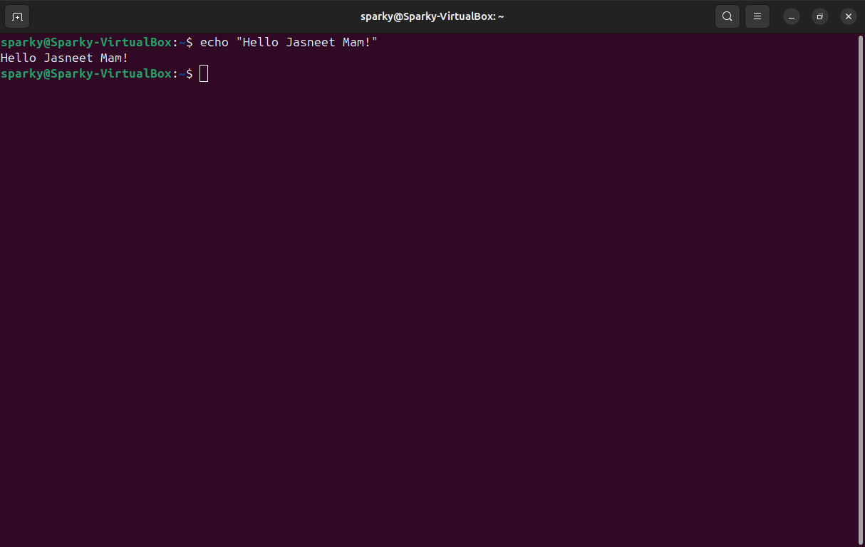

11. ) grep:-

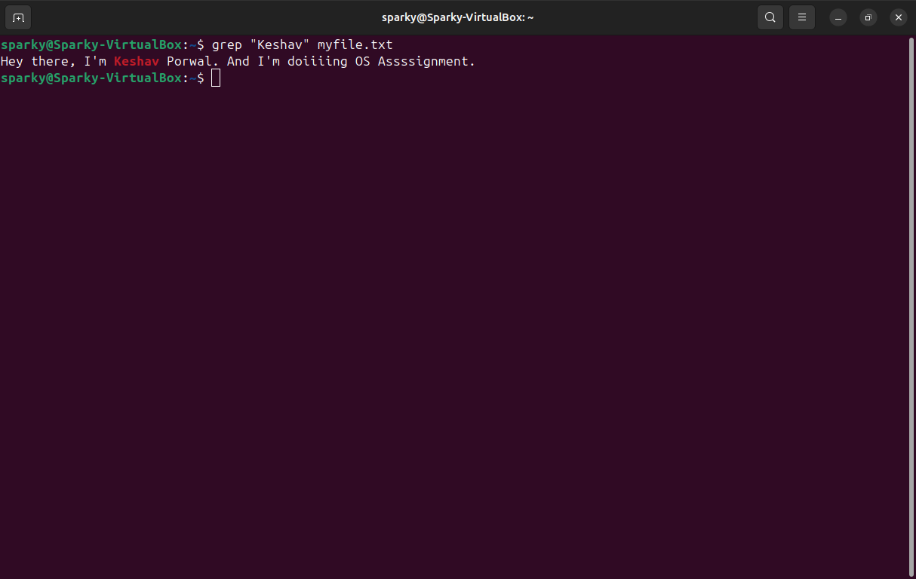

12. ) fgrep:-

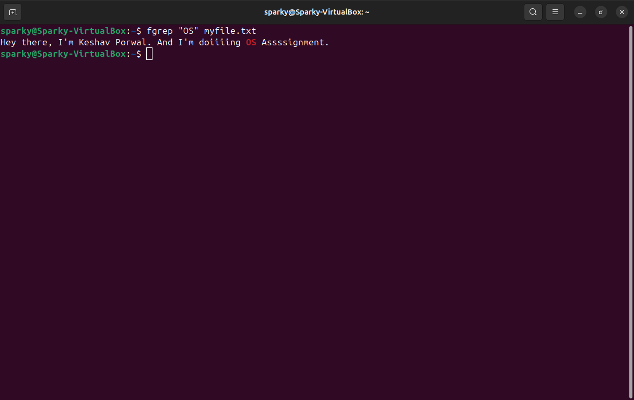

13. ) mv:-

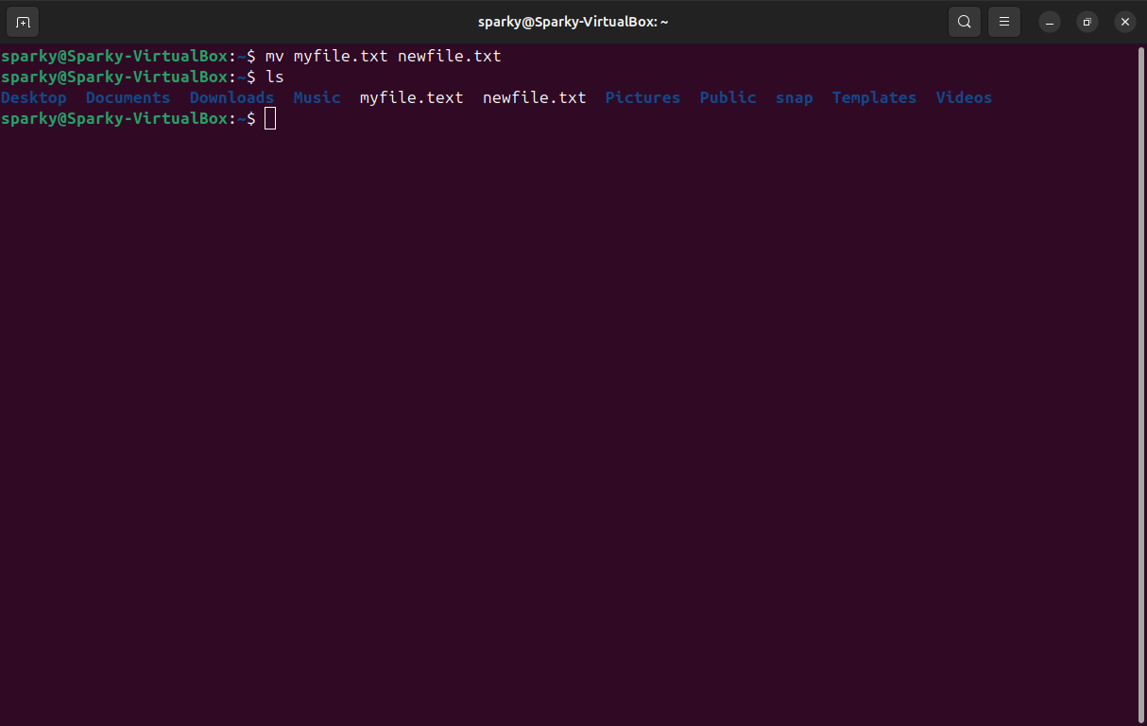

14. ) cp:-

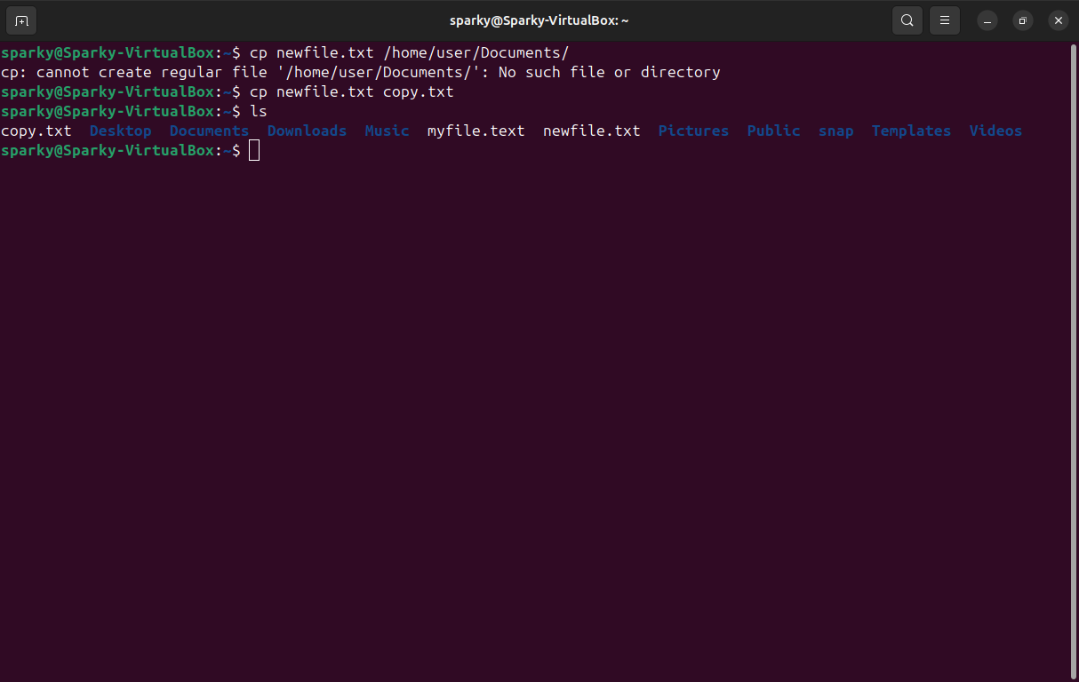

15. ) more:-

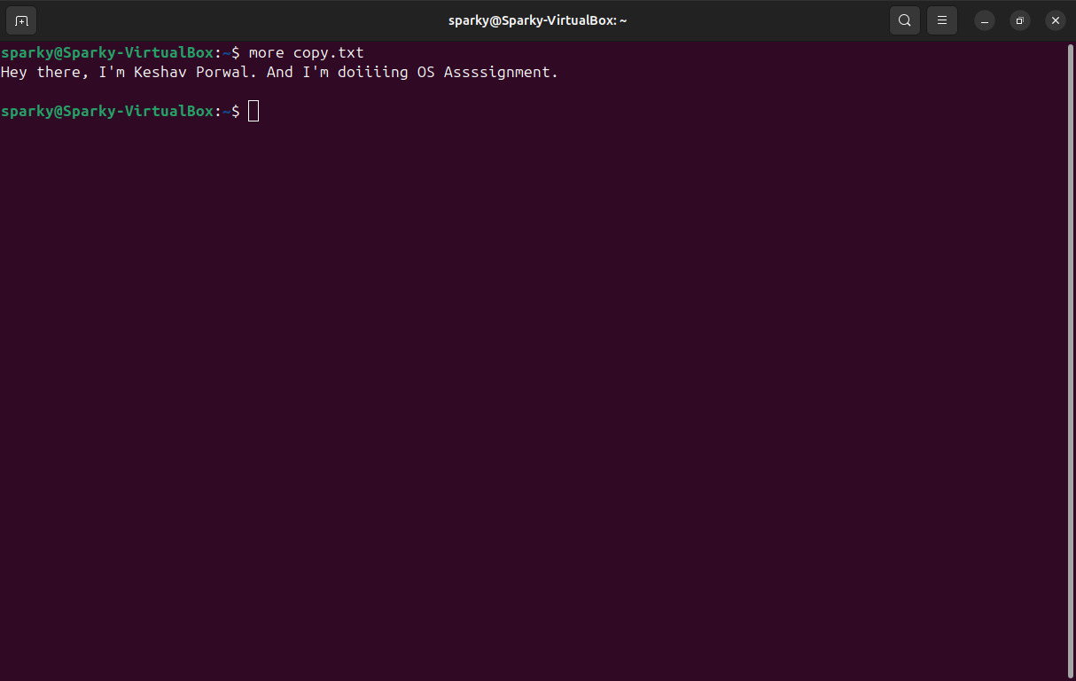

16. ) less:-

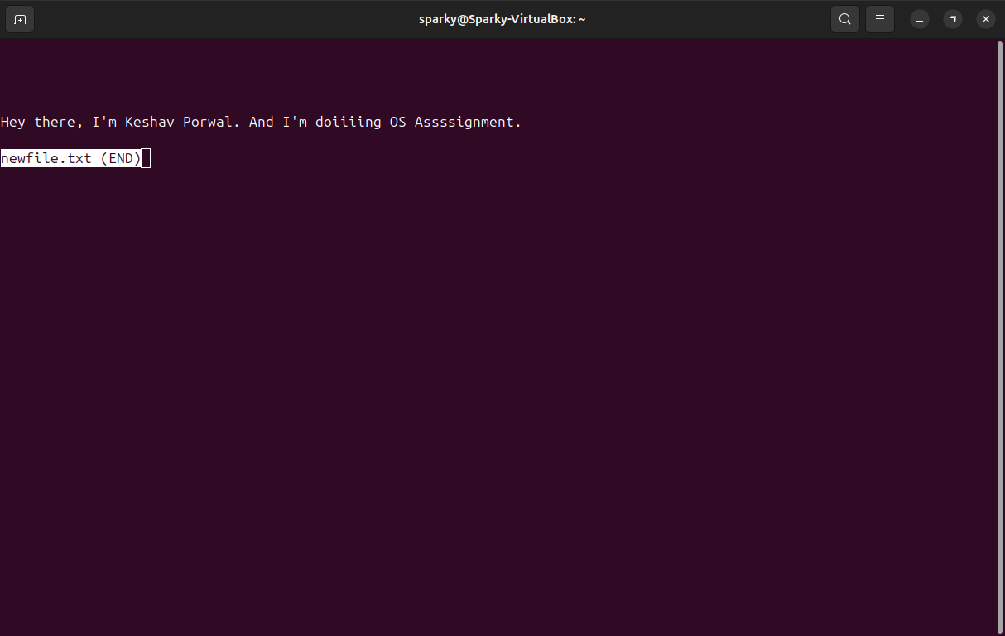

17. ) wc:-

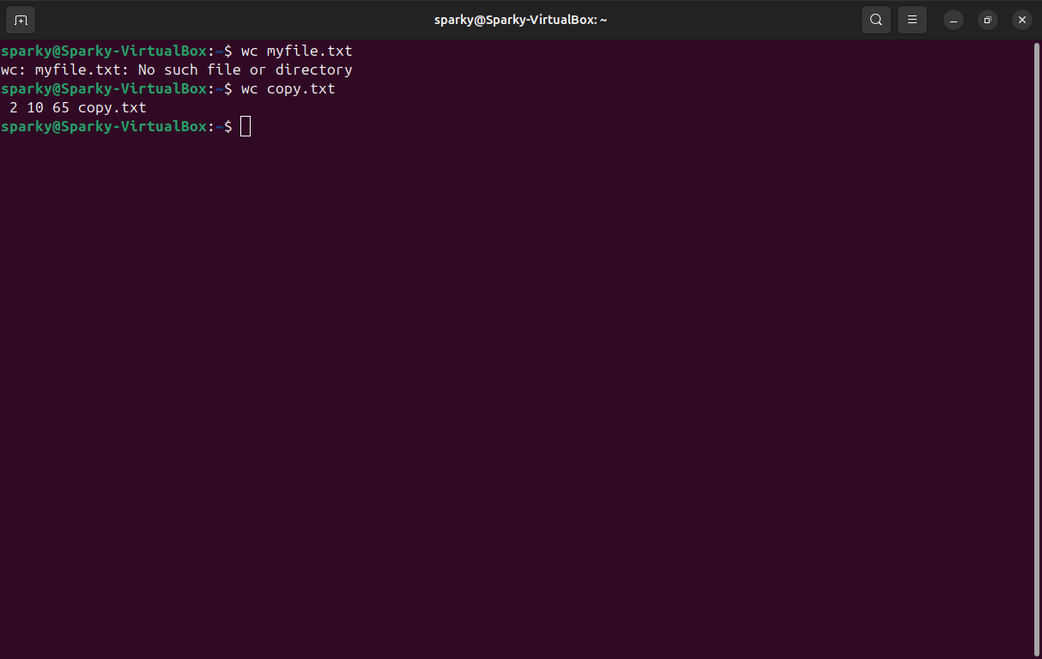

18. ) awk:-

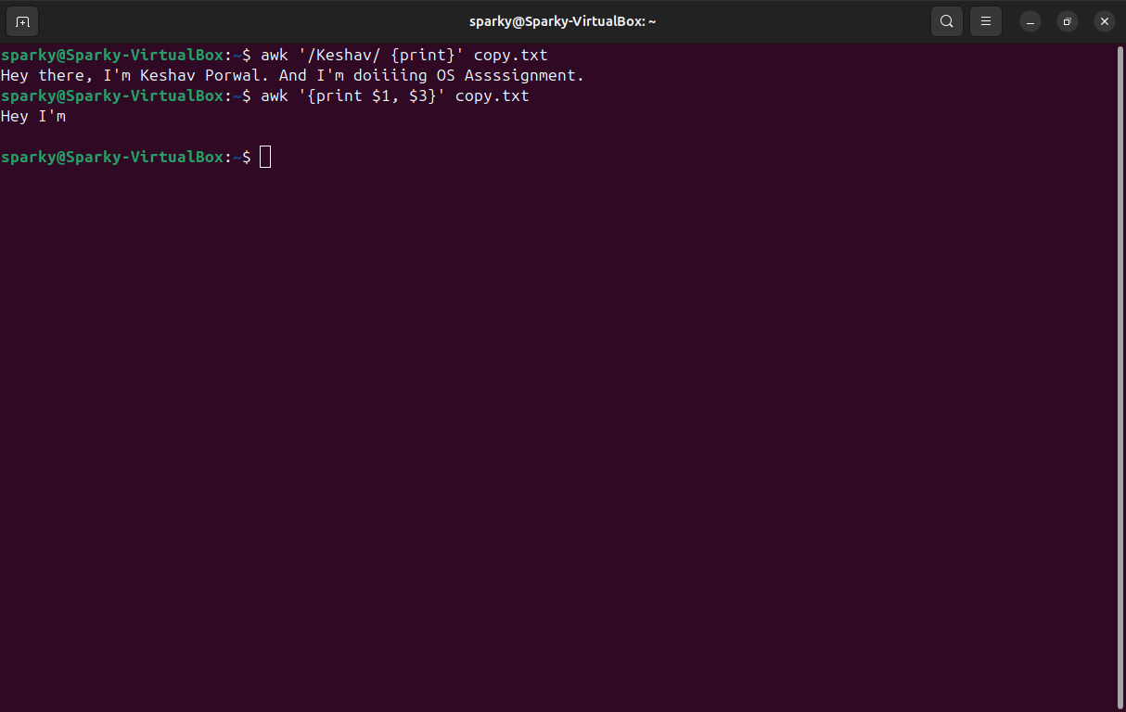

19. ) sed:-

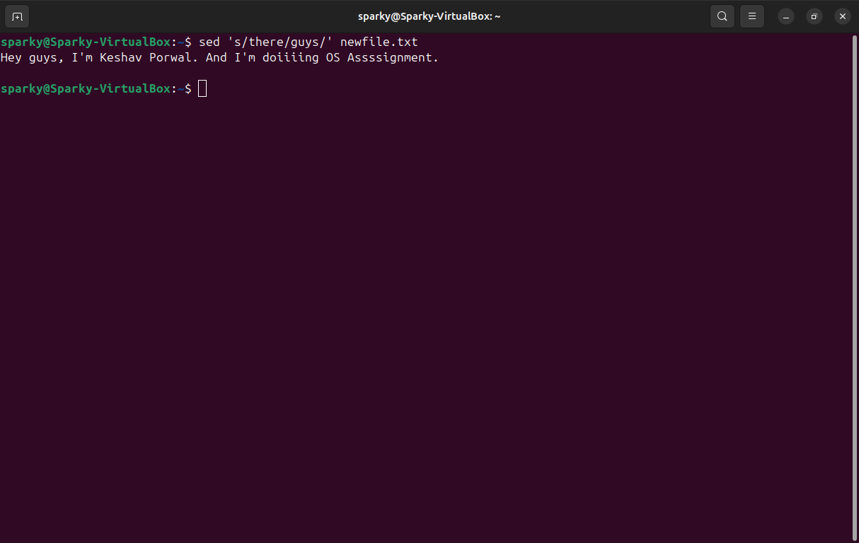

20. ) tail:-

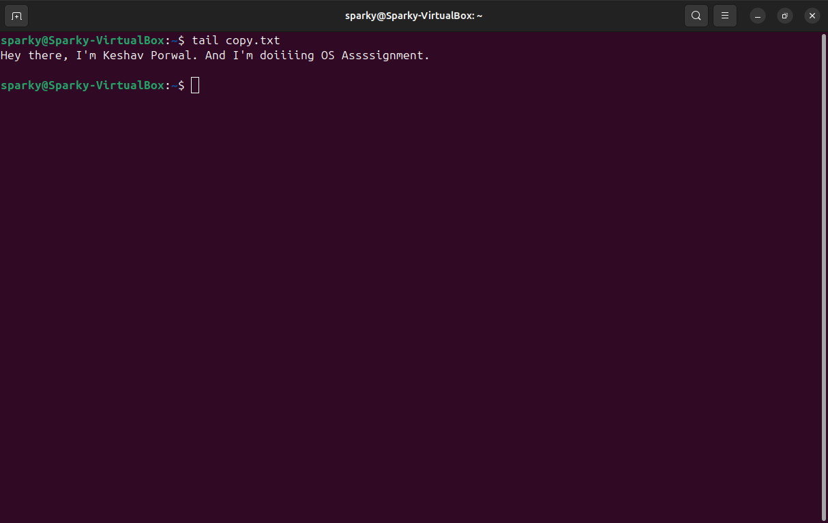

Part 2

Answers to the following Questions: (you need to supply commands):

1. How to navigate to a Specific Directory?

1. Move into a Folder: cd folder_name
2. Move to a Specific Path: cd /home/user/Documents
3. Go Back One Level: cd .. (Moves to the parent directory)
4. Go to Home Directory: cd ~
5. Go to Root Directory: cd /
6. Check Current Directory: pwd

2. See Detailed Information About Files and Directories Using ls?

* Use ls -l to display **detailed information** (permissions, owner, size, modification date).
* Use ls -lh for **human-readable file sizes** (e.g., KB, MB).
* Use ls -la to **include hidden files** in the listing.

3. Create Multiple Directories Using mkdir

* Create multiple directories at once: mkdir dir1 dir2 dir3
* Create nested directories: mkdir -p parent/child/grandchild

4. Remove Multiple Files at Once Using rm

* Delete multiple files: rm file1.txt file2.txt file3.txt
* Use wildcards to delete multiple files: rm *.txt (removes all .txt files in the directory)

5. Use rm to Delete Directories

* Remove an **empty** directory: rmdir folder_name
* Remove a **non-empty** directory: rm -r folder_name

6. Copy Files and Directories in Linux

* Copy a file: cp file1.txt destination/
* Copy multiple files: cp file1.txt file2.txt destination/
* Copy an entire directory: cp -r dir1 destination/

7. Rename a File Using mv

* Rename a file: mv oldname.txt newname.txt

8. Move Multiple Files Using mv

* Move multiple files to a directory: mv file1.txt file2.txt destination/

9. Create Multiple Empty Files Using touch

* Create multiple files: touch file1.txt file2.txt file3.txt

10. View the Content of Multiple Files

* Display content of multiple files: cat file1.txt file2.txt

11. Create a File and Add Content Using cat

* cat > file.txt → Type content, then press Ctrl + D to save.

12. Append Contents of One File to Another Using cat

* cat file1.txt >> file2.txt (Appends file1.txt content to file2.txt)

13. Use cat When File Content is Too Large

* Use cat file.txt | more or cat file.txt | less to **view content page by page**

14. Merge Multiple Files Using cat

* cat file1.txt file2.txt > merged.txt (Combines both into merged.txt)

15. Append to an Existing File Using cat

* cat >> file.txt → Type content, then press Ctrl + D to save.

16. Understanding chmod Permissions

* chmod 777 file.txt → **Full access** (read, write, execute) for everyone.
* chmod 755 file.txt → **Owner full access, others read & execute only.**
* chmod +x script.sh → **Make script executable.**

17. Find Number of Lines Matching a Pattern

* grep -c "pattern" file.txt (Counts lines matching "pattern")

18. Display Files Containing a Specific String

* grep "pattern" *.txt (Finds all files containing "pattern")

19. Show Line Number of Matched Lines

* grep -n "pattern" file.txt (Displays matched line numbers)

20. Match Lines Starting with a String

* grep "^string" file.txt (Finds lines starting with "string")

21. Sort Files in Descending Order

* sort -r file.txt (Sorts in **reverse order**)

22. Sort a File Based on a Specific Column

* sort -k2 file.txt (Sorts based on the **second column**)