
IILM UNIVERSITY, GURUGRAM
SCHOOL OF COMPUTER SCIENCE & ENGINEERING

ASSIGNMENT
VERSION CONTROL SYSTEM

Submitted By: Keshav Singh Submitted to: Dr. Puja Batra
Section – 3A ( Associate Professor )
URN: 2581011

Problem Statement: Demonstrate the use of Git’s staging area by adding multiple files to staging and removing a selected file from the staging area without deleting it from the working directory.

Task : Add multiple files to the Git staging area and remove one selected file from the staging area without deleting it from the working directory. Verify the staging status using Git commands.

Commands used and screenshots:

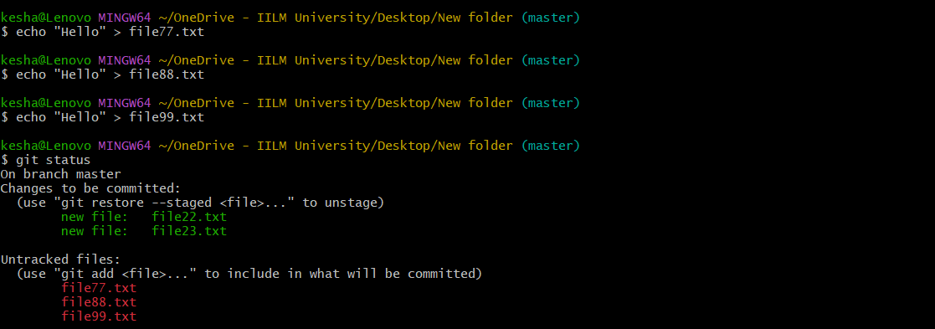
kesha@Lenovo MINGW64 ~/OneDrive - IILM University/Desktop/New folder (master)
$ echo "Hello" > file77.txt

kesha@Lenovo MINGW64 ~/OneDrive - IILM University/Desktop/New folder (master)
$ echo "Hello" > file88.txt

kesha@Lenovo MINGW64 ~/OneDrive - IILM University/Desktop/New folder (master)
$ echo "Hello" > file99.txt

kesha@Lenovo MINGW64 ~/OneDrive - IILM University/Desktop/New folder (master)
$ git status
On branch master
Changes to be committed:
(use "git restore --staged <file>..." to unstage)
new file: file22.txt
new file: file23.txt

Untracked files:
(use "git add <file>..." to include in what will be committed)
file77.txt
file88.txt
file99.txt
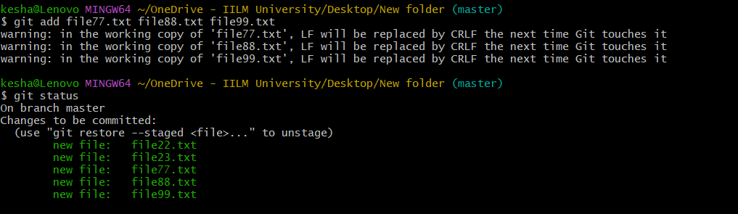
kesha@Lenovo MINGW64 ~/OneDrive - IILM University/Desktop/New folder (master)
$ git add file77.txt file88.txt file99.txt
warning: in the working copy of 'file77.txt', LF will be replaced by CRLF the next time Git touches it
warning: in the working copy of 'file88.txt', LF will be replaced by CRLF the next time Git touches it
warning: in the working copy of 'file99.txt', LF will be replaced by CRLF the next time Git touches it

kesha@Lenovo MINGW64 ~/OneDrive - IILM University/Desktop/New folder (master)
$ git status
On branch master
Changes to be committed:
(use "git restore --staged <file>..." to unstage)
new file: file22.txt
new file: file23.txt
new file: file77.txt
new file: file88.txt
new file: file99.txt
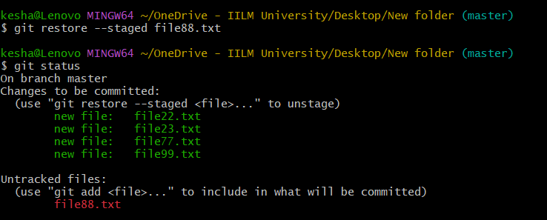

kesha@Lenovo MINGW64 ~/OneDrive - IILM University/Desktop/New folder (master)
$ git restore --staged file88.txt

kesha@Lenovo MINGW64 ~/OneDrive - IILM University/Desktop/New folder (master)
$ git status
On branch master
Changes to be committed:
(use "git restore --staged <file>..." to unstage)
new file: file22.txt
new file: file23.txt
new file: file77.txt
new file: file99.txt

Untracked files:
(use "git add <file>..." to include in what will be committed)
file88.txt

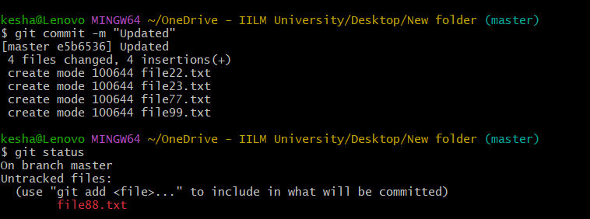

kesha@Lenovo MINGW64 ~/OneDrive - IILM University/Desktop/New folder (master)
$ git commit -m "Updated"
[master e5b6536] Updated
4 files changed, 4 insertions(+)
create mode 100644 file22.txt
create mode 100644 file23.txt
create mode 100644 file77.txt
create mode 100644 file99.txt

kesha@Lenovo MINGW64 ~/OneDrive - IILM University/Desktop/New folder (master)
$ git status
On branch master
Untracked files:
(use "git add <file>..." to include in what will be committed)
file88.txt

Learning Outcomes :
1.Understand the Git staging area and its purpose.
2.Add multiple files to the staging area using git add.
3.Remove a file from staging without deleting it from the working directory.
4.Differentiate between staged and unstaged files.
5.Use git status to check which files are staged and unstaged.
6.Understand how staging prepares changes for a commit.
7.Manage changes selectively before creating a Git commit.

