[1]

VISHWAKARMA INSTITUE OF TECHNOLOGY, PUNE

BRAIN TUMOR DETECTION

Prof. Shilpa lambor, Keshav Sarda (11911381), Rachita Kalambarkar (11910026), Vijay Khobragade (11910472), Kunal Kurve (11910973)

**DEPARTMENT OF INSTRUMENTATION AND CONTROL ENGINERRING**

*Abstract* — In this paper we propose adaptive brain tumor detection, Image processing is used in the medical tools for detection of tumor, only MRI images are not able to identify the tumorous region in this paper we are using Convolutional Neural Network (CNN) with preprocessing of image. We are first cropping the extra part in image and then using Data Augmentation. To make this system an adaptive we are using VGG-16, VGG16 is a convolution neural net (CNN) architecture which was used to win ILSVR (Imagenet) competition in 2014. It is considered to be one of the excellent vision model architecture till date. It is expected that the experimental results of the proposed system will give better result in comparison to other existing systems.

Index Terms—CNN, VGG-16, Image segmentation, Data Augmentation

INTRODUCTION

It is an important to find out tumor from MRI images but it is somewhat time-consuming and difficult task sometime performed manually by medical experts. Large amount of time was spent by radiologist and doctors for identification of tumor and segmenting it from other brain tissues. However, exact labeling brain tumors is a time-consuming task, and considerable variation is observed between doctors. Subsequently, over the last decade, from various research results it is being observed that it is very time-consuming method but it will get faster if we use image processing techniques. Primary brain tumors do not spread to other body parts and can be malignant or benign and secondary brain tumors are always malignant. Malignant tumor is more dangerous and life threatening than benign tumor. The benign tumor is easier to identify than the malignant tumor. Also, the first stage tumor may be malignant of benign but after first stage it will change to dangerous malignant tumor which is life threatening. Different brain tumor detection algorithms have been developed in the past few years. Normally, the automatic segmentation problem is very challenging and it is yet to be fully and satisfactorily solved. The main aim of this system is to make an automated system for detecting and identifying the tumor from normal MRI. It takes into account the statistical features of the brain structure to represent it by significant feature points. Most of the early methods obtainable for tumor detection and segmentation may be largely divided into three groupings: region-based, edge-based and fusion of region and edge-based methods.

What is Brain Tumor?

A brain tumor occurs when abnormal cells form within the brain. There are two main types of tumors: cancerous (malignant) tumors and benign tumors. Cancerous tumors can be divided into primary tumors, which start within the brain, and secondary tumors, which have spread from elsewhere, known as brain metastasis tumors. All types of brain tumors may produce symptoms that vary depending on the part of the brain involved. These symptoms may include headaches, seizures, problems with vision, vomiting and mental changes. The headache is classically worse in the morning and goes away with vomiting. Other symptoms may include difficulty walking, speaking or with sensations. As the disease progresses, unconsciousness may occur.

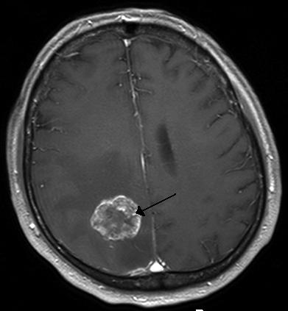

# Literature Review

R.Muthukrishnan,: - Proposed brain tumor detection in which Segmentation separates an image into its component regions or objects. Image segmentation it needs to segment the object from the background to read the image properly and classify the content of the image carefully. In this framework, edge detection was an important tool for image segmentation. In this paper their effort was made to study the performance of most commonly used edge detection techniques for image segmentation and also the comparison of these techniques was carried out with an experiment.

M.Saritha - Proposed approach by integrating wavelet entropy based spider web plots and probabilistic neural network for the classification of Brain MRI. The proposed technique uses two steps for classification i.e. Wavelet entropy based spider web plot for feature withdrawal and probabilistic neural network for classification. The obtained brain MRI, the feature extraction was done by wavelet transform and its entropy value was calculated and spider web plot area calculation was done. With the help of entropy value classification using probabilistic neural network was calculated. Probabilistic neural network provides a general solution for pattern classification problem and its classification accuracy is about 100%.

P.NandaGopal : - In their paper they presented a combination of wavelet statistical features (WST) and cooccurrencewavelet texture feature (WCT) obtained from two level distinct wavelet transform was used for the organization of abnormal brain matters in to benign and malignant. The planned system was consists of four stages: segmentation of region of interest, discrete wavelet disintegration, feature abstraction, feature selection, organization and evaluation. The support vector machine was employed for brain tumor segmentation. A grouping of WST and WCT was used for feature extraction of tumor region extracted from two level discrete wavelet transform. Genetic algorithm was used to select the optimal texture features from the set of mined features. The probabilistic neural network was used to classify abnormal brain tissue in to benign and malignant and the performance evaluation was done by comparing the classification result of PNN with other neural network classifier. The classification accuracy of the proposed system is 97.5%.

A. Laxami : - proposed the work on information (region of interest) in the medical image and thereby vastly improve upon the computational speed for tumor segmentation results. Significant feature points based approach for primary brain tumor segmentation was proposed. Axial slices of T1- weighted Brain MR Images with contrast enhancement have been analyzed. In order to extract significant feature points in the image, applied a feature point extraction algorithm based on a fusion of edge maps using morphological and wavelet methods. Evaluation of feature points thus obtained has been done for geometric transformations and image scaling. A region growing algorithm was then employed to isolate the tumor region. Preliminary results show that our approach has achieved good segmentation results. Also this approach was reduces a large amount of calculation. Future work will involve an investigation of the method in automatic 3D tumor segmentation, segmentation of ROI’s in other medical images, as well as the importance of implemented technique in medical image retrieval applications.

III. PROPOSED METHOD

The main purpose of this paper is to identify the region of tumor and which will used in treating the cancer patient the detailed about the proposed system is given below.

## Preprocessing

In the image processing the gray scale image is processed by using different techniques like brightness, threshold and Filtering, Brightness makes the image by which white objects are distinguished from gray and light items from dark objects and then cropping image. Hence by changing the size of the image the tumor detection in the MRI image is easier.

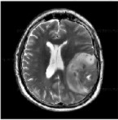

Fig1. Original Image

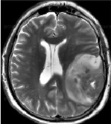

Fig2. Cropped Image

## Data Augmentation

Need for data augmentation Data augmentation is an integral process in deep learning, as in deep learning we need large amounts of data and in some cases it is not feasible to collect thousands or millions of images, so data augmentation comes to the rescue. It helps us to increase the size of the dataset and introduce variability in the dataset.

## CNN model

The ImageNet Large Scale Visual Recognition Challenge (ILSVRC) is an annual computer vision competition. Each year, teams compete on two tasks. The first is to detect objects within an image coming from 200 classes, which is called object localization. The second is to classify images, each labeled with one of 1000 categories, which is called image classification. VGG 16 was proposed by Karen Simonyan and Andrew Zisserman of the Visual Geometry Group Lab of Oxford University in 2014 in the paper “VERY DEEP CONVOLUTIONAL NETWORKS FOR LARGE-SCALE IMAGE RECOGNITION”. This model won the 1st and 2nd place on the above categories in 2014 ILSVRC challenge

This model achieves 92.7% top-5 test accuracy on ImageNet dataset which contains 14 million images belonging to 1000 classes.

**RESULT**

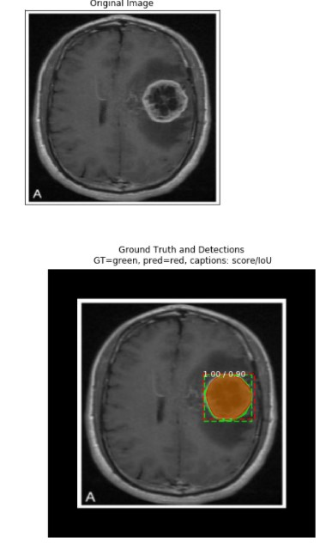

This project was a combination of CNN model classification problem (to predict wheter the subject has brain tumor or not) & Computer Vision problem (to automate the process of brain cropping from MRI scans). The final accuracy is much higher than 50% baseline (random guess). However, it could be increased by larger number of train images or through model hyperparameters tuning

References

1. [1] S.R.Telrandhe, A.Pimpalkar and A.Kendhe, “Brain Tumor Detection using Object Labeling Algorithm & SVM”, in International Engineering Journal For Research & Development Vol. 2, special issue, pp. 2-8, Nov 2015. [2] SobriMuda and M. Mokji, “Brain Lesion Segmentation from Diffusion-Weighted MRI Based On Adaptive Thresholding And Gray Level Co-Occurrence Matrix”, J. Telecommunication Electronic and Computer Engineering, Vol. 3, No. 2, 2011. [3] S. Cha et.al, “Review Article: Update on Brain Tumor Imaging: From Anatomy to Physiology”, Journal of Neuro radiology, Vol.27, pp.475- 487, 2006. [4] R. Adams and L. Bischof, “Seeded region growing,” IEEE Trans. On Pattern Analysis and Machine Intelligence, vol.16, no.6, pp.641–647, 1994. [5] J.Selvakumar, A.Lakshmi and T.Arivoli, “Brain tumor segmentation and its area calculation in brain MR images using k-mean clustering and fuzzy c-mean algorithm” in Proceedings in IEEE-International Conference On Advances In Engineering, Science And Management, pp. 186-190, 2012. [6] R.Muthukrishnan and M.Radha, “Edge Detection Techniques for Image Segmentation” in International Journal of Computer Science & Information Technology, Vol 3, No 6, Dec 2011. [7] M.Saritha and K.Paul Joseph, ”Classification of MRI brain images using combined wavelet entropy based spider web plot and probabilistic neural network” ELSEVIER, pattern Recognition letters 34, pp. 2151- 2159, 2013. [8] P.N.Gopal and R.Sukanesh,” wavelet statistical feature based segmentation and classification of brain computed tomography images” IET Image Prosess Vol.7 pp 25 -32 2013 [9] A. Laxmi and P.Samata, “Optimization of visual presentation of MRI image for accurate detection of tumor in human brain using virtual instrument” in The Biomedical Engineering International Conference 2012. [10]G.Hamerly and C.Elkan, “Learning the k in K-Means” in Proceedings 7th Annual Conference on Neural Information Processing Systems (NIPS), pp. 281-288, 2003. [11]B.C.Patel and G.R.Sinha, “An adaptive K-Means Clustering algorithm for breast image segmentation” International Journal of Computer Applications, vol. 7, no. 4, pp. 35-38, 2010. [12]T.Kalaiselvi and K.Somasundaram, “Fuzzy c-means technique with histogram based centroid initialization for brain tissue segmentation in MRI of head scans” in Proceedings in IEEE-international Symposium on Humanities, Science and Engineering Research, pp. 149- 154, 2011. [13]M.Shasidhar, Y.S.Raja and B.Y.Kumar, “MRI brain image segmentation using modified fuzzy c-means clustering algorithm,” in Proceedings in IEEEInternational Conference on Communication Systems and Network Technologies, pp. 473-478, 2011. [14]S.Koley and A.Majumder, “Brain MRI segmentation for tumor detection using cohesion based self-merging algorithm,” in Proceedings in IEEE-3rd International Conference on Communication Software and Networks, pp. 781-785, 2011. [15]M.U.Akram and A.Usman, “Computer aided system for brain tumor detection and segmentation,” in Proceedings in IEEE-International Conference on Computer Networks and Information Technology, vol. 1, pp. 299-302, 2011. [16]K.Thapaliya and G.Kwon, “Extraction of brain tumor based on morphological operations,” in Proceedings in IEEE-8th international Conference on Computing Technology and Information Management, pp. 515-520, 2012. [17]M.Schmidt, I.Levner, R.Greiner, A.Murtha and Bistritz, “Segmenting brain tumors using alignment based features,” in Proceedings in IEEE-4th International Conference on Machine Learning and Applications, pp.567-578, 2005. [18]Elamy and M. Hu, “Mining brain tumors and tracking their growth rates,” in Proceedings in IEEE-Canadian Conference On Electrical and Computer Engineering, Seaside, CA, USA, pp. 872-875, 2007. [19]S.H.Teoh et.al, “Median Filtering Frameworks for Reducing Impulse Noise from Grayscale Digital Images: A Literature Survey” in International Journal of Future Computer and Communication, Vol. 1, No. 4, pp. 323- 333 December 2012. [20]J.Vijay and J.Subhashini, “An Efficient Brain Tumor Detection Methodology Using K- Means Clustering Algorithm” in International conference on Communication and Signal Processing, April 3-5, pp.653- 658, 2013.

1.