**Resource Manager Application.**

***Concentrated on implementing the logic rather than UI.***

Features:

* One resource can be hold by only one person at a time.
* A user can request for a resource and if the resource is available then it will be allocated to the user.
* If the resource is not available and is already being used by any user then, next user can request for the resource and then a message will be sent to the user holding the resource and then its upon that user to release the resource or not.
* When the resource is released by the user it will automatically be allocated the next user.
* Only admin and add and delete resources.
* User data is stored in MongoDB.

**Screenshots of the application**:

1. Register Page

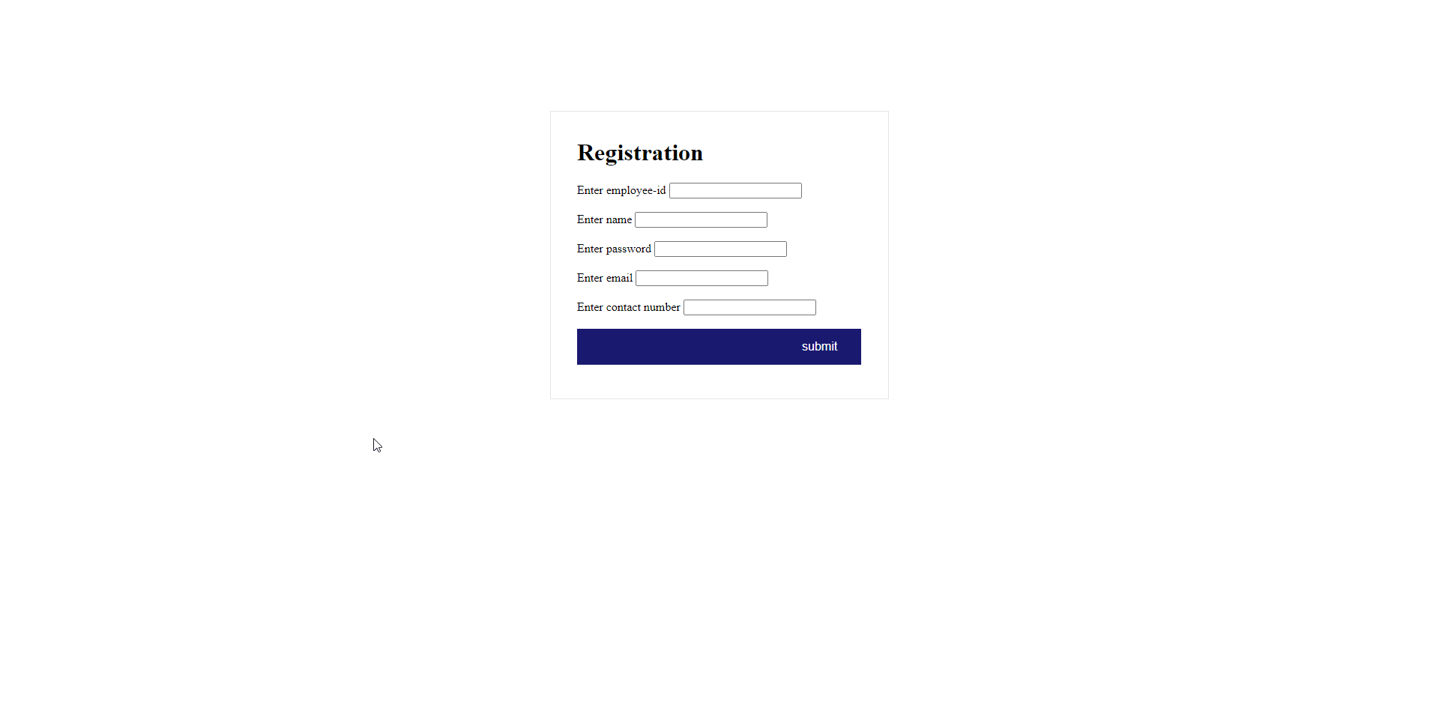

1. Login Page

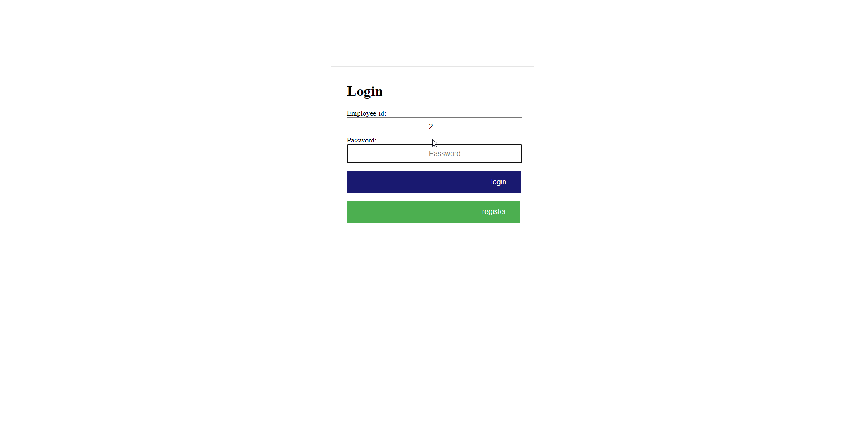

1. Home Page

(Shows available resources in middle)

(allocated resources on the left)

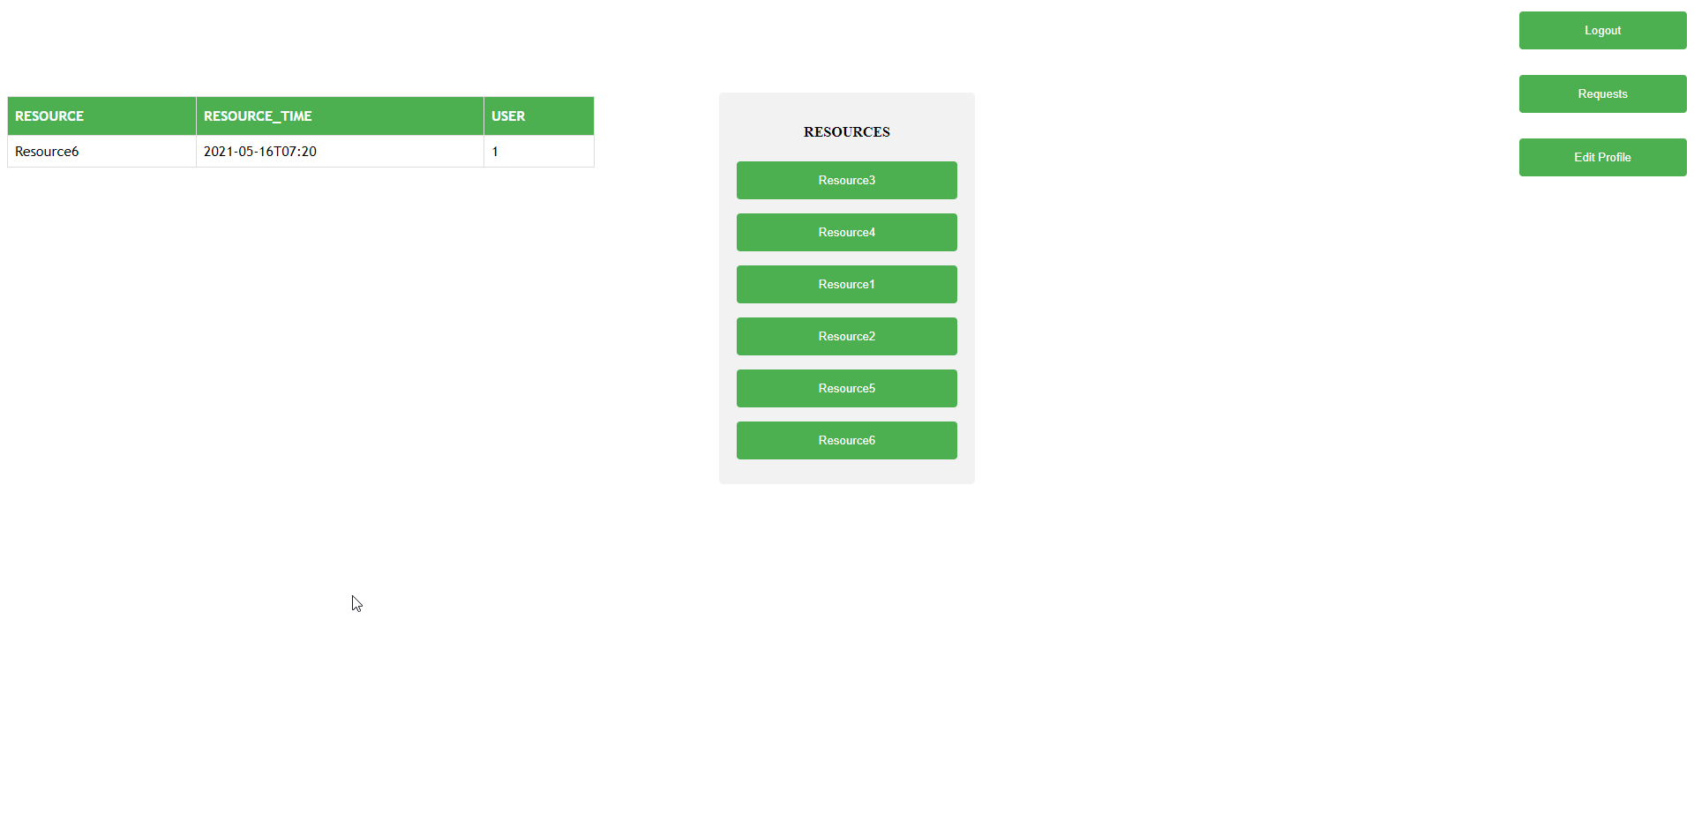

1. Request for the resource by clicking on the resource

(Enter time until with user want to hold the resource)

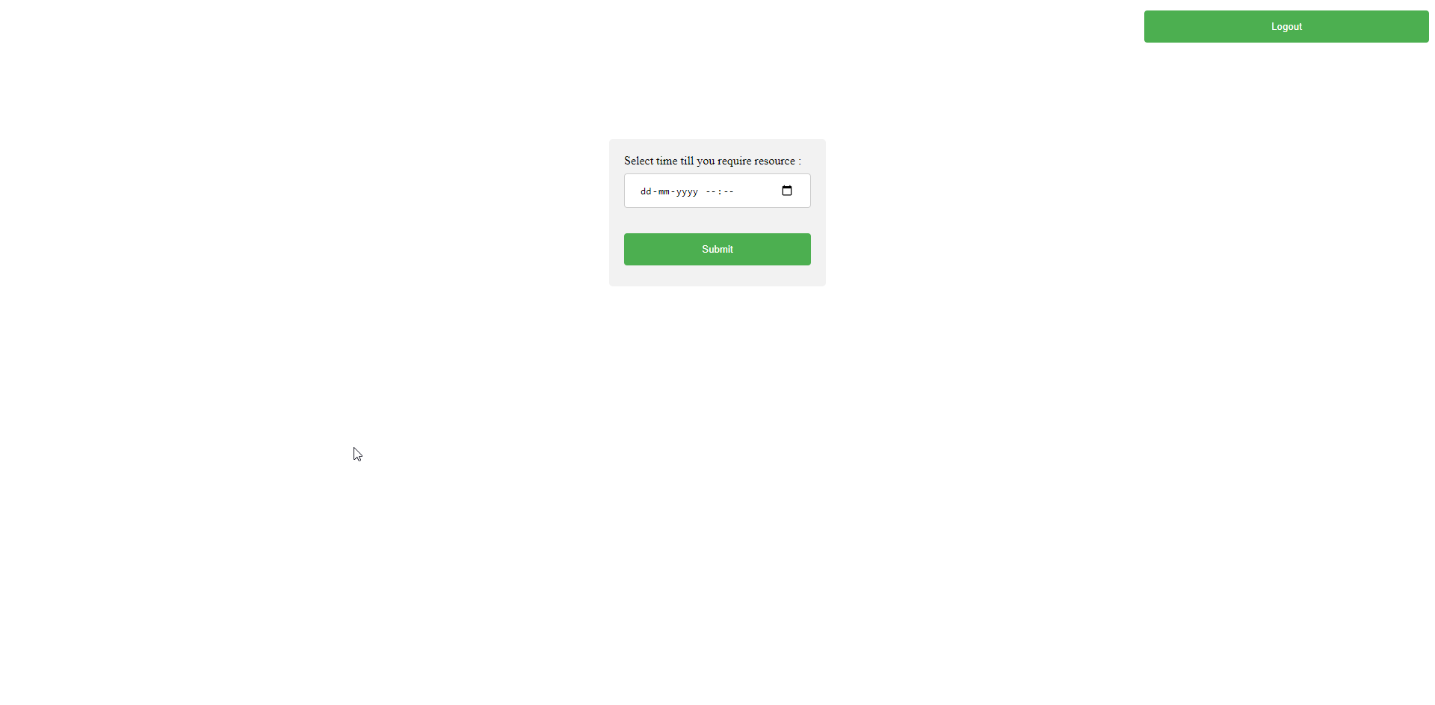

1. Request for the resource that is already being hold by any user.

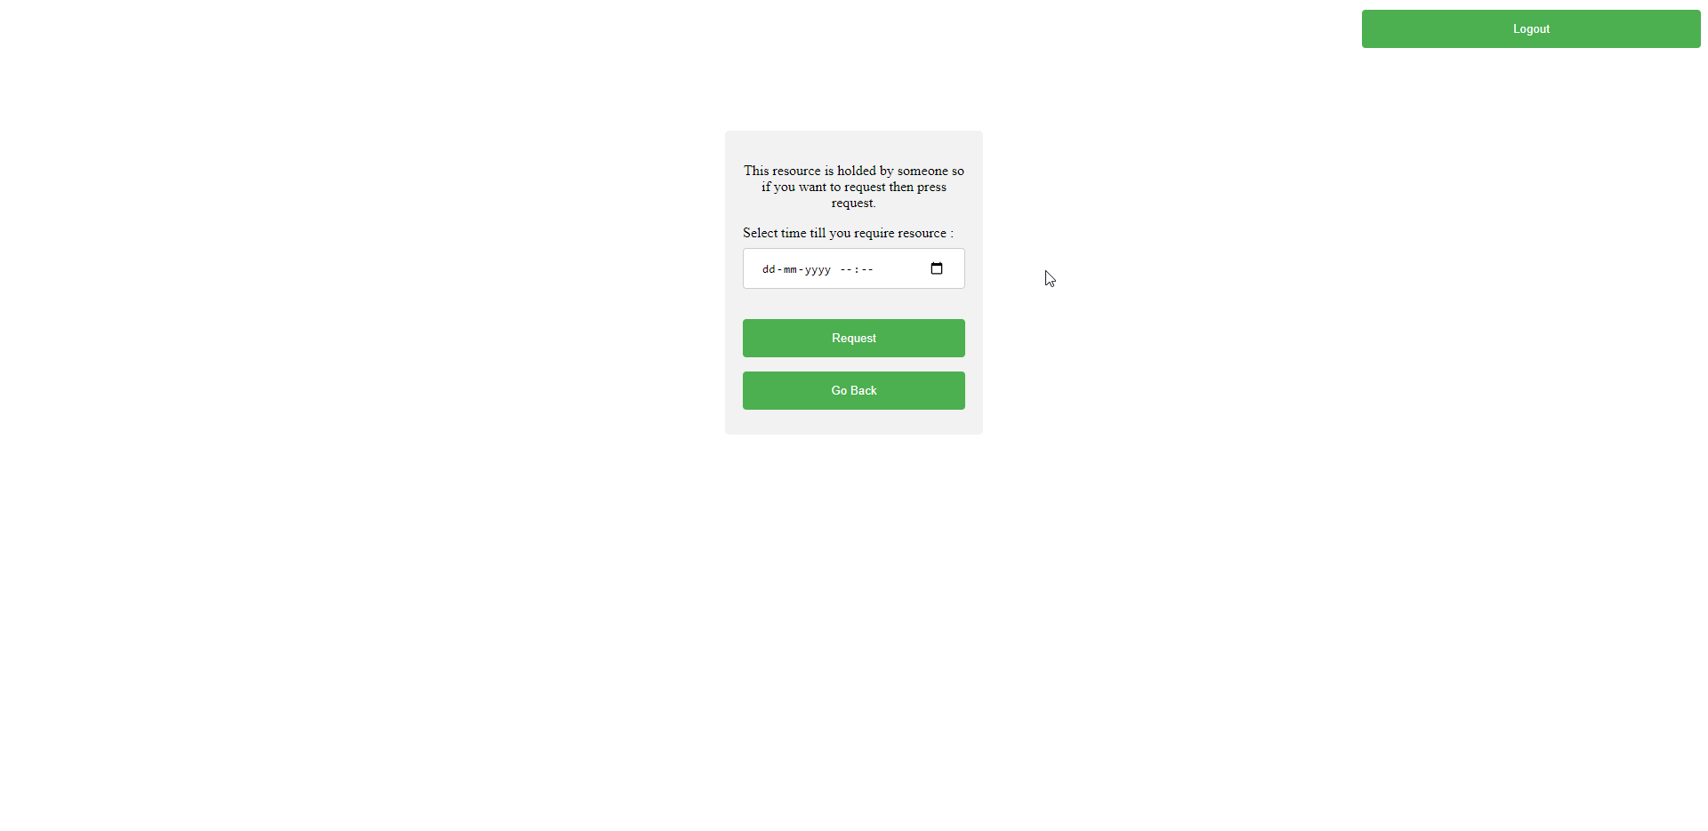

1. After requesting a message will be send to the user holding the resource.

