Question No :10
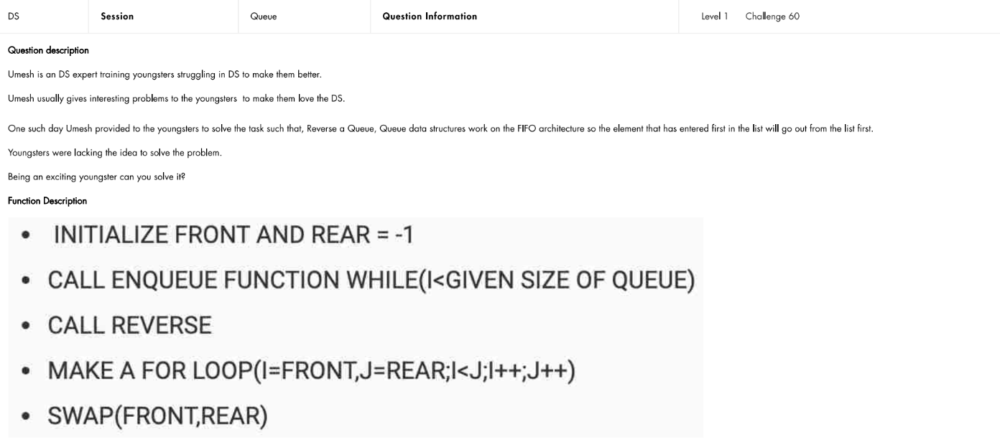
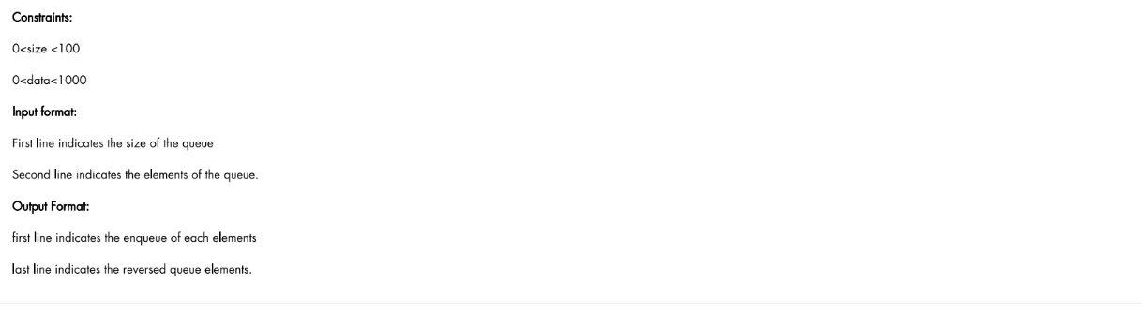

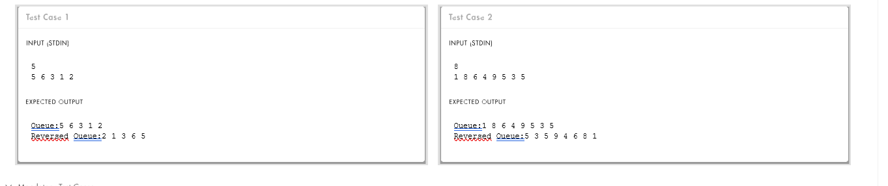

Code :
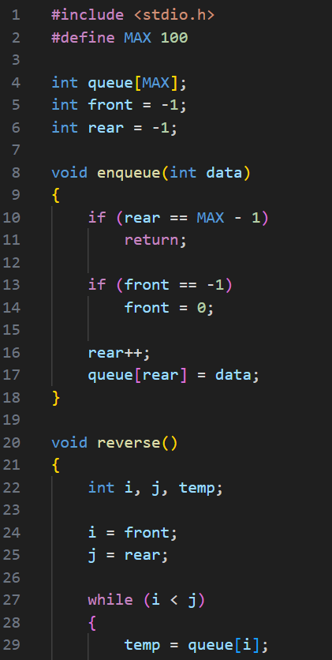

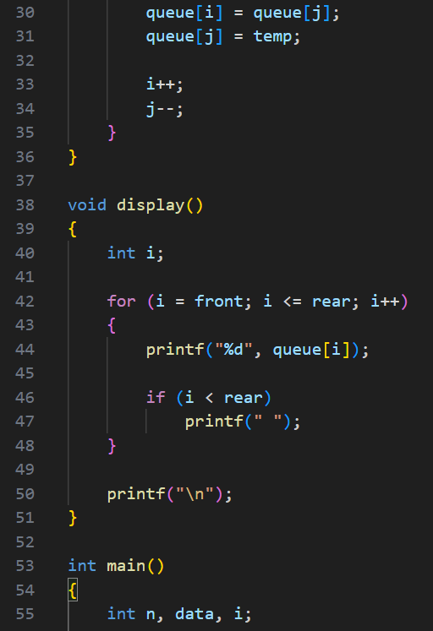

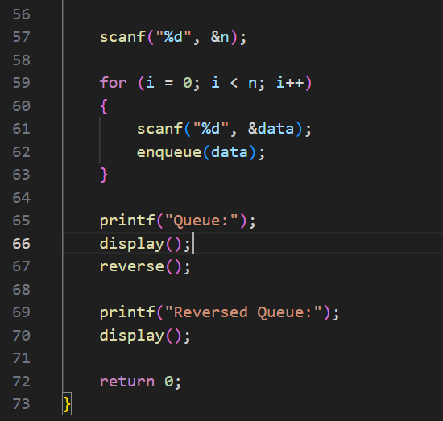

Output :

Test Case-1 :
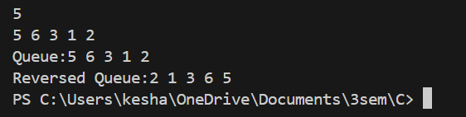

Test Case-2 :

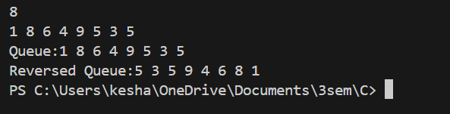

Keshav Kumar Rauniyar
CH.SC.U4CSE25236

