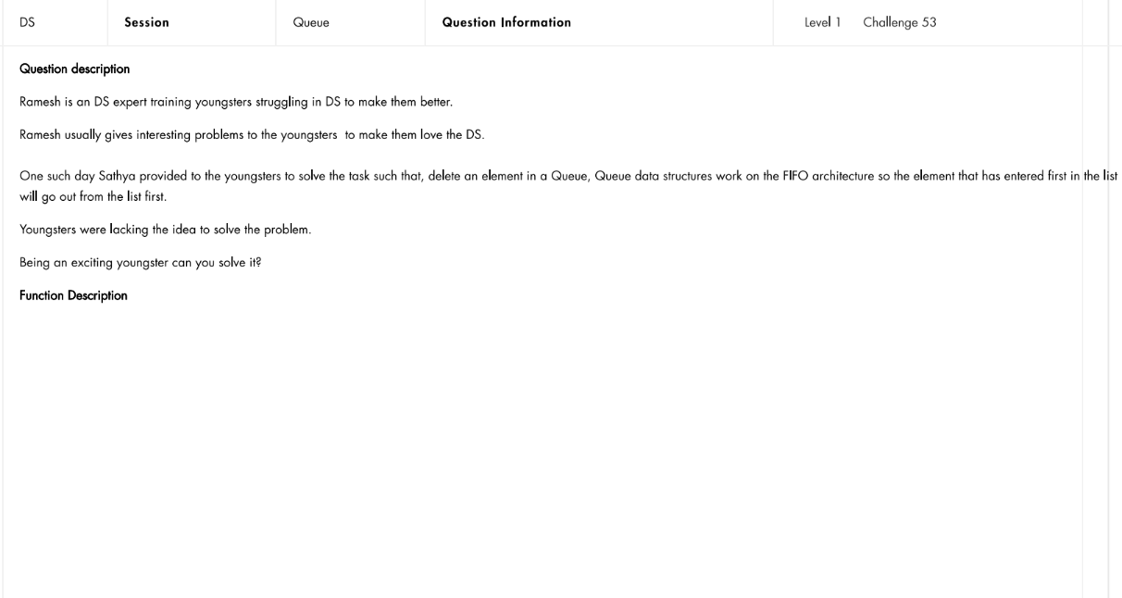
Question No:3

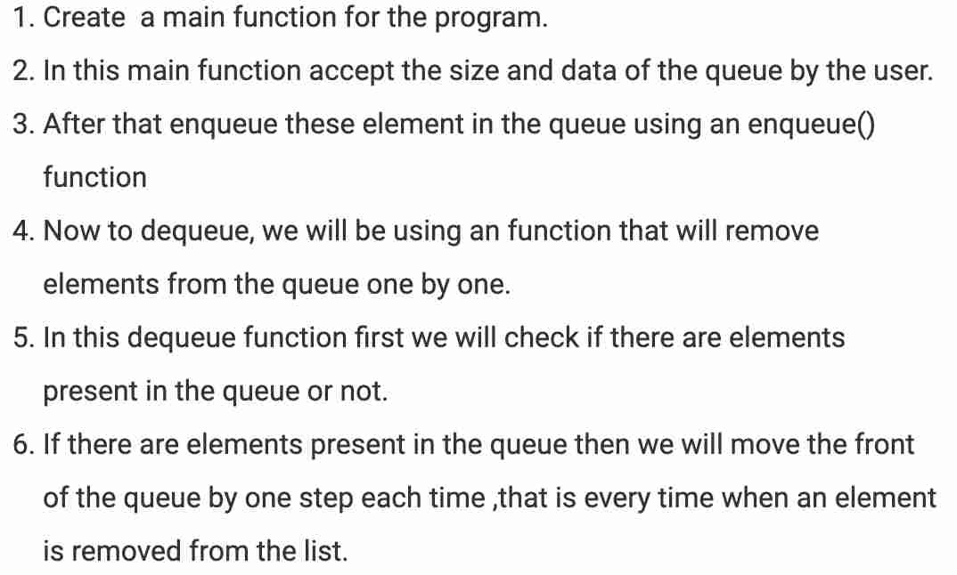

5
5 6 3 1 2
8
1 8 6 4 9 5 3 5

Dequeuing elements:
6 3 1 2
3 1 2
1 2
2
Dequeuing elements:
8 6 4 9 5 3 5
6 4 9 5 3 5
4 9 5 3 5
9 5 3 5
5 3 5
3 5
5

void enqueue(int data) for(i=front;i<=rear;i++) enqueue(data);

void dequeue()

Code:

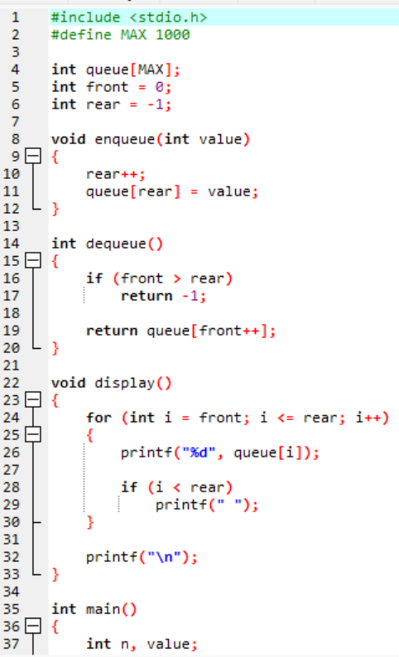

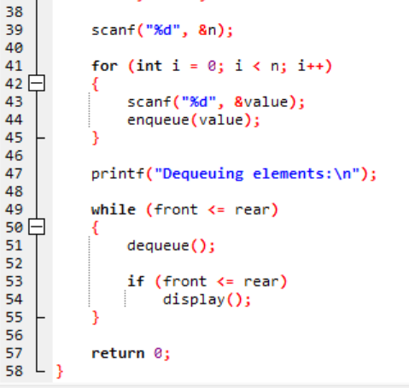

Output:

Test Case-1:
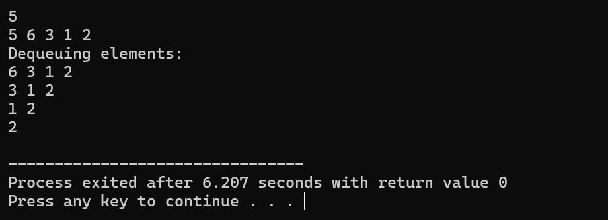

Test Case-2:
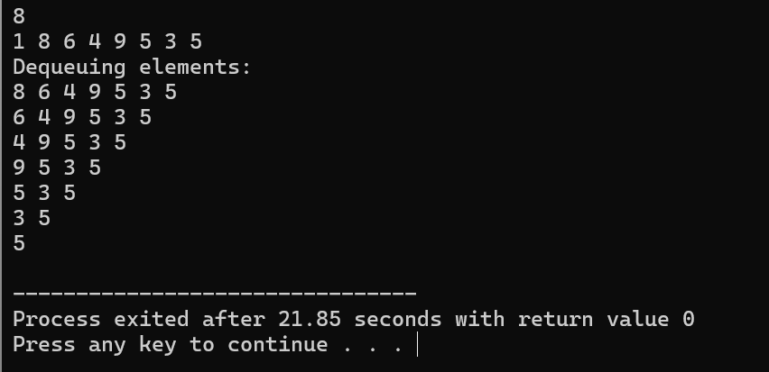

Keshav Kumar Rauniyar
CH.SC.U4CSE25236

