Question No:5
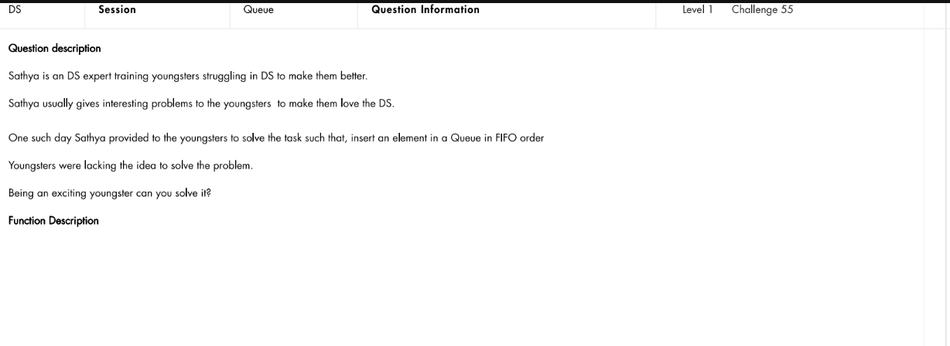

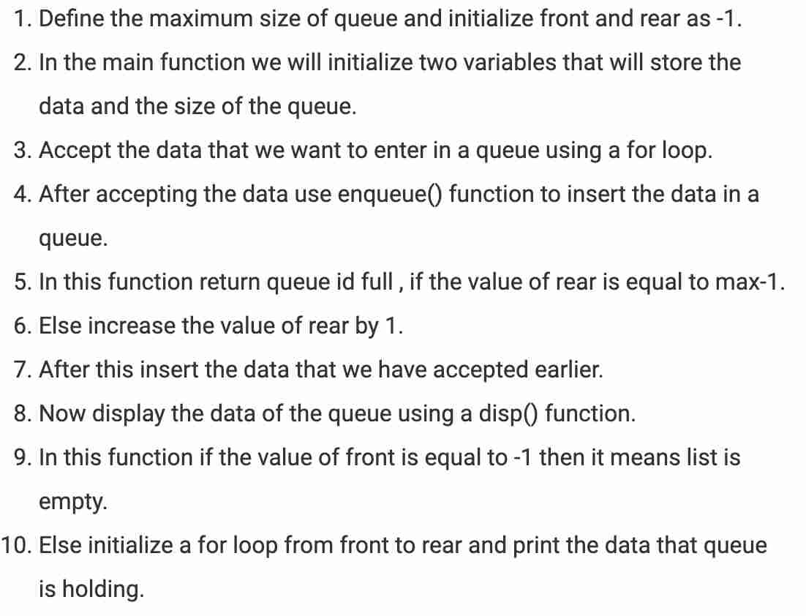

5
5 6 3 1 2
8
1 8 6 4 9 5 3 5

Enqueuing 5
5 Enqueuing 6
5 6 Enqueuing 3
5 6 3 Enqueuing 1
5 6 3 1 Enqueuing 2
5 6 3 1 2
Enqueuing 1
1 Enqueuing 8
1 8 Enqueuing 6
1 8 6 Enqueuing 4
1 8 6 4 Enqueuing 9
1 8 6 4 9 Enqueuing 5
1 8 6 4 9 5 Enqueuing 3
1 8 6 4 9 5 3 Enqueuing 5
1 8 6 4 9 5 3 5

void enqueue(int data) for(i=front;i<=rear;i++) enqueue(data);

Code:
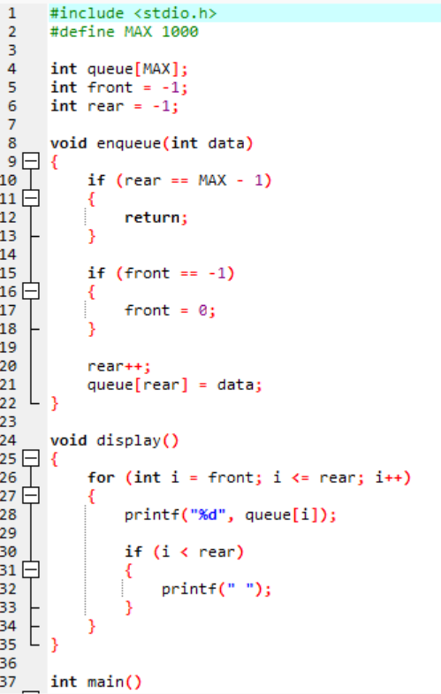

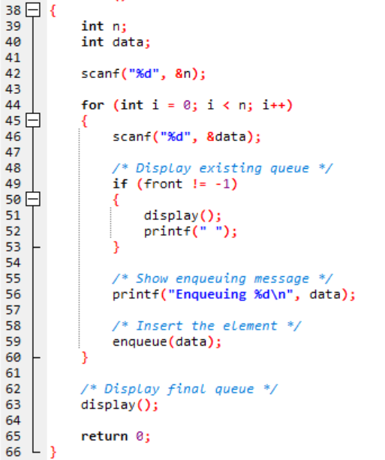

Output:
Test Case-1:

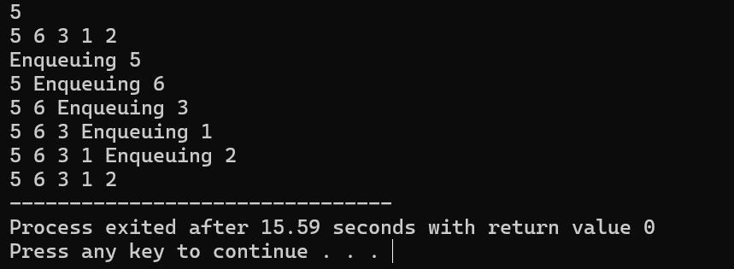

Test Case-2:

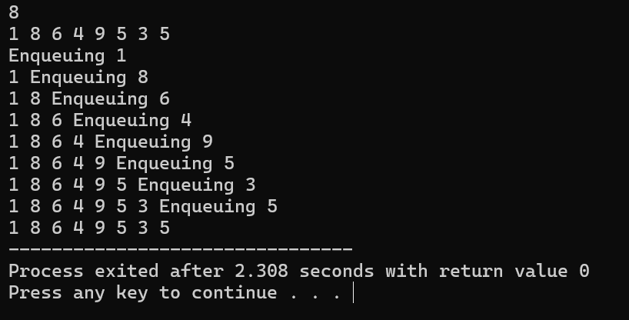

Keshav Kumar Rauniyar
CH.SC.U4CSE25236

