Question No:10

4
9 77 12 6
2
6
45 21 91 77 12 61
4

Linked List:->12->6 Linked List:->12->61
Code:
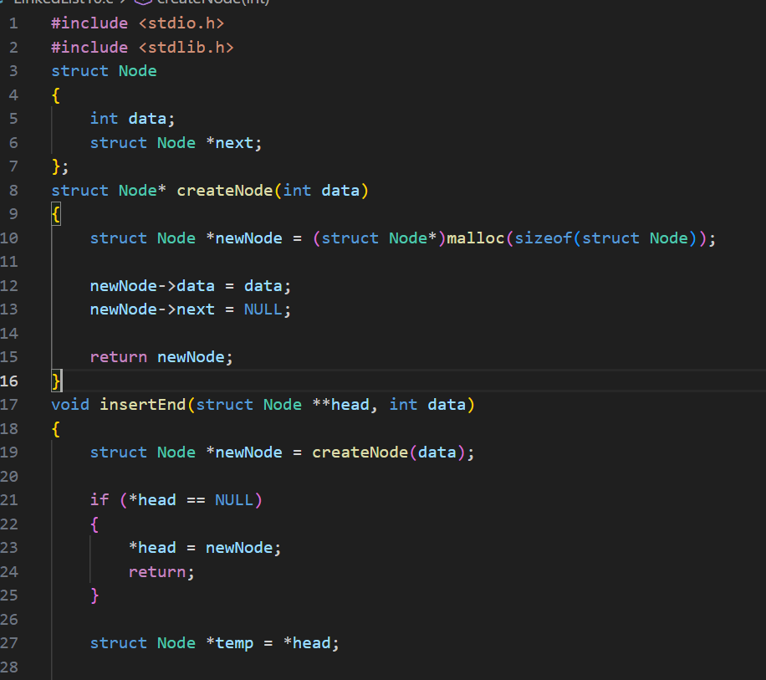

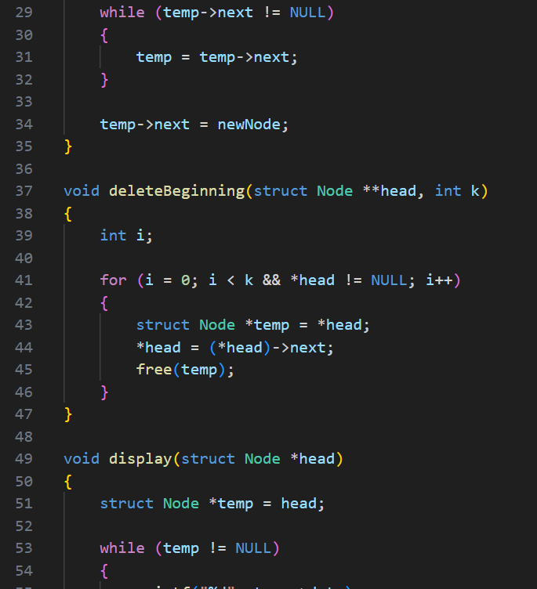

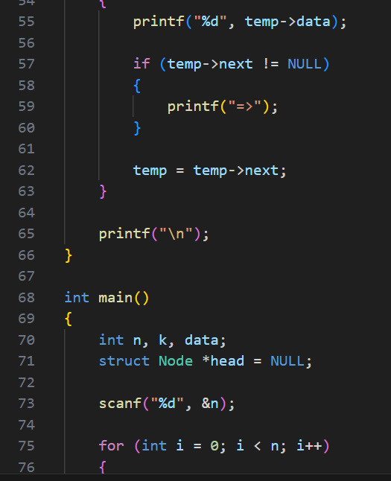

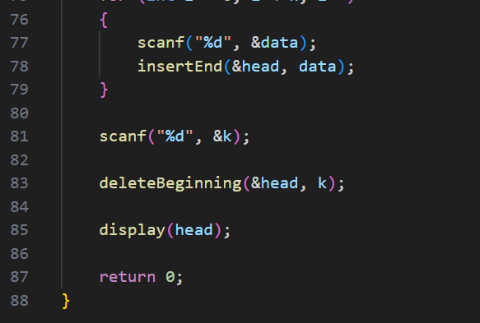

Output:
Test Case-1:
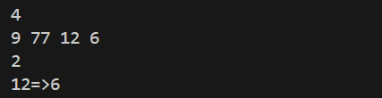

Test Case-2:
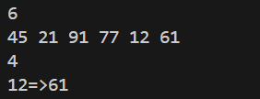

Keshav Kumar Rauniyar
CH.SC.U4CSE25236

