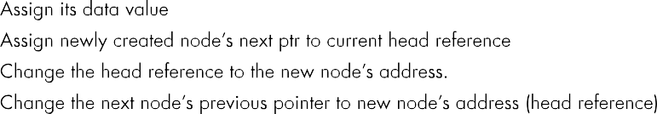
Question No:2

16
1 3 4 7 9 11 13 14 18 19 23 24 56 32 98 17
15
0 1 2 0 1 1 1 0 2 0 2 2 0 1 2

17 98 32 56 24 23 19 18 14 13 11 9 7 4 3 1
1 3 4 7 9 11 13 14 18 19 23 24 56 32 98 17
2 1 0 2 2 0 2 0 1 1 1 0 2 1 0
0 1 2 0 1 1 1 0 2 0 2 2 0 1 2

struct Node struct Node *next; struct Node *prev;

Code:
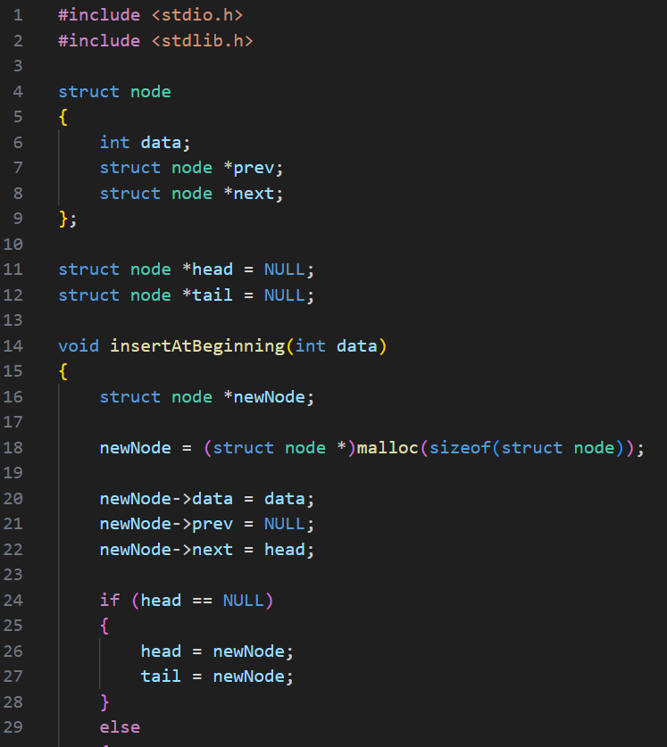

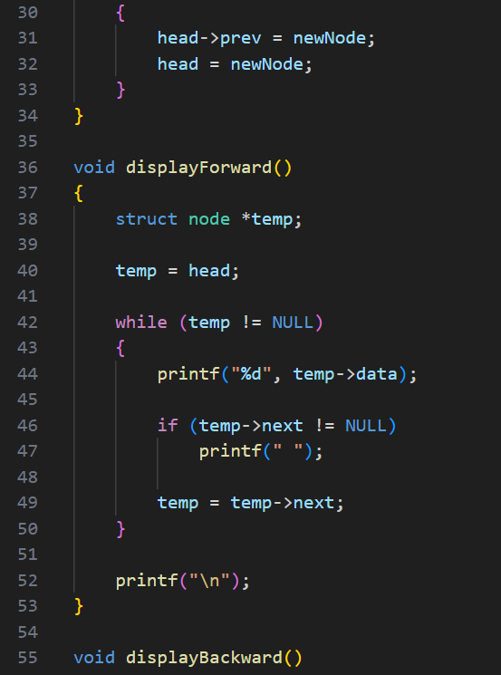

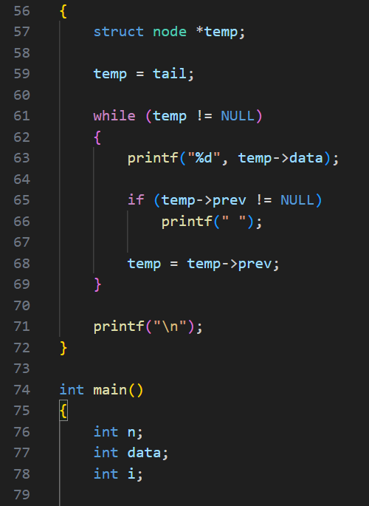

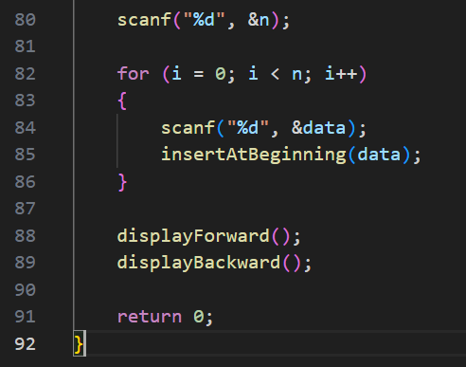

Output:

Test Case-1:
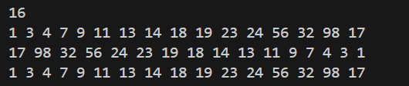

Test Case-2:
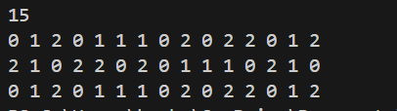

Keshav Kumar Rauniyar
CH.SC.U4CSE25236

