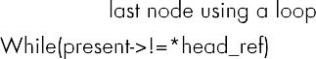
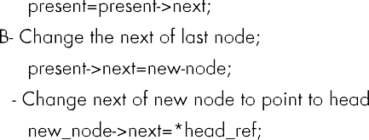
Question No:3

6
10 20 30 45 34 56
6
1 2 11 12 56 90

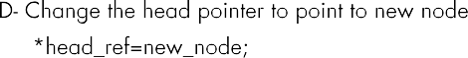
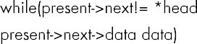
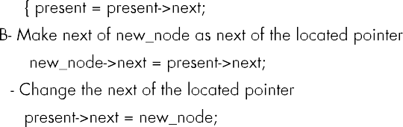


10 20 30 34 45 56 1 2 11 12 56 90

Code:
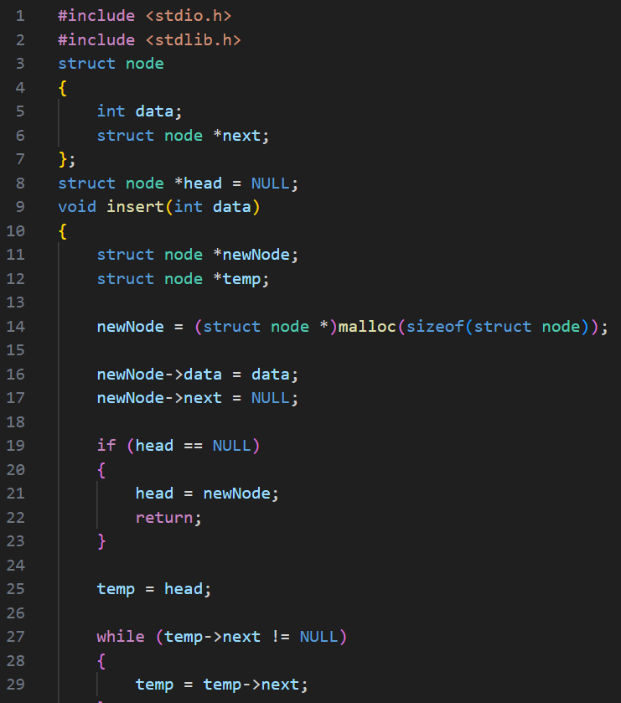

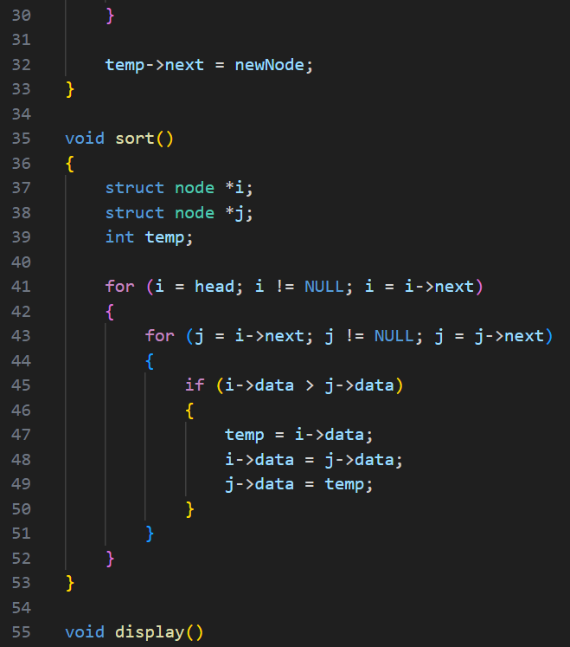

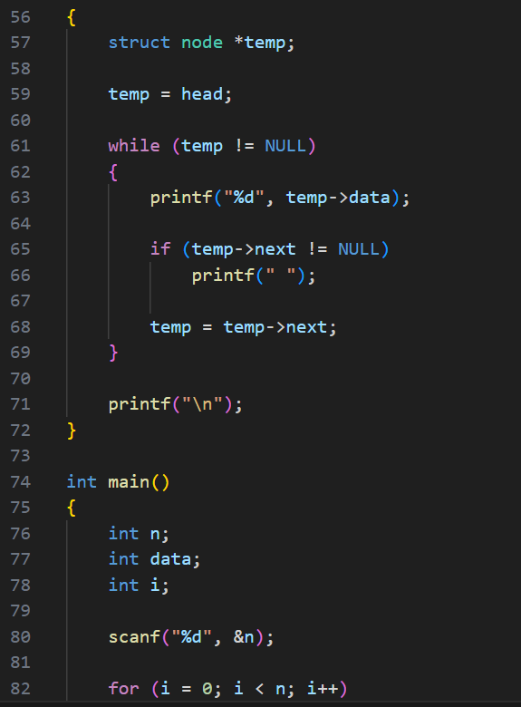

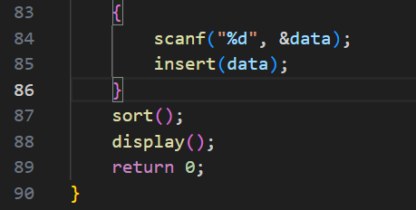

Output:

Test Case-1:
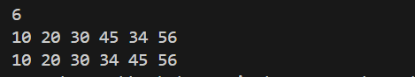

Test Case-2:
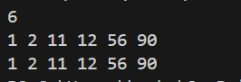

Keshav Kumar Rauniyar
CH.SC.U4CSE25236

