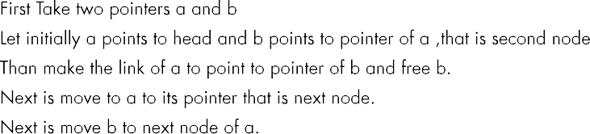
Question No:5

10 20

1 3 5 7 9 1 3 5 7 9 11 13 15 17 19

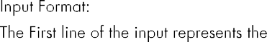
void insert_Data(struct node
**head)
void delete_Alt(struct node
**head)

Code:
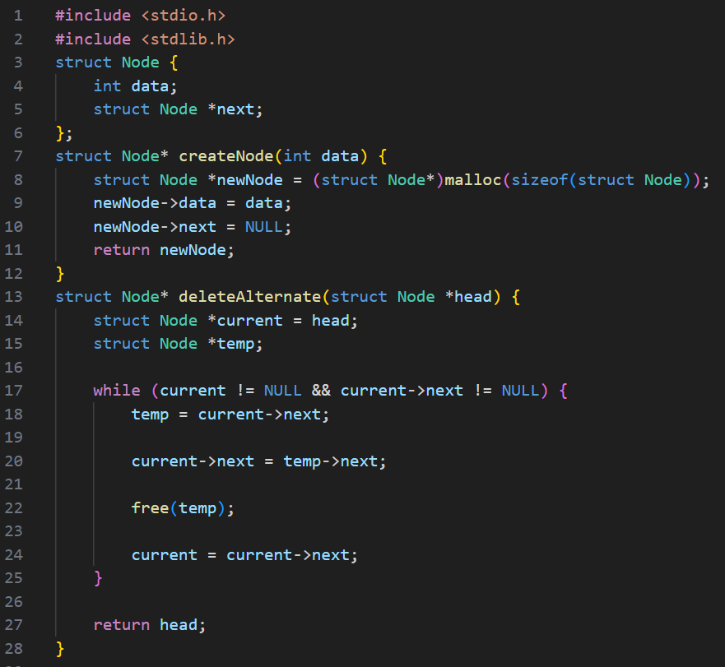

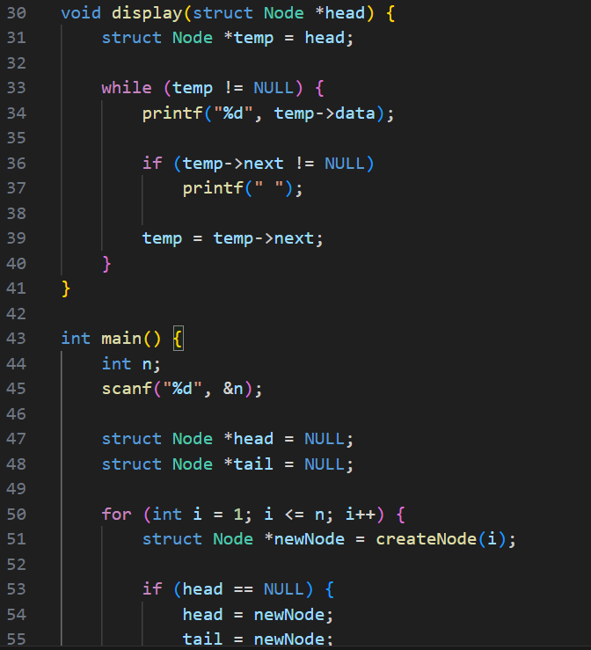

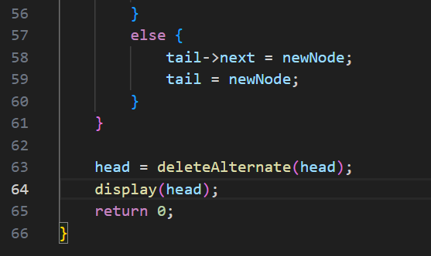

Output:
Test Case-1:
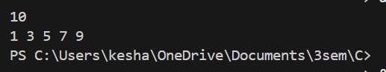

Test Case-2:
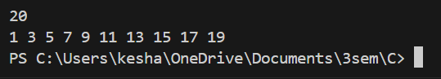

Keshav Kumar Rauniyar
CH.SC.U4CSE25236

