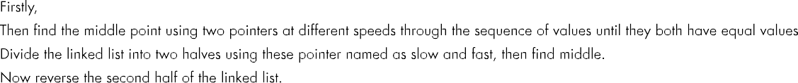
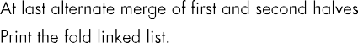
Question No:8

16
1 3 4 7 9 11 13 14 18 19 23 24 56 32 98 17
15
0 1 2 0 1 1 1 0 2 0 2 2 0 1 2

Link list data:1 3 4 7 9 11 13 14 18 19 23 24 56 32 98
17
Link list data after fold:1 17 3 98 4 32 7 56 9 24 11
23 13 19 14 18
Link list data:0 1 2 0 1 1 1 0 2 0 2 2 0 1 2
Link list data after fold:0 2 1 1 2 0 0 2 1 2 1 0 1 2
0

struct node void print(struct node *head) struct node *next;

void create(struct node
**head,int data)

Code:
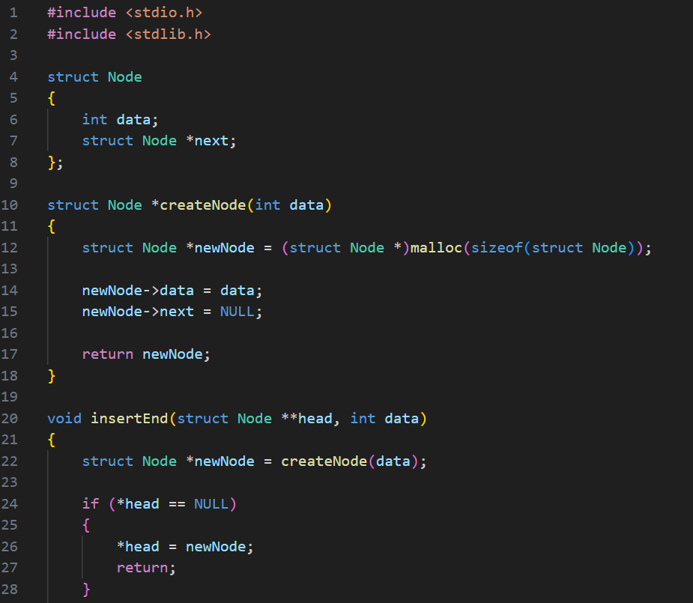

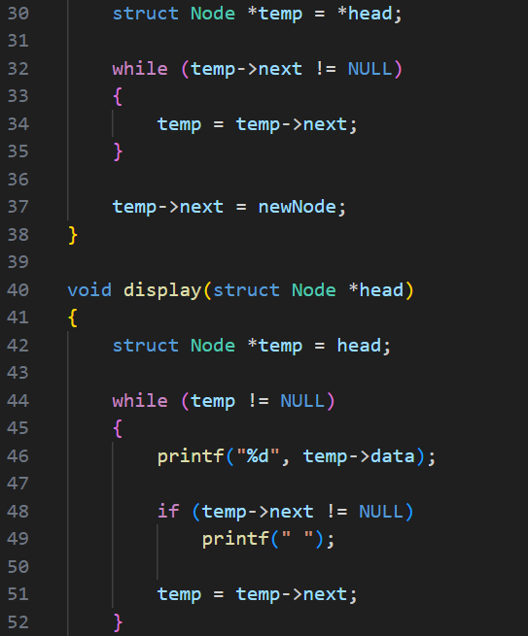

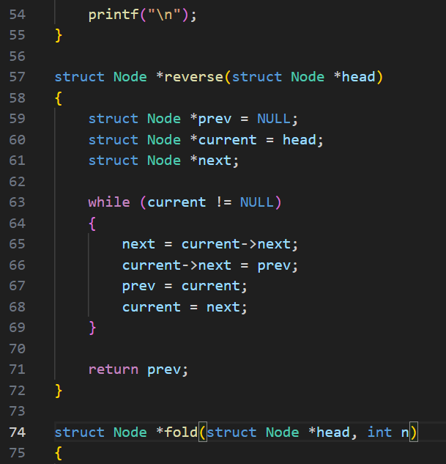

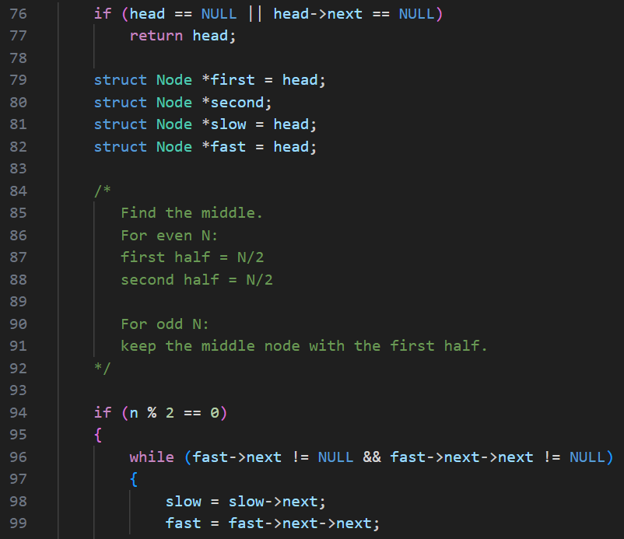

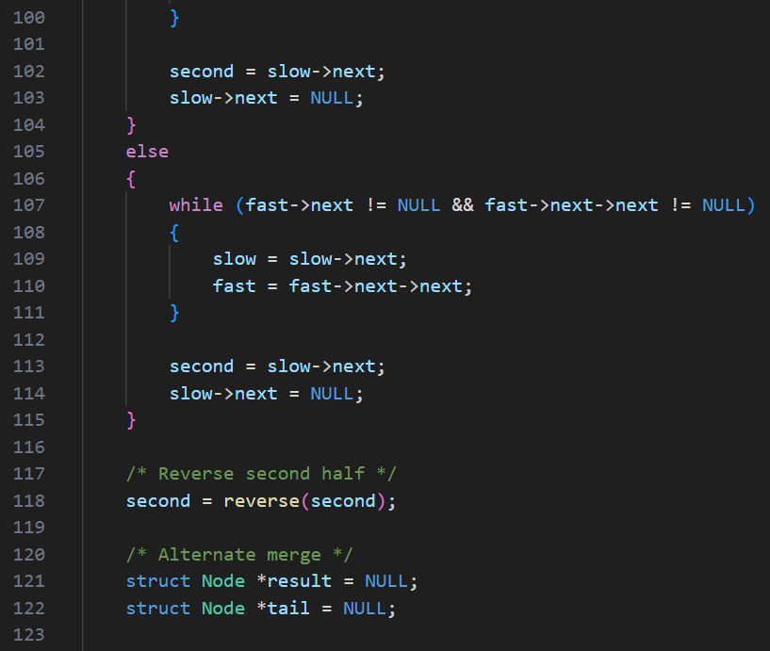

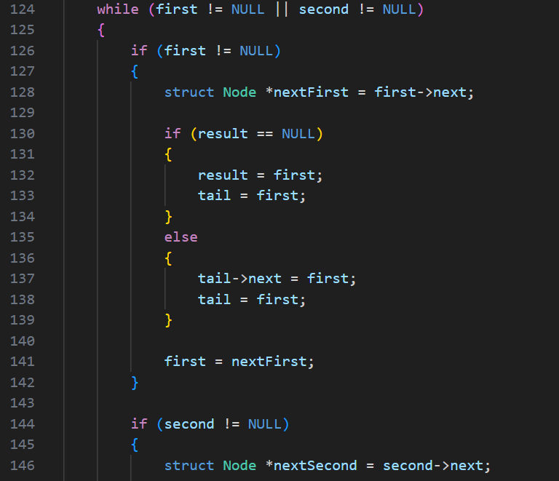

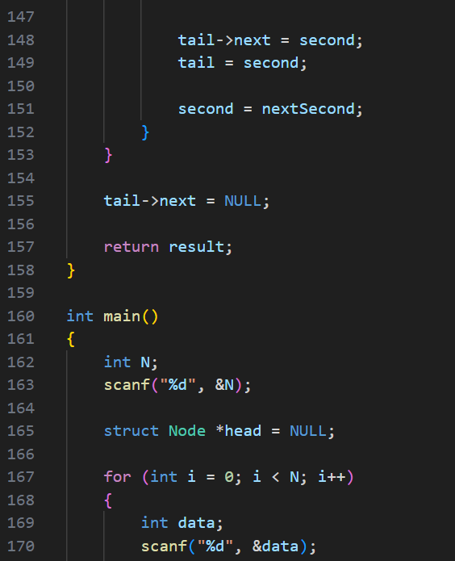

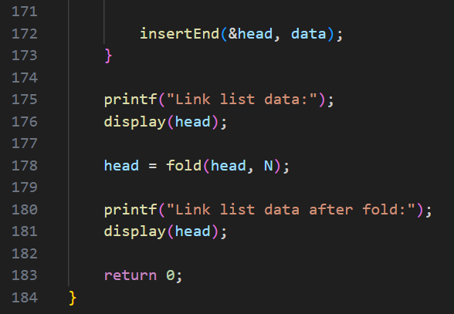

Output:
Test Case-1:
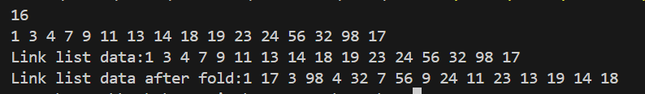

Test Case-2:
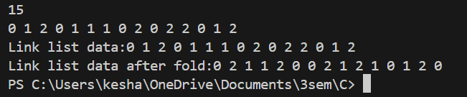

Keshav Kumar Rauniyar
CH.SC.U4CSE25236

