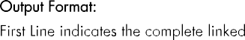
Question No:9

6 15

Complete linked_list: [h]=>1=>2=>3=>4=>5=>6=>[h]
Odd: [h]=>1=>3=>5=>[h]
Even: [h]=>2=>4=>6=>[h]
Complete linked_list: [h]=>1=>2=>3=>4=>5=>6=>7=>8=>9=>10=>11=>12=>13=>14=>15=
>[h]
Odd: [h]=>1=>3=>5=>7=>9=>11=>13=>15=>[h]
Even: [h]=>2=>4=>6=>8=>10=>12=>14=>[h]

void insert(int data) struct n *next; void display(struct n *h)

115
4 620

Code:
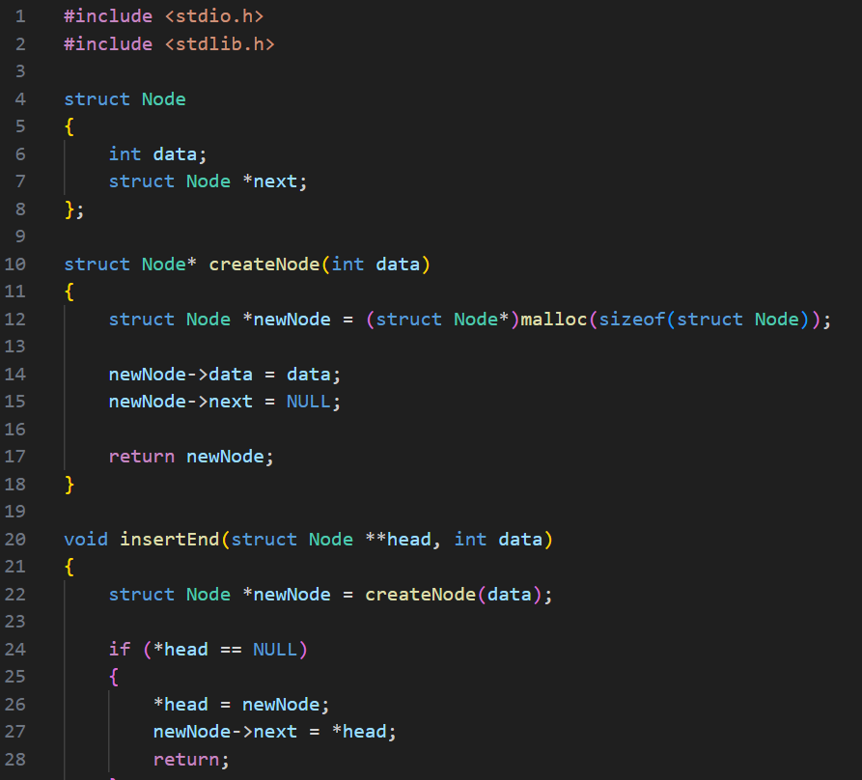

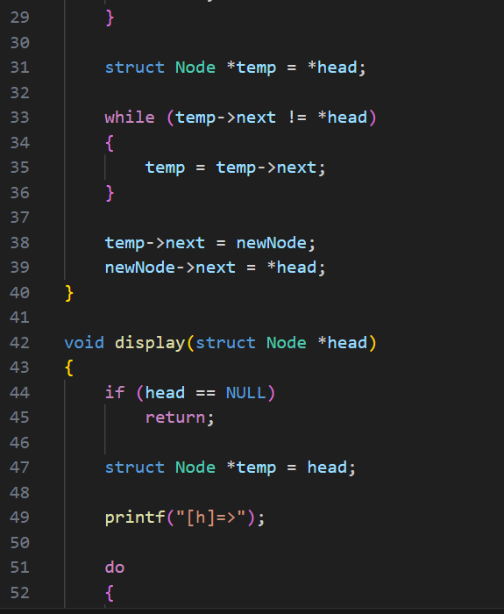

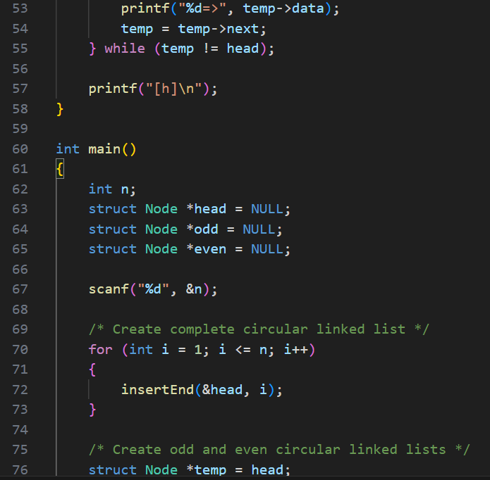

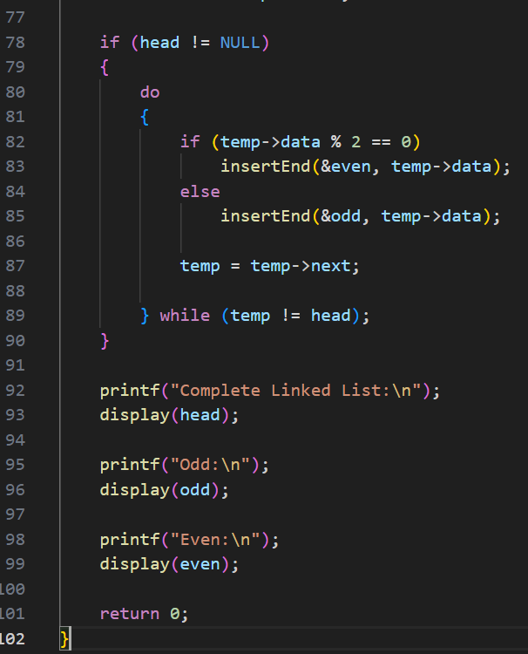

Output:
Test Case-1:
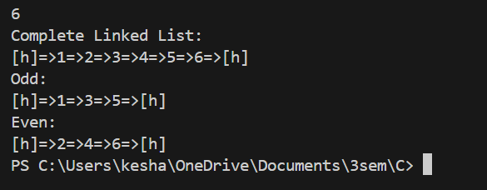

Test Case-2:
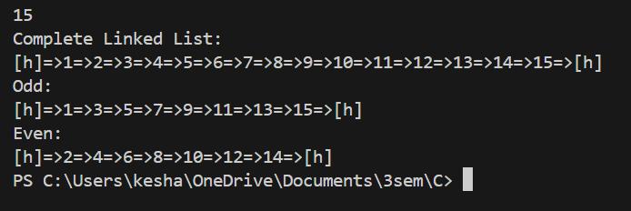

Keshav Kumar Rauniyar
CH.SC.U4CSE25236

