
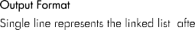
Linked List
Question No:1

6
7 9 8 8 4 2
8
10
5 3 7 2 7 9 8 8 4 2
2

Linked List:->7->9->4->2 Linked List:->5->3->7->7->9->8->8->4

Code:

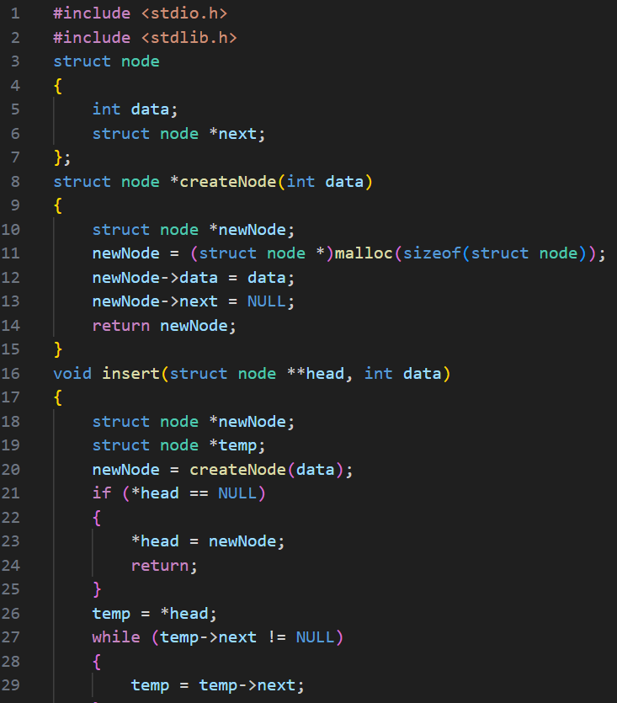

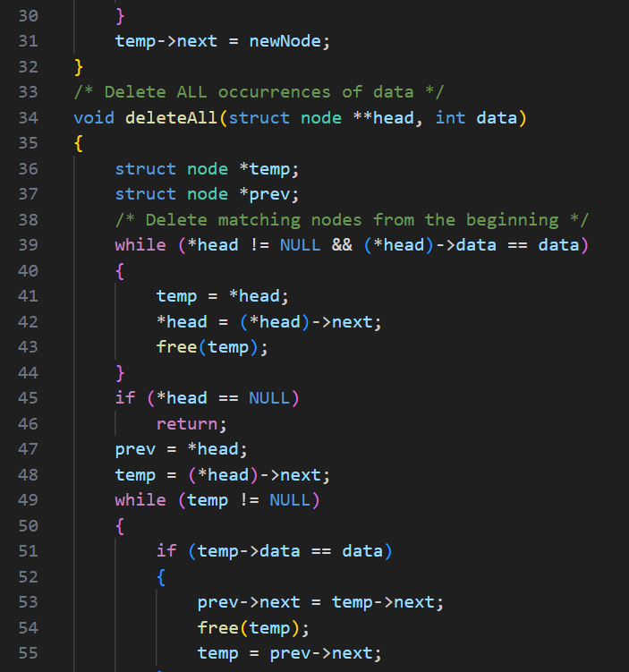

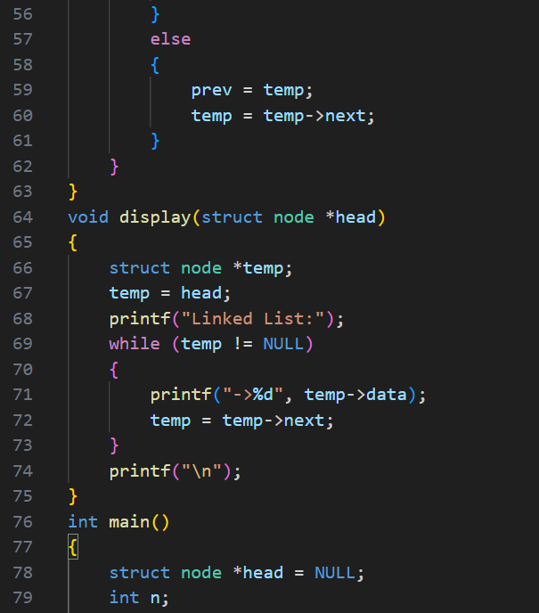

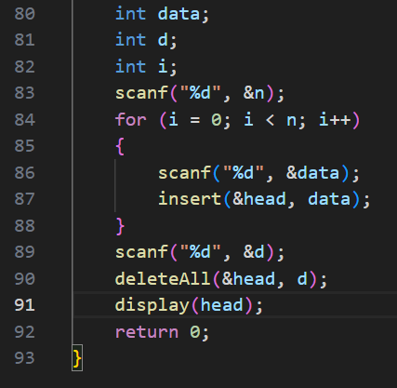

Output:

Test Case-1:
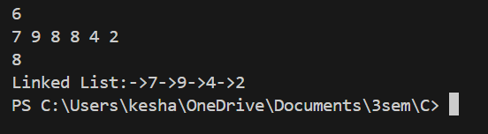

Test Case-2:

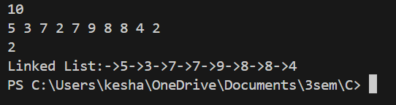

Keshav Kumar Rauniyar
CH.SC.U4CSE25236

