Question No:4

4
115 210 116 110
116
17
4
15 20 16 10
25
17

Linked List:->115->210->17->116->110
Node not found!
Linked List:->15->20->16->10

struct node node *next; *start

p2->next=p1; void display()

Code:
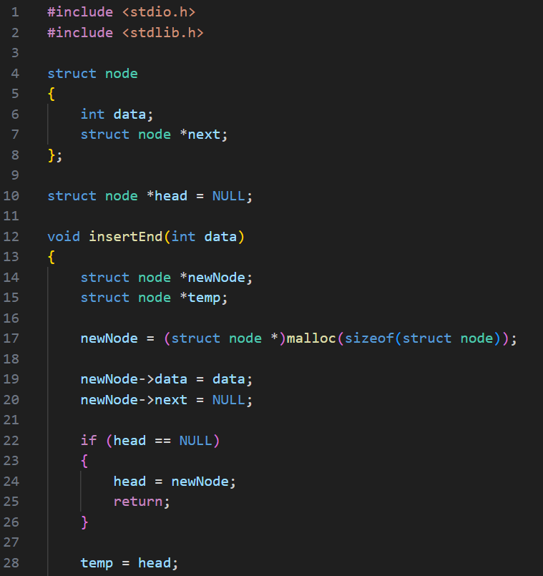

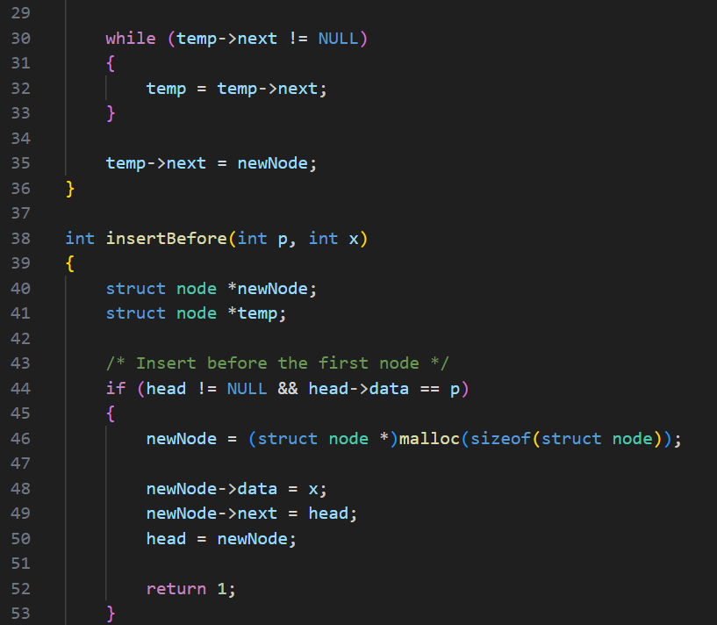

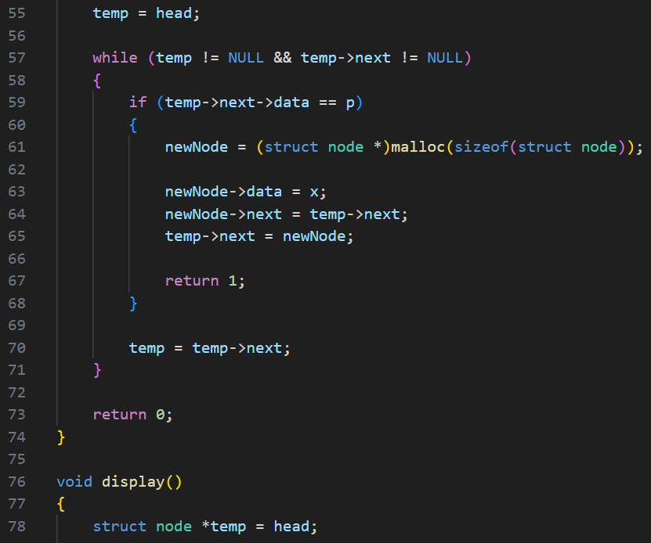

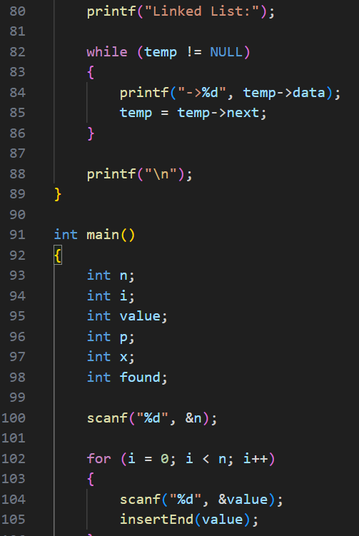

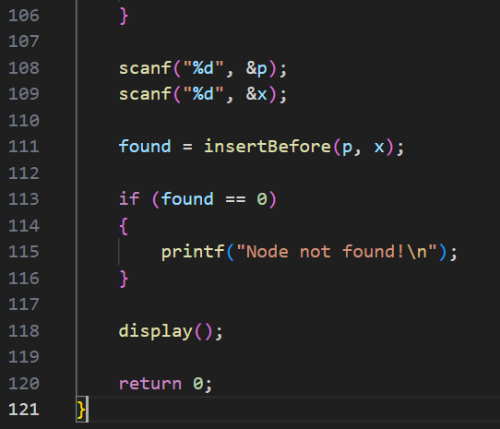

Output:
Test Case-1:
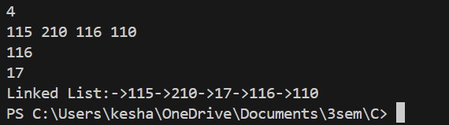
Test Case-2:
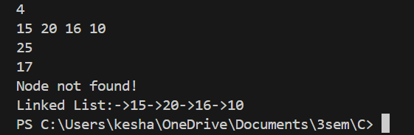

Keshav Kumar Rauniyar
CH.SC.U4CSE25236

