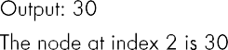
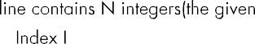
Question No:6

4
1 2 3 4
2
4
11 21 31 41
3

Linked list:-->4-->3-->2-->1 Node at index=2:3
Linked list:-->41-->31-->21-->11
Node at index=3:21



struct node struct node *next; int GetNth(struct node* head,int index)

Code:
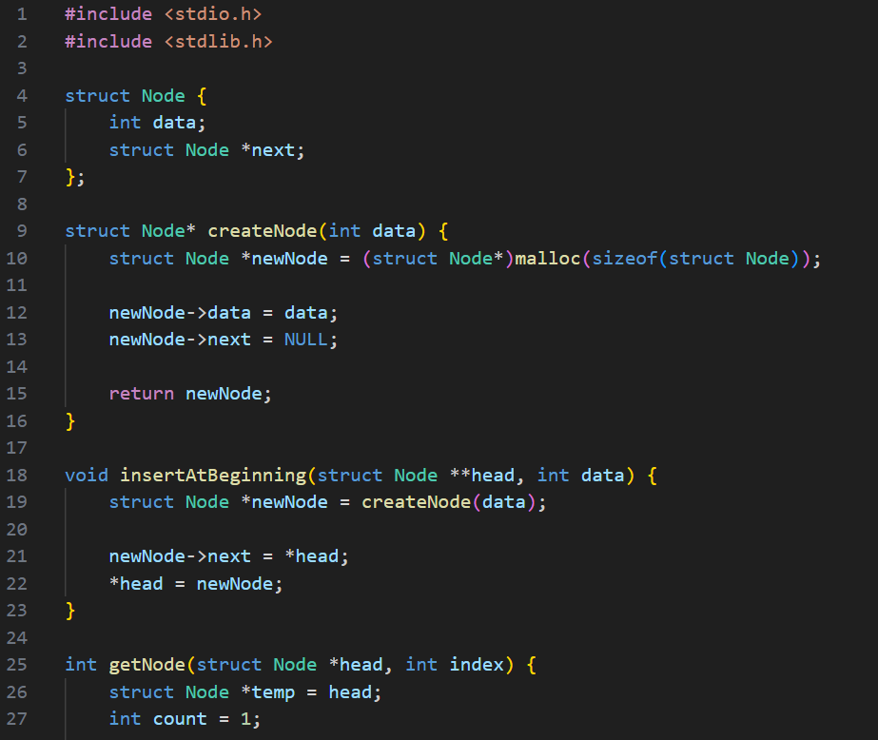

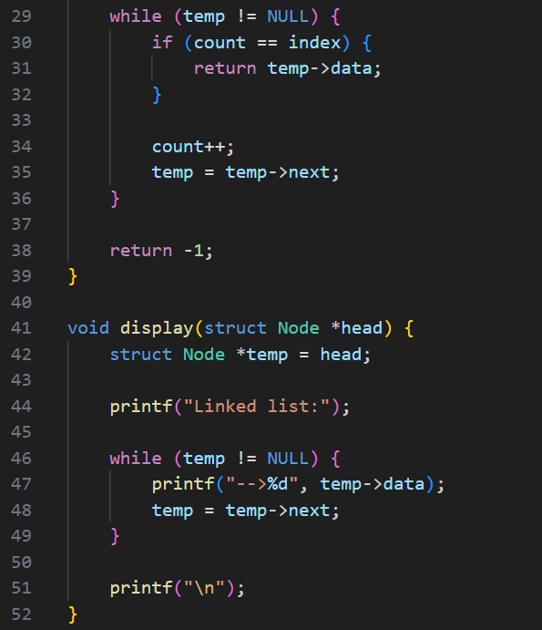

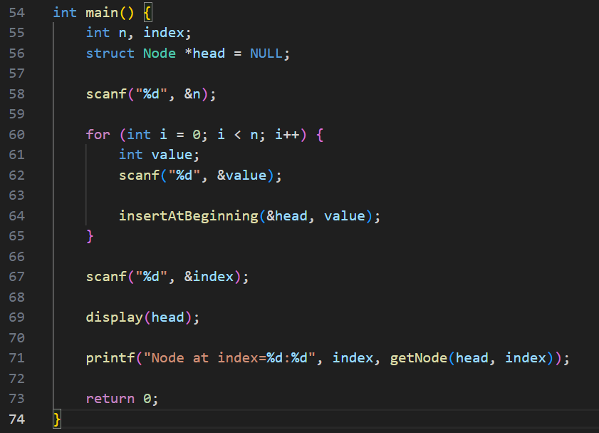

Output:
Test Case-1:
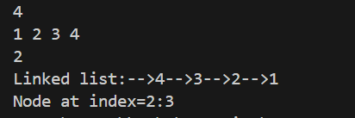

Test Case-2:
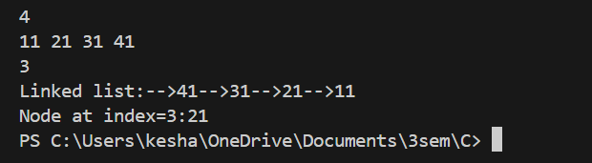

Keshav Kumar Rauniyar
CH.SC.U4CSE25236

