Question No:7

4
9 77 12 6
12
4
91 77 12 61
2

Linked List:->12->6 Invalid Node! Linked List:->91->77->12->61

struct node node *next; void create()

Code:
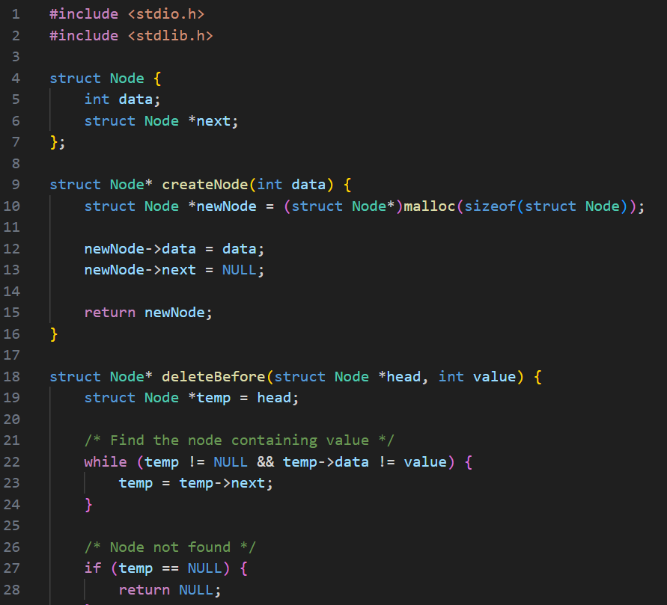

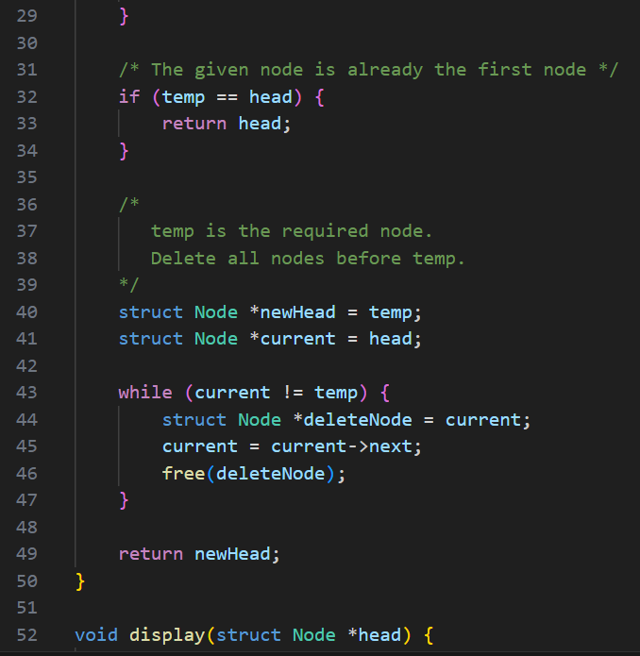

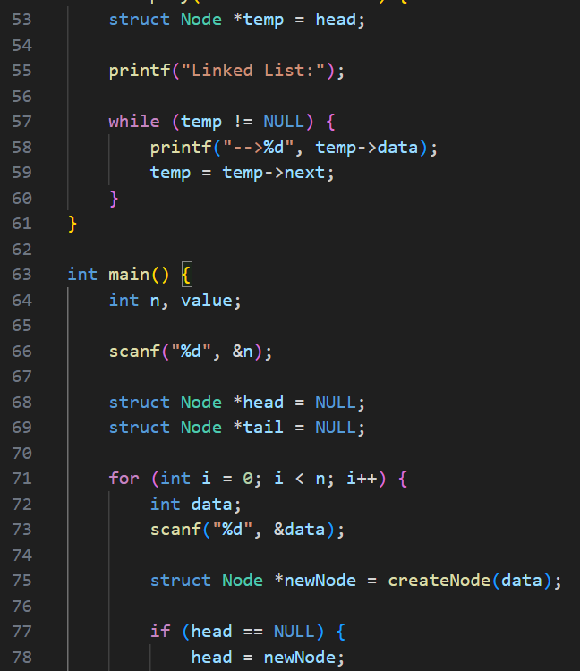

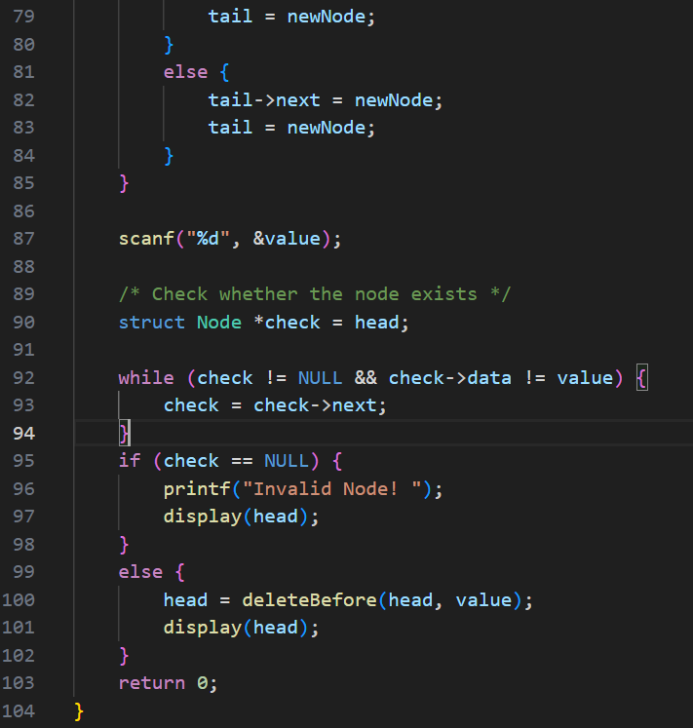

Output:
Test Case-1:
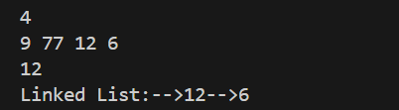

Test Case-2:
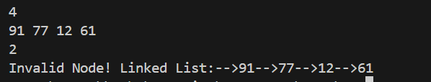

Keshav Kumar Rauniyar
CH.SC.U4CSE25236

