Introduction to Agentic AI 3

Defining Agentic AI 3

The Evolution of AI: From Traditional Models to Agentic Systems 4

Key Milestones in the Evolution of AI 4

Key Differences Between Traditional AI and Agentic AI 5

Understanding Agentic Systems 6

What Are Agents in the Context of AI? 6

Characteristics of Agentic Systems 6

Reactive vs. Deliberate Agents 6

The Role of Autonomy and Decision-Making in Agents 8

Key Differences from Conventional AI Mechanisms 11

Real-World Applications of Reasoning Agents 12

The Computational Foundation 9

Importance of Train-Time Compute for Agent-Centric Models 9

Analyzing Performance and Effectiveness in Agentic Systems 10

Scaling Laws: How They Apply to Agentic AI Development 13

Clarifying Test-Time Compute for Agents 14

Understanding Test-Time Computation in Agentic Contexts 14

Comparing Training and Test-Time Compute: Implications for Agents 14

Scaling and Practicality in Agentic AI 14

Re-examining Scaling Laws in the Age of Agents 14

Practical Scaling Strategies for Agentic Models 14

Methods of Evaluation and Test-Time Strategies 15

Overview of Evaluation Techniques for Agentic AI 15

Verifier-Based Search Techniques 15

Optimizing Sample Selection Mechanisms 15

Advanced Search Strategies: Beam Search and Beyond 15

Monte Carlo Tree Search in Agentic Environments 15

Enhancing Agentic AI Performance through Prompting 16

An Introductory Guide to Prompting in Agentic Contexts 16

The Impact of Prompting on Agent Decision-Making 16

Advanced Reasoning Techniques in Agentic AI 16

Overview of STaR and Its Relevance to Agentic Systems 16

Introducing DeepSeek-R1: Features and Capabilities 16

Exploring Reasoning Strategies with DeepSeek-R1 17

Practical Applications and Efficiency of DeepSeek-R1 17

Learning Efficient Reasoning Methods with DeepSeek-R1 17

Learning from Challenges in Agentic AI 17

Key Insights from Unsuccessful Experiments 17

Common Pitfalls in Agentic Machine Learning Implementation 17

Conclusion and Future Directions 18

Looking Forward: Innovations in Agentic AI 18

The Ethics of Agentic AI: Navigating Challenges 18

Interdisciplinary Collaboration in Agentic AI Development 18

User-Centric Design in Agentic Systems 18

The Role of Feedback Loops in Agentic Learning 18

Future Skills for Working with Agentic AI 18

# Introduction to Agentic AI

## Defining Agentic AI

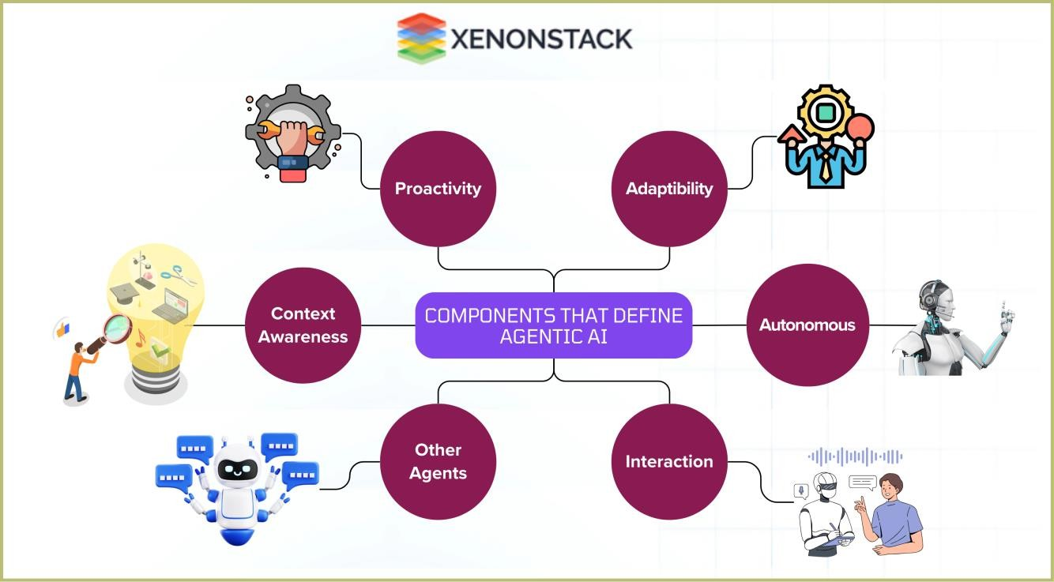

A conceptual diagram illustrating the components that define agentic AI—autonomy, adaptability, and interaction—along with their relationships.

Agentic AI refers to an advanced category of artificial intelligence that exhibits higher levels of autonomy, adaptability, and interaction with its environment. Unlike traditional AI systems that operate based on fixed rules, agentic AI systems possess the capability to make independent decisions based on the information they gather and process.

## The Evolution of AI: From Traditional Models to Agentic Systems

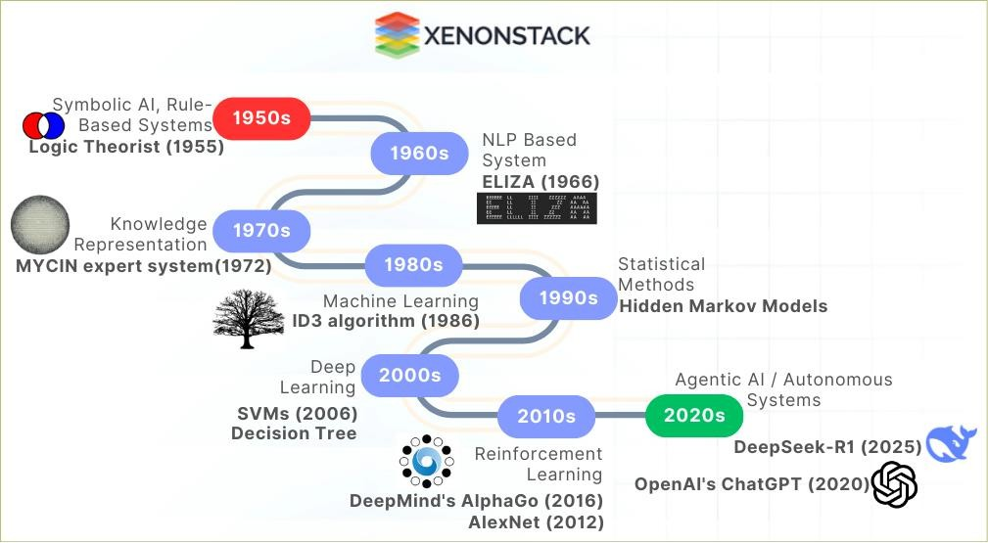

A graph showing the evolution of AI from traditional rule-based systems to modern agentic AI, indicating key milestones and advancements over time.

The journey of artificial intelligence has seen a significant transformation over the decades, moving from primitive symbolic AI and rule-based systems to the emergence of sophisticated agentic frameworks.

### Key Milestones in the Evolution of AI:

#### 1950s–1980s: Rule-Based Systems

* **1956:** Dartmouth Workshop (birth of AI).
* **1965:** ELIZA (early NLP chatbot).
* **1980s:** Expert systems (e.g., MYCIN for medical diagnosis).

#### 1990s–2010s: Machine Learning (ML)

* **1997:** IBM Deep Blue defeats Kasparov (chess).
* **2006:** Rise of support vector machines (SVMs), decision trees.

#### 2010s–2020s: Deep Learning & Neural Nets

* **2012:** AlexNet revolutionizes image classification.
* **2016:** AlphaGo defeats Lee Sedol (Go).

#### 2020s–Present: Agentic AI

* **2023:** GPT-4 and AutoGPT (self-prompting AI).
* **2024:** AI agents in robotics (e.g., Tesla Optimus).
* **2025:** DeepSeek, Reasoning LLM

This evolution reflects significant technological advancements that allow AI to undertake increasingly complex tasks involving decision-making and autonomous action. As AI continues to evolve, it moves closer to achieving true agentic capabilities, enabling systems to operate independently and interact with the world in more meaningful and sophisticated ways.

## Key Differences Between Traditional AI and Agentic AI

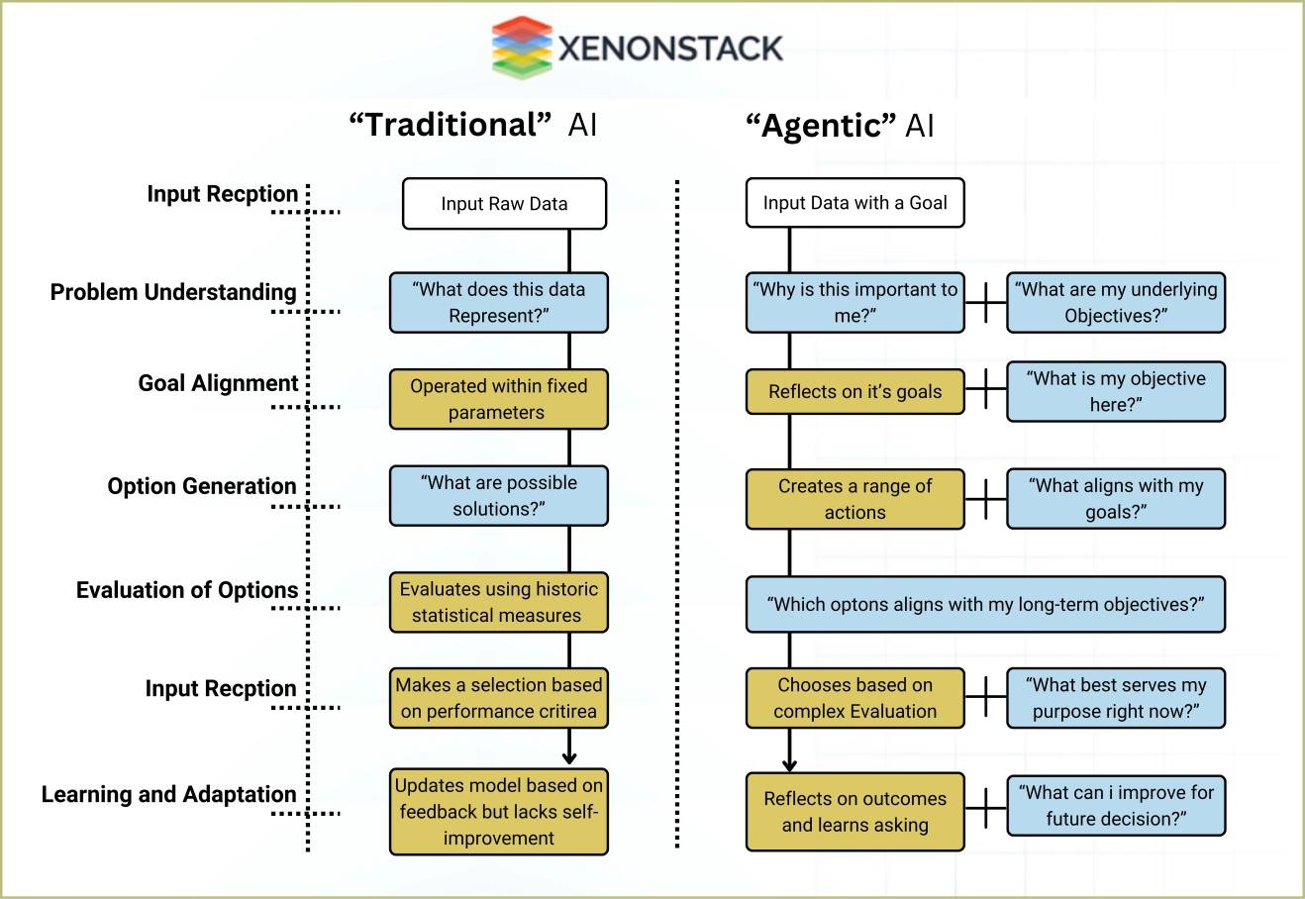

Thought Processing in Traditional AI and Agentic AI

The primary distinction between traditional AI and agentic AI lies in their adaptability and autonomy. Traditional AI processes input data within fixed parameters, operating under predefined paths to evaluate possible solutions based solely on historical patterns. It addresses questions like "What does this data represent?" and "What are possible solutions?" while making selections based on performance criteria and lacking meaningful self-improvement.

In contrast, agentic AI engages with dynamic environments, reflecting on its goals and continuously learning from its experiences. It poses deeper questions such as "What aligns with my goals?" and "Which options best serve my long-term objectives?" This adaptive approach allows agentic AI to create a range of actions, make decisions informed by its evolving understanding, and ultimately refine its decision-making process for future scenarios.

# Understanding Agentic Systems

## What Are Agents in the Context of AI?

Agentic systems are composed of entities agents that can perceive their environment, make informed decisions, and take actions based on those decisions. These agents are engineered to function within intricate and often unpredictable environments, enabling them to adapt and respond effectively.

## Characteristics of Agentic Systems

In the realm of agentic systems, several key components define their functionality:

* **Sensors**: Enable agents to gather information from their surroundings, providing the necessary data for decision-making.
* **Processing**: Involves analyzing the data collected from the environment, allowing the agent to interpret and understand the current context.
* **Control**: Agents utilize their processing capabilities to determine actions that correspond to their goals, ensuring effective interaction with the environment.
* **Domain Knowledge**: This refers to the understanding and expertise within a specific area that guides the agent’s actions and decisions.
* **Rules**: Established protocols that dictate how agents should behave under various circumstances, shaping their responses.
* **Environment**: The external context within which agents operate, encompassing all relevant factors that influence decision-making.

## Reactive vs. Deliberate Agents

Agentic systems can be categorized into two primary types: reactive agents and deliberate agents.

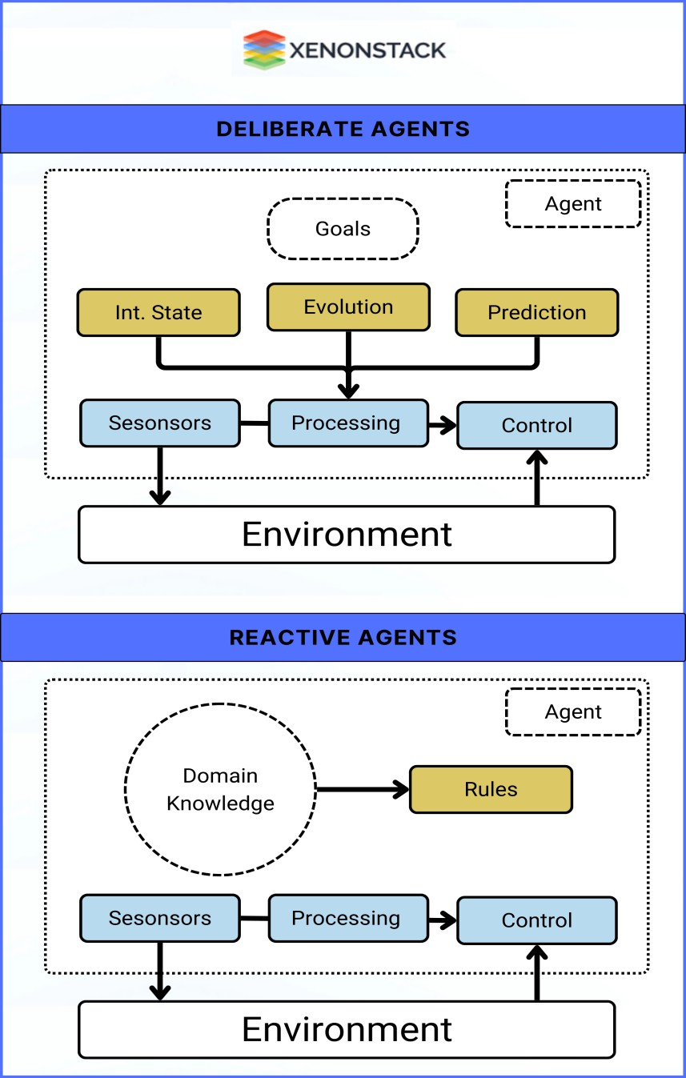

**Fig:** Typical working of Deliberate and Reactive agents

# **Reactive Agents:** These agents act based on immediate sensory input, following predefined rules for quick responses. They prioritize current stimuli over long-term planning, making them ideal for dynamic environments.

# **Deliberate Agents:** These agents use higher-level reasoning and planning, analyzing their environment to align decisions with long-term goals. They adapt over time based on experience, improving performance in complex scenarios.

# The Role of Autonomy and Decision-Making in Agents

The autonomy of agentic systems empowers them to make decisions without human intervention, enhancing their applicability in real-world scenarios. This independence is fundamental to their effectiveness and efficiency.

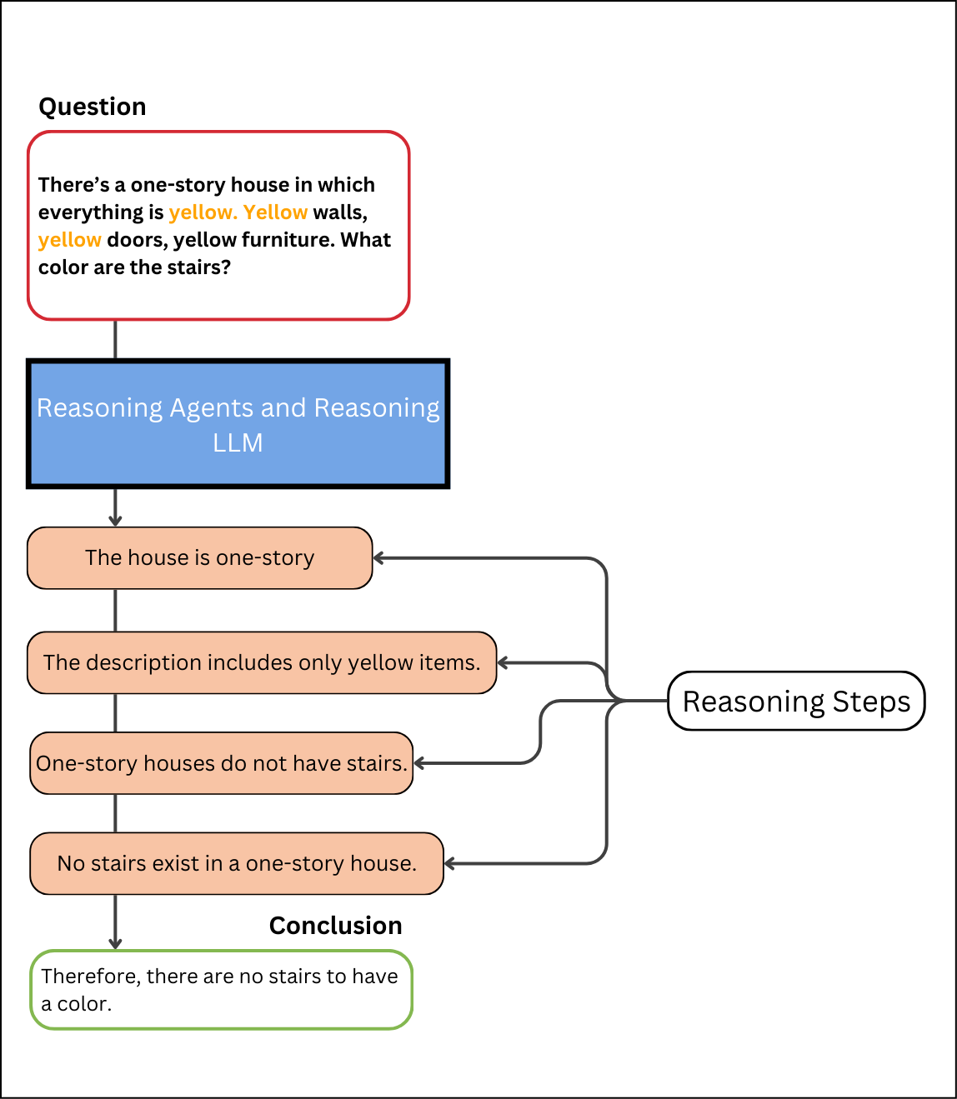

**Fig:** Reasoning Process of Reasoning Agents and Reasoning LLMs

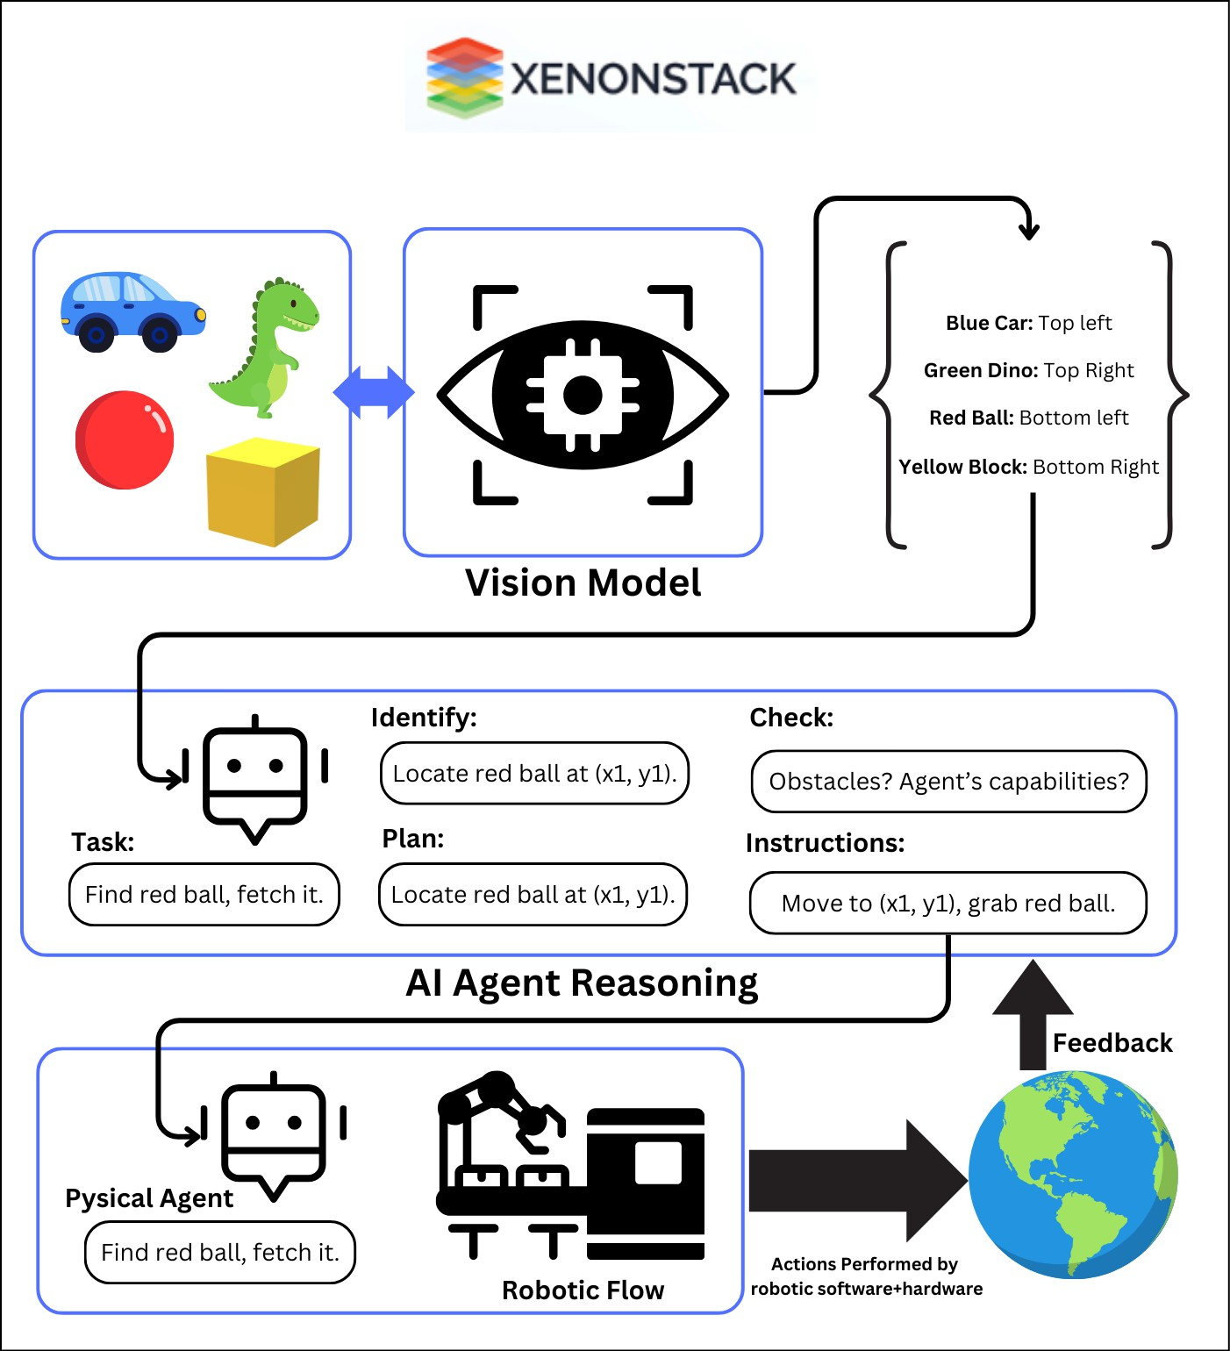

**Fig:** A flowchart detailing the decision-making process in agentic AI, showing how inputs are processed to produce outputs based on reasoning algorithms.

Reasoning plays a fundamental role in agentic AI, empowering agents to assess situations, evaluate multiple alternatives, and arrive at well-informed decisions. This reasoning workflow is essential for enhancing the efficiency and dependability of agentic systems.

For example, consider the task of finding and retrieving a red ball. The agent initiates the process with a clear instruction: “Find red ball, fetch it.” The next steps involve locating the red ball's coordinates, identified as (x1, y1). As the agent deciphers its environment, it must also consider potential obstacles and evaluate its capabilities. Once this analysis is complete, the agent executes the movement to (x1, y1) and successfully retrieves the red ball.

The reasoning process involves multiple components, including a Vision Model that identifies various objects in the environment, such as a blue car (top left), a green dinosaur (top right), a red ball (bottom left), and a yellow block (bottom right). The agent's task is to plan its actions based on the information gathered, using a combination of robotic software and hardware to perform the necessary actions and respond to feedback effectively.

## Key Differences from Conventional AI Mechanisms

Agentic AI employs advanced reasoning mechanisms that differentiate it from conventional AI systems. These mechanisms facilitate better understanding and adaptability to new and complex situations.

## Real-World Applications of Reasoning Agents

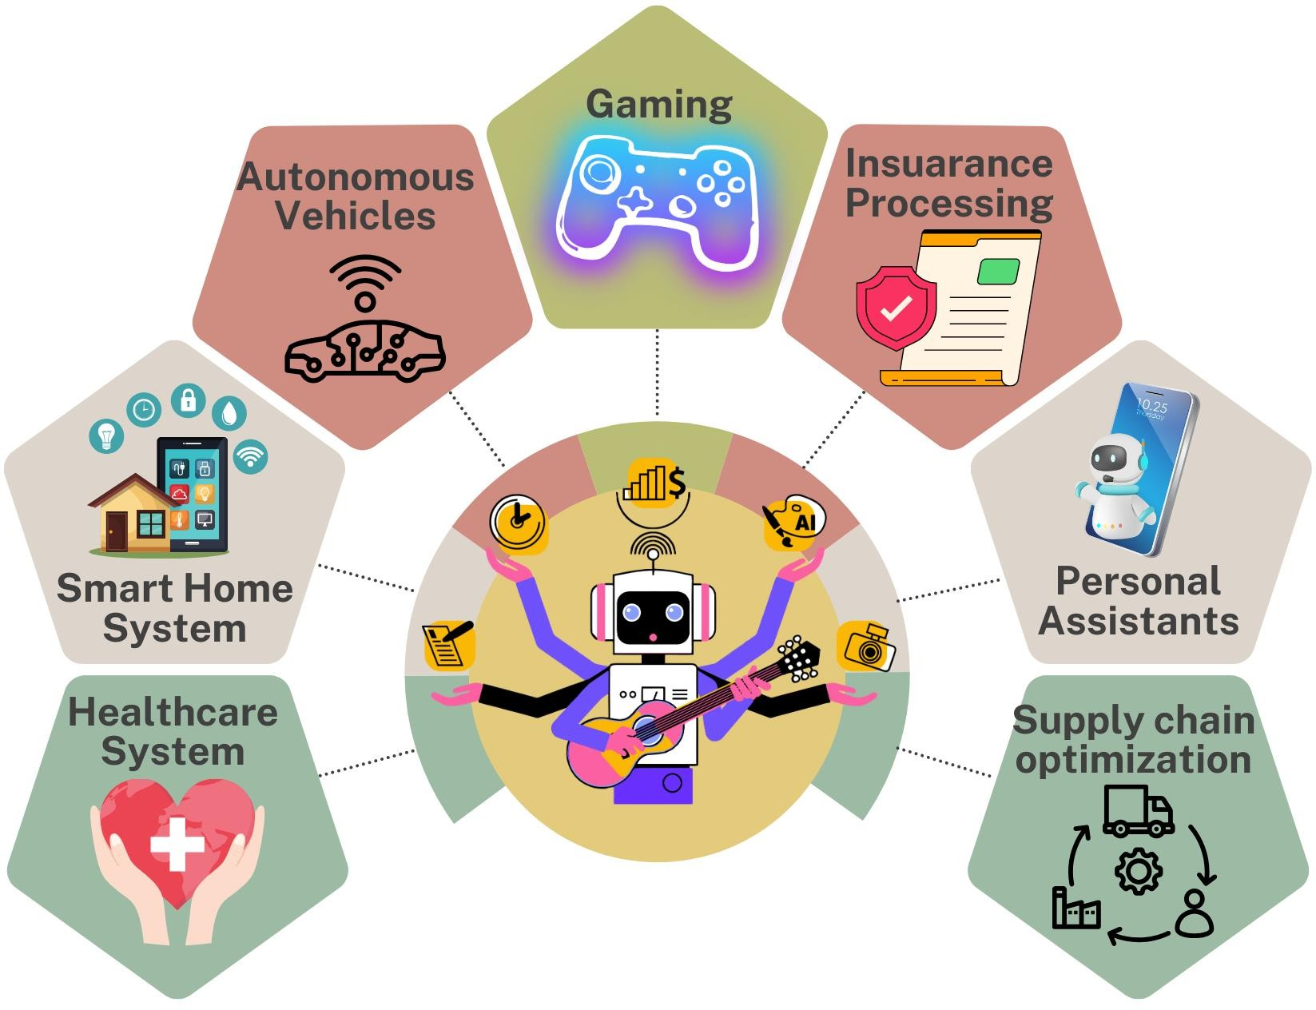

**Fig:** Various Application of agentic Ai in fields including health care, supply-chain, banking etc.

Reasoning agents are already making significant impacts in numerous industries such as healthcare for diagnostics, finance for risk assessment, and autonomous vehicles for navigation and decision-making.

# The Computational Foundation

Enhancing the performance of agent-centric AI models has necessitated significant computational resources during the training phase. This is vital for developing robust neural networks that can learn and operate autonomously.

## Importance of Train-Time Compute for Agent-Centric Models

Developers typically focus on increasing:

* **Model Size** (number of parameters)
* **Dataset Volume** (number of tokens)
* 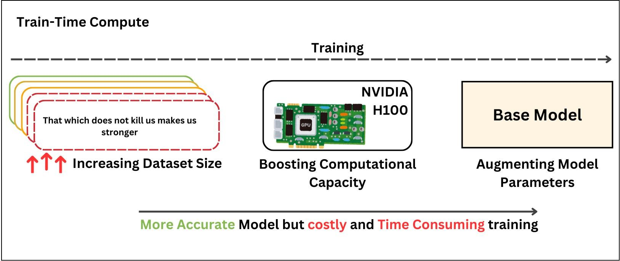**Compute Power** (number of FLOPs)

**Fig:** The trade-off between training cost and accuracy of model

These three elements combined form what is known as train-time compute, underscoring the concept that the pretraining data acts as the "fossil fuel of AI." Essentially, the greater the pretraining budget, the more effective and capable the resulting model will be.

## Analyzing Performance and Effectiveness in Agentic Systems

Train-time compute encompasses not only the computational resources required during the initial training but also those needed during fine-tuning. This comprehensive approach has become a key strategy in elevating the performance of agent-centric AI systems.

# Scaling Laws and Their Impact on Agentic AI

Scaling laws describe how a model’s performance improves as compute, dataset size, and model parameters increase. These relationships follow a power law, meaning that proportional increases in one or more of these factors lead to predictable improvements in model capabilities. Typically represented on a log-log scale, these laws illustrate the exponential growth in compute required to achieve marginal gains in performance.

Two of the most influential scaling laws—**Kaplan’s Scaling Law (2020)** and **Chinchilla’s Scaling Law (2022)**—have shaped the trajectory of large-scale AI development. While early research focused on expanding model size as the primary driver of performance, later findings emphasized the importance of balancing model parameters with adequate training data.

In 2020, Jared Kaplan and colleagues introduced a scaling law that emphasized increasing model size as the most effective way to boost performance when compute was fixed. This approach led to the rapid development of massive neural networks like GPT-3, which showcased remarkable improvements in language generation. However, as models grew to hundreds of billions of parameters, inefficiencies emerged, with many models being undertrained relative to their size, leading to diminishing returns.

In 2022, DeepMind researchers challenged Kaplan’s findings with the Chinchilla Scaling Law, which showed that model size and dataset size must scale together for optimal performance. They found that many previous models were excessively large for the amount of data they were trained on, leading to inefficiencies. This insight led to a shift toward more data-efficient architectures, allowing smaller but well-trained models like Chinchilla to outperform larger, inefficient predecessors.

By 2024, while compute power, dataset size, and model parameters continued to expand, performance gains began to plateau. Challenges such as data saturation, energy consumption, and inference costs have limited the benefits of pure scaling. As a result, researchers are now exploring alternative approaches like retrieval-augmented generation (RAG), modular AI architectures, and agentic AI systems that integrate reasoning and memory rather than relying solely on scale.

# Clarifying Test-Time Compute for Agents

## Understanding Test-Time Computation in Agentic Contexts

Test-time computation refers to the resources and processes that occur during the execution phase of an agentic AI model, which are crucial for its decision-making effectiveness.

## Comparing Training and Test-Time Compute: Implications for Agents

**Fig 12**: A comparative table showcasing key differences in resource allocation, duration, and methods used during training vs. test phases for agentic AI models.

Understanding the distinctions between training and test-time compute is vital, as this comparison highlights how resources are allocated differently based on the phase of operation.

# Scaling and Practicality in Agentic AI

## Re-examining Scaling Laws in the Age of Agents

The scaling laws relevant to agentic AI shed light on the necessary resources needed to enhance the capabilities of these advanced systems. Adjusting these strategies is essential for future advancements.

## Practical Scaling Strategies for Agentic Models

**Fig 10**: An infographic summarizing dynamic scaling processes in agent-based models, demonstrating adaptability in resource allocation.

Practical scaling strategies involve dynamic resource allocation that adapts based on real-time performance metrics, ensuring the agentic systems remain efficient under varying loads.

# Methods of Evaluation and Test-Time Strategies

## Overview of Evaluation Techniques for Agentic AI

**Fig 14**: A flowchart outlining various techniques and frameworks for evaluating the performance and effectiveness of agentic AI models.

Evaluating agentic AI systems requires a variety of techniques to ensure that performance and effectiveness meet the desired standards.

## Verifier-Based Search Techniques

Agentic AI systems rely on **verifier-based search techniques** to improve decision-making by evaluating and refining generated outputs. These techniques help models navigate complex reasoning steps by scoring potential answers based on quality and consistency. Verifiers, often large language models fine-tuned for evaluation, are categorized as **Outcome Reward Models (ORM)** that judge the final result or **Process Reward Models (PRM)** that assess the reasoning steps leading to an answer.

**Self-Consistency and Majority Voting**

A simple yet effective verification method is **self-consistency**, where an AI model generates multiple responses to the same query and selects the most frequently occurring answer. This approach, akin to **majority voting**, enhances reliability by ensuring that the chosen response aligns with the model’s most probable reasoning path.

## Best-of-N Sampling for Optimized Responses

In **Best-of-N sampling**, a model generates multiple candidate answers, which are then evaluated by an ORM. The response with the highest quality score is selected. Alternatively, PRMs can be used to score individual reasoning steps, ensuring that the final selection is based on both logical coherence and correctness. This method can be further refined using **Weighted Best-of-N Sampling**, where the best answer is chosen based on cumulative reward scores.

## Beam Search for Structured Reasoning

Beam search extends the **Best-of-N** approach by maintaining multiple high-scoring reasoning paths throughout the generation process. Each step is scored by a PRM, allowing inefficient reasoning branches to be pruned early. This structured search technique is particularly useful for **Tree of Thought (ToT)** reasoning, where multi-step logical sequences must be evaluated dynamically.

## Monte Carlo Tree Search for Adaptive Decision-Making

Monte Carlo Tree Search (MCTS) is a powerful method for structuring decision-making in agentic AI. The process consists of:

1. **Selection:** Choosing a reasoning path based on prior evaluations.
2. **Expansion:** Generating additional possible steps.
3. **Rollout:** Simulating multiple outcomes by following different reasoning paths.
4. **Backpropagation:** Updating parent node scores based on newly computed results.

This iterative cycle allows models to balance **exploration (trying new reasoning paths)** and **exploitation (refining known good paths)**, leading to more **strategic decision-making** rather than brute-force answer generation.

# Enhancing Agentic AI Performance through Prompting

Prompting serves as a key strategy in directing agentic AI models toward more effective reasoning and decision-making. Well-crafted prompts help shape how models process information, ensuring more structured and reliable outputs.

## Strategic Prompting for Improved Reasoning

By refining the way instructions are presented, models can be encouraged to generate more logical and well-structured responses. Providing context-rich prompts helps align AI-generated reasoning with intended objectives. However, conventional prompting remains a **fixed approach**, meaning the model follows instructions as given but does not independently refine or reassess its reasoning when inaccuracies arise.

# Advanced Reasoning Techniques in Agentic AI

## 

## Self-Taught Reasoning (STaR) in Agentic AI

The **STaR framework (Self-Taught Reasoner)** is a novel approach to improving reasoning in agentic AI by training models to generate structured reasoning steps. Instead of relying solely on external datasets, STaR enables AI to create its own reasoning data, refining its logical pathways through reinforcement learning and supervised fine-tuning. This method enhances the model’s ability to follow systematic reasoning, making it a powerful tool for agentic AI systems.

## Iterative Learning and Synthetic Reasoning Data

In STaR, a model first generates reasoning steps and an answer. If the answer is correct, the reasoning sequence is added to a dataset for fine-tuning. If incorrect, the model receives a **hint** (correct answer) and generates a revised reasoning path before incorporating it into training. This process **iteratively improves logical consistency**, ensuring the AI internalizes structured reasoning. By leveraging **synthetic training examples**, STaR enables scalable reasoning refinement, making it highly effective for distilling complex reasoning processes in advanced agentic models.

# Introducing DeepSeek-R1: Features and Capabilities

DeepSeek-R1 is an advanced open-source AI model designed to excel in reasoning, problem-solving, and decision-making tasks. Developed by DeepSeek, it integrates reinforcement learning techniques to enhance logical inference, self-verification, and chain-of-thought reasoning. Its key features include:

* **Mathematical and Logical Reasoning:** The model demonstrates superior performance in solving mathematical and logical problems, surpassing existing benchmarks.
* **Transparent Thought Process:** Unlike black-box AI models, DeepSeek-R1 reveals its step-by-step reasoning, enhancing interpretability.
* **Efficiency and Accessibility:** It is optimized for efficient deployment on consumer-grade hardware, making high-level AI accessible to a broader audience.
* **Open-Source Availability:** Released under the MIT license, DeepSeek-R1 encourages collaborative development and commercial applications without restrictions.

## Exploring Reasoning Strategies with DeepSeek-R1

DeepSeek-R1 employs advanced reasoning strategies that adapt dynamically to complex scenarios. Its methodologies include:

* **Chain-of-Thought (CoT) Reasoning:** The model decomposes problems into structured steps, improving accuracy in complex tasks.
* **Self-Reflection and Verification:** It can refine its responses by evaluating initial answers, leading to more reliable outputs.
* **Contextual Adaptation:** The model adjusts its reasoning based on real-time inputs, enhancing its effectiveness across diverse problem domains.
* **Multi-Step Inference:** By breaking down multi-variable problems, DeepSeek-R1 improves decision accuracy and reduces errors.

These strategies enable the model to outperform traditional AI approaches in domains requiring structured and contextual reasoning.

## Practical Applications and Efficiency of DeepSeek-R1

DeepSeek-R1 has been successfully implemented across various sectors, demonstrating efficiency and effectiveness in:

* **Software Development:** Assisting in code generation, debugging, and optimization for developers.
* **Mathematical Problem-Solving:** Delivering high-accuracy solutions for complex math problems, excelling in standardized evaluations.
* **Scientific Research:** Analyzing datasets, generating hypotheses, and improving knowledge synthesis in academic and industrial research.
* **Financial Analysis:** Enhancing risk assessment and predictive modeling for investment strategies.
* **Decision Support Systems:** Offering intelligent recommendations in business and strategic planning.

Additionally, DeepSeek-R1's optimized architecture allows it to function efficiently on standard hardware, reducing computational costs while maintaining high performance.

## Learning Efficient Reasoning Methods with DeepSeek-R1

DeepSeek-R1 refines its reasoning processes through a combination of learning techniques:

* **Reinforcement Learning from Human Feedback (RLHF):** The model improves by learning from expert evaluations and iterative feedback loops.
* **Self-Supervised Learning:** It enhances its knowledge base without requiring large-scale labeled data, making it more adaptable.
* **Error Correction Mechanisms:** By recognizing and adjusting incorrect outputs, DeepSeek-R1 increases reliability in decision-making.
* **Knowledge Distillation:** The model integrates insights from multiple data sources to optimize its reasoning efficiency.

# Learning from Challenges in Agentic AI

## Key Insights from Unsuccessful Experiments

**Fig 23**: A case study summary showing key failures in agentic AI implementations and the lessons learned from them, enhancing future designs.

Learning from failures is crucial in the development of agentic AI, providing insights into potential pitfalls and areas requiring improvement.

## Common Pitfalls in Agentic Machine Learning Implementation

**Fig 24**: An infographic displaying common pitfalls in the implementation of agentic machine learning, with suggestions for mitigation.

Identifying common pitfalls in agentic machine learning implementations aids practitioners in avoiding mistakes that can hinder performance.

# Conclusion and Future Directions

## Looking Forward: Innovations in Agentic AI

**Fig 25**: A forward-looking roadmap illustrating anticipated innovations and emerging trends in agentic AI over the next decade.

The future of agentic AI holds tremendous potential, with innovations expected to transform various industries and improve user experiences.

## The Ethics of Agentic AI: Navigating Challenges

**Fig 26**: A balanced scale highlighting ethical dilemmas and considerations in the deployment of agentic AI technologies, with examples.

Ethical considerations are paramount in the development of agentic AI, necessitating a careful balance between innovation and responsibility.

Interdisciplinary Collaboration in Agentic AI Development

**Fig 27**: A collaborative network diagram showcasing various fields and stakeholders working together to advance agentic AI research and applications.

Advancing agentic AI requires collaborative efforts across various disciplines, uniting experts to create more robust and effective systems.

User-Centric Design in Agentic Systems

**Fig 28**: A user journey map that illustrates the interaction of end-users with agentic AI systems, identifying points of engagement and feedback.

Focusing on user-centric design ensures that agentic AI systems align with user needs and expectations, enhancing overall satisfaction and effectiveness.

The Role of Feedback Loops in Agentic Learning

**Fig 29**: A feedback loop diagram demonstrating how continuous feedback enhances learning processes in agentic AI systems.

Feedback loops play a critical role in refining the learning processes of agentic systems, facilitating continuous improvement and adaptation.

Future Skills for Working with Agentic AI

**Fig 30**: A skill matrix illustrating essential skills and competencies needed to work with and develop agentic AI technologies in the future.

As the field of agentic AI evolves, a new set of skills and competencies will be required for individuals to thrive in this innovative landscape.

This extensive analysis of Agentic AI highlights both the current landscape and future direction for research and implementation, providing valuable insights into its potential applications and ethical considerations.