Crop Price Forecasting using Linear Regression

1. Dataset Summary
Training samples : 150,000
Testing samples : 60,000

2. Model Details
Algorithm: Linear Regression

3. Training Metrics
Metric | Value
MAE | 39.8270
RMSE | 49.9084
R² Score | 0.8895

4. Testing Metrics
Metric | Value
MAE | 39.7825
RMSE | 49.9076
R² Score | 0.8898
The model shows good generalization with a small performance gap between training and testing.

5. Visualisations
Training Data (Sorted): Actual vs Predicted
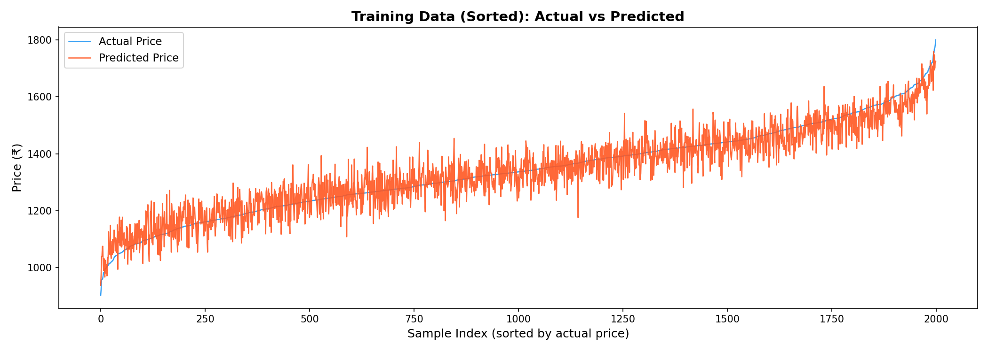
Testing Data (Sorted): Actual vs Predicted
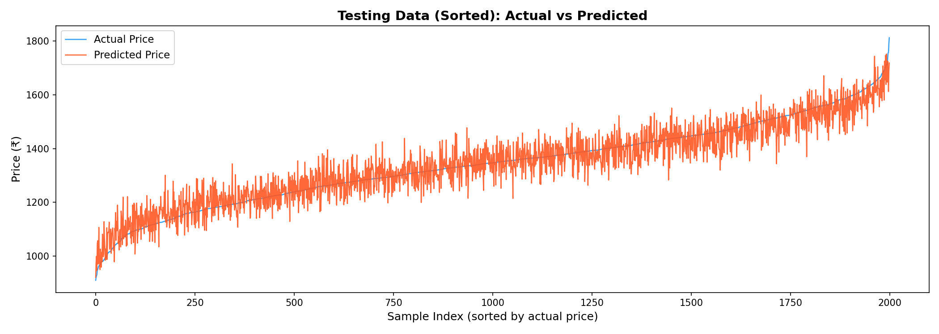
Sorted plots improve trend visibility.
Actual vs Predicted Scatter Plot
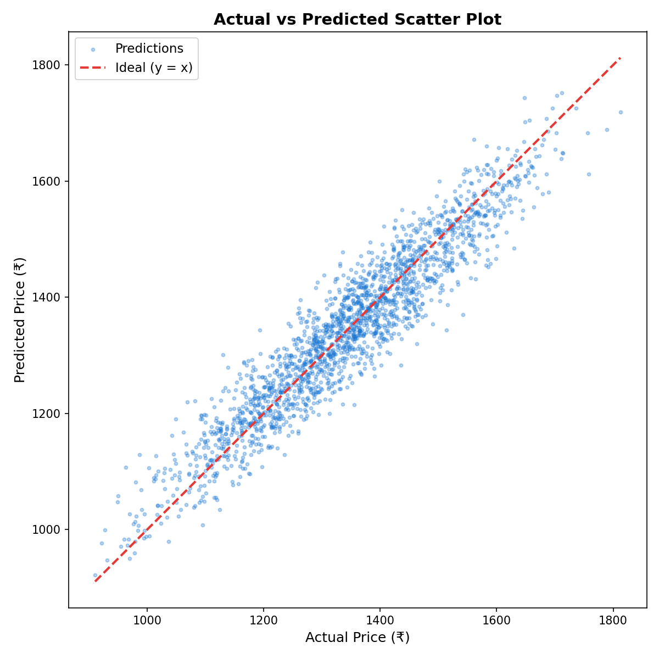
Scatter plot shows prediction accuracy.

6. Sample Predictions (First 20 — Test Data)
Actual Price | Predicted Price | Recommendation
1309.60 | 1309.10 | SELL
1257.03 | 1208.49 | SELL
1242.70 | 1224.85 | SELL
1226.56 | 1241.89 | SELL
1260.88 | 1373.78 | WAIT
1629.86 | 1484.48 | SELL
1337.05 | 1368.05 | WAIT
1410.20 | 1415.35 | SELL
1291.77 | 1425.29 | HOLD
1353.78 | 1395.93 | WAIT
1017.72 | 1041.43 | WAIT
1372.15 | 1352.43 | SELL
1472.06 | 1388.57 | SELL
1274.20 | 1348.70 | WAIT
1128.06 | 1162.23 | WAIT
1175.43 | 1152.84 | SELL
1420.01 | 1467.11 | WAIT
1571.58 | 1543.33 | SELL
1227.11 | 1249.20 | SELL
1306.93 | 1311.05 | SELL

