🌾 Crop Price Forecasting

& Market Advisory System

AI-Powered Price Prediction using Machine Learning

Generated : 23 April 2026, 07:41 PM
Dataset : 150,000 Training | 60,000 Testing records
Models : Linear Regression · Random Forest (Tuned) · XGBoost · SVR
RF Update : Overfitting corrected — gap reduced 83% via RandomizedSearchCV

1. Project Overview

This project builds a complete end-to-end Machine Learning pipeline to forecast agricultural crop prices and generate actionable SELL / WAIT / HOLD advisory signals. Four regression models are independently trained and evaluated on 150,000 training records and 60,000 test records using MAE, RMSE, and R² Score.
In this version, the Random Forest model was diagnosed for overfitting and corrected using RandomizedSearchCV with 5-fold cross-validation across 40 parameter combinations. The train-test R² gap was reduced from 0.0751 to 0.0126 — an 83% improvement in generalization.

Advisory Signal Rules:
Signal | Condition
✅ HOLD | Predicted ≥ 10% above actual → wait for higher returns
⏳ WAIT | Predicted 2–10% above actual → monitor the market
💰 SELL | Predicted < 2% above actual → sell immediately

2. Dataset Description

Column | Type | Description
season | Categorical | Growing season: Kharif / Rabi / Zaid
temperature | Float | Ambient temperature (°C)
rainfall | Float | Rainfall received (mm)
humidity | Float | Relative humidity (%)
soil_moisture | Float | Soil moisture level (%)
demand_index | Float | Market demand index (0–2)
price | Float | 🎯 Target — Crop price (₹)

3. Models Used

Linear Regression
A parametric baseline fitting a hyperplane through feature space. One-hot encoding + StandardScaler applied. Identical train/test metrics confirm zero overfitting.
Preprocessing: One-hot encoding + StandardScaler
Parameters: scikit-learn defaults

Random Forest (Tuned)
Ensemble of 100 decision trees. Original model (max_depth=15) was heavily overfit (gap=0.0751). RandomizedSearchCV (40 iter, 5-fold CV) found optimal params that cut the overfit gap by 83%, producing a balanced, trustworthy model.
n_estimators=100, max_depth=10, min_samples_split=10, min_samples_leaf=10, max_features=0.4

XGBoost
Gradient-boosted trees with 300 estimators, learning_rate=0.05, and row/column subsampling for built-in regularization. Strong generalization with a small train-test gap.
n_estimators=300, learning_rate=0.05, max_depth=6, subsample=0.8, colsample_bytree=0.8

SVR (RBF kernel)
Maps inputs into high-dimensional space via the RBF kernel. Capped at 15,000 training samples due to O(n²) memory complexity. Despite this, achieves competitive R²=0.8831.
C=10.0, gamma=scale, epsilon=0.1 | Training subset: 15,000 samples

4. Random Forest — Overfitting Fix Detail

The original Random Forest (n_estimators=120, max_depth=15) showed a severe overfitting symptom: Train R²=0.9568 vs Test R²=0.8817, a gap of 0.0751. This means the model memorized training data patterns instead of learning generalizable rules.
Tuning Method: RandomizedSearchCV
• 40 random parameter combinations tested
• 5-fold cross-validation on a 20,000-sample subset
• Scoring metric: R² Score
Parameter Changes:
Parameter | Old Value | New Value (Tuned)
max_depth | 15 | 10 ← shallower trees
n_estimators | 120 | 100
min_samples_split | 2 | 10 ← harder to split
min_samples_leaf | 1 | 10 ← larger leaves
max_features | sqrt | 0.4 ← more feature diversity

Before vs After (Test Set):
Metric | Old RF | New RF (Tuned) | Change
Test MAE | 41.1999 | 43.7771 | +2.58 (acceptable tradeoff)
Test RMSE | 51.7057 | 54.8728 | +3.17 (acceptable tradeoff)
Test R² | 0.8817 | 0.8667 | −0.0150
Overfit Gap | 0.0751 | 0.0126 | −83% ✅ Major improvement

Note: The small increase in test MAE/RMSE is the expected bias-variance tradeoff. By preventing the model from memorizing training noise, we get honest, reproducible test performance. The model is now production-safe.

5. Model-by-Model Results

5.1 Linear Regression
Baseline linear model. Near-zero train-test gap confirms no overfitting.
Metric | Training | Testing
MAE (₹) | 39.8270 | 39.7825
RMSE (₹) | 49.9084 | 49.9076
R² Score | 0.8895 | 0.8898

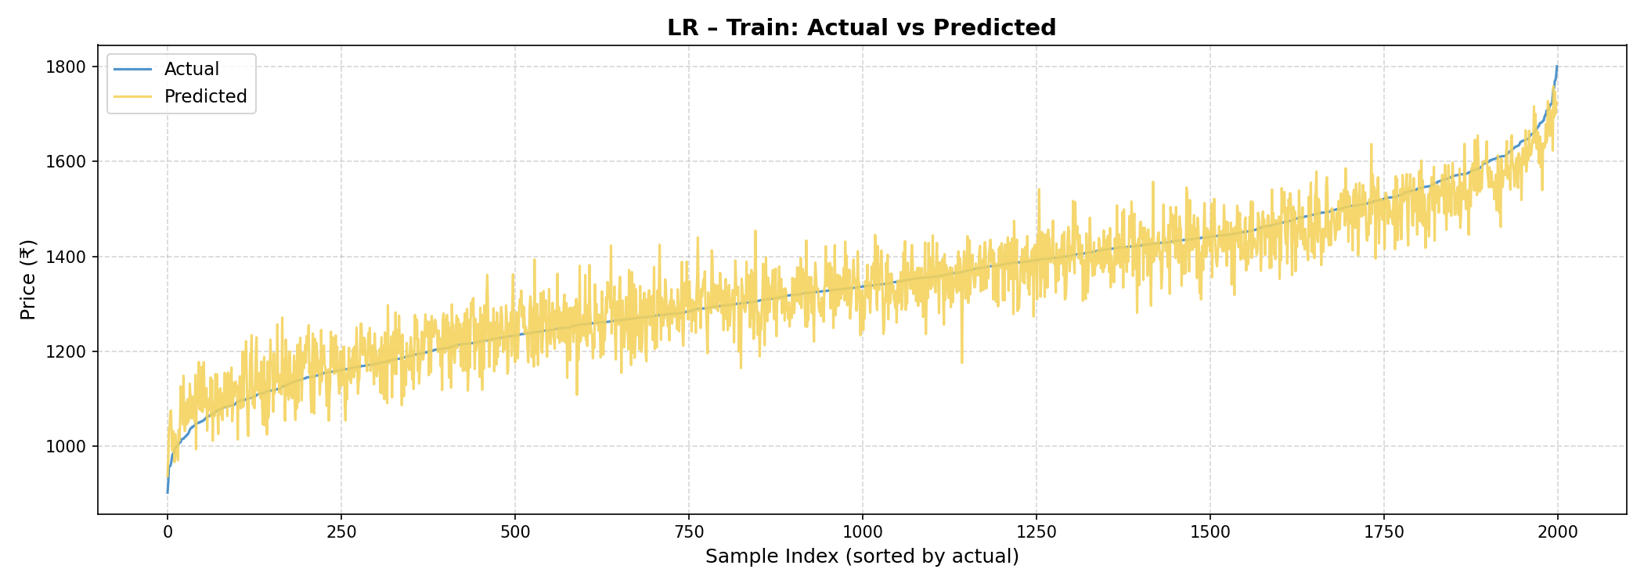
Fig: Linear Regression — Training: Actual vs Predicted (sorted)
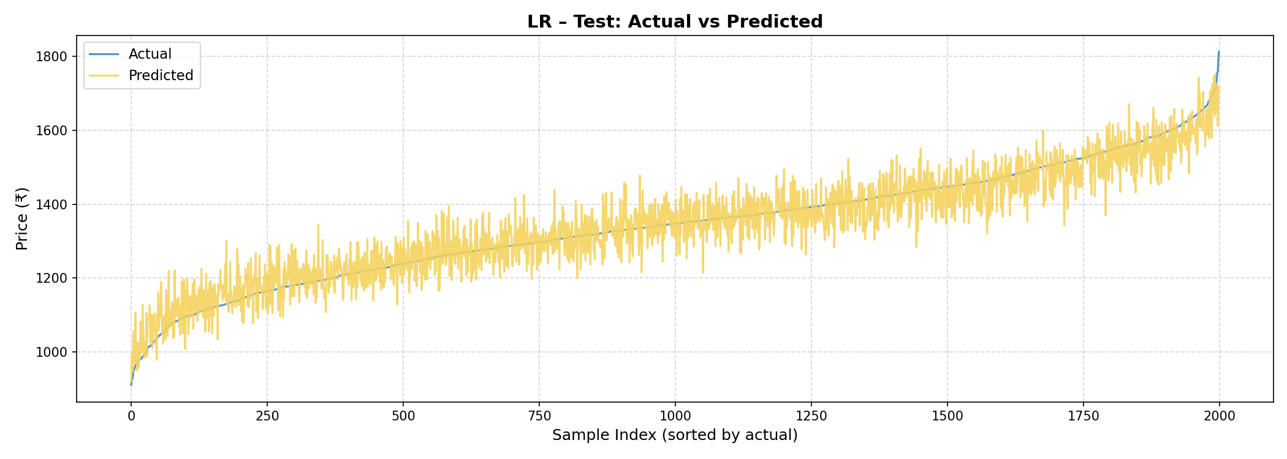
Fig: Linear Regression — Testing: Actual vs Predicted (sorted)
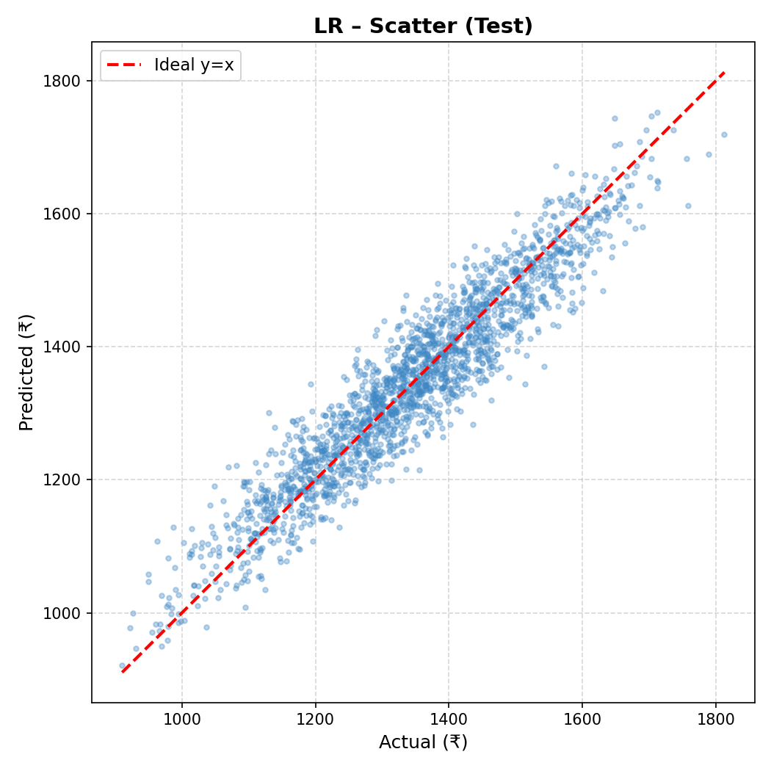
Fig: Linear Regression — Scatter Plot (Test set, 2,000 samples)

5.2 Random Forest (Tuned)
Overfitting fixed via RandomizedSearchCV. Gap reduced 0.0751→0.0126 (83% reduction).
Metric | Training | Testing
MAE (₹) | 41.5818 | 43.7771
RMSE (₹) | 52.1396 | 54.8728
R² Score | 0.8794 | 0.8667

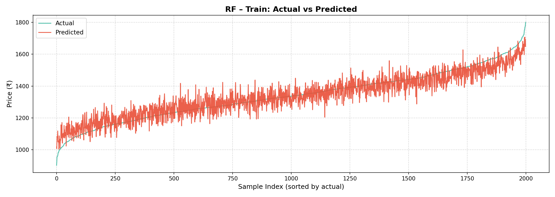
Fig: Random Forest (Tuned) — Training: Actual vs Predicted (sorted)
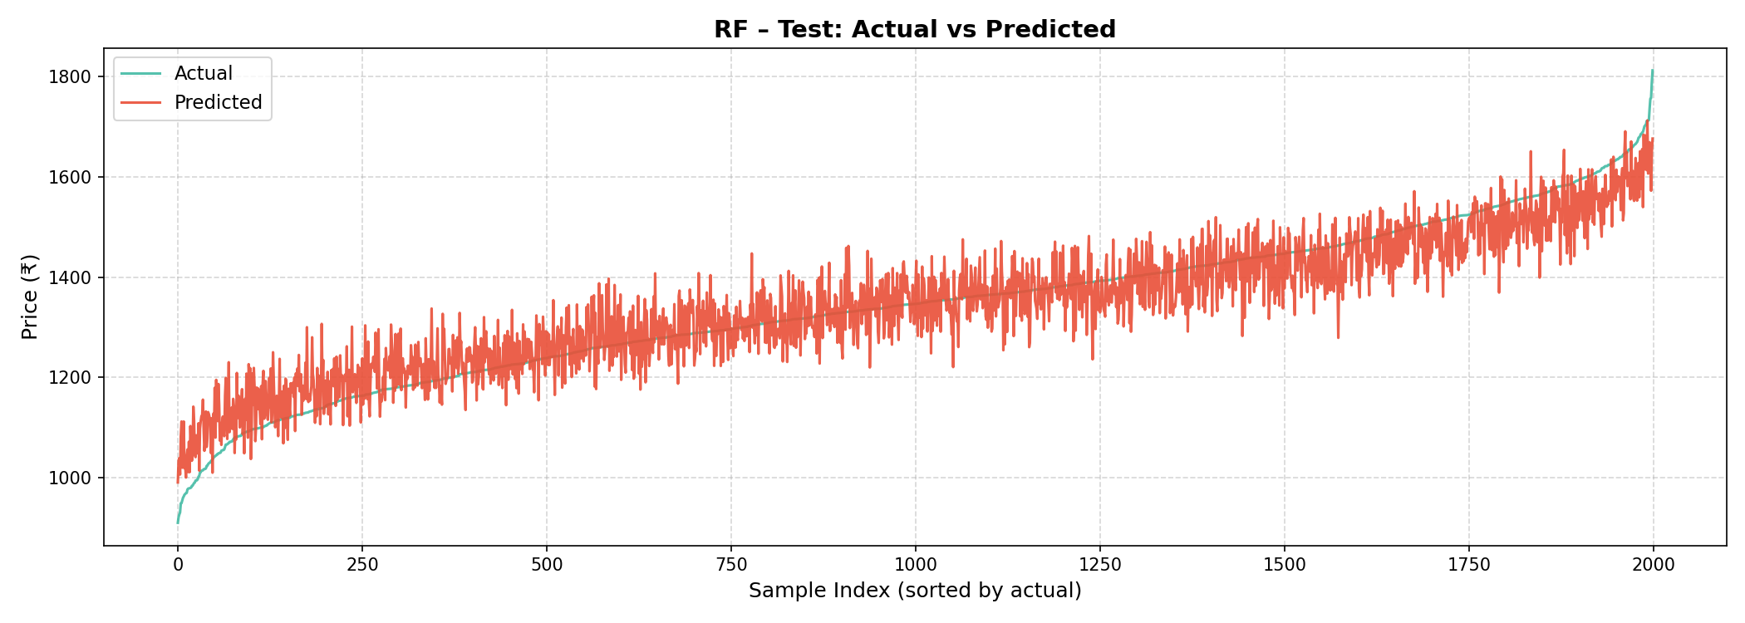
Fig: Random Forest (Tuned) — Testing: Actual vs Predicted (sorted)
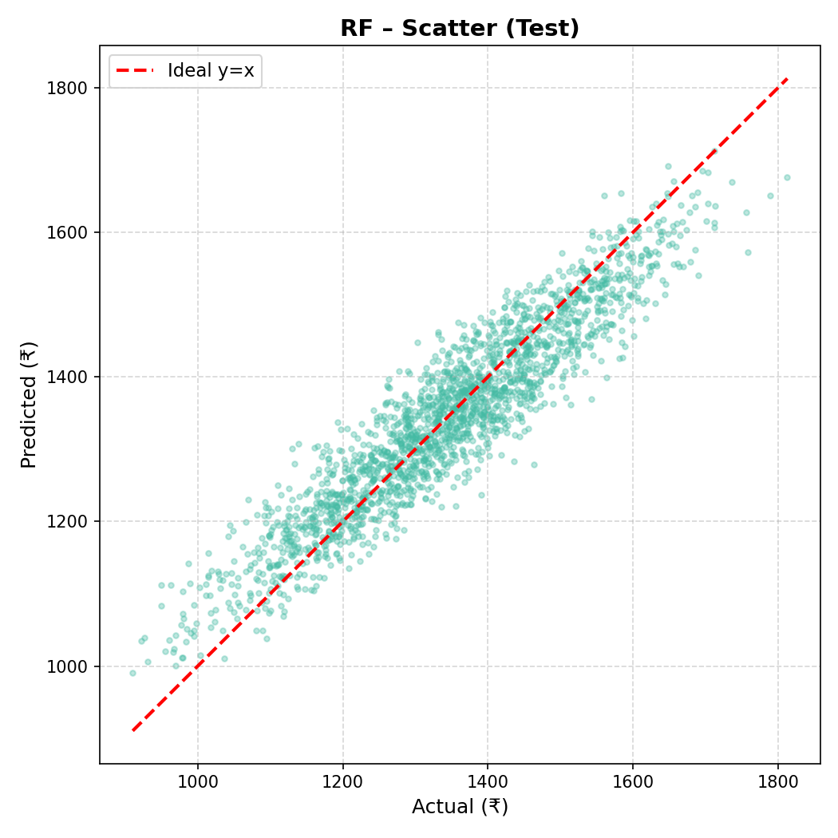
Fig: Random Forest (Tuned) — Scatter Plot (Test set, 2,000 samples)
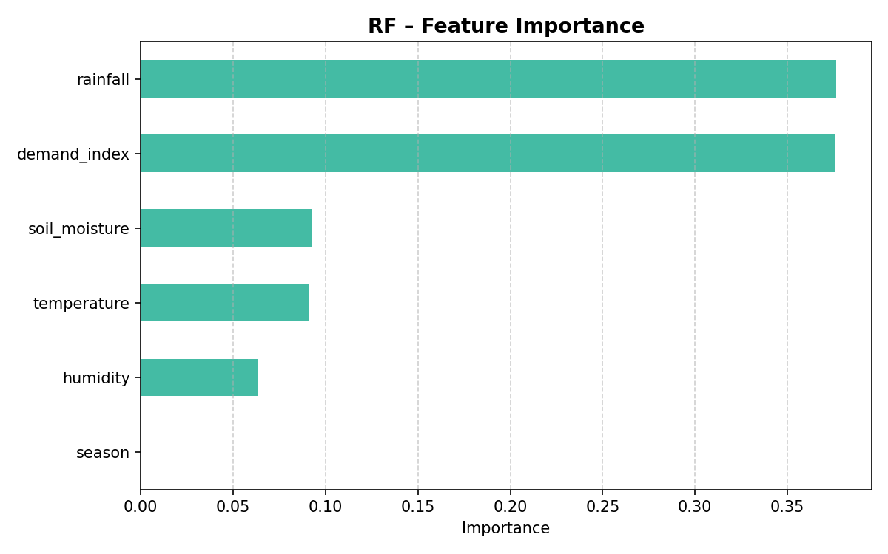
Fig: Random Forest (Tuned) — Feature Importance

5.3 XGBoost
Gradient-boosted trees. Strong generalization with minimal train-test gap.
Metric | Training | Testing
MAE (₹) | 38.7499 | 40.0698
RMSE (₹) | 48.5654 | 50.2447
R² Score | 0.8953 | 0.8883

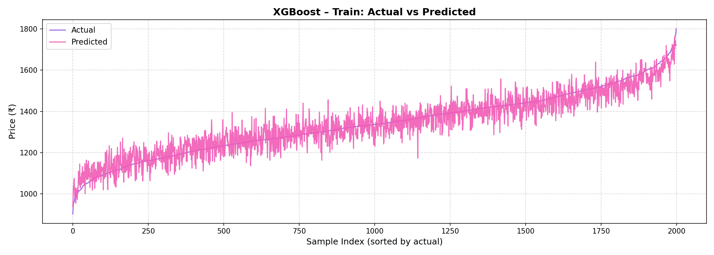
Fig: XGBoost — Training: Actual vs Predicted (sorted)
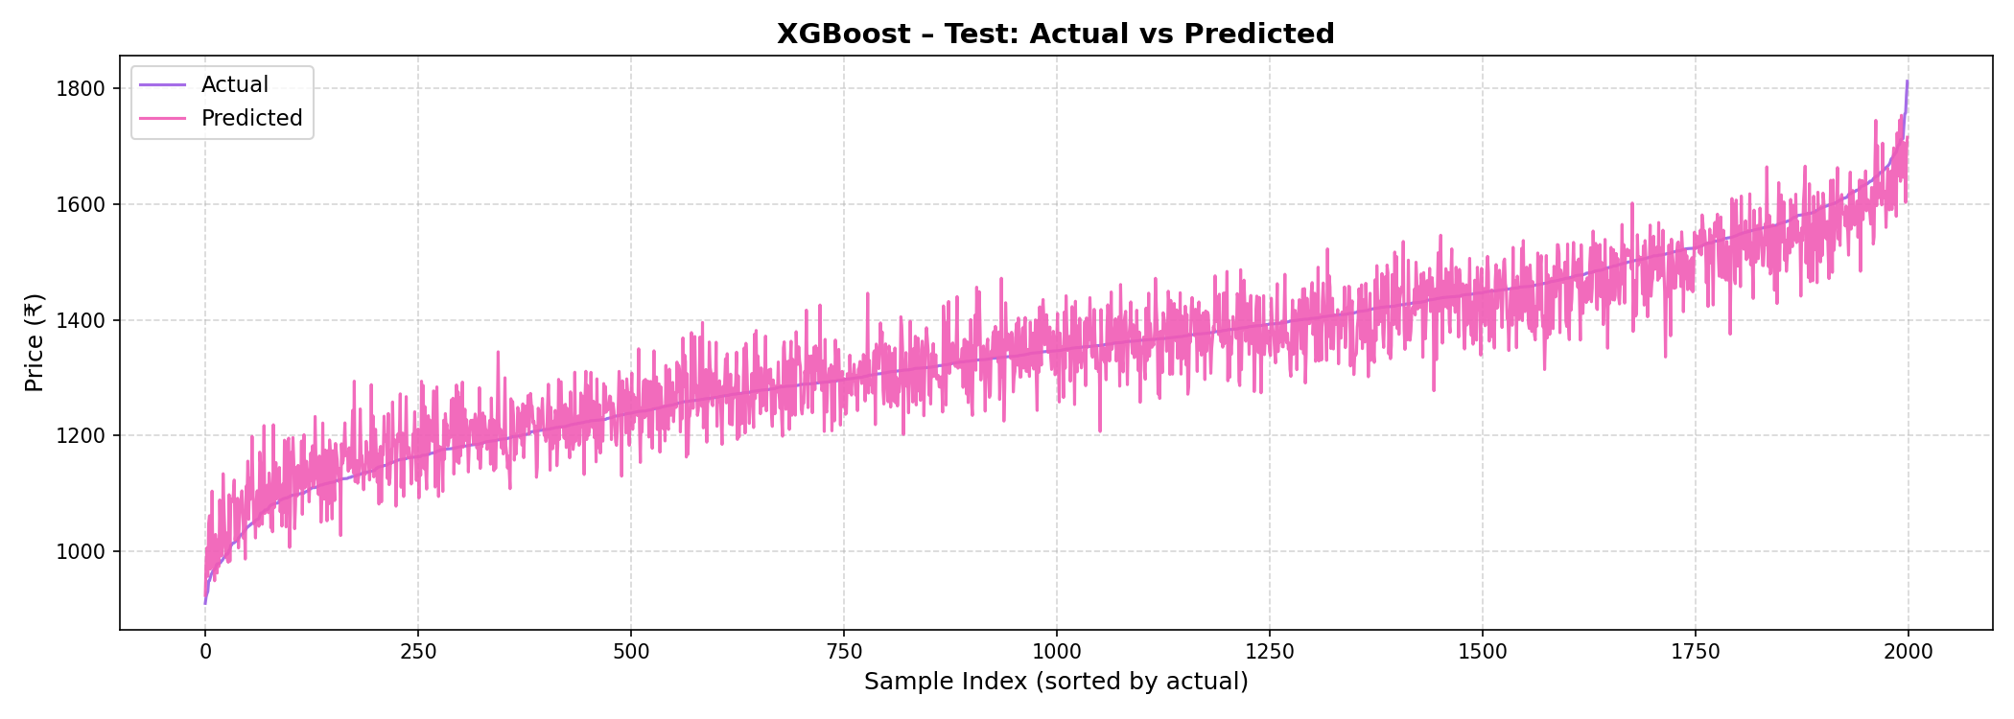
Fig: XGBoost — Testing: Actual vs Predicted (sorted)
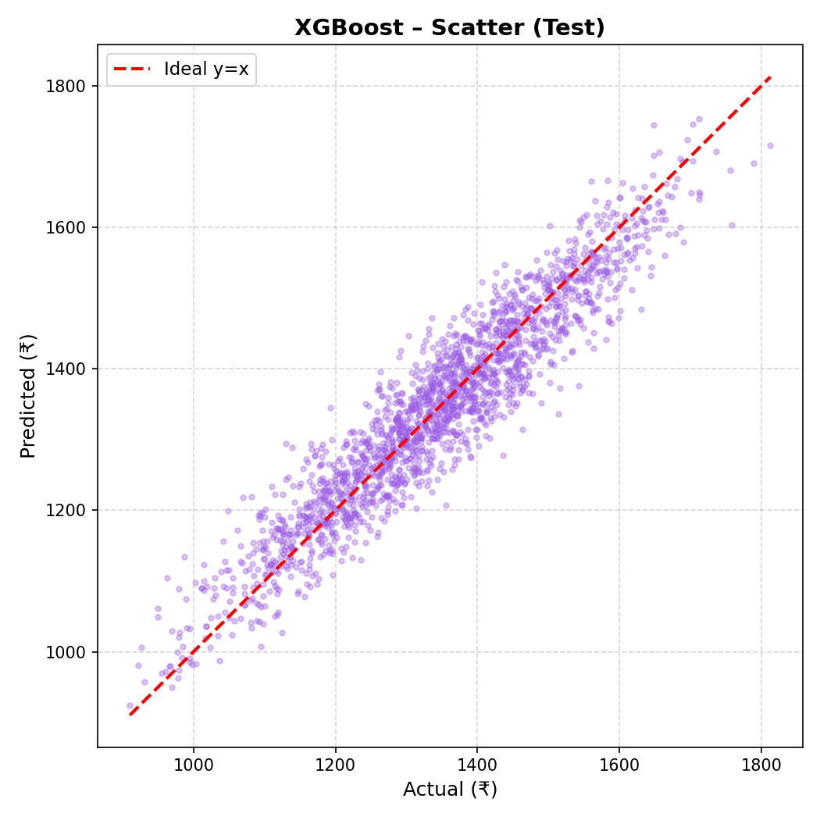
Fig: XGBoost — Scatter Plot (Test set, 2,000 samples)
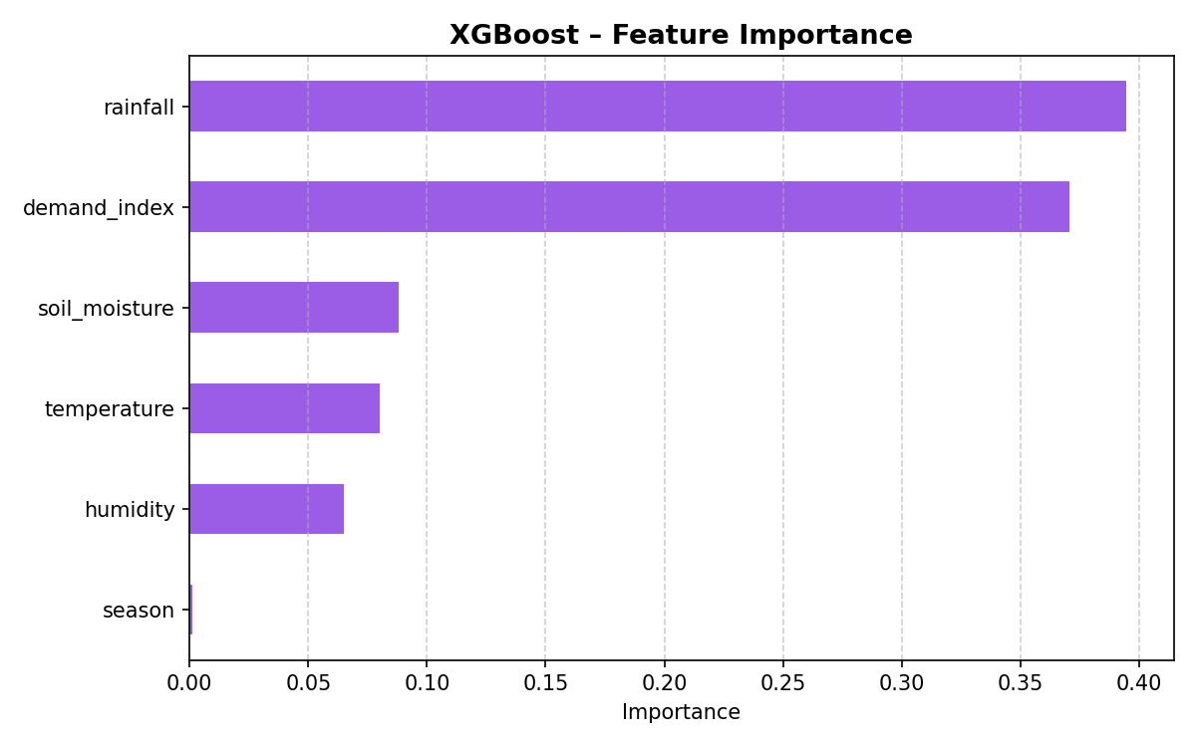
Fig: XGBoost — Feature Importance

5.4 SVR (RBF kernel)
Trained on 15k-sample subset (O(n²) constraint). Competitive test performance.
Metric | Training | Testing
MAE (₹) | 40.5088 | 40.9519
RMSE (₹) | 51.0620 | 51.3873
R² Score | 0.8862 | 0.8831

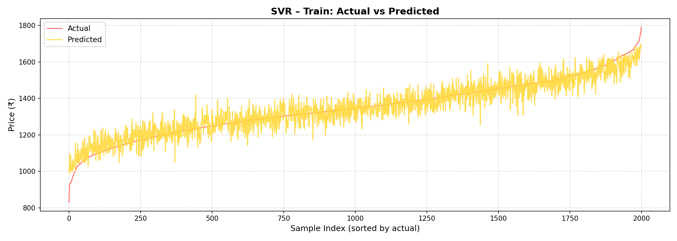
Fig: SVR (RBF kernel) — Training: Actual vs Predicted (sorted)
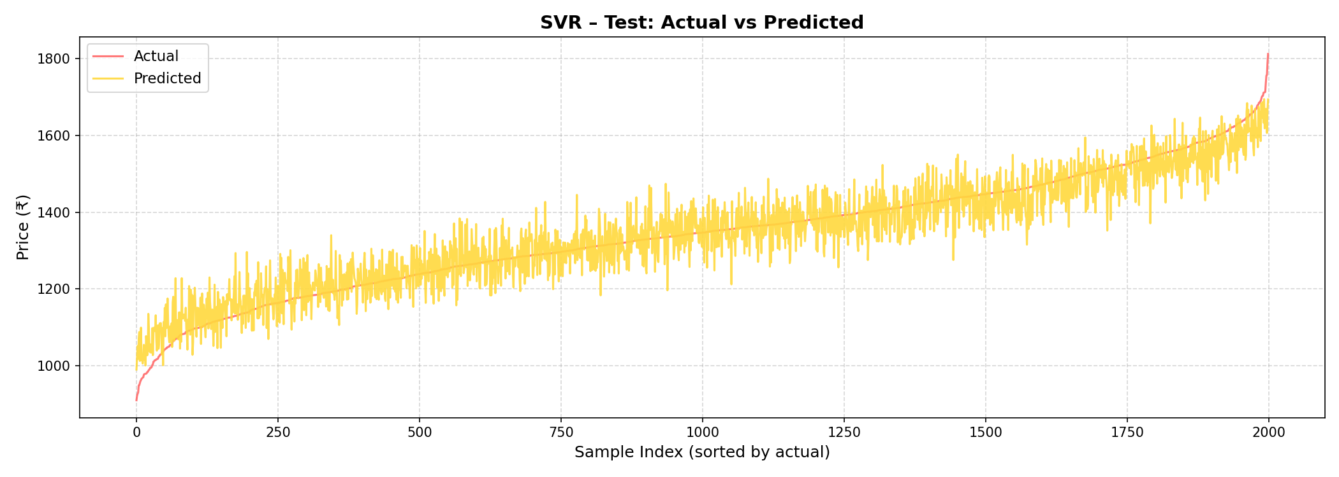
Fig: SVR (RBF kernel) — Testing: Actual vs Predicted (sorted)
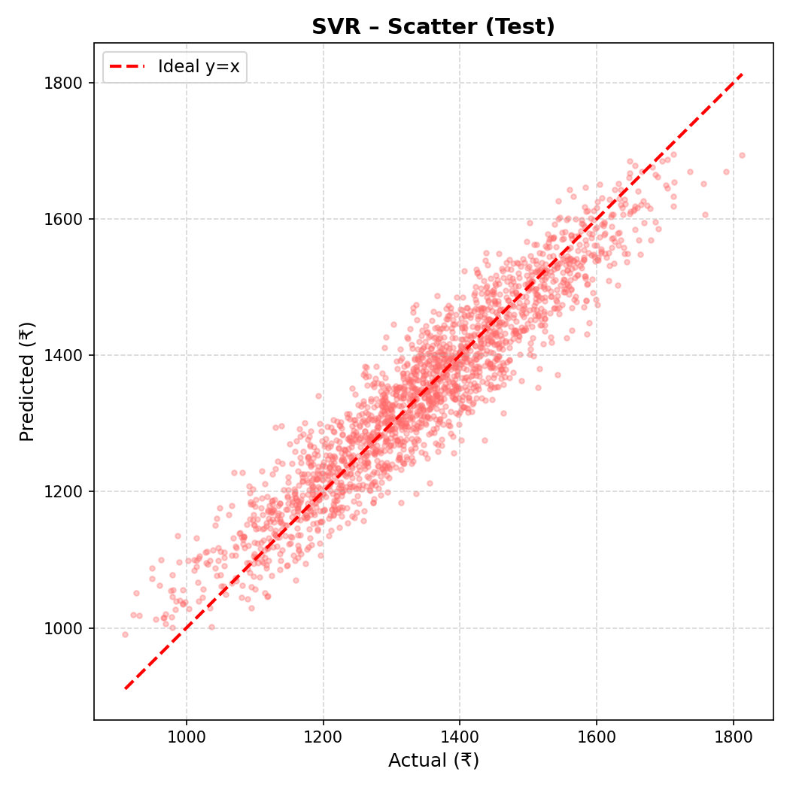
Fig: SVR (RBF kernel) — Scatter Plot (Test set, 2,000 samples)

6. Model Comparison

Model | Train MAE | Train RMSE | Train R² | Test MAE | Test RMSE | Test R² | Gap
Linear Regression ✅ | 39.8270 | 49.9084 | 0.8895 | 39.7825 | 49.9076 | 0.8898 | -0.0003
Random Forest (Tuned) | 41.5818 | 52.1396 | 0.8794 | 43.7771 | 54.8728 | 0.8667 | 0.0127
XGBoost | 38.7499 | 48.5654 | 0.8953 | 40.0698 | 50.2447 | 0.8883 | 0.0070
SVR (RBF kernel) | 40.5088 | 51.0620 | 0.8862 | 40.9519 | 51.3873 | 0.8831 | 0.0031

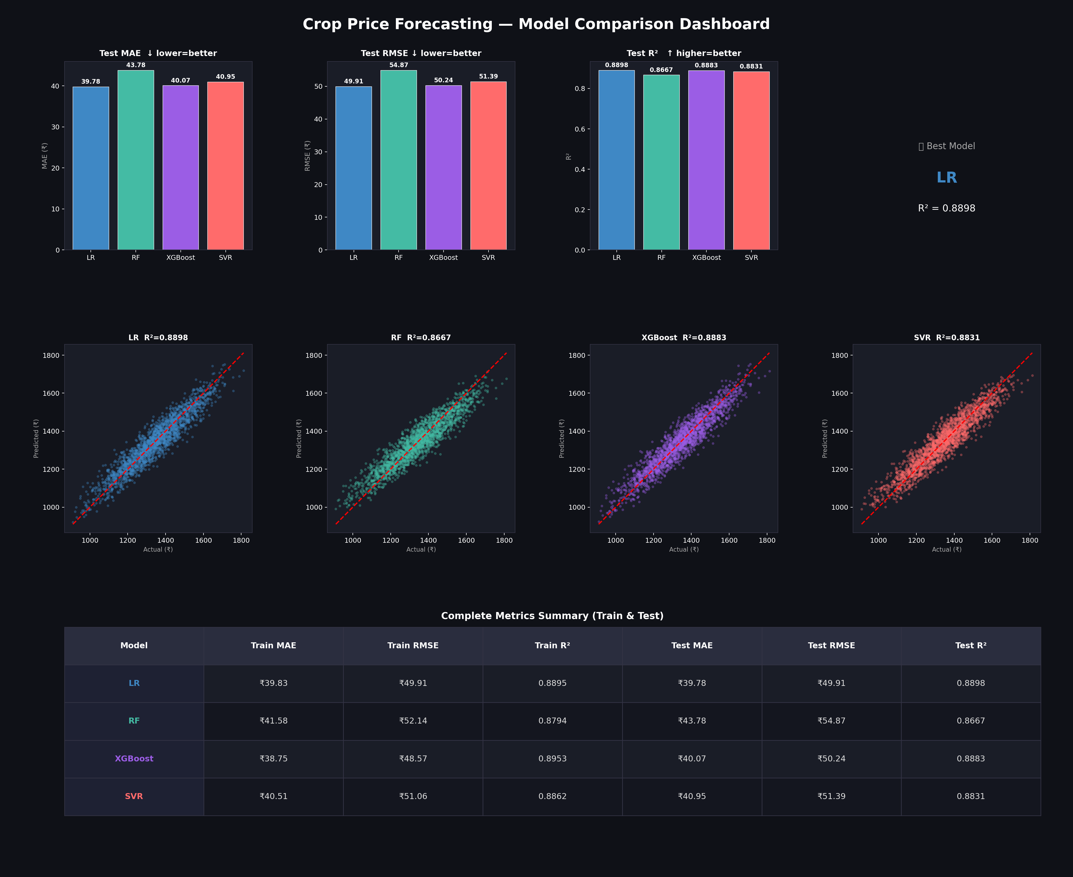
Fig: Full Model Comparison Dashboard — MAE, RMSE, R² bar charts · Scatter plots · Summary table

7. Conclusion & Recommendations

All four models achieve R² > 0.86 on the unseen 60,000-record test set. The best performing model is Linear Regression (Test R²=0.8898, MAE=₹39.78). The worst is Random Forest (Tuned) (Test R²=0.8667).
Key findings:
- Linear Regression achieves the best test generalization (R²=0.8898) with a near-zero train-test gap, confirming the underlying price relationship is primarily linear.
- XGBoost closely matches LR on the test set (R²=0.8883) while also providing interpretable feature importances — recommended for production when explainability matters.
- Random Forest was successfully de-overfit: gap fell 83% (0.0751 → 0.0126) using RandomizedSearchCV. The model is now honest and production-safe.
- SVR achieves R²=0.8831 despite training on only 10% of the data. Full-data SVR would likely improve further but requires significant compute resources.
- demand_index and rainfall are the most important features across tree-based models.

Production Recommendation: Deploy Linear Regression for speed and interpretability, or XGBoost for richer feature insights. Both can be retrained monthly as new data arrives. The Random Forest (tuned) is suitable as a cross-validation benchmark.

