HARDWARE BUILD LOGBOOK
Custom Differential-Drive Wheeled Mobile Robot (WMR)
Project: A Lightweight Fusion-based Approach for Autonomous Indoor Boundary Mapping
Author: Nilay Mande, Keshav Kr Singh, Jinesh Machchhar, and Narendra Kumar Dhar
1. Objective
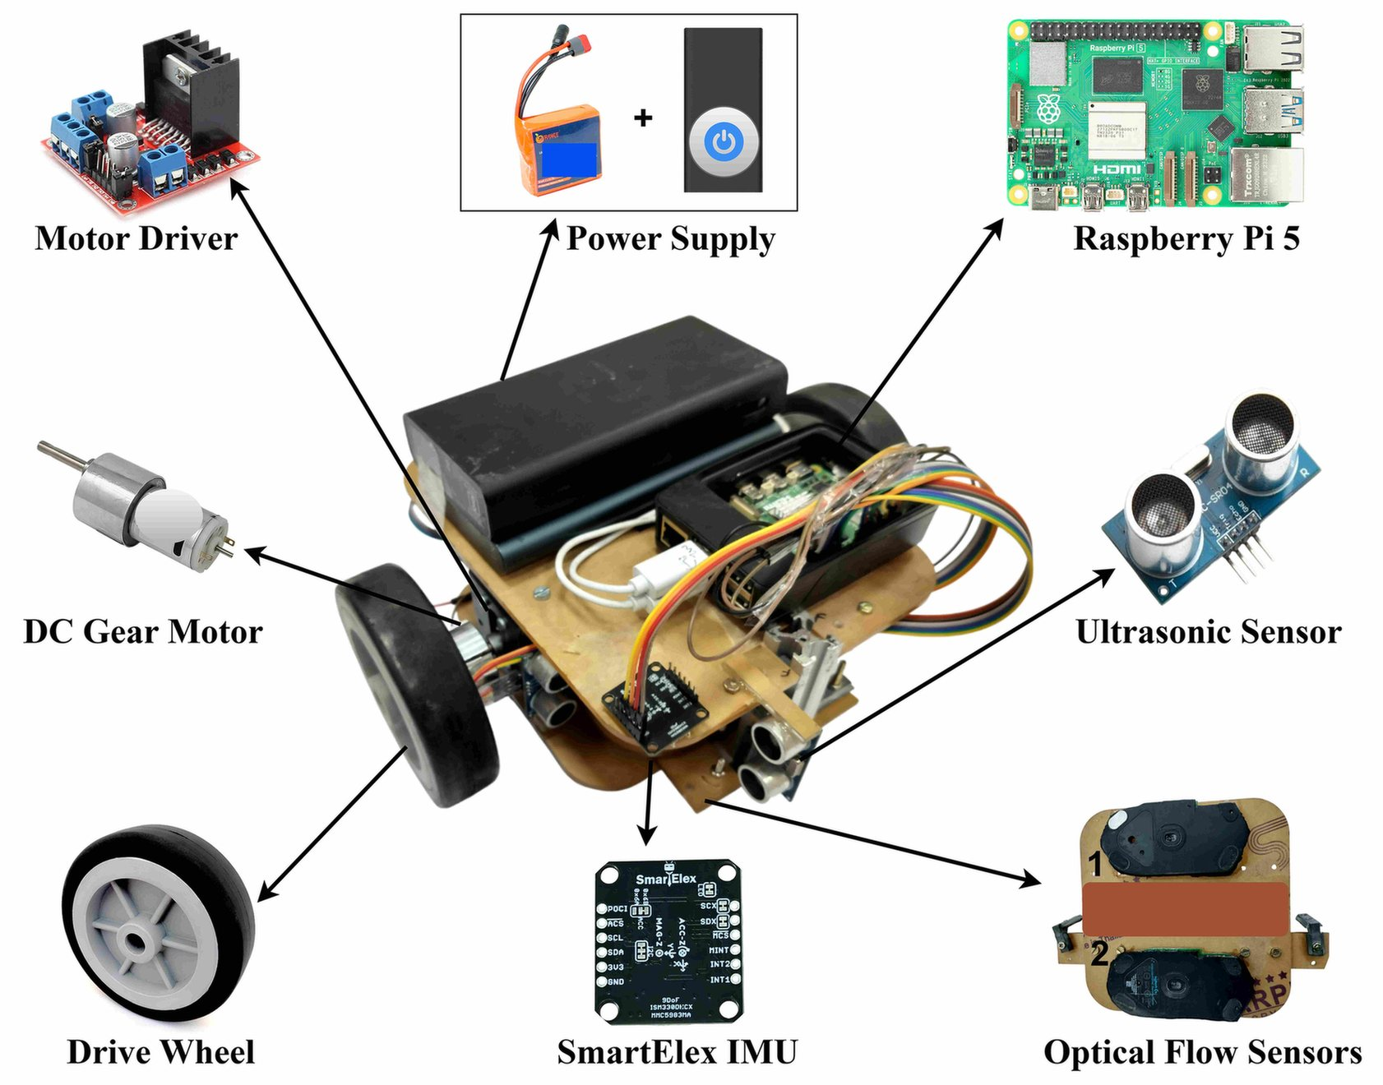
This logbook documents the design and construction of a custom-built wheeled mobile robot (WMR) developed for low-cost indoor boundary mapping. The platform utilizes dual optical flow odometry, a MEMS gyroscope, and ultrasonic ranging on a single onboard controller, enabling high-frequency dead reckoning and wall-following navigation under strict cost and compute constraints.

Figure 1. Custom-built WMR with all hardware components labeled.

2. Materials
Component | Specification | Qty | Function
Chassis | Acrylic plate | 1 | Compact mounting for all mechanical and electronic parts
Onboard computer | Raspberry Pi 5 | 1 | Sensor polling, data logging, actuation, 100 Hz fusion
Motor driver | L298N dual H-bridge | 1 | Receives PWM from Pi 5, drives the two motors
Drive motors | DC gear motors | 2 | Differential drive, forward motion, and steering
Power | 11.1 V Li-ion battery + switch | 1 | System power via integrated power switch
Optical flow | USB optical mouse sensors, 8000 DPI | 2 | Planar displacement (OFS1, OFS2) for dead reckoning
OFS mount | Shared acrylic plate (underside) | 1 | Near-constant ground contact, and baseline d = 99.51 mm
Gyroscope (IMU) | SmartElex ISM330DHCX | 1 | Continuous yaw rate is fused to reduce rotational drift
Range sensors (Ultrasonic) | HC-SR04 ultrasonic | 4 | Front, rear, and lateral ranging for wall following & mapping
3. Mechanical Assembly
- Locomotion: two DC gear motors mounted on a rigid base plate in a differential-drive configuration. Forward motion and steering are achieved through differential speed control.
- Optical flow unit: OFS1 and OFS2 are fixed to a shared acrylic plate on the chassis underside in near-constant ground contact. Reference points are separated by a caliper-measured baseline d = 99.51 mm, with the sensing x-axis aligned to the robot's forward direction.
- Perception sensors: The ISM330DHCX IMU is rigidly mounted on the chassis. HC-SR04 units face the front, rear, and lateral sides for wall following and boundary-point extraction.
4. Electrical and Wiring
- Actuation: Raspberry Pi 5 GPIO supplies PWM and direction signals to the L298N dual H-bridge, whose outputs drive the two DC motors.
- Power: The 11.1 V Li-ion battery powers the motor supply via an integrated switch, with a regulated 5 V rail powering the sensors, while a power bank supplies power to the Raspberry Pi 5.
- Sensor interfaces: OFS1/OFS2 via USB, the ISM330DHCX via I²C, and the HC-SR04 trigger/echo lines via GPIO.
5. Software, Data Logging, and Calibration
- Fusion and logging: the Pi 5 polls all sensors and logs timestamped data. Optical-flow displacement and gyroscopic yaw rate are fused at 100 Hz (Δt = 0.01 s). Poses and projected boundary points are stored for offline trajectory reconstruction.
- Per-trial calibration: OFS scale factors are obtained as s = C_avg / d_s by translating the sensors on a uniform section of the test surface. Two fixed end points (mechanical stoppers) were positioned at a precisely measured distance (d_s) apart. The sensors were repeatedly moved between these stoppers, ensuring that each traversal covered the same known distance along a reference flat vertical surface. Multiple trials were conducted, and the corresponding sensor counts were recorded to determine the average number (C_avg) of units measured.
- The gyroscope bias b is estimated under stationary conditions before each run, and the OFS baseline d is measured using callipers.
6. Build Log
Build phase | Activity
Mechanical | Assembled base plate, mounted DC gear motors in differential layout, fitted drive wheels and caster, attached OFS acrylic plate to underside.
Electrical | Wired Pi 5 to L298N (PWM + direction), connected motor outputs, battery, and power switch, and verified 5 V rail and motor actuation.
Sensors | Integrated OFS1/OFS2 (USB), ISM330DHCX (I²C), and HC-SR04 array (GPIO), and confirmed polling and 100 Hz logging.
Calibration | Measured OFS baseline (99.51 mm), computed per-axis scale factors, and estimated gyro bias under stationary conditions.

