INTERNSHIP REPORT
ON

Shop Management System
(Front-End Development)

Submitted By
Process Rimal
Roll No: 29995/078
TU Registration No: 5-2-1194-18-2021

Submitted To
Department of Computer Science and Information Technology
Lumbini ICT Campus
Tribhuvan University

In partial fulfillment of the requirements for the degree of
Bachelor of Science in Computer Science and Information Technology (B.Sc. CSIT)

February 2026

MENTOR’S RECOMMENDATION FROM COMPANY

SUPERVISOR’S RECOMMENDATION
I hereby recommend that this internship report prepared by Process Rimal (29995/078) on “Frontend Web Development on Shop Management System” under my supervision in partial fulfillment of the requirement for the Degree of BSc. in Computer Science and Information Technology, be processed for evaluation. In my best knowledge, this is an original work in Computer Science.

……………………..
Er. Pukar Neupane
(Internship Supervisor)
Lumbini ICT Campus

CERTIFICATION OF APPROVAL

ACKNOWLEDGEMENT
I would like to express my sincere gratitude to all the individuals and organizations that have supported me throughout my internship journey. First and foremost, I am deeply thankful to LVF Technology for providing me with this valuable opportunity to apply my academic knowledge in a real-world setting.
I am equally grateful to my academic supervisor, Er. Pukar Neupane, for his supervision
and academic guidance. His insights and recommendations were instrumental in shaping
this report and ensuring its successful completion. I would also like to express my sincere
appreciation to the coordinator, Er. Mod Nath Acharya, and the Principal, Mr. Pratap
Koirala, for their guidance, institutional support, and for facilitating the academic
framework that made this internship possible.
I am also grateful to the entire development team for their cooperation, knowledge sharing, and team spirit which made the internship experience both productive and enjoyable.
Special thanks to the Department of Computer Science and Information Technology, Lumbini ICT Campus, Tribhuvan University, for organizing the internship program as a core component of the B.Sc. CSIT curriculum. The internship program has been an exceptional bridge between theoretical learning and practical application. Lastly, my sincere thanks extend to all the staff at LVF Technology, who provided unwavering assistance and administrative, technical, and statistical aspects related to this study.
Process Rimal
(29995/078)

ABSTRACT
This report presents a comprehensive account of the internship activities undertaken at LVF Technology during October 10, 2025 to January 10, 2026. The internship focused primarily on front-end development for a Shop Management System (SMS), a full-featured, multi-tenant retail management platform built using Django and Bootstrap 5.
The Shop Management System is designed to streamline retail operations by providing a centralized platform for managing sales, inventory, customers, vendors, and staff. The system supports multiple user roles including Super Admin, Shop Owner, Vendor, Staff, and Regular Users, each with role-specific dashboards and access controls.
During the internship, the primary front-end responsibilities included designing and implementing HTML/CSS/JavaScript templates using Django's templating engine, building a real-time Point of Sale (POS) interface with barcode scanning capabilities, developing an inventory management UI with dynamic filtering and search, creating a customer relationship management (CRM) interface, and implementing an analytics dashboard. Bootstrap 5 was used as the primary CSS framework, supplemented by custom CSS properties and vanilla JavaScript for dynamic behavior.
The internship provided a practical learning environment to apply academic knowledge in UI/UX design, responsive web development, and JavaScript DOM manipulation. It also fostered professional skills in team collaboration, version control using Git, and following software development best practices.

TABLE OF CONTENTS
ACKNOWLEDGEMENT 5
ABSTRACT 6
LIST OF TABLES 9
LIST OF FIGURES 10
LIST OF ABBREVIATIONS 11
CHAPTER 1: INTRODUCTION 12
1.1 Introduction 12
1.2 Problem Statement 12
1.3 Objectives 13
1.3.1 Objectives of internship 13
1.4 Scope and Limitations 13
1.4.1 Scope: 13
1.4.2 Limitations: 13
1.5 Report Organization 14
CHAPTER 2: ORGANIZATIONAL DETAILS AND LITERATURE REVIEW 15
2.1 Introduction to Organization 15
2.2 Organization Hierarchy 15
16
2.3 Working Domains of Organization 16
2.4 Description of Intern Department 17
2.5 Literature Review 17
2.5.1 Web-Based Retail Management Systems 17
2.5.2 Front-End Frameworks and Technologies 18
2.5.3 Point of Sale (POS) UI Design 18
2.5.4 Barcode Scanning in Web Applications 18
2.5.6 Multi-Tenant Architecture 19
CHAPTER 3: INTERNSHIP ACTIVITIES 20
3.1 Roles and Responsibilities 20
3.2 Weekly Logs 21
3.3 Description of the Project 22
3.3.1 Key Features of the Front-End 25
3.4 Tasks/Activities Performed 27
CHAPTER 4: CONCLUSION AND LEARNING OUTCOMES 28
4.1 Conclusion 28
4.2 Learning Outcomes 29
REFERENCES 31
APPENDIX 32

LIST OF TABLES
Table 1: Contact Details of Company 14
Table 2: Internship Details 16
Table 3:Week;y Log 20
Table 4: System Modules and Their Descriptions 22
Table 5: Frontend Pages and Key Features 23

LIST OF FIGURES
Figure 1: Organization Hierarchy of the Company 15
Figure 2: Dashboard / Home Page 31
Figure 3: Point of Sale (POS) Interface 31
Figure 4:Inventory / Products List Page 32
Figure 5: Customer Management Page 32
Figure 6: Sales History Page 33
Figure 7: Login Page 33

LIST OF ABBREVIATIONS
SMS – Shop Management System
POS – Point of Sale
CRM – Customer Relationship Management
HTML – HyperText Markup Language
CSS – Cascading Style Sheets
JS – JavaScript
UI – User Interface
UX – User Experience
API – Application Programming Interface
CRUD – Create, Read, Update, Delete
CSRF – Cross-Site Request Forgery
SKU – Stock Keeping Unit
QR – Quick Response
CSIT – Computer Science and Information Technology
TU – Tribhuvan University
MVC – Model-View-Controller
DOM – Document Object Model
REST – Representational State Transfer
MVT – Model-View-Template
SSR – Server-Side Rendering

CHAPTER 1: INTRODUCTION

1.1 Introduction
The rapid advancement of digital technologies has transformed how businesses manage their daily operations. Retail businesses, in particular, have seen a significant shift from manual record-keeping and cash-register-based systems to sophisticated, software-driven platforms that integrate sales, inventory, customer relationship management, and financial reporting into a single unified system.
The Shop Management System (SMS) is one such platform — a web-based, multi-tenant retail management solution developed to simplify and automate the core operational tasks of a retail shop. The system supports various roles such as Super Admin, Shop Owner, Vendor, Staff, and Regular Users, providing each with customized dashboards and access to relevant features.
This internship, undertaken at LVF Technology (Gaidakot-4, Nawalpur), involved contributing to the front-end development of the SMS project. The work encompassed designing and implementing user interfaces for all major modules including the Point of Sale (POS) system, inventory management, customer management, sales reporting, and staff management. The front-end was built using Django's server-side templating engine with HTML5, CSS3 (Bootstrap 5), and Vanilla JavaScript.

1.2 Problem Statement
Small to medium-sized retail businesses in Nepal frequently rely on manual processes or disconnected software tools for managing their sales, inventory, and customer data. This leads to inefficiencies such as stock discrepancies, delayed reporting, difficulty in tracking customer credit, and the inability to generate reliable business insights.
Furthermore, existing systems often lack intuitive user interfaces, making them difficult to adopt for staff who are not technically proficient. The challenge, therefore, is to develop a front-end interface that is clean, intuitive, and functional — one that reduces the learning curve while providing comprehensive management capabilities.
The SMS front-end addresses these challenges by offering a modern, responsive, and role-aware user interface that allows shop staff to efficiently manage sales, track inventory, handle customer records, and view business analytics — all within a single browser-based application.

1.3 Objectives

1.3.1 Objectives of internship
The primary objectives of the internship are as follows:
- To design and implement a clean, responsive front-end for the Shop Management System using HTML5, CSS3, Bootstrap 5, and JavaScript.
- To build a fully functional Point of Sale (POS) interface supporting barcode scanning, cart management, and multiple payment methods.
- To develop an inventory management UI with product listing, filtering, search, stock-level indicators, and CRUD operations.
- To implement a customer relationship management (CRM) interface for managing regular and walk-in customers including credit tracking.
- To create a sales management module covering transaction history, returns, cancellations, and receipt generation.
- To build role-specific dashboards with relevant KPIs for shop owners, staff, and super administrators.
- To ensure the UI is accessible, consistent, and follows modern web design principles across all pages of the system.

1.4 Scope and Limitations

1.4.1 Scope:
- Full front-end implementation of all major modules: POS, Inventory, Customers, Sales, Reports, Vendors, Staff, and Authentication.
- Responsive design compatible with desktop and tablet screen sizes.
- Integration of the front-end with Django back-end APIs for dynamic data rendering.
- Support for real-time cart operations, barcode scanning (via Quagga.js), and QR code display for payment.
- Role-based UI rendering that adjusts available features depending on the logged-in user's role.

1.4.2 Limitations:
- The front-end is server-side rendered via Django templates; a full single-page application (SPA) approach was not used.
- Advanced data visualization charts (e.g., trend graphs) were not included in the current scope.
- Offline functionality and progressive web app (PWA) features were not implemented.
- The front-end was primarily tested on desktop browsers; full mobile optimization requires further testing.

1.5 Report Organization
This report is organized into the following chapters:
- Chapter 1 – Introduction: Provides background, problem statement, objectives, scope, and limitations.
- Chapter 2 – Organizational Details and Literature Review: Describes the internship organization and relevant background research.
- Chapter 3 – Internship Activities: Details roles, weekly activities, project description, and tasks performed.
- Chapter 4 – Conclusion and Learning Outcomes: Summarizes experience, outcomes, and professional growth.
- References: Lists all cited sources in APA format.
- Appendix: Contains UI screenshots of the implemented system.

CHAPTER 2: ORGANIZATIONAL DETAILS AND LITERATURE REVIEW

2.1 Introduction to Organization
LVF Technology is a software development and IT solutions company located at Gaidakot-4, Nawalpur. The organization specializes in custom software development, web application development, and retail technology solutions. Founded in 2018, the company has established itself as a trusted technology partner for businesses seeking digital transformation solutions in the region.
The organization provides a collaborative environment for interns and junior developers, offering hands-on experience with real-world software projects. During the internship, the intern was placed under the mentorship of Er. Pukar Neupane, who served as both technical mentor and project supervisor.
Table 1: Contact Details of Company
Company Name: | LVF Technology
Address: | Gaidakot-4, Nawalpur, Nepal
Contact:
Mail:
Website:
Opening Hours: | 9am – 5pm

2.2 Organization Hierarchy
The organization ranks employees at various levels, each level is one above the other. Dreamwork comprises an administrative team along with interns, junior and senior programmers and web designers.
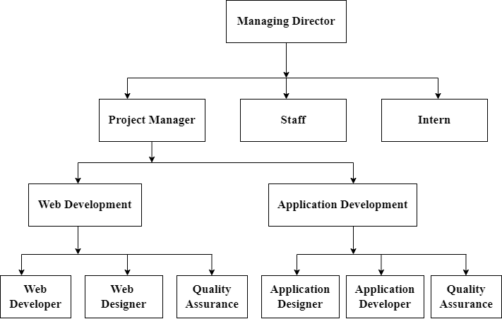
Figure 1: Organization Hierarchy of the Company

CEO: The CEO is responsible for carrying out existing plans and policies, improving the company's finances, supporting digital business changes, and planning future strategies.
HR: HR handles the employee life cycle, including recruiting, hiring, onboarding, training, and firing employees, as well as managing employee benefits.
Project Manager: The project manager oversees the daily management of the project, handling the scope, schedule, budget, risks, quality, and resources.
Project Leader: A project leader guides the team and ensures the project is completed successfully.
Team Leader: A team leader provides direction and instructions to the group working on a project or several projects.
Developer: Developer designs and builds the application.
Interns: Interns focus on learning, fixing small bugs, and performing tasks like testing, adding new features/functionalities and fixing design issues. They are involved in almost all areas of the project.

2.3 Working Domains of Organization
LVF Technology works across the following technology domains:
- Web Application Development: Building full-stack web applications using Django, React, and related frameworks.
- Retail Technology Solutions: Developing POS systems, inventory management, and e-commerce platforms.
- Database Design and Management: Designing relational databases using PostgreSQL, MySQL, and SQLite.
- API Development: Building RESTful APIs for integration with front-end applications and third-party services.

2.4 Description of Intern Department
The internship was carried out within the Software Development Department at LVF Technology, specifically within the front-end sub-team working on the Shop Management System project. The intern's immediate team consisted of the project supervisor Er. Pukar Neupane, one senior developer, and one additional intern. Daily tasks were assigned through team stand-up meetings, and progress was tracked using version control (Git) and project management tools.
Table 2: Internship Details
Start Date: | 10th October, 2025
End Date: | 10th January, 2026
Total Duration: | 3 months
Position: | Intern as a Frontend Web Developer
Mentor: | Er.
Office Hour: | 9am – 5pm

2.5 Literature Review

2.5.1 Web-Based Retail Management Systems
Modern retail management has increasingly moved towards web-based systems that offer real-time data access from any device with a browser. According to various studies in retail technology, web-based POS and inventory systems outperform traditional desktop-only applications in terms of flexibility, cost of maintenance, and scalability (Brown & Whitman, 2020). The shift toward cloud and web-based platforms has enabled small and medium enterprises (SMEs) to leverage enterprise-grade tools without heavy upfront investment.

2.5.2 Front-End Frameworks and Technologies
The selection of appropriate front-end technologies is critical to building maintainable and performant web applications. Bootstrap 5, released by the Bootstrap team (2021), is one of the most widely adopted CSS frameworks for responsive web design. Its grid system, pre-built components, and utility classes significantly reduce development time while ensuring cross-browser compatibility.
Django's templating engine provides a robust server-side rendering (SSR) mechanism that allows developers to render dynamic HTML on the server before sending it to the client. This approach improves initial page load performance and is highly SEO-friendly compared to client-side rendering frameworks (Django Documentation, 2023).

2.5.3 Point of Sale (POS) UI Design
A well-designed POS interface is essential for efficient retail operations. Studies in HCI (Human Computer Interaction) highlight that POS systems should minimize the number of interactions required to complete a transaction, provide clear visual feedback, and support both touch and keyboard/mouse input (Nielsen, 1994). The SMS POS interface was designed with these principles in mind, incorporating a split-panel layout with a product search area and a live cart panel.

2.5.4 Barcode Scanning in Web Applications
Browser-based barcode scanning has become possible with the advancement of the Web API specifications, particularly the MediaDevices API which allows web applications to access the device camera. Libraries such as Quagga.js (Ericsson, 2014) provide JavaScript-based barcode detection supporting Code 128, EAN, and UPC formats. Integrating camera-based scanning into the POS system eliminates the need for dedicated hardware barcode scanners, making the system more accessible and cost-effective for small retailers.

2.5.5 Responsive Design and Accessibility
Responsive web design, as introduced by Marcotte (2010), is the practice of building web pages that adapt their layout and content presentation based on the screen size of the viewing device. For a retail management system used on various devices (desktops, tablets, and occasionally mobile phones), responsive design ensures a consistent user experience. The use of CSS custom properties (variables) allows for centralized theming and easy maintenance of the design system across all pages.

2.5.6 Multi-Tenant Architecture
Multi-tenancy is a software architecture pattern where a single instance of an application serves multiple tenants (organizations or users), with data isolation between tenants (Bezemer & Zaidman, 2010). The SMS uses a multi-tenant architecture to support multiple vendors/shop owners on a single platform. From a front-end perspective, this manifests as role-specific dashboards and conditional UI rendering based on the authenticated user's tenant and role.

CHAPTER 3: INTERNSHIP ACTIVITIES

3.1 Roles and Responsibilities
As a front-end development intern at LVF Technology working on the Shop Management System, the following roles and responsibilities were assigned by supervisor Er. Pukar Neupane:
- UI Design and Implementation: Designing and coding all HTML/CSS/JavaScript templates for every major module of the system, following the project's design system and Bootstrap 5 conventions.
- POS Interface Development: Building the real-time Point of Sale interface with client-side cart management, barcode scanning integration (Quagga.js), and multi-payment-method support.
- Template Integration with Django: Ensuring all front-end templates correctly integrate with Django's back-end context variables, URL routing, and form handling (including CSRF tokens).
- Responsive Design: Implementing responsive layouts using Bootstrap 5 grid and CSS media queries to ensure usability across desktop and tablet devices.
- JavaScript Functionality: Writing Vanilla JavaScript for dynamic UI behavior including cart operations, real-time total calculation, DOM manipulation, form validation, and toast notifications.
- Component Consistency: Maintaining visual and functional consistency across all 62+ templates by extending a base template (base.html) with shared navigation, sidebar, and footer components.
- Bug Fixing and Code Review: Identifying and resolving UI bugs, participating in code reviews, and incorporating feedback from the senior developer.
- Version Control: Using Git for source control, committing code regularly with meaningful commit messages, and collaborating with the backend team via feature branches.

3.2 Weekly Logs
Table 3:Week;y Log
Week | Start Date | End Date | Activities
Week 1 | 10 Oct 2025 | 17 Oct 2025 | Attended orientation, understood the SMS project requirements and architecture. Set up development environment (VS Code, Python/Django, Git).
Week 2 | 18 Oct 2025 | 24 Oct 2025 | Studied Bootstrap 5 components and Django templating. Created base.html master template with sidebar navigation, top bar, and design tokens (CSS variables). Implemented login and authentication pages.
Week 3 | 25 Oct 2025 | 31 Oct 2025 | Developed the main Dashboard page with statistics cards (Products, Today's Sales, Customers, Low Stock) and Quick Actions section.
Week 4 | 1 Nov 2025 | 7 Nov 2025 | Built the Inventory module front-end: Products List page with image thumbnails, color-coded stock badges, search and filter system. Implemented product add, edit, and delete confirmation pages.
Week 5 | 8 Nov 2025 | 14 Nov 2025 | Developed Category management pages (list, add, edit, delete). Started work on the POS interface.
Week 6 | 15 Nov 2025 | 21 Nov 2025 | Completed POS interface: implemented client-side cart with add/remove/quantity controls, real-time total calculations, discount system, and three payment methods (Cash, QR, Credit). Added Quagga.js barcode scanning.
Week 7 | 22 Nov 2025 | 28 Nov 2025 | Built Customers module: customer list with search/filter/sort, customer add/edit/delete forms, customer detail view, credit tracking. Implemented walk-in (IR) customer support with separate table.
Week 8 | 29 Nov 2025 | 5 Dec 2025 | Developed Sales module: sales history list, sales detail view, sales edit/return/cancel pages. Implemented receipt template for printing.
Week 9 | 6 Dec 2025 | 12 Dec 2025 | Created Vendor and Staff management interfaces. Built Staff list, create, edit and delete pages. Implemented Vendor list, add, edit, delete pages. Added changelog and activity log pages.
Week 10 | 13 Dec 2025 | 19 Dec 2025 | Implemented Tenant/Super Admin module: superadmin dashboard with vendor statistics, vendor detail, create vendor, activate/deactivate vendor, reset vendor password, and delete vendor pages.
Week 11 | 20 Dec 2025 | 26 Dec 2025 | Performed cross-browser testing and responsive design fixes. Resolved UI inconsistencies across pages.
Week 12 | 27 Dec 2025 | 10 Jan 2026 | Final review and bug fixes. Documented the UI component library and template structure. Prepared internship report and conducted final demo of the completed front-end to the supervisor.

3.3 Description of the Project
The Shop Management System (SMS) is a comprehensive, multi-tenant web application designed to streamline the operations of retail shops. The system is built on the Django framework (Python) with a server-side rendered front-end using Django templates, HTML5, CSS3 (Bootstrap 5), and Vanilla JavaScript. The platform supports multiple user roles and provides each with a tailored interface for their specific responsibilities.
System Architecture Overview:
The SMS follows the Django MVT (Model-View-Template) architectural pattern. The front-end layer consists of 62+ HTML templates organized by module, all extending a common base.html template. The base template defines the global design system through CSS custom properties, includes Bootstrap 5, and provides the sidebar navigation, top bar, and footer used across all pages.
Table 4: System Modules and Their Descriptions
Module | Description
Authentication & Accounts | Multi-role login system supporting Super Admin, Vendor, Staff, and Regular Users with secure session management.
Dashboard & Reports | Role-specific dashboards showing KPIs (total products, today's sales, customer count, low stock alerts) with quick action navigation.
Point of Sale (POS) | Real-time cart-based sales interface with product search, barcode scanning, customer selection, discount application, and multi-payment support.
Inventory Management | Product catalog management with stock tracking, category organization, image upload, barcode/SKU management, and low-stock alerts.
Customer Management (CRM) | Comprehensive customer database supporting regular customers with credit tracking and walk-in (irregular) customers.
Sales Management | Complete sales transaction management including sales history, receipts, returns, cancellations, and credit record management.
Vendor Management | Management of vendor accounts with CRUD operations and permission assignment.
Staff Management | Staff account creation, profile management, and access control within a shop's user hierarchy.
Multi-Tenant System | Super Admin panel for managing multiple vendor tenants with activation, deactivation, and password reset capabilities.
Table 5: Frontend Pages and Key Features
Page / Template | URL | Key Front-End Features
Login | /login/ | Centered card layout, role-based login, error messaging, CSRF-secured form.
Dashboard | / | Stats cards grid, quick action buttons, role-aware content rendering.
POS System | /sales/pos/ | Split-panel layout, live cart, Quagga.js barcode scanner, payment modal, JS DOM manipulation.
Products List | /inventory/products/ | Table with image thumbnails, color-coded stock badges, search/filter bar, category filter buttons.
Product Add/Edit | /inventory/products/add/ | Form with image upload, category dropdown, pricing fields, book-specific fields.
Customer List | /customers/ | Dual tables (regular + walk-in), search/filter with multiple field options, credit badges.
Customer Detail | /customers/<id>/ | Full profile with sales history, credit payment button.
Sales List | /sales/ | Paginated transaction history with status badges, action buttons.
Sales Receipt | /sales/<id>/receipt/ | Printable receipt layout with shop branding, itemized list, totals.
Low Stock Report | /reports/low-stock/ | Filtered product listing showing items below threshold with red/amber indicators.
Superadmin Dashboard | /tenants/superadmin/ | Vendor statistics cards, vendor table with status badges, permission chips.
Staff List | /accounts/staff/ | Staff directory with role badges, action buttons for edit/delete.

3.3.1 Key Features of the Front-End
A. Point of Sale (POS) Interface
The POS interface is the most complex and critical component of the SMS front-end. It consists of a split-panel layout: the left panel houses the product search, customer selection, and payment controls, while the right panel displays the live shopping cart.
- Cart Management: Products are added to a client-side JavaScript cart object. Quantity can be adjusted using +/- buttons, and items can be removed individually. The cart total and item count update in real time.
- Barcode Scanning: Three modes are supported — Manual (type barcode), Camera (Quagga.js library uses the device webcam for real-time scanning), and None. The camera scanner supports Code 128, EAN-13, and UPC-A formats and provides audio feedback (Web Audio API) on successful scan.
- Customer Selection: Users can search for registered customers by name or phone number. Walk-in customers are supported as an alternative. Credit balance is displayed for registered customers.
- Payment Processing: Three payment methods (Cash, QR Code, Credit) are implemented. Cash payment shows a change calculator. QR payment displays the shop's QR code image. Credit payment records the amount owed by the customer.
- Discount System: Supports both fixed (Rs.) and percentage-based discounts applied to the cart total.
- Sale Submission: On checkout, cart data is serialized and sent via a CSRF-protected AJAX POST request to the backend API (/sales/api/create-sale/). Toast notifications confirm success or report errors.

B. Inventory Management Interface
- Products are displayed in a responsive table with image thumbnails (34×34px with fallback placeholder for missing images).
- Stock levels are color-coded: Red (out of stock, ≤0), Amber (low stock, ≤5), Green (in stock, >5).
- A multi-criteria filter bar allows filtering by name, SKU, barcode, category, or price, and sorting by name, price, or stock level.
- Category filter buttons provide one-click filtering by product category.

C. Customer Management Interface
- Two customer types: Regular Customers (with full profile and credit tracking) and Walk-in/Irregular Customers (simplified records).
- Advanced filter bar supporting search across multiple fields (name, phone, email, city, credit amount).
- Credit due amounts are displayed with amber badges; a 'Pay' button appears only for customers with outstanding credit.
- Sorting options include alphabetical (A-Z, Z-A) and credit amount (low-high, high-low).
D. Dashboard and Analytics
- The dashboard presents four KPI cards: Total Products, Today's Sales Revenue, Total Customers, and Low Stock Count.
- Quick action buttons provide one-click navigation to the most common tasks (New Sale, Manage Products, View Customers, Sales History).
- The Super Admin sees a different dashboard with Vendor-focused statistics and a vendor management table.
- Color-coded stat cards use icons and background overlays to indicate the nature of each metric.

3.4 Tasks/Activities Performed
The following tasks were performed throughout the internship period:
- Base Template Construction: Designed and implemented base.html — the master template that all other pages extend. Defined CSS variables (design tokens) for the color palette, spacing, shadows, and border radii. Built the sidebar navigation with active link highlighting, the top bar with page title and user profile dropdown, and responsive layout utilities.
- Authentication Pages: Implemented login pages for all five user roles with a consistent card-based centered layout, gradient branding icon, form validation feedback, and 'Remember Me' functionality.
- Dashboard Implementation: Created the main dashboard with statistics cards, quick action buttons, and role-conditional content rendering using Django template tags.
- POS System Front-End: Wrote 400+ lines of Vanilla JavaScript for the POS module covering cart state management, product addition/removal, quantity updates, barcode scanning integration (Quagga.js), customer search, payment method rendering, discount calculation, and form submission via Fetch API.
- Inventory Module Pages: Built the complete inventory front-end including 8 templates (products list, product add/edit/delete, category list, category add/edit/delete) with consistent design patterns.
- Customer Module Pages: Developed 7 customer-related templates including the dual-table customer list, detailed customer profile page, payment receipt, and CRUD forms.
- Sales Module Pages: Implemented 9 sales templates covering the sales list, sales detail, receipt (print-ready layout), edit, return, cancel, and credit records pages.
- Staff and Vendor Management: Built staff and vendor management interfaces with table listings, add/edit/delete forms, and an inline category creation modal.
- Multi-Tenant Admin Interface: Designed and implemented the super admin pages for vendor management including vendor overview dashboard, creation flow, and status management pages.
- Changelog and Notification System: Implemented the activity changelog page and notification/alert system integrated into the base template's sidebar.
- QR Code Integration: Integrated QR code image display in the POS payment section and on relevant profile/settings pages.
- Cross-Template Consistency and Bug Fixes: Ensured all 62+ templates maintained consistent spacing, typography, and color coding. Fixed layout issues, resolved JavaScript errors in the POS cart logic, and improved error state messaging throughout the application.

CHAPTER 4: CONCLUSION AND LEARNING OUTCOMES

4.1 Conclusion
The internship at LVF Technology successfully provided a real-world environment to apply and deepen the front-end web development knowledge acquired during the B.Sc. CSIT program at Lumbini ICT Campus. Working on the Shop Management System from interface design to full front-end implementation offered a comprehensive view of what professional web development entails — from structuring a coherent design system to integrating JavaScript-driven interactivity with a Django back-end.
The primary goal of building a functional, consistent, and user-friendly front-end for all major modules of the SMS was achieved. The completed front-end includes over 62 fully functional HTML templates covering authentication, dashboard, POS, inventory, customer management, sales management, vendor management, staff management, and multi-tenant administration.
The most technically challenging and rewarding part of the internship was the development of the POS interface, which required writing complex client-side JavaScript for real-time cart management, integrating the Quagga.js barcode scanning library, and implementing a robust payment processing workflow. This experience significantly improved JavaScript proficiency and deepened understanding of how front-end code interacts with back-end APIs.
Overall, the internship under the guidance of Er. Pukar Neupane was an invaluable experience that bridged the gap between the theoretical concepts studied in CSIT and the practical realities of building production-level web applications in a professional team setting.

4.2 Learning Outcomes
The internship at LVF Technology yielded the following key learning outcomes:
Technical Skills: Gained hands-on proficiency in Django template development, Bootstrap 5, CSS custom properties, Vanilla JavaScript (ES6+), DOM manipulation, the Fetch API, Web Audio API, and the Quagga.js barcode library. Learned to integrate front-end templates seamlessly with a Django MVT back-end architecture.
UI/UX Design Principles: Developed a solid understanding of building clean, consistent, and accessible user interfaces. Learned the importance of a design system (color tokens, typography scale, component library) in maintaining consistency across a large number of pages.
JavaScript Programming: Significantly improved JavaScript skills through the implementation of the POS cart system, which required managing application state client-side, handling asynchronous API calls, and manipulating the DOM dynamically in response to user interactions.
Responsive Design: Gained experience in implementing responsive layouts using Bootstrap 5's grid system and CSS media queries, ensuring the application adapts correctly to different screen sizes used in a retail environment.
Version Control with Git: Improved proficiency in Git for daily version control — committing work regularly, writing clear commit messages, working with branches, and collaborating with team members through a shared repository.
Professional Work Culture: Experienced the realities of working on a professional software project including participating in stand-up meetings, receiving and giving code review feedback, meeting deadlines, and communicating progress to the supervisor.
Problem-Solving: Developed problem-solving skills through debugging complex JavaScript issues in the POS module, resolving layout inconsistencies across pages, and finding solutions to integration challenges between the front-end templates and Django back-end context data.
Project Understanding: Gained a broad understanding of full-stack web application architecture, understanding how the front-end, back-end, database, and API layers interact, even while working primarily on the front-end layer.

REFERENCES
Bootstrap Team. (2021). Bootstrap 5.0: The world's most popular CSS framework. https://getbootstrap.com/docs/5.0/
Bezemer, C., & Zaidman, A. (2010). Multi-tenant SaaS applications: Maintenance dream or nightmare? In Proceedings of the Joint ERCIM Workshop on Software Evolution.
Django Software Foundation. (2023). Django documentation: Templates. https://docs.djangoproject.com/en/4.2/topics/templates/
Ericsson, E. (2014). Quagga.js: Barcode-scanner entirely written in JavaScript. https://github.com/ericblade/quagga2
Marcotte, E. (2010). Responsive web design. A List Apart. https://alistapart.com/article/responsive-web-design/
Mozilla Developer Network. (2023). MediaDevices API. https://developer.mozilla.org/en-US/docs/Web/API/MediaDevices
Nielsen, J. (1994). Usability Engineering. Morgan Kaufmann Publishers.
Brown, S., & Whitman, D. (2020). Cloud-based POS systems for retail SMEs: A comparative analysis. Journal of Retail Technology, 12(3), 45–67.
W3C. (2023). Web Content Accessibility Guidelines (WCAG) 2.1. https://www.w3.org/TR/WCAG21/

APPENDIX
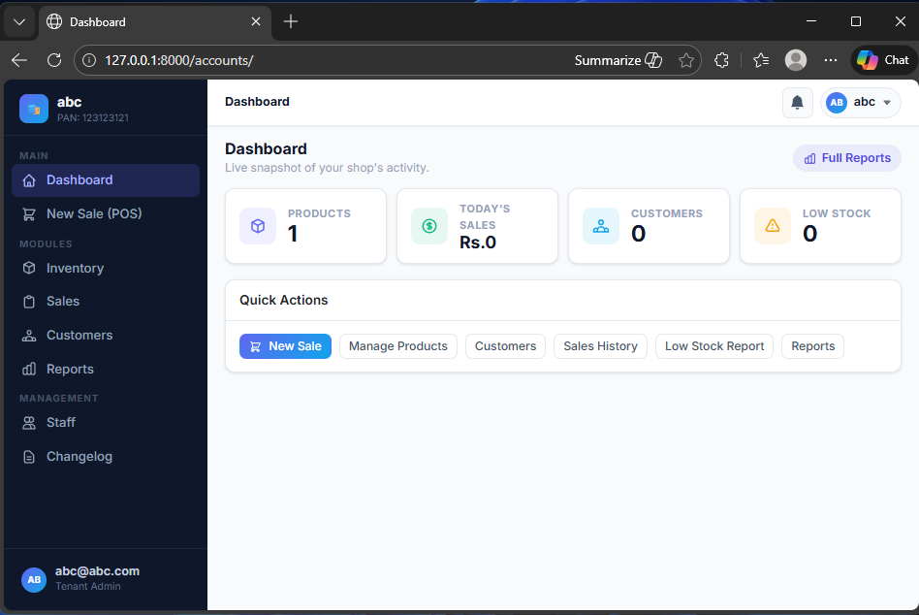
Figure 2: Dashboard / Home Page
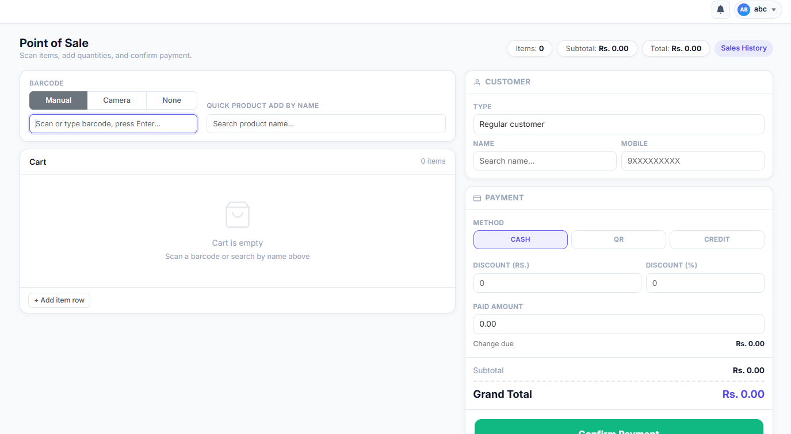
Figure 3: Point of Sale (POS) Interface
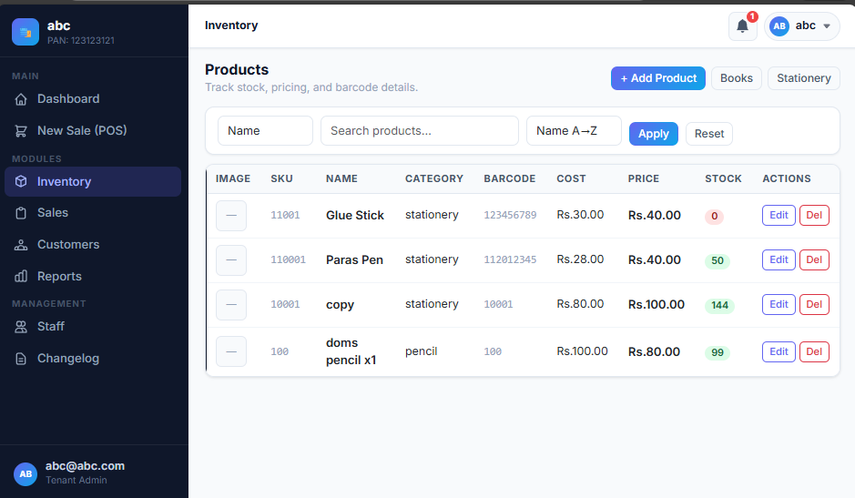
Figure 4:Inventory / Products List Page

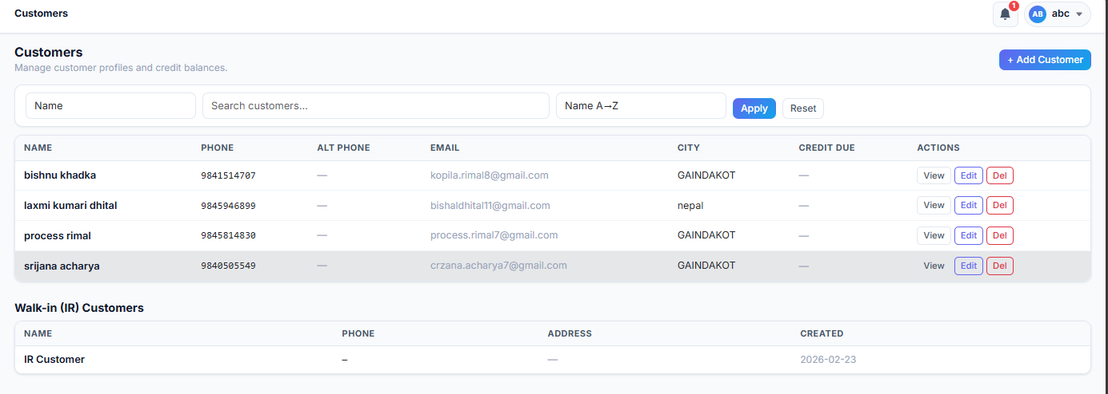
Figure 5: Customer Management Page
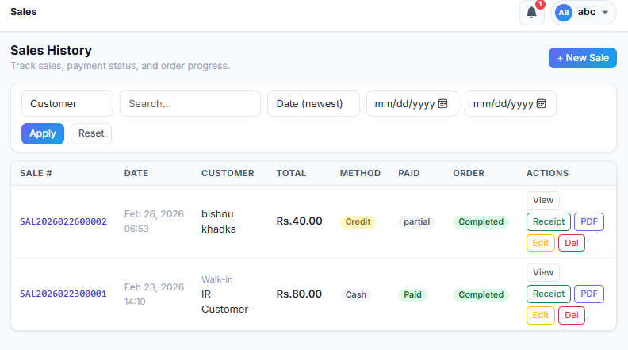
Figure 6: Sales History Page
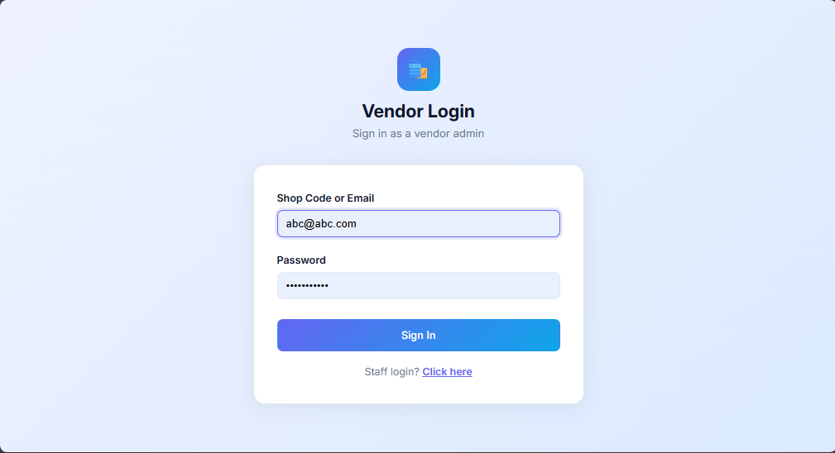
Figure 7: Login Page

