Q1.

**Exceptions in constructors and destructors pose unique challenges in object-oriented programming. Constructors are responsible for initializing object states, and if an exception occurs during this process, it can leave the object in an incomplete or inconsistent state. This may lead to resource leaks or undefined behavior. Handling exceptions in constructors requires careful consideration, often involving a rollback mechanism to release resources acquired during initialization. Destructors, on the other hand, are responsible for cleanup activities, and if an exception occurs during the destruction process, it can be challenging to handle effectively. Developers need to be cautious about potential resource leaks and ensure that the object is left in a consistent state, despite the exceptional circumstances. Exception safety in both constructors and destructors is crucial for writing robust and reliable object-oriented code.**

#include <iostream>

using namespace std;

class *myclass*{

    public:

        myclass(){

            if(1){

                throw *runtime_error*("Failed to Initialize");

            }

        }

};

int main(){

*myclass* myC;

    return 0;

}

**O/P🡪**

**Q2.**

**Exception handling in C++ is essential for writing robust and reliable code by providing a mechanism to gracefully handle and recover from runtime errors. It allows programmers to separate error-handling code from the main logic, improving code readability and maintainability. For example, consider a file operation like opening a file. Without exception handling, the code would need extensive checks to handle possible errors, making it cluttered and less readable. With exception handling, a try-catch block can be used to encapsulate the file-opening code, and any exceptions, such as a file not found or permission issue, can be caught and handled in a centralized and clear manner. This promotes cleaner code and helps prevent unexpected crashes, enhancing the overall robustness of C++ programs.**

**Q3.**

**A namespace is a container that holds a set of identifiers, such as classes, functions, and variables, preventing naming conflicts. It helps organize code and avoids naming collisions between different parts of a program.**

**// Example of a namespace definition**

**namespace MyNamespace {**

**int myFunction(int a, int b) {**

**return a + b;**

**}**

**}**

**int main() {**

**// Using the namespace to access the function**

**int result = MyNamespace::myFunction(10, 20);**

**return 0;**

**}**

**The using keyword is used to bring a specific identifier or an entire namespace into the current scope, making it more convenient to use without explicit qualification.**

**// Example of using the 'using' keyword**

**using namespace MyNamespace; // Bringing the entire namespace into scope**

**int main() {**

**int result = myFunction(10, 20); // No need for MyNamespace::**

**return 0;**

**}**

**The std is a namespace that contains standard C++ library components. It is used to access standard functionalities like input/output operations, algorithms, containers, and more.**

**// Example using 'std' namespace**

**#include <iostream>**

**int main() {**

**// Using cout without explicitly qualifying with ''**

**cout << "Hello, World!" << endl;**

**return 0;**

**}**

**Q4.**

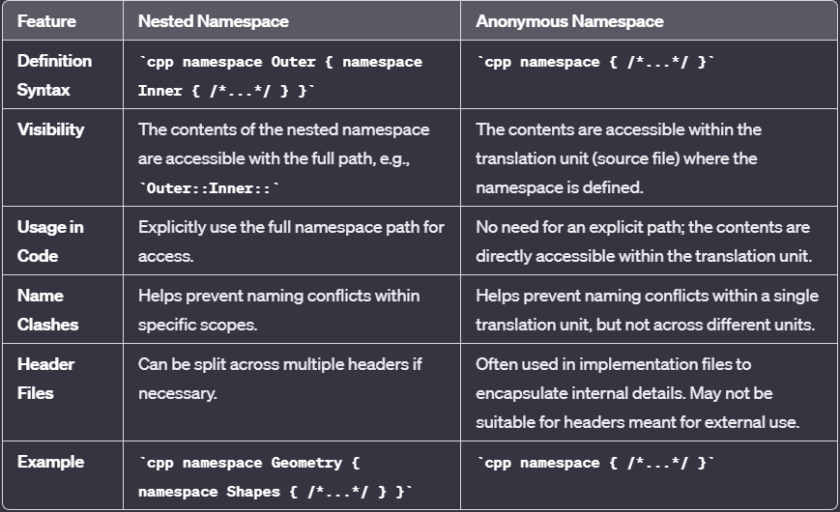

**Q5.**

**The statement using namespace std; is a directive in C++ programming that tells the compiler to consider the std namespace as the default namespace for the program. In C++, a namespace is a way to group related identifiers (such as classes, functions, and variables) together to avoid naming conflicts.**

**The std namespace is the standard namespace in C++ and contains many standard C++ libraries, including input/output operations, strings, algorithms, and more. By using the using namespace std; statement, you can avoid having to prefix every identifier from the std namespace with . This can make your code cleaner and more concise.**

**Q6.**

**Templates in C++ provide a way to write generic code that works with different data types. They allow you to define functions or classes with placeholders for the data types, and then instantiate them with specific types when needed. Templates are useful when you want to write code that can work seamlessly with different data types without duplicating the code for each type.**

#include <iostream>

*// Function template with multiple arguments*

template <typename *T1*, typename *T2*>

void swapValues(*T1* *&*a, *T2* *&*b) {

*T1* temp = a;

    a = static_cast<*T1*>(b);

    b = static_cast<*T2*>(temp);

}

int main() {

*// Example with integers*

    int x = 5, y = 10;

    cout << "Before swapping: x = " << x << ", y = " << y << endl;

    swapValues(x, y);

    cout << "After swapping: x = " << x << ", y = " << y << endl;

*// Example with doubles*

    double a = 3.14, b = 6.28;

    cout << "Before swapping: a = " << a << ", b = " << b << endl;

    swapValues(a, b);

    cout << "After swapping: a = " << a << ", b = " << b << endl;

    return 0;

}

**Q7.**

**In C++, file pointer handling is typically done using the fstream library, which provides classes for handling file operations. The commonly used classes are ifstream (for input), ofstream (for output), and fstream (for both input and output).**

**Opening a file**

**#include <fstream>**

**#include <iostream>**

**using namespace std;**

**int main() {**

**// Create an ofstream (output file stream) object**

**ofstream outFile;**

**// Open a file named "example.txt" for writing**

**outFile.open("example.txt");**

**// Check if the file is successfully opened**

**if (outFile.is_open()) {**

**cout << "File opened successfully." << endl;**

**// Perform file operations here**

**// Close the file when done**

**outFile.close();**

**} else {**

**cout << "Error opening the file." << endl;**

**}**

**return 0;**

**}**

**Reading a file**

**#include <fstream>**

**#include <iostream>**

**#include <string>**

**int main() {**

**// Create an ifstream (input file stream) object**

**ifstream inFile;**

**// Open a file named "example.txt" for reading**

**inFile.open("example.txt");**

**// Check if the file is successfully opened**

**if (inFile.is_open()) {**

**cout << "File opened successfully." << endl;**

**// Read data from the file**

**int number;**

**string line;**

**// Reading an integer**

**inFile >> number;**

**cout << "Read integer from file: " << number << endl;**

**// Reading a line**

**getline(inFile, line);**

**cout << "Read line from file: " << line << endl;**

**// Close the file when done**

**inFile.close();**

**} else {**

**cout << "Error opening the file." << endl;**

**}**

**return 0;**

**}**

**Writing to a File**

**#include <fstream>**

**#include <iostream>**

**int main() {**

**// Create an ofstream (output file stream) object**

**ofstream outFile;**

**// Open a file named "example.txt" for writing**

**outFile.open("example.txt");**

**// Check if the file is successfully opened**

**if (outFile.is_open()) {**

**cout << "File opened successfully." << endl;**

**// Write data to the file**

**int number = 42;**

**outFile << "This is a number: " << number << endl;**

**// Close the file when done**

**outFile.close();**

**} else {**

**cout << "Error opening the file." << endl;**

**}**

**return 0;**

**}**

**Checking for End of File**

**#include <fstream>**

**#include <iostream>**

**int main() {**

**// Create an ifstream (input file stream) object**

**ifstream inFile;**

**// Open a file named "example.txt" for reading**

**inFile.open("example.txt");**

**// Check if the file is successfully opened**

**if (inFile.is_open()) {**

**cout << "File opened successfully." << endl;**

**// Read data from the file until the end is reached**

**int number;**

**while (inFile >> number) {**

**cout << "Read integer from file: " << number << endl;**

**}**

**// Close the file when done**

**inFile.close();**

**} else {**

**cout << "Error opening the file." << endl;**

**}**

**return 0;**

**}**