Name-Keshav Deo Sharma

Id-761240

GithubID-https://github.com/KeshavDeoSharma/Milestone1

Screens of Admin Module

1.Sign Up Page 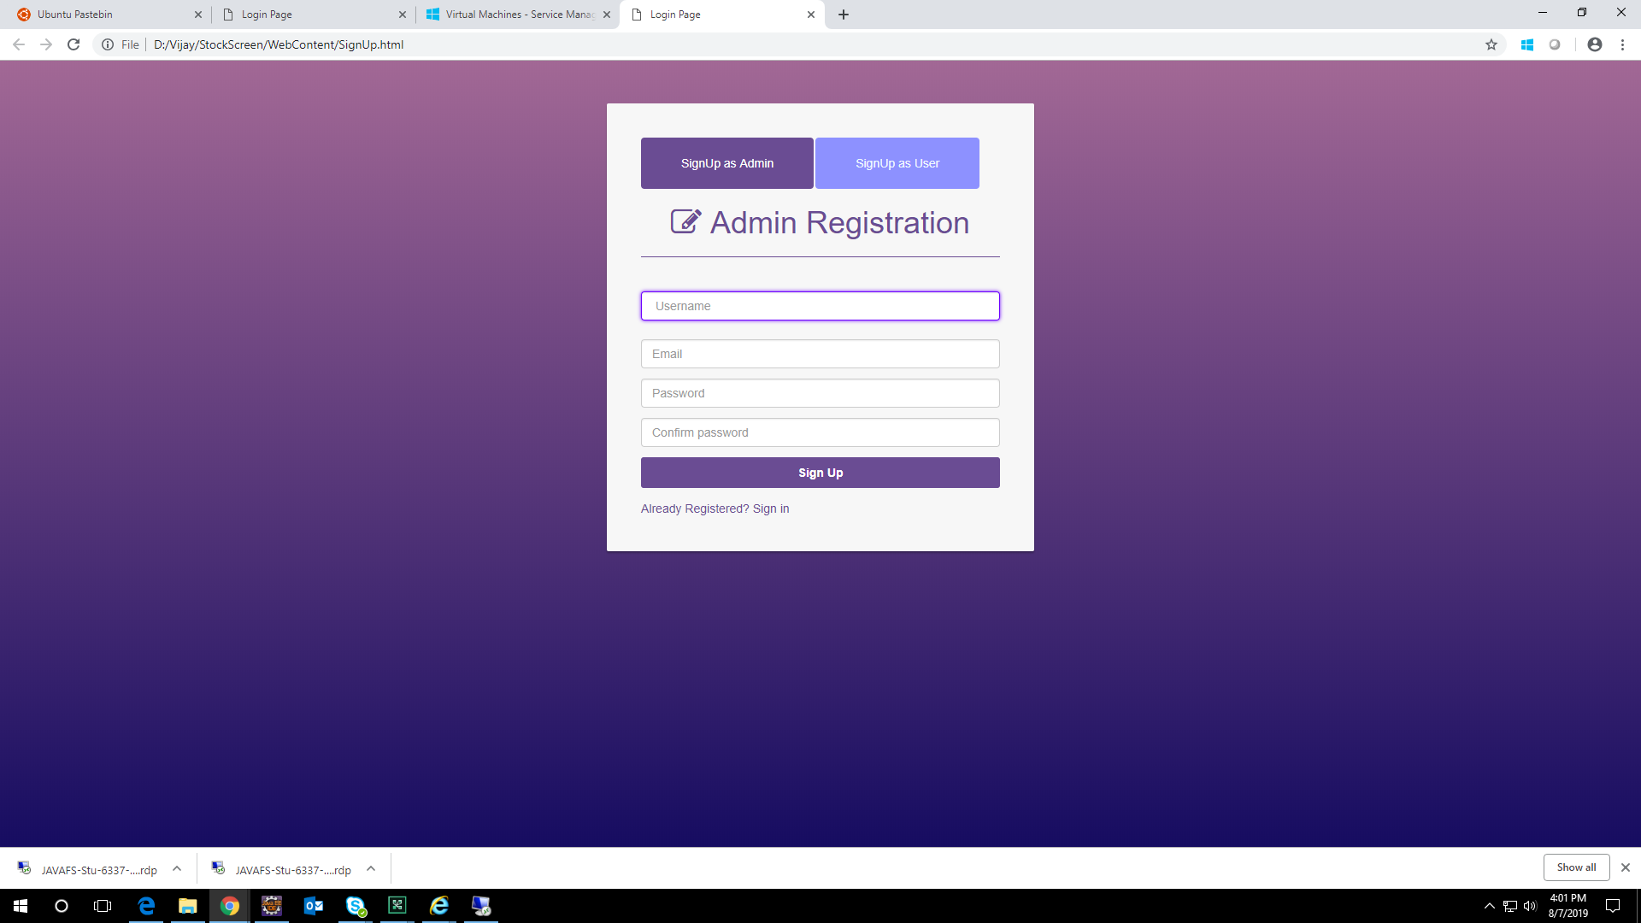

2.Login Page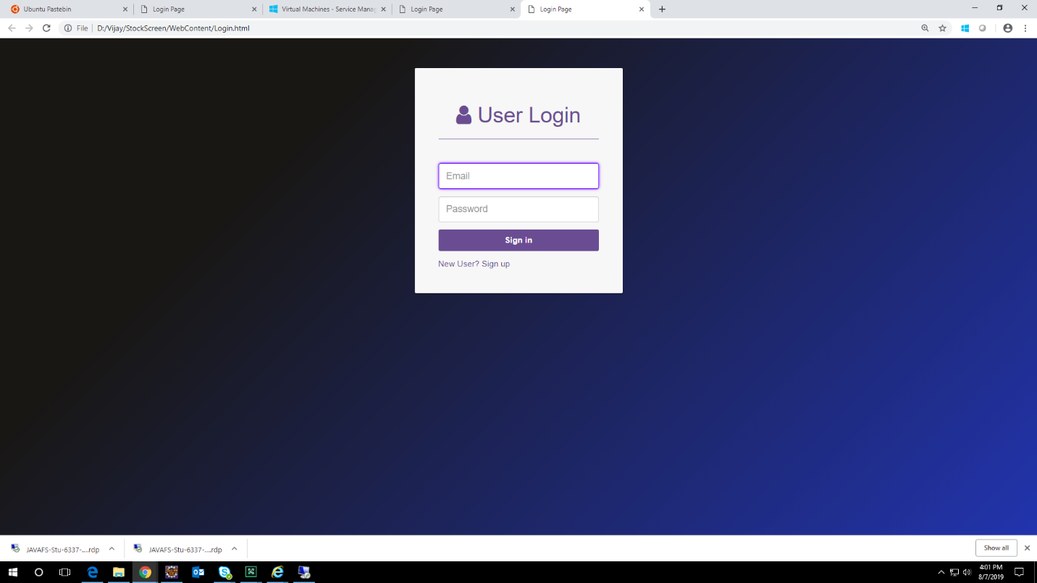

3.Import Data Page

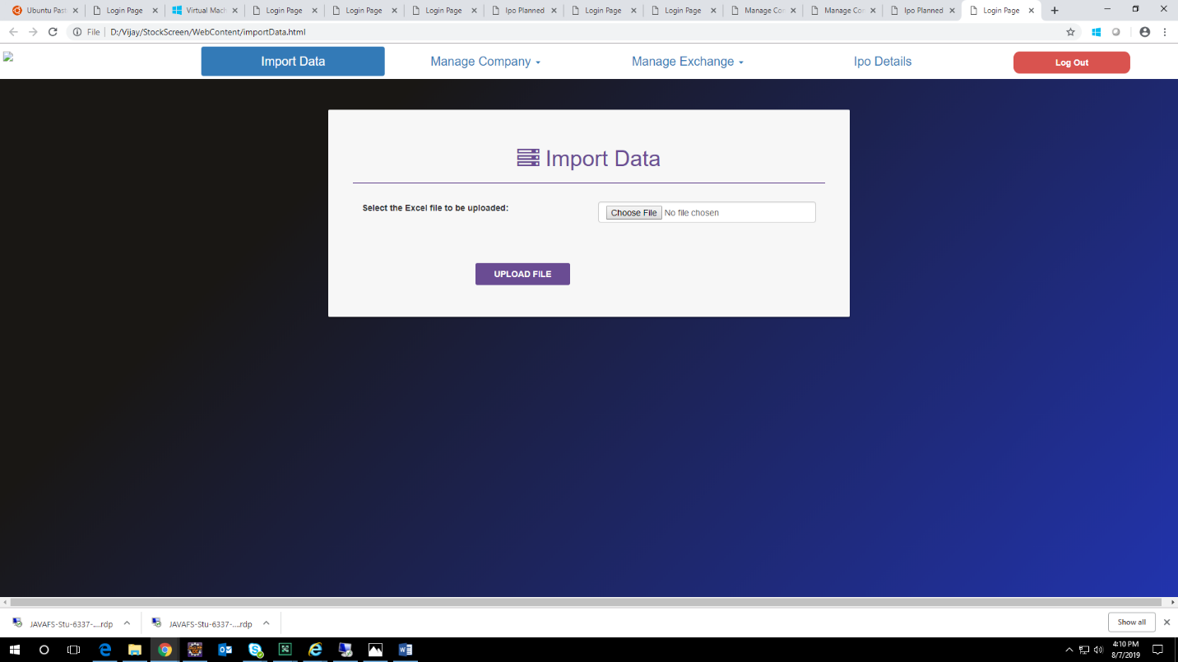

4.Add Company Details

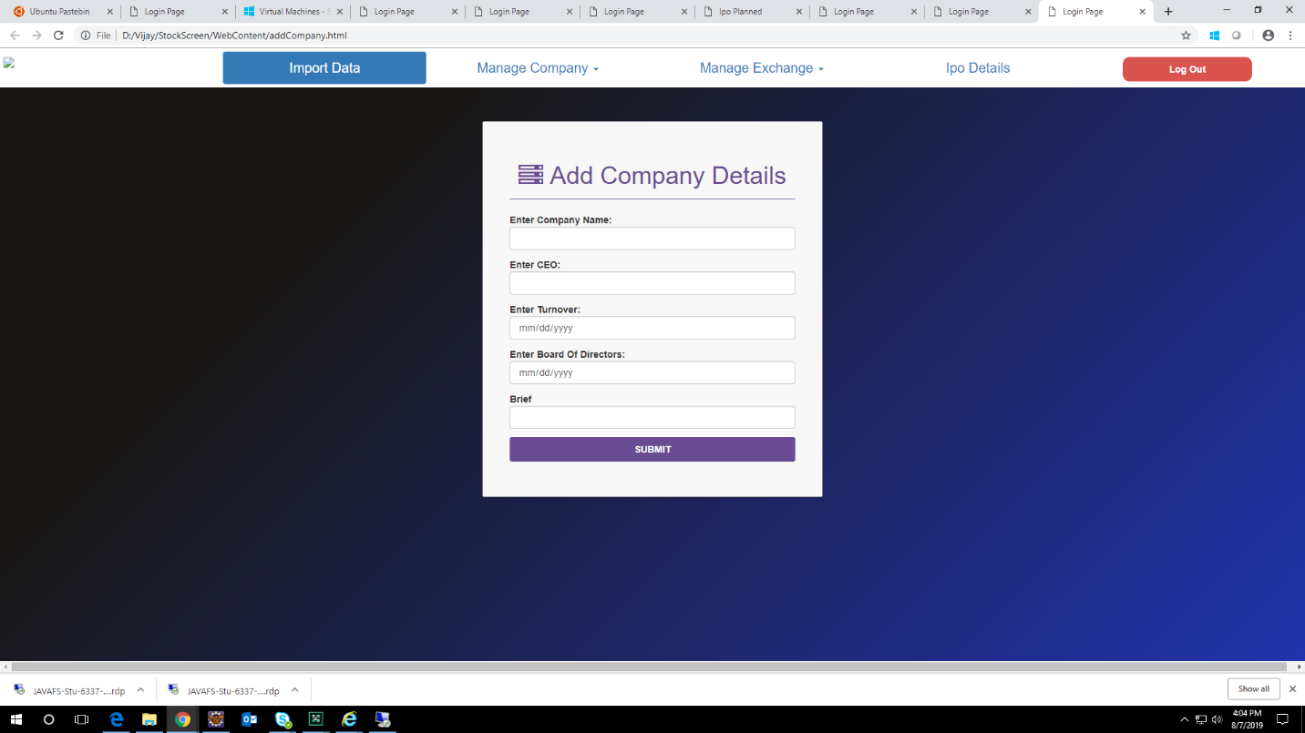

5.Manage Company Details

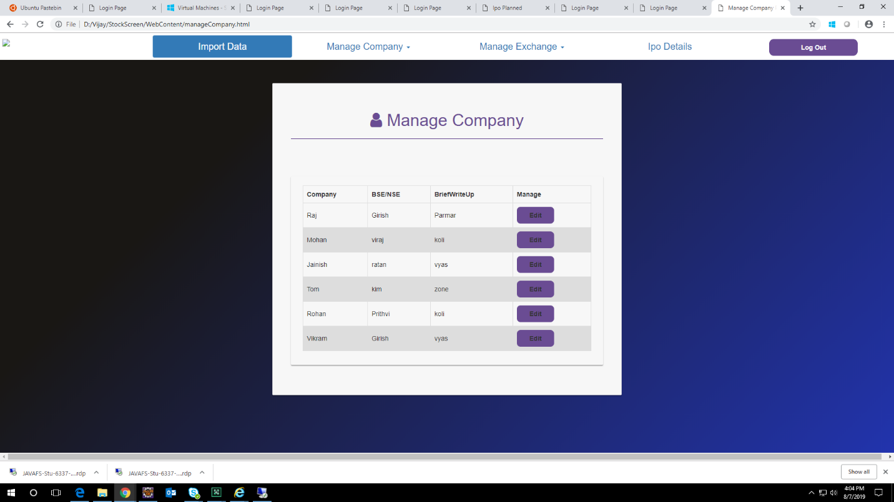

6.List Company Details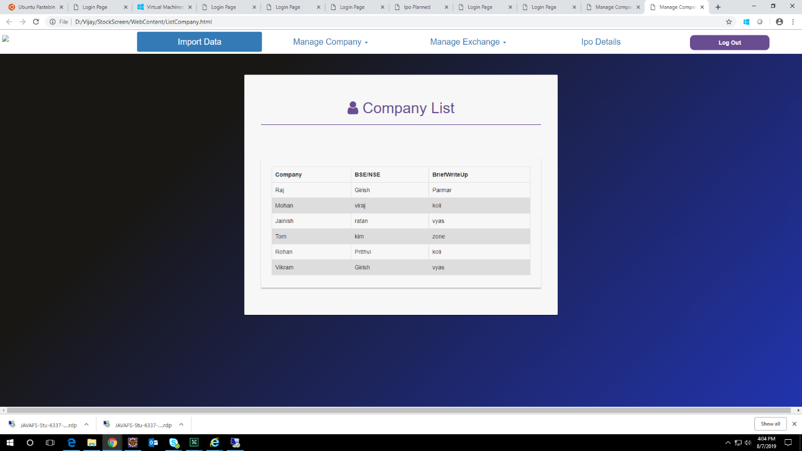

7.Add Stock Exchange

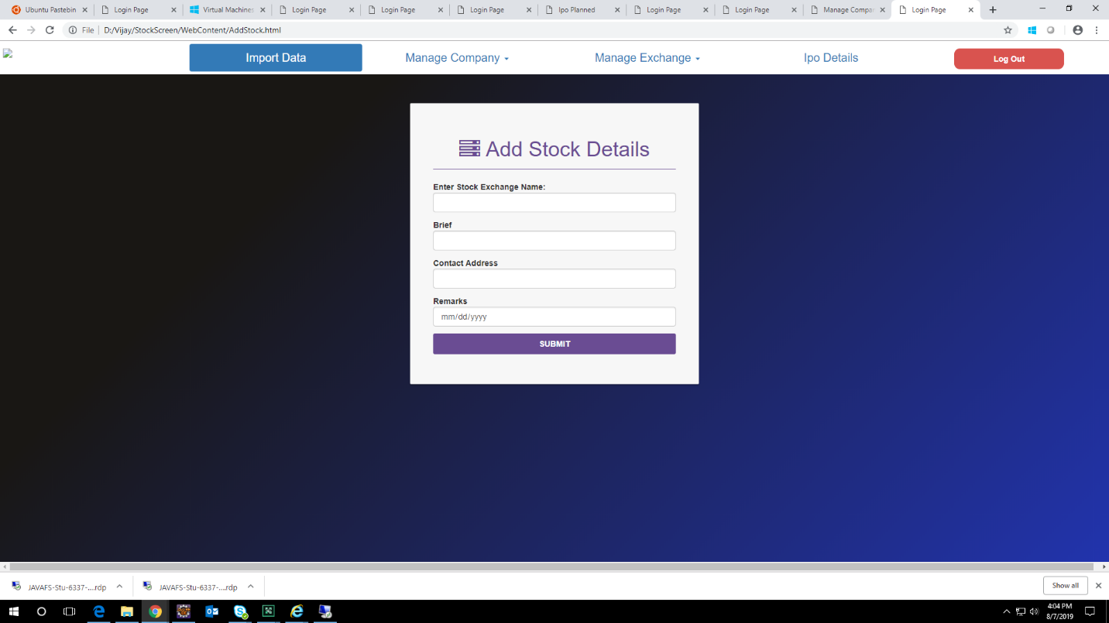

8.List Stock Exchange Details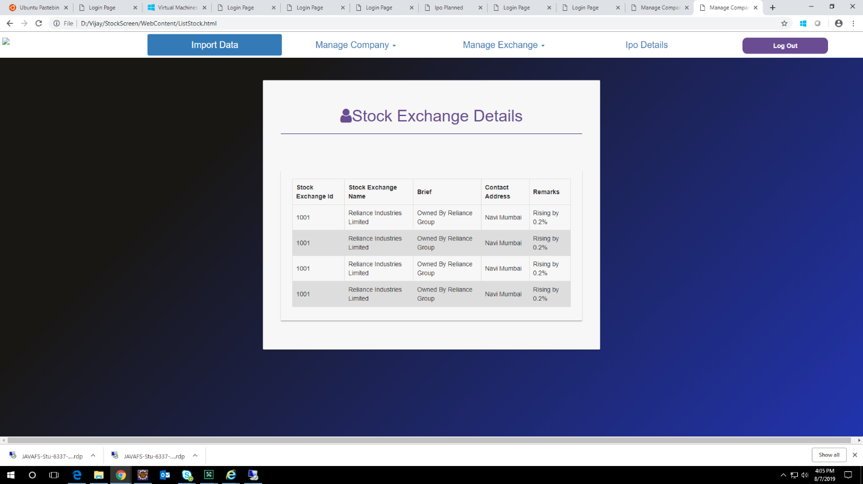

9.Update Ipo Details

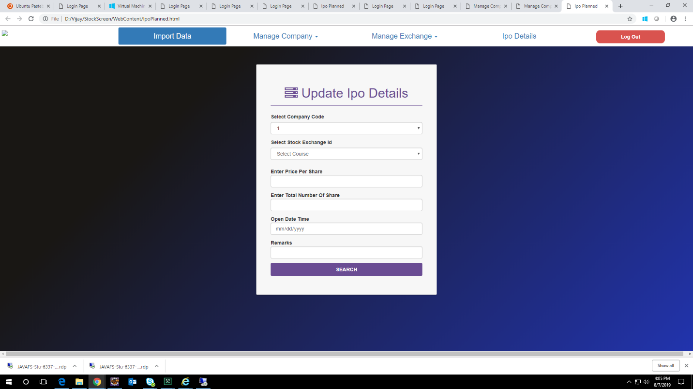

Schema Diagram

