Grilled Cheese Sandwich

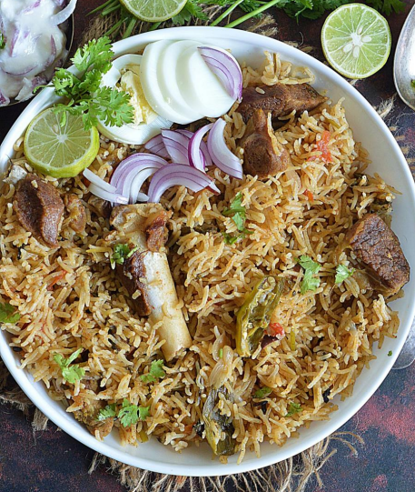

Ingredients Overview
- Mutton Marination (1 kg): Combined with yogurt, ginger-garlic paste, lemon juice, salt, and spices (chili, turmeric, and garam/biryani masala).
- Rice (750g Basmati): Soaked, then boiled with whole spices and salt.
- Base & Layering: Thinly sliced onions, ghee, oil, whole spices, fresh mint, coriander, green chilies, and saffron-infused milk.
6-Step Cooking Process
- Marinate (2–4 hours): Mix the mutton with the marination ingredients and refrigerate (bring to room temperature before cooking).
- Fry Onions (15 mins): Fry sliced onions in ghee and oil until crispy; set aside 75% of them (birista) for layering.
- Cook Mutton (40 mins): Sauté whole spices and marinated meat in the remaining oil. Simmer or pressure cook until the mutton is 90% tender and the gravy thickens.
- Par-boil Rice (15 mins): Boil the soaked Basmati rice with whole spices and salt until al dente (70-80% cooked), then drain.
- Layer (10 mins): Layer half of the herbs and fried onions over the mutton, cover evenly with the hot rice, and top with the remaining herbs, onions, and saffron milk.
- Dum Cook (20 mins): Seal the pot tightly with foil/a towel and a lid. Cook on the lowest heat for 15–20 minutes, then let it rest for 10 minutes before serving.
Pro Tip: Place a flat iron griddle (tawa) under the pot during the final steam (dum) phase to act as a heat diffuser and prevent the bottom layer from burning.

