**PIZZA SALES SQL QUERIES**

# PART A (KPI REQUIREMENTS)

1. **Total Revenue:**

SELECT ROUND(SUM(total_price),2) AS 'Total Revenue'

FROM pizza_sales;

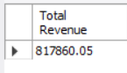

1. **Avg order value**

SELECT ROUND(SUM(total_price)/COUNT(DISTINCT order_id) ,2) AS 'Avg Order Value' FROM pizza_sales;

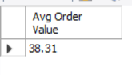

1. **Total Pizza sold**

SELECT SUM(quantity) AS 'Total pizza sold' FROM pizza_sales;

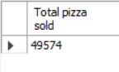

1. **Total orders**

SELECT COUNT(DISTINCT order_id) AS 'Total Orders' FROM pizza_sales;

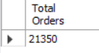

1. **Avg pizza sold per order**

SELECT SUM(quantity)/COUNT(DISTINCT order_id) AS 'Avg pizza sold per order' FROM pizza_sales;

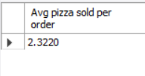

PART B (CHART REQUIREMENTS)

1. **Daily trend**

## CONVERTING IN DATE FORMAT

select * from pizza_sales;

UPDATE pizza_sales

SET order_date = str_to_date(order_date, "%d-%m-%Y");

ALTER TABLE pizza_sales

MODIFY order_date DATE;

SELECT dayname(order_date) AS 'Day',COUNT(DISTINCT order_id) AS 'Orders' FROM pizza_sales

GROUP BY Day

ORDER BY Orders DESC;

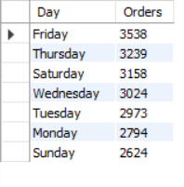

1. **Monthly trend**

SELECT monthname(order_date) AS 'Month',COUNT(DISTINCT order_id) AS 'Orders' FROM pizza_sales

GROUP BY Month

ORDER BY Orders DESC;

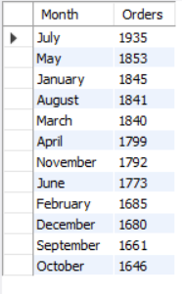

1. **Percentage of sales by pizza category**

SELECT pizza_category, ROUND(SUM(total_price),2) AS 'Total Revenue',

round(

SUM(total_price) / (SELECT SUM(total_price) from pizza_sales)*100,2

) AS 'PCT' FROM pizza_sales

GROUP BY pizza_category;

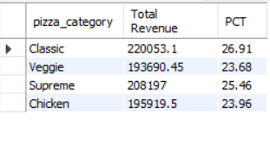

1. **Percentage of sales by pizza size**

SELECT pizza_size, ROUND(SUM(total_price),2) AS 'Total Revenue',

round(

SUM(total_price) / (SELECT SUM(total_price) from pizza_sales)*100,2

) AS 'PCT' FROM pizza_sales

GROUP BY pizza_size;

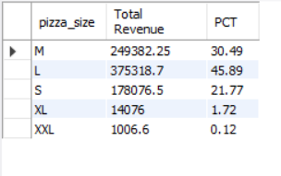

1. **Pizza sold by pizza catergory**

SELECT pizza_category,sum(quantity) AS 'Total Pizza sold' FROM pizza_sales

GROUP BY pizza_category;

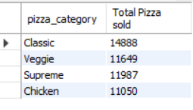

1. **Top 5 best seller by revenue,total quantity and total Orders**
2. **Top 5 Best seller by revenue**

SELECT pizza_name,sum(total_price) AS 'Total_Revenue' FROM pizza_sales

GROUP BY pizza_name

ORDER BY Total_Revenue DESC LIMIT 5;

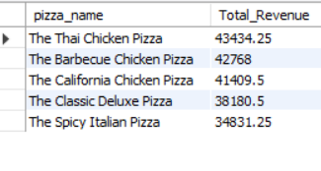

1. **best seller by total quantity**

SELECT pizza_name,sum(quantity) AS 'Total_quantity_sold' FROM pizza_sales

GROUP BY pizza_name

ORDER BY Total_quantity_sold DESC LIMIT 5;

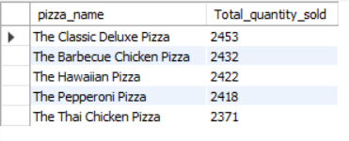

1. **best seller by total orders**

SELECT pizza_name, COUNT(distinct order_id) AS 'Total_orders' FROM pizza_sales

GROUP BY pizza_name

ORDER BY Total_orders DESC LIMIT 5;

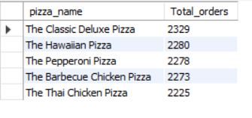

1. **Bottom 5 seller by revenue,total quantity and total Orders**
2. **Bottom 5 seller by revenue**

SELECT pizza_name,sum(total_price) AS 'Total_Revenue' FROM pizza_sales

GROUP BY pizza_name

ORDER BY Total_Revenue LIMIT 5;

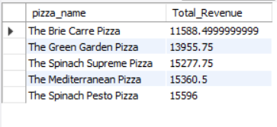

**b. Bottom 5 seller by total quantity**

SELECT pizza_name,sum(quantity) AS 'Total_quantity_sold' FROM pizza_sales

GROUP BY pizza_name

ORDER BY Total_quantity_sold LIMIT 5;

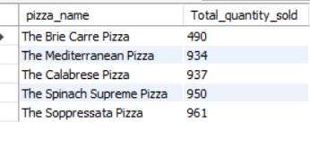

**c. Bottom 5 seller by total orders**

SELECT pizza_name, COUNT(distinct order_id) AS 'Total_orders' FROM pizza_sales

GROUP BY pizza_name

ORDER BY Total_orders LIMIT 5;

