Component
A component in graphical terms is icon but in function terms it is a set of instructions that does a particular task.

Components of Talend
- tFileInputDelimited
It is used to read data from files.
Configurations
    - Edit Schema – Used to map the columns of file to the component headers.
    - Path – Location of the file.
    - Row Separator – How 2 rows are separated from each other.
    - Column Separator – How adjacent columns are separated from each other.
    - Header – If the file has first columns as the columns name, then first column need to be specified by giving value “1”.
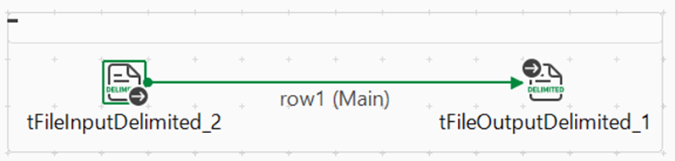

- tFileOutputDelimited
It is used to copy data from source to a new file.
Configurations
    - Path – Location of the file.
    - Row Separator – How 2 rows are separated from each other.
    - Column Separator – How adjacent columns are separated from each other.
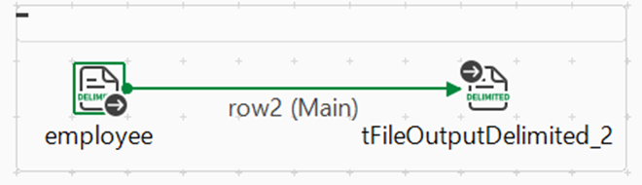

- tLogRow
It is used to output/print the result of talend job into the console.
Configurations
    - Mode – Print the output on console specified by the mode. “Basic” will print the rows as a single column and each row will be in separate line. “Print values in cells as table” will print the data in form of rows and columns.
    - Sync Column – Synchronize the schema of the file to the output schema.
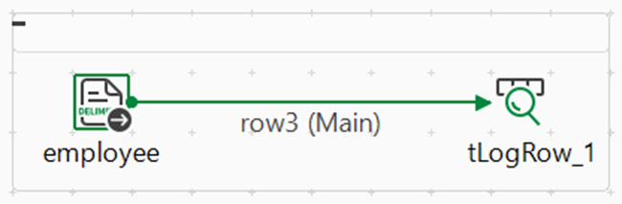

- tUniqRow
It is used to filter the row on given conditions on particular column and more than one condition is joined using “and” and “or” options.
Configurations
    - Sync Column – Synchronize the schema of the file to the output schema.
    - Unique Key – Specify the the column in which you want the unique condition to follow.
    - Row
      - Uniques – Gives the unique records as output.
      - Duplicates – Gives the records which are present multiple times.
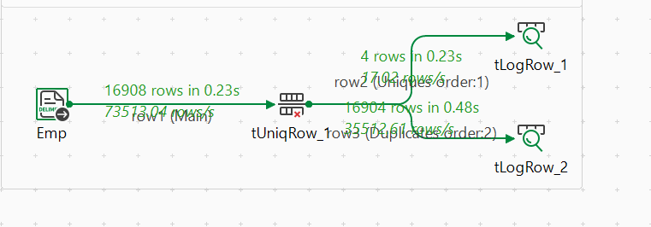
- tSortRow
It is used to sort the rows of a file based on the given column name.
Configurations
    - Sync Column – Synchronize the schema of the file to the output schema.
    - Criteria
      - Schema Column – Column on which the sorting will apply.
      - Sort num or alpha – Is the given column specified for sorting is of type numeric or alpha numeric.
      - Order – Whether to sort the rows in ascending or descending order.
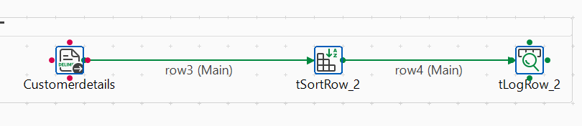
- tSampleRow
It is used to filter the row on the basis of given regular expression.
- 1,5 : line 1 and 5
- 10..20 : from line 10 to 20
Range(1,5,10..20) : select row 1, 5, 10, 11, 12, 13, 14, 15, 16, 17, 18 ,19 ,20
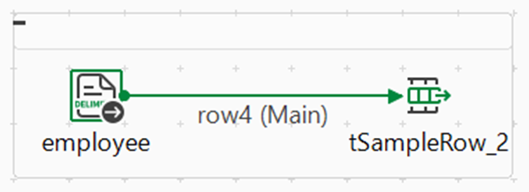
- tFileList
It is used to select file from a directory where more than one file is present. This component uses the extension type to select the source file.
Configurations
    - Filemask – Specify the extension of the file that to be extracted.
    - Directory – Give the path of the directory where the source is located.
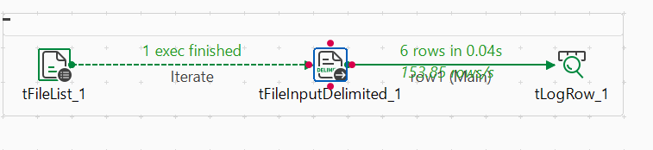

- tUnite
It is used to merge the data of multiple files into one target file.
Note :- The schema of the all the source file must be same.
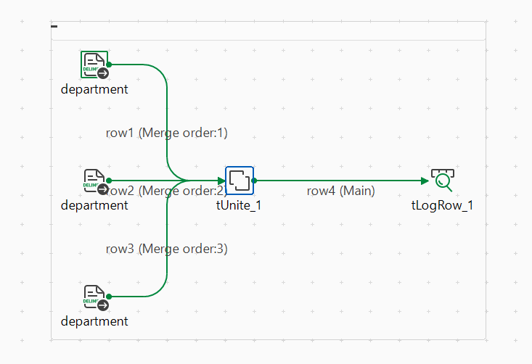

- tFilterColumn
It is used to select only those column to you want to be present in the target file.
Configurations
    - Edit Schema – Select those columns using the greater than sign that will be present in the target file.
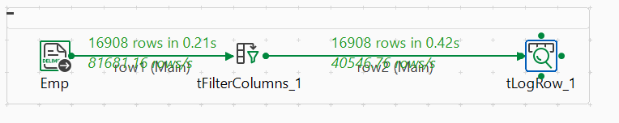

- tReplicate
It is used to replicate the content of a file to multiple target files.
