LAB-3

A\* MISPLACED TILES OUTPUT

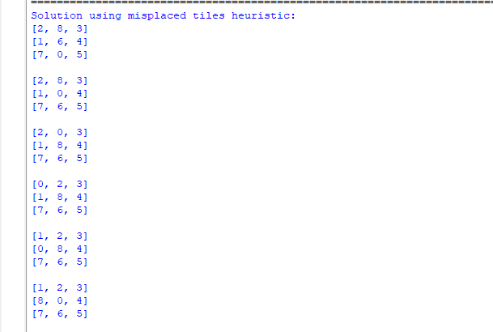

A\* MANHATTAN DISTANCE OUTPUT

