**Prepositional Logic and Truth Table Enumeration**

**Algorithm:**

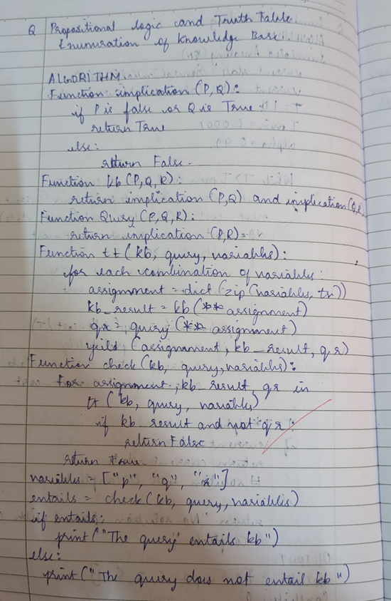

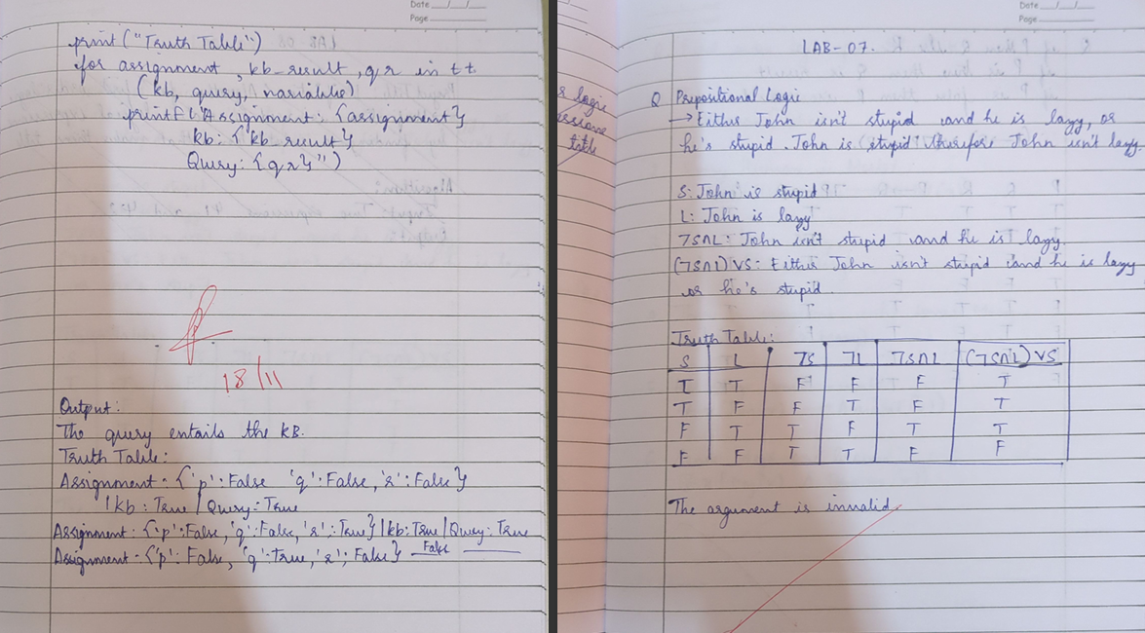

**Code:**

from itertools import product

def implication(p, q):

    return not p or q

def kb(p, q, r):

    return implication(p, q) and implication(q, r)

def query(p, q, r):

    return implication(p, r)

def truth_table(kb, query, variables):

    for truth_values in product([False, True], repeat=len(variables)):

        # Create a dictionary for the current variable assignments

        assignment = dict(zip(variables, truth_values))

        kb_result = kb(**assignment)

        query_result = query(**assignment)

        yield (assignment, kb_result, query_result)

def check_entailment(kb, query, variables):

    for assignment, kb_result, query_result in truth_table(kb, query, variables):

        if kb_result and not query_result:

            return False  # Query does not entail KB

    return True  # Query entails KB

variables = ['p', 'q', 'r']

entails = check_entailment(kb, query, variables)

if entails:

    print("The query entails the KB.")

else:

    print("The query does NOT entail the KB.")

print("\nTruth Table:")

for assignment, kb_result, query_result in truth_table(kb, query, variables):

    print(f"Assignment: {assignment} | KB: {kb_result} | Query: {query_result}")

**Output:**

