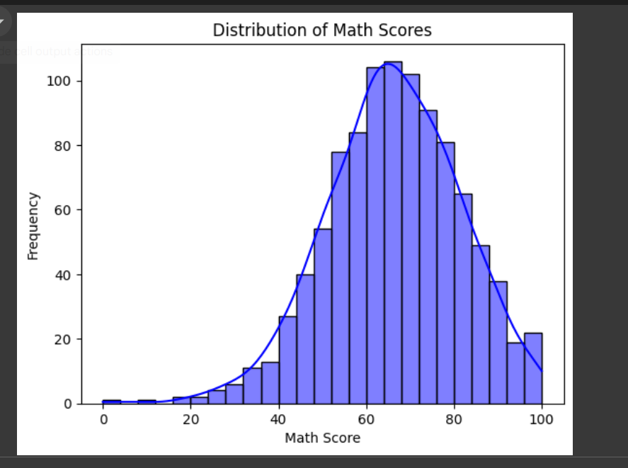

1. **Histogram (Math Scores)**:  
    I can see how math scores are spread out among the students. This helps me understand if most students are scoring in a particular range or if the scores are more evenly distributed. It also lets me identify if there’s a skew in the data, meaning more students are scoring low or high.

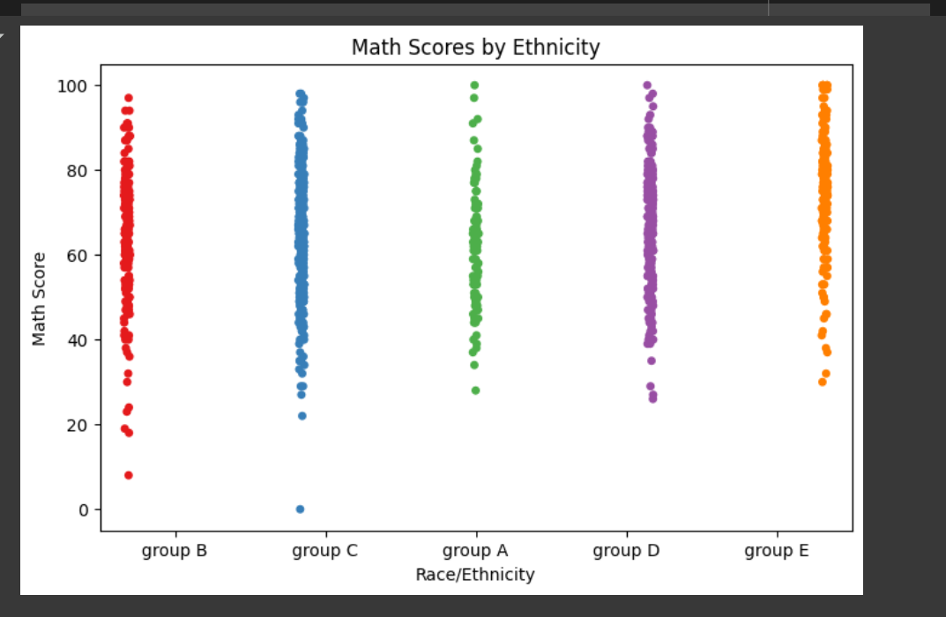

1. **Histogram (Reading Scores)**:  
    This gives me a sense of the reading scores distribution. I can quickly spot if a majority of students have low, medium, or high scores. It also shows how varied the scores are and if there are any extreme values (outliers) in the data.

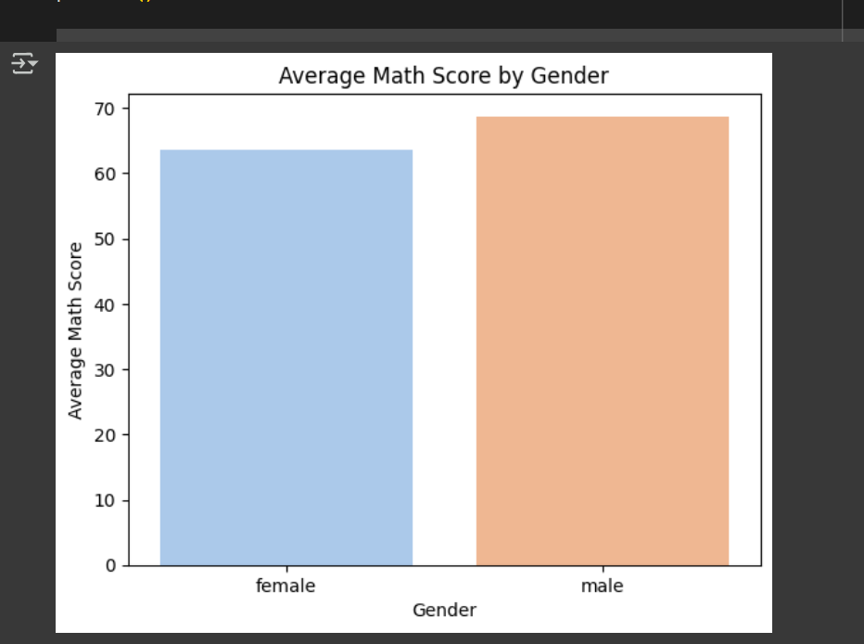

1. **Strip Plot (Math Scores by Race/Ethnicity)**:  
    This plot shows how math scores differ across ethnic groups. It helps me spot patterns, like whether certain groups tend to score higher or lower, and how wide the score variation is within each group. I can also see if any group has a lot of students scoring at the extremes.

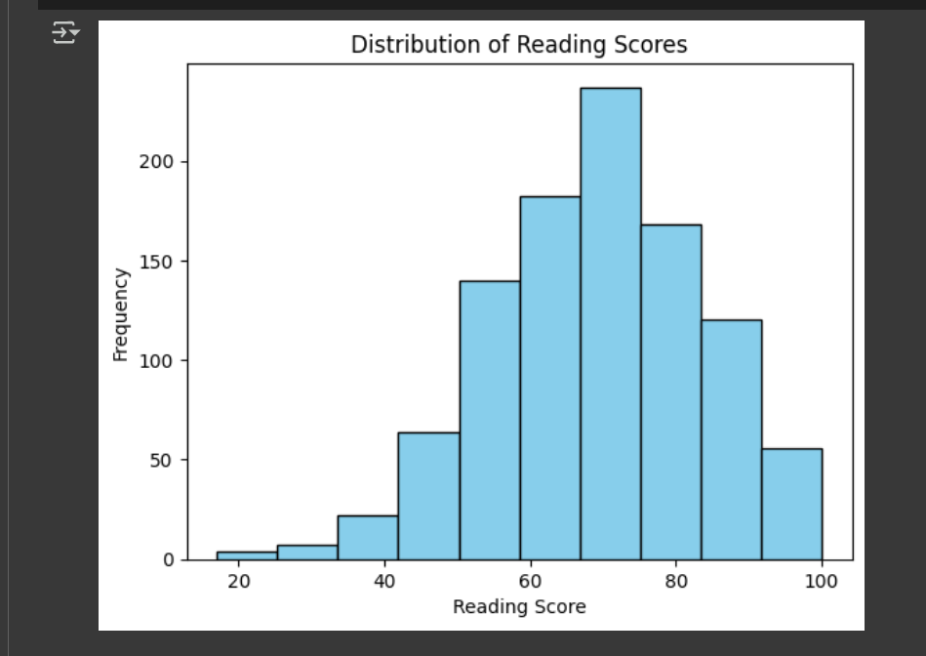

1. **Bar Plot (Average Math Scores by Gender)**:  
    This gives me a clear comparison between male and female students' average math scores. It makes it easy to spot if one gender outperforms the other in math. I can also notice if there’s a significant difference in performance between them.

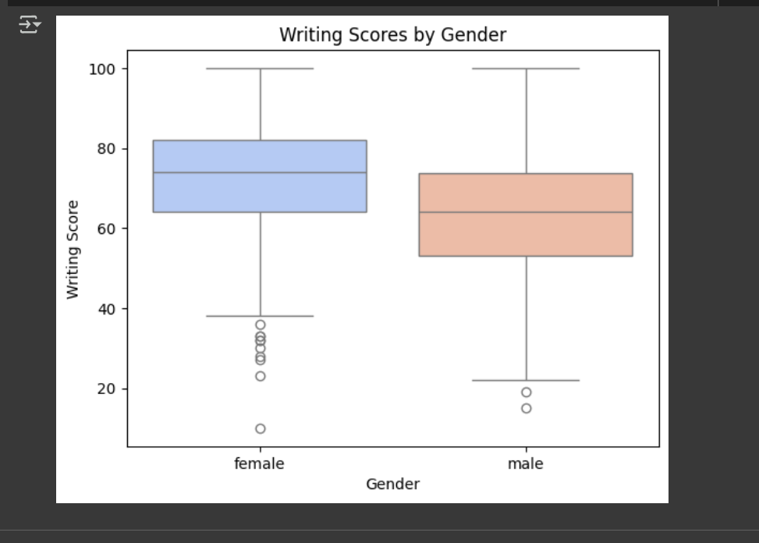

1. **Box Plot (Writing Scores by Gender)**:  
    The box plot helps me compare writing scores between genders. I can quickly see how the scores are distributed and identify any gender differences in the spread or central tendency of the scores. If one gender has a wider range of scores or more outliers, I can observe that right away.

### **Overall My POV**

These visualizations give me a clear understanding of how scores are distributed and compared across different categories like gender, race, and subject. They help me identify trends, outliers, and variations, making it easier to analyze the data and draw insights from it.