UNIVERSITY INSTITUTE OF COMPUTING

Machine Learning Applications in Student Performance Analytics
Subject Name: Fundamental of Data Science SUBJECT CODE: 25CAT-121

SUBMITED BY:
Name: Keshav Saini UID: 25BCD10101
Branch: BCA (Hons.) (Data Science) Group: B Section: 25BCD2 Semester: 1st

SUBMITED TO:

Name: Rajat Patial D.O.SUBMITION: 6/Nov/2025

Designation: Assistant Professor

Sign:

Project Report: E-Auction Model – eBay

Title:
Machine Learning Applications in Student Performance Analytics

Aim / Introduction of the Project:
The aim of this case study is to analyze how Machine Learning (ML), specifically supervised and unsupervised learning techniques, enhances student performance tracking, prediction, and personalization in the education sector.

ML in education helps institutions understand student behavior, identify learning gaps, personalize content delivery, and improve academic outcomes.

Objective:

  - To explore ML techniques applied in student performance analytics

  - To understand supervised and unsupervised learning use-cases in academic environments

  - To identify data used, workflow, benefits, and challenges

Overview of E-Commerce Concept Used:
Machine Learning uses data-driven algorithms to predict academic performance, group students by learning behaviour, and assist institutions in intelligent decision-making.

  - Supervised Learning: Models learn from labeled student data to predict outcomes.

  - Unsupervised Learning: Algorithms discover hidden patterns like student clusters without labeled data.

Working Model / Process Flow:

- Data Collection

  - Student grades, attendance, assignment submissions, LMS interaction logs, behavior data

- Data Pre-processing

  - Cleaning, handling missing values, scaling

- Model Selection

  - Supervised: Regression, Decision Trees, Random Forest, SVM

  - Unsupervised: K-Means, Hierarchical Clustering, PCA

- Model Training & Testing

- Prediction / Analysis

- Insights for Faculty & Students

- Intervention & Personalization

Benefits and Limitations:

Benefits Limitations
Early identification of weak students. Requires large & quality datasets. Personalized learning pathways. Privacy & data security concerns. Optimized teaching strategies. Algorithm bias risk.
Automated evaluation & reporting. Implementation cost in institutions.

Technology and Payment System Used:
  - Python, Scikit-Learn, Pandas, TensorFlow
  - LMS Data Sources (Moodle, Google Classroom, Blackboard)
  - Visualization: Power BI / Tableau

Risk and Security Measures:
Risk Factors:
- Data Privacy Risk
Sensitive student data (marks, behavior, personal info) may be misused if not protected properly.
- Bias in Algorithms
ML models may unintentionally discriminate or rank students unfairly based on biased data.
- Wrong Predictions
Incorrect performance predictions could mislabel bright students or overlook weaker ones.
- System Dependency Risk
Excessive reliance on automated systems may reduce human judgement in academic decisions.
- Unauthorized Access
Organizational insider threats or hacking attempts could leak academic and personal student data.
Security Measures:
- Data Encryption
Encrypt all academic & personal student records during storage and transfer.
- Student Data Anonymization
Remove personal identifiers before feeding data into ML models.
- Access Control Policies
Provide only role-based and permission-based access to student data.
- Regular Security Audits
Periodic assessments to detect model vulnerabilities & data breaches.
- Model Fairness & Bias Testing
Validate ML predictions to ensure fairness across student groups.
- Secure Cloud Storage & Backup
Use secure servers and maintain encrypted backups to prevent data loss.

Findings / Analysis:
  - Supervised ML predicts academic success and dropout risks accurately if quality data is provided.

  - Unsupervised ML segments learners into groups like fast-learners, slow- learners, inconsistent performers, and high-interaction users.
  - Early interventions improve academic outcomes and student engagement.

Conclusion:
Machine Learning plays a transformative role in education by predicting student outcomes, identifying at-risk learners, and recommending personalized content. Both supervised and unsupervised learning enhance educator decision-making and improve student success rates.

Learning Outcomes:
  - Understood ML applications in student performance analytics.
  - Learned difference between supervised and unsupervised methods in education.
  - Gained knowledge of data types, processes, and challenges in ML adoption.

References:
  - Research Papers on ML in Education (IEEE, Springer).
  - EdTech company reports (Coursera, Google for Education, Byju’s).
  - Scikit-Learn & Python ML documentation.

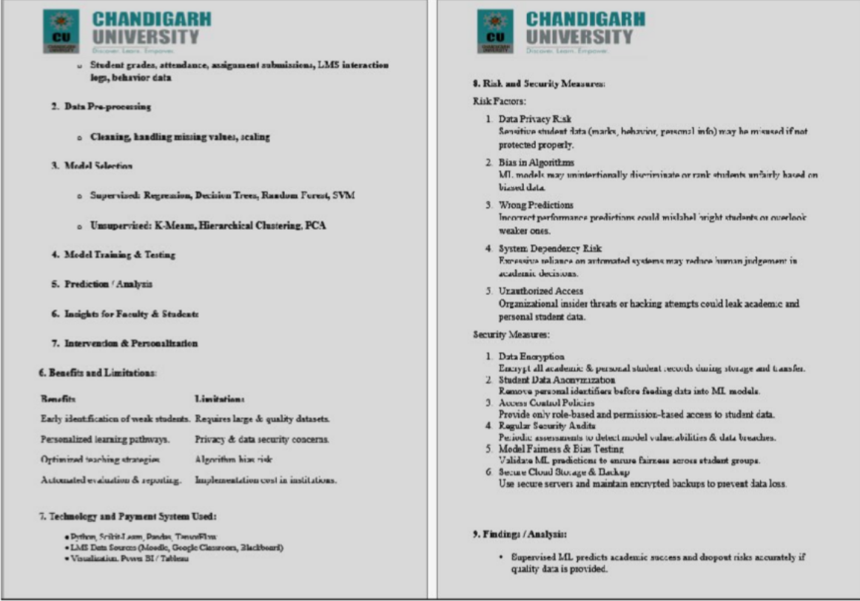
Screenshots

:

LinkedIn: https://www.linkedin.com/posts/keshav-saini-a99583331_machine-learning- plays-a-transformative-role-activity-7391886958806945792- HTmd?utm_source=social_share_send&utm_medium=member_desktop_web&rcm=A CoAAFOOblUBSIwVxEP7lqJhqtVf3WQHmUvZSQI

Github: https://github.com/KeshavSaini124/Fundamental-of-Data-Science-Project- 1ST-Sem..git

Teacher Signature

