
CASE STUDY
SMART PARKING MANAGEMENT SYSTEM
Solving a Real-Life Problem with Object-Oriented Programming in C++

Submitted by:
Keshav Saini
UID: 25BCD10101

Submitted to:
Mr. Jitendra Kumar
Designation: Professor

in partial fulfillment of the Object-Oriented Programming (C++) course

Chandigarh University
Date of Submission: 21 October 2026

TABLE OF CONTENTS
Section | Page
1. Case Background and Problem Statement | 3
2. Analysis of the Existing System and Proposed Solution | 4
3. System Design | 5
4. Implementation | 7
5. Execution and Output | 9
6. Testing and Results | 11
7. Findings and Conclusion | 12

1. CASE BACKGROUND AND PROBLEM STATEMENT

1.1 The Case
A small college has a parking area with five slots near the main gate. Students, staff and visitors arrive on bikes, cars and sometimes in small goods trucks. The area is looked after by one attendant, who writes the number plate and the arrival time in a notebook and, when the vehicle leaves, calculates the charge by hand.
This causes everyday problems. The attendant sometimes forgets which slots are free and a visitor is turned away although a slot is empty. The same vehicle is sometimes entered twice. The charge is calculated wrongly in a hurry – a truck is charged like a car, or the hours are counted incorrectly – and at the end of the day the total collection does not match the notebook.

1.2 Problem Statement
To design and develop a simple software system in C++ that records vehicles entering and leaving a parking lot of five slots, allots a slot automatically, refuses duplicate and overflow entries, calculates the correct fee for each type of vehicle, and gives the attendant a clear status view and a daily report. The system must be built using Object-Oriented Programming so that it is easy to understand and to extend.

1.3 Objectives
- Replace manual record keeping with an automatic, menu-driven program.
- Calculate the fee correctly by vehicle type and time spent, including a heavy-vehicle charge for trucks.
- Prevent common mistakes: duplicate entries, parking in a full lot, unknown vehicles and wrong exit times.
- Show how the principles of OOP – encapsulation, abstraction, inheritance and polymorphism – solve a real problem.

1.4 Scope
The system is a console application for one parking lot with five slots, three vehicle types and whole-hour timing. It keeps data in memory while the program is running and does not use a database.

2. ANALYSIS OF THE EXISTING SYSTEM AND PROPOSED SOLUTION

2.1 Existing (Manual) System
Problem | Effect
Free slots are remembered by the attendant | Free slot not given to a waiting vehicle; wrong slot allotted
No check for repeated entries | Same vehicle written twice; total vehicles count is wrong
Fee calculated by hand | Arithmetic mistakes; no fixed rule for trucks
Daily total added at the end of the day | Collection does not match; money loss is hard to find
Notebook can be lost or damaged | No record of vehicles parked

2.2 Proposed System
The proposed system stores every vehicle as an object inside the slot it occupies. When a vehicle arrives, the program searches for the first free slot, rejects a duplicate plate and tells the attendant if the lot is full. When a vehicle leaves, the program finds it by its number plate, calculates the fee by the rule of its own vehicle type and prints a parking ticket. All earnings are added automatically, so the day's report is always correct.

2.3 Requirements
Functional requirements | Non-functional requirements
Park a Car, Bike or Truck in a free slot | Easy to use menu with clear messages
Remove a vehicle and print a ticket with the fee | No crash on wrong input
Show the status of all five slots | Easy to extend with new vehicle types
Show vehicles served and total earnings | Fast response; runs on any C++ compiler
Reject duplicate, full-lot and unknown-vehicle cases | No memory leaks

2.4 Why Object-Oriented Programming?
In this case every real thing has a matching object in the program: each vehicle is an object, the parking lot is an object, and each type of vehicle behaves a little differently. OOP lets the code follow the real situation. If the college later wants to charge buses or electric cars, only one new class has to be written; the parking lot and the menu keep working without any change.

3. SYSTEM DESIGN

3.1 Class Diagram
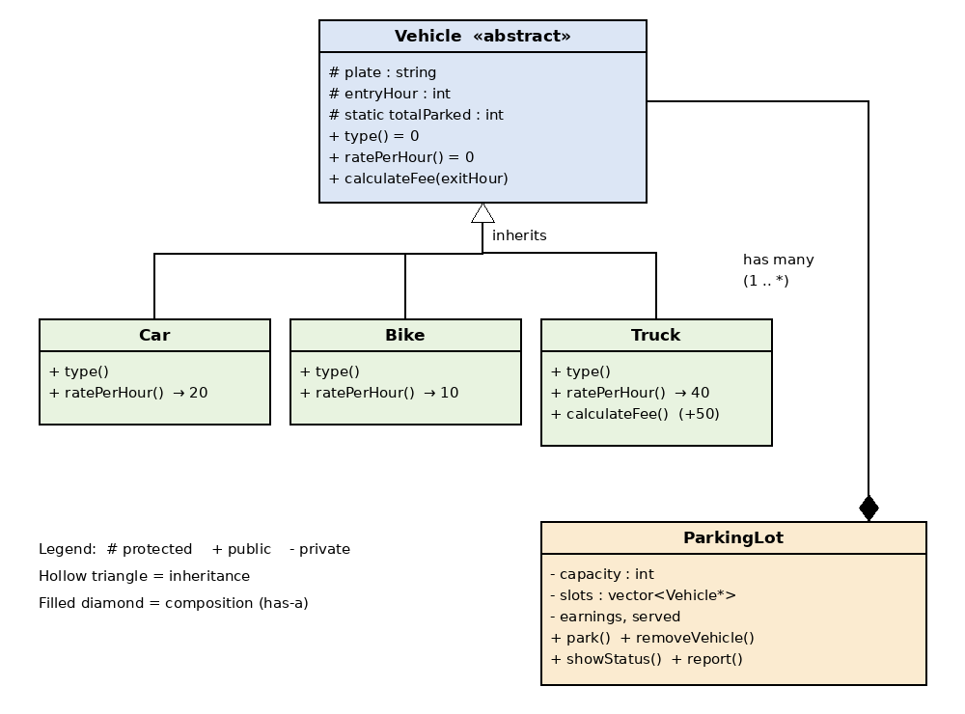
Figure 1: Class diagram of the Smart Parking Management System

3.2 Mapping the Case to OOP Concepts
Concept | Where it is used
Encapsulation | Data members are protected / private; accessed through member functions
Abstraction | Vehicle is an abstract class with pure virtual functions
Inheritance | Car, Bike and Truck inherit from Vehicle
Polymorphism | slots[i]->calculateFee() runs the correct version at run time (virtual function)
Constructor / destructor | Vehicle and ParkingLot; destructors free memory and update the counter
Static member | Vehicle::totalParked counts the vehicles in the lot
Friend + operator overloading | operator<< prints a Vehicle with cout
Composition | A ParkingLot has many Vehicle objects

3.3 Fee Rules
Vehicle | Rate per hour | Rule
Car | Rs. 20 | hours × 20
Bike | Rs. 10 | hours × 10
Truck | Rs. 40 | hours × 40 + Rs. 50 heavy-vehicle charge
Hours = exit hour − entry hour, with a minimum of 1 hour.

3.4 Algorithm
- Start: create a ParkingLot of five slots and show the menu until the user chooses Quit.
- Park: read type, plate and entry hour → create the vehicle object → reject if the plate already exists → place it in the first empty slot → if none is empty show “FULL”.
- Remove: read plate and exit hour → search the plate → reject if not found or exit time is earlier → calculate the fee → print the ticket → add to earnings → delete the object and free the slot.
- Status / Report: show every slot and the number of parked vehicles; show vehicles served and total earnings.

4. IMPLEMENTATION
The program is written in standard C++ (C++11) in a single file, parking_system.cpp, of about 190 lines, using the headers iostream, iomanip, string and vector. The important parts are explained below.

4.1 The Abstract Vehicle Class
Vehicle holds the data common to all vehicles and forces every derived class to say its own type and rate by declaring two pure virtual functions. The static counter totalParked is shared by all objects.
class Vehicle { // abstract base class
protected:
string plate;
int entryHour;
static int totalParked; // shared by all objects
public:
Vehicle(const string& p, int h) : plate(p), entryHour(h) { totalParked++; }
virtual ~Vehicle() { totalParked--; }
virtual string type() const = 0; // pure virtual
virtual double ratePerHour() const = 0; // pure virtual
virtual double calculateFee(int exitHour) const {
int hours = exitHour - entryHour;
if (hours < 1) hours = 1; // minimum 1 hour
return hours * ratePerHour();
}
};

4.2 Derived Classes – Inheritance and Overriding
Car and Bike only give their type and rate. Truck also overrides calculateFee() to add the heavy-vehicle charge to the common calculation.
class Truck : public Vehicle {
public:
Truck(const string& p, int h) : Vehicle(p, h) {}
string type() const override { return "Truck"; }
double ratePerHour() const override { return 40; }
double calculateFee(int exitHour) const override {
return Vehicle::calculateFee(exitHour) + 50; // heavy charge
}
};

4.3 The ParkingLot Class – Encapsulation and Polymorphism
ParkingLot keeps the slots private as a vector of Vehicle pointers (nullptr means empty). In removeVehicle(), the call slots[i]->calculateFee() chooses the right fee rule at run time for a car, a bike or a truck. The destructor deletes every vehicle that is still parked, so memory is never leaked.
double fee = slots[i]->calculateFee(exitHour); // polymorphism
cout << "\n------------- PARKING TICKET -------------\n";
cout << *slots[i] << "\n"; // operator<<
cout << "Fee : Rs. " << fee << "\n";
earnings += fee;
delete slots[i]; // free memory
slots[i] = nullptr; // slot is empty again

4.4 Operator Overloading and the Menu
The insertion operator << is overloaded as a friend of Vehicle so that a vehicle can be printed with cout. The main() function shows a menu in a do-while loop and calls the matching ParkingLot function until the user chooses 0 to quit. The complete source code is available in the GitHub repository.
ostream& operator<<(ostream& os, const Vehicle& v) {
os << left << setw(7) << v.type() << setw(12) << v.plate
<< "Entry: " << v.entryHour << ":00";
return os;
}

5. EXECUTION AND OUTPUT
The program was compiled with g++ -std=c++11 parking_system.cpp -o parking (no errors or warnings with -Wall) and run in the console. A day of parking was simulated: three vehicles arrive, a duplicate and an overflow are attempted, and two vehicles leave.
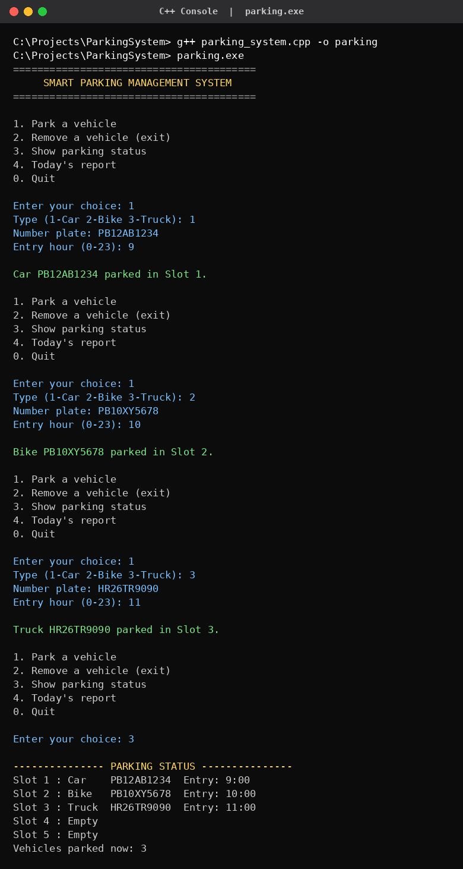  Output 1: Compile, run and park three vehicles | 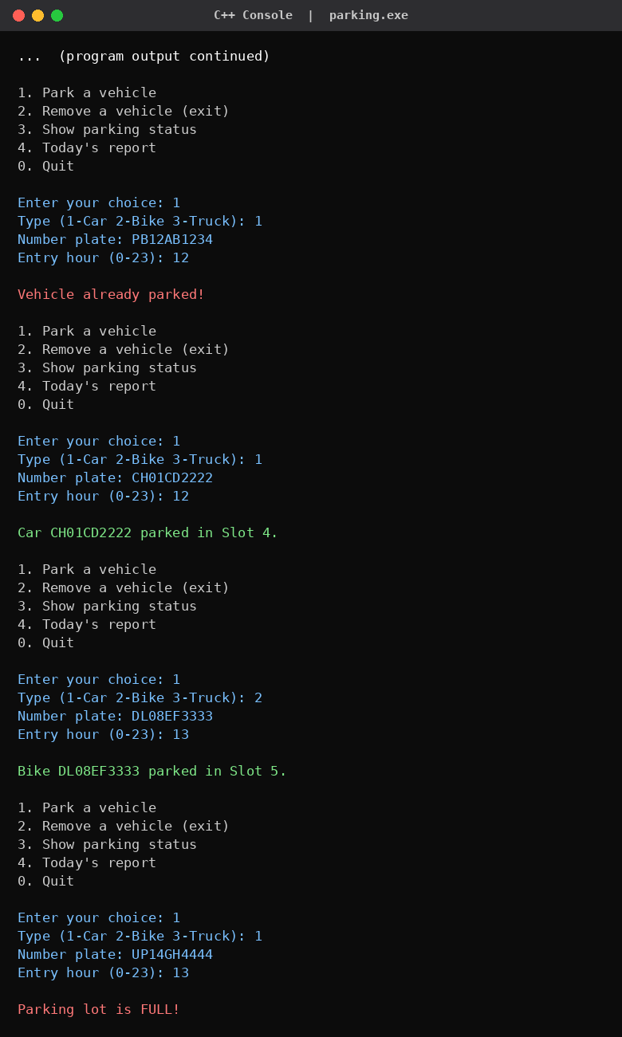  Output 2: Duplicate check, full lot and status

5. EXECUTION AND OUTPUT (continued)
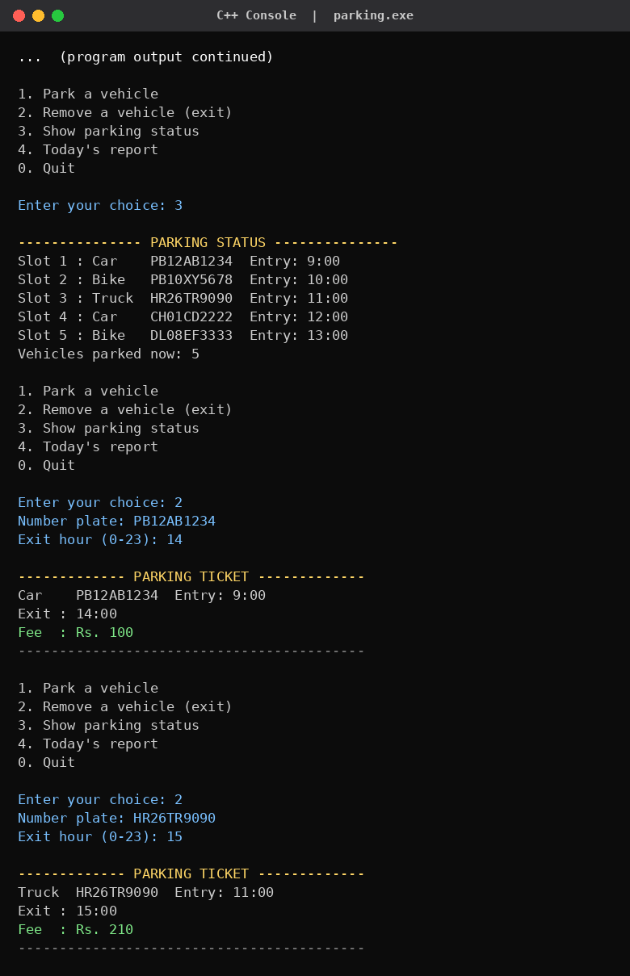  Output 3: Removing vehicles – tickets and fees | 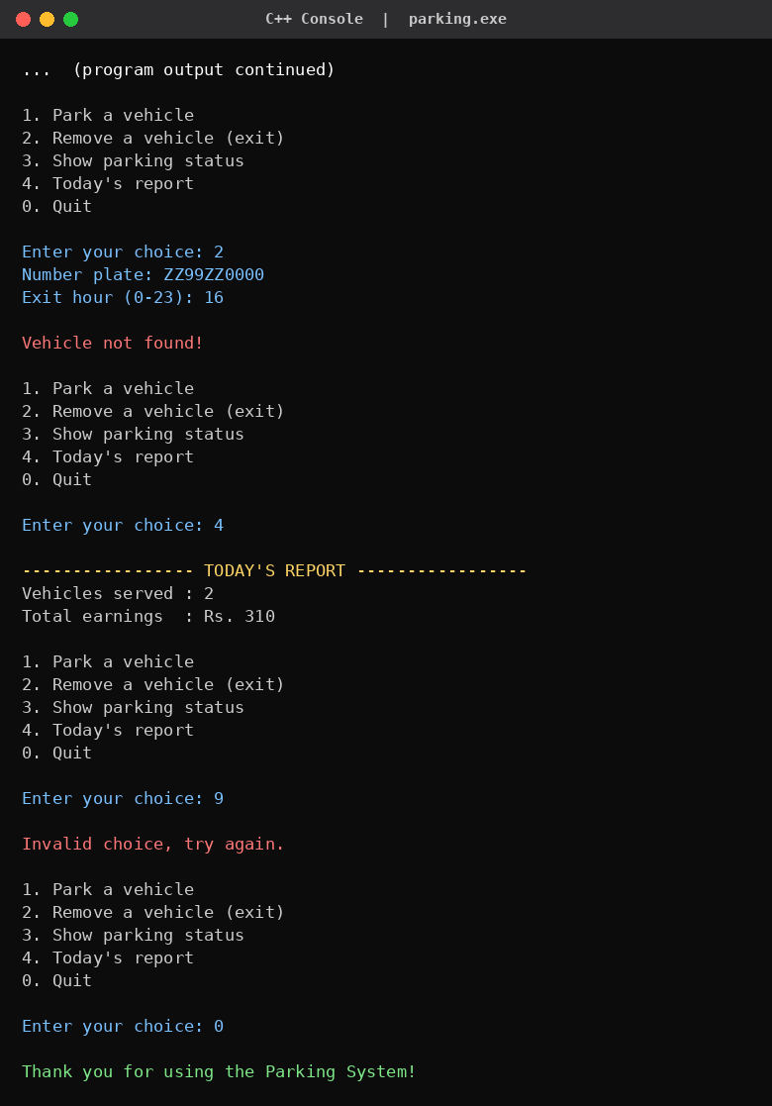  Output 4: Report, invalid choice and quit

6. TESTING AND RESULTS

6.1 Test Cases
No. | Test performed | Expected result | Result
1 | Park a Car, a Bike and a Truck | Placed in slots 1, 2 and 3 | Pass
2 | Park the same plate twice | “Vehicle already parked!” | Pass
3 | Park when all 5 slots are full | “Parking lot is FULL!” | Pass
4 | Remove a Car after 5 hours | Fee = 5 × 20 = Rs. 100 | Pass
5 | Remove a Truck after 4 hours | Fee = 4 × 40 + 50 = Rs. 210 | Pass
6 | Remove a plate that is not parked | “Vehicle not found!” | Pass
7 | Enter menu choice 9 | “Invalid choice, try again.” | Pass
8 | Show report after two exits | Served = 2, earnings = Rs. 310 | Pass

6.2 Fee Calculation Check
Vehicle | Parked time | Calculation | Fee
Car PB12AB1234 | 9:00 to 14:00 (5 hrs) | 5 × 20 | Rs. 100
Truck HR26TR9090 | 11:00 to 15:00 (4 hrs) | 4 × 40 + 50 | Rs. 210
Total earnings |  | 100 + 210 | Rs. 310

6.3 Manual System vs Proposed System
Aspect | Manual notebook | Parking system (C++)
Free slot | Remembered by attendant | Found automatically
Duplicate entry | Not checked | Rejected
Fee | Calculated by hand | Calculated by the vehicle's class
Daily collection | Added at the end of the day | Always up to date in the report
New vehicle type | New rule to remember | One new derived class

7. FINDINGS AND CONCLUSION

7.1 Findings
- Common mistakes were removed. Duplicate entries, parking in a full lot, unknown vehicles and wrong exit times are all detected and answered with a clear message.
- Fees are always correct. Because each class knows its own rate, the Car fee of Rs. 100 and the Truck fee of Rs. 210 in the test were calculated exactly as the rules say.
- Polymorphism kept the code short. The lot calls one function, calculateFee(), for every vehicle and does not need if-else checks for the vehicle type.
- The design is easy to extend. A new vehicle such as a bus needs only a new derived class of about six lines; no change is required in ParkingLot or main().
- Memory is managed safely. Vehicles are deleted on exit, on rejection and in the destructor, so the program does not leak memory.
- The earnings report is accurate. After two exits the report showed 2 vehicles served and Rs. 310 earned, matching the fee table.

7.2 Conclusion
This case study took a real everyday problem – managing a small parking lot – and solved it with Object-Oriented Programming in C++. The abstract class Vehicle with its derived classes Car, Bike and Truck models the real vehicles, the ParkingLot class manages them safely, and virtual functions make the fee calculation correct and simple. All test cases passed, which shows that the system is a reliable replacement for the paper notebook. The case also shows why OOP is useful: the code is organised like the real situation, so it is easy to understand, test and extend.

7.3 Limitations and Future Scope
- Data is kept only in memory; saving records to a file or database would keep them after the program closes.
- Only whole hours are used; actual date and time can be used for exact fees.
- More vehicle types, a graphical interface and online payment can be added in future.

7.4 GitHub
GitHub repository link:
https://github.com/KeshavSaini124/SMART_PARKING_MANAGEMENT_SYSTEM_c-.git

References
- Bjarne Stroustrup, The C++ Programming Language, Addison-Wesley.
- E. Balagurusamy, Object-Oriented Programming with C++, McGraw-Hill Education.
- cppreference.com – https://en.cppreference.com

