
MINI PROJECT REPORT
SMART PARKING MANAGEMENT SYSTEM
Object-Oriented Programming in C++

Submitted by:
Keshav Saini
UID: 25BCD10101

Submitted to:
Mr. Jitendra Kumar
Designation: Professor

in partial fulfillment of the Object-Oriented Programming (C++) course

Chandigarh University
Date of Submission: 21 October 2026

1. INTRODUCTION
Parking is a daily problem in cities, colleges and malls. An attendant must remember which slots are free, which vehicle is parked where, when it arrived and how much it must pay when it leaves. Doing this on paper is slow and error-prone.
The Smart Parking Management System is a menu-driven C++ console application built with Object-Oriented Programming (OOP). Car, Bike and Truck are classes that inherit from an abstract class Vehicle, and a ParkingLot class manages the slots, prints a parking ticket with the correct fee and keeps the day's earnings. Parking is a real-life system, so it maps naturally onto objects and is a good way to practise the four pillars of OOP.

2. OBJECTIVES / PROBLEM STATEMENT
Problem statement: to design and implement a simple parking management system in C++ that stores vehicles in a fixed number of slots, prevents duplicate and overflow entries, calculates the fee according to vehicle type and time, and shows the status and daily earnings – using OOP.
- To apply encapsulation, abstraction, inheritance and polymorphism.
- To create an abstract base class with pure virtual functions and derive Car, Bike and Truck from it.
- To use virtual functions and overriding so that each vehicle calculates its own fee.
- To use constructors, destructors and dynamic memory (new / delete) without memory leaks.
- To use a static member, a friend function and operator overloading.
- To build a simple menu-driven interface with input checks.

3. MODULES, TOOLS AND TECHNOLOGIES USED

3.1 Header Files
Header file | Purpose in the project
iostream | Console input and output (cin, cout)
iomanip | Neat column formatting (setw)
string | Storing number plates
vector | Storing the parking slots as a dynamic array of Vehicle pointers

3.2 Classes Used
Class | Type | Responsibility
Vehicle | Abstract base class | Plate, entry hour; pure virtual type() and ratePerHour(); calculateFee()
Car | Derived class | Rs. 20 per hour
Bike | Derived class | Rs. 10 per hour
Truck | Derived class | Rs. 40 per hour + Rs. 50 heavy-vehicle charge (overrides calculateFee)
ParkingLot | Manager class | Holds slots; parks / removes vehicles; status and report

3.3 OOP Concepts Used
Concept | Where it is used
Encapsulation | Data members are protected / private; accessed through member functions
Abstraction | Vehicle is an abstract class with pure virtual functions
Inheritance | Car, Bike and Truck inherit from Vehicle
Polymorphism | slots[i]->calculateFee() runs the correct version at run time (virtual function)
Constructor / destructor | Vehicle and ParkingLot; destructors free memory and update the counter
Static member | Vehicle::totalParked counts the vehicles in the lot
Friend + operator overloading | operator<< prints a Vehicle with cout
Composition | A ParkingLot has many Vehicle objects

3.4 Tools and Technologies
Tool / Technology | Details
Language | C++ (C++11 standard)
Compiler | GCC – g++ parking_system.cpp -o parking
Editor / IDE | VS Code / Code::Blocks / Dev-C++
Version control | Git and GitHub

4. DESIGN

4.1 Class Diagram
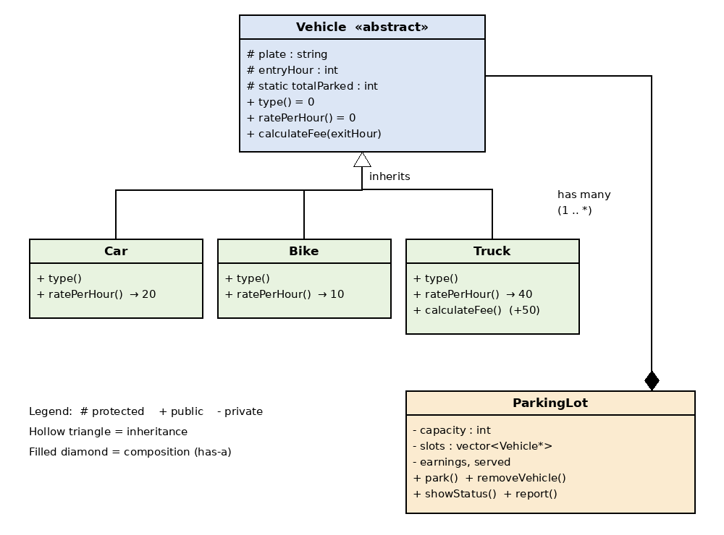
Figure 1: Class diagram

4.2 Working and Fee Rules
- Park: read type, plate and entry hour; reject duplicate plates; put the vehicle in the first empty slot; show “FULL” if none is free.
- Remove: find the plate; reject if not found or exit time is before entry; call calculateFee() polymorphically; print the ticket; free the slot.
Vehicle | Rate per hour | Rule
Car | Rs. 20 | hours × 20
Bike | Rs. 10 | hours × 10
Truck | Rs. 40 | hours × 40 + Rs. 50 heavy-vehicle charge
Hours = exit hour − entry hour, minimum 1 hour.

5. CODE WITH OUTPUT

5.1 Source Code – parking_system.cpp
/*
* Smart Parking Management System - C++ OOP Mini Project
* Submitted by : Keshav Saini (UID: 25BCD10101)
* Submitted to : Mr. Jitendra Kumar, Professor
*
* Concepts: classes & objects, encapsulation, abstraction,
* inheritance, polymorphism, constructors/destructors,
* static members, friend function, operator overloading.
*/
#include <iostream>
#include <iomanip>
#include <string>
#include <vector>
using namespace std;

// ===== PART 1: Vehicle classes (abstraction, inheritance) =====
class Vehicle { // abstract base class
protected:
string plate;
int entryHour;
static int totalParked; // shared by all objects
public:
Vehicle(const string& p, int h) : plate(p), entryHour(h) {
totalParked++;
}
virtual ~Vehicle() { totalParked--; }

virtual string type() const = 0; // pure virtual
virtual double ratePerHour() const = 0; // pure virtual

virtual double calculateFee(int exitHour) const {
int hours = exitHour - entryHour;
if (hours < 1) hours = 1; // minimum 1 hour
return hours * ratePerHour();
}
string getPlate() const { return plate; }
int getEntryHour() const { return entryHour; }
static int getTotalParked() { return totalParked; }

friend ostream& operator<<(ostream& os, const Vehicle& v);
};
int Vehicle::totalParked = 0;

ostream& operator<<(ostream& os, const Vehicle& v) {
os << left << setw(7) << v.type() << setw(12) << v.plate
<< "Entry: " << v.entryHour << ":00";
return os;
}

class Car : public Vehicle {
public:
Car(const string& p, int h) : Vehicle(p, h) {}
string type() const override { return "Car"; }
double ratePerHour() const override { return 20; }
};

class Bike : public Vehicle {
public:
Bike(const string& p, int h) : Vehicle(p, h) {}
string type() const override { return "Bike"; }
double ratePerHour() const override { return 10; }
};

class Truck : public Vehicle {
public:
Truck(const string& p, int h) : Vehicle(p, h) {}
string type() const override { return "Truck"; }
double ratePerHour() const override { return 40; }
double calculateFee(int exitHour) const override {
return Vehicle::calculateFee(exitHour) + 50; // heavy charge
}
};

// ===== PART 2: ParkingLot class (encapsulation, composition) =====
class ParkingLot {
private:
int capacity;
vector<Vehicle*> slots;
double earnings;
int served;

int findPlate(const string& plate) const {
for (int i = 0; i < capacity; i++)
if (slots[i] && slots[i]->getPlate() == plate) return i;
return -1;
}
public:
ParkingLot(int cap) : capacity(cap), slots(cap, nullptr),
earnings(0), served(0) {}
~ParkingLot() {
for (Vehicle* v : slots) delete v;
}

void park(Vehicle* v) {
if (findPlate(v->getPlate()) != -1) {
cout << "\nVehicle already parked!\n";
delete v;
return;
}
for (int i = 0; i < capacity; i++) {
if (!slots[i]) {
slots[i] = v;
cout << "\n" << v->type() << " " << v->getPlate()
<< " parked in Slot " << i + 1 << ".\n";
return;
}
}
cout << "\nParking lot is FULL!\n";
delete v;
}

void removeVehicle(const string& plate, int exitHour) {
int i = findPlate(plate);
if (i == -1) { cout << "\nVehicle not found!\n"; return; }
if (exitHour < slots[i]->getEntryHour()) {
cout << "\nExit time cannot be before entry time!\n";
return;
}
double fee = slots[i]->calculateFee(exitHour); // polymorphism
cout << "\n------------- PARKING TICKET -------------\n";
cout << *slots[i] << "\n";
cout << "Exit : " << exitHour << ":00\n";
cout << "Fee : Rs. " << fee << "\n";
cout << "------------------------------------------\n";
earnings += fee;
served++;
delete slots[i];
slots[i] = nullptr;
}

void showStatus() const {
cout << "\n--------------- PARKING STATUS ---------------\n";
for (int i = 0; i < capacity; i++) {
cout << "Slot " << i + 1 << " : ";
if (slots[i]) cout << *slots[i] << "\n";
else cout << "Empty\n";
}
cout << "Vehicles parked now: " << Vehicle::getTotalParked() << "\n";
}

void report() const {
cout << "\n----------------- TODAY'S REPORT -----------------\n";
cout << "Vehicles served : " << served << "\n";
cout << "Total earnings : Rs. " << earnings << "\n";
}
};

// ===== PART 3: main program (menu-driven) =====
int main() {
ParkingLot lot(5);
int choice;
cout << "========================================\n";
cout << " SMART PARKING MANAGEMENT SYSTEM\n";
cout << "========================================\n";
do {
cout << "\n1. Park a vehicle\n2. Remove a vehicle (exit)\n";
cout << "3. Show parking status\n4. Today's report\n0. Quit\n";
cout << "\nEnter your choice: ";
cin >> choice;

if (choice == 1) {
int t, hour; string plate;
cout << "Type (1-Car 2-Bike 3-Truck): "; cin >> t;
cout << "Number plate: "; cin >> plate;
cout << "Entry hour (0-23): "; cin >> hour;
if (t == 1) lot.park(new Car(plate, hour));
else if (t == 2) lot.park(new Bike(plate, hour));
else if (t == 3) lot.park(new Truck(plate, hour));
else cout << "\nInvalid vehicle type!\n";
} else if (choice == 2) {
int hour; string plate;
cout << "Number plate: "; cin >> plate;
cout << "Exit hour (0-23): "; cin >> hour;
lot.removeVehicle(plate, hour);
} else if (choice == 3) lot.showStatus();
else if (choice == 4) lot.report();
else if (choice != 0) cout << "\nInvalid choice, try again.\n";
} while (choice != 0);

cout << "\nThank you for using the Parking System!\n";
return 0;
}

5.2 Output
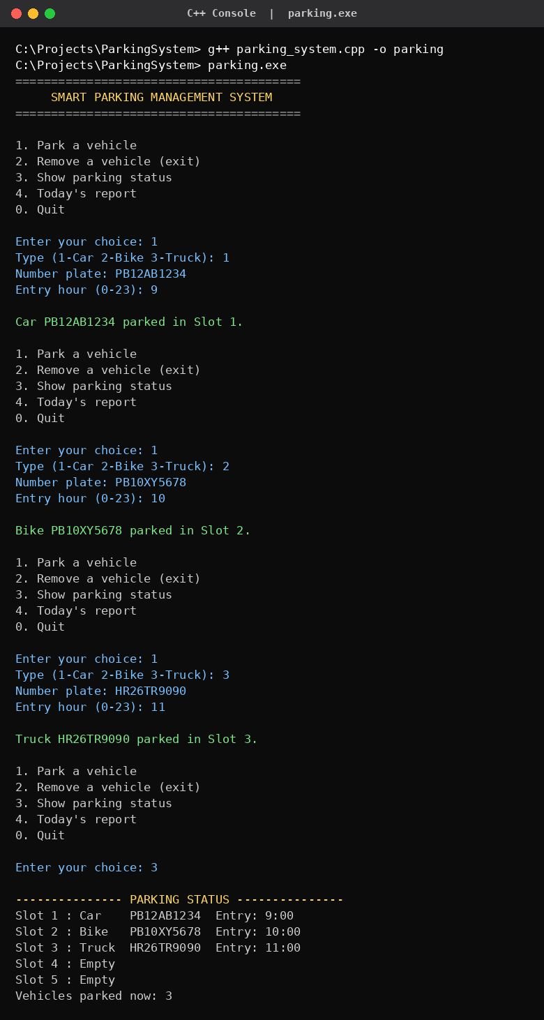  Output 1: Compile, run and park vehicles | 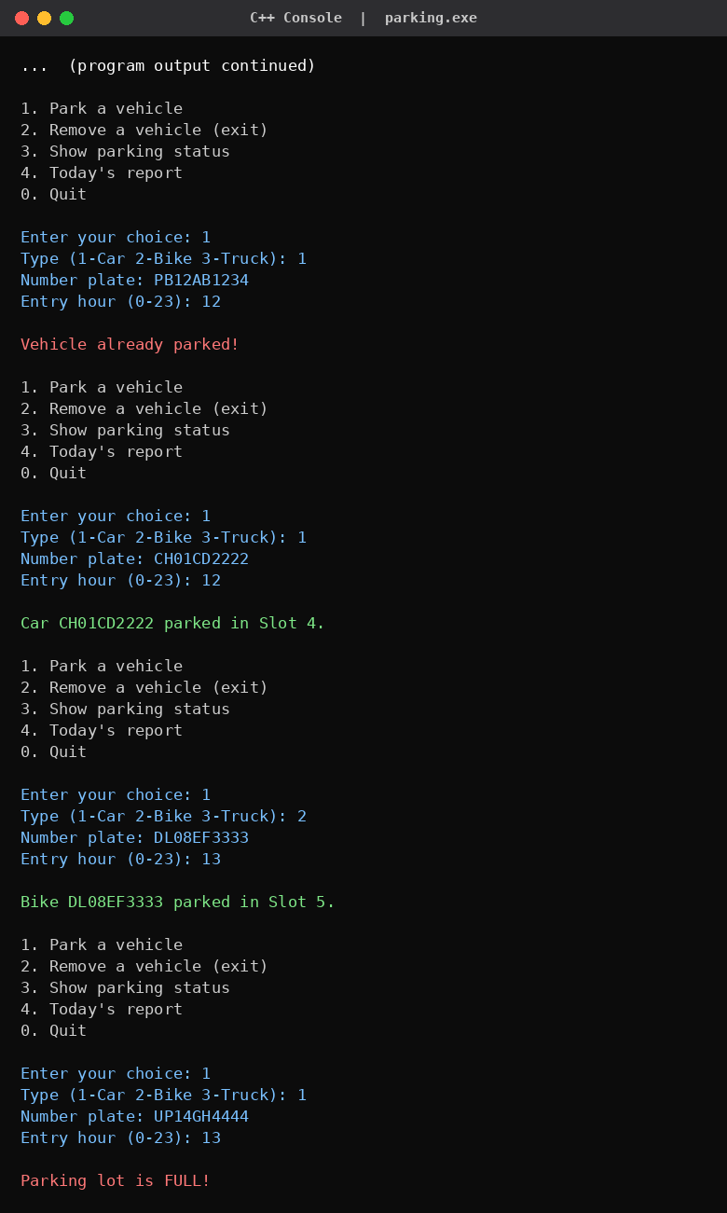  Output 2: Duplicate check and FULL message

5.2 Output (continued)
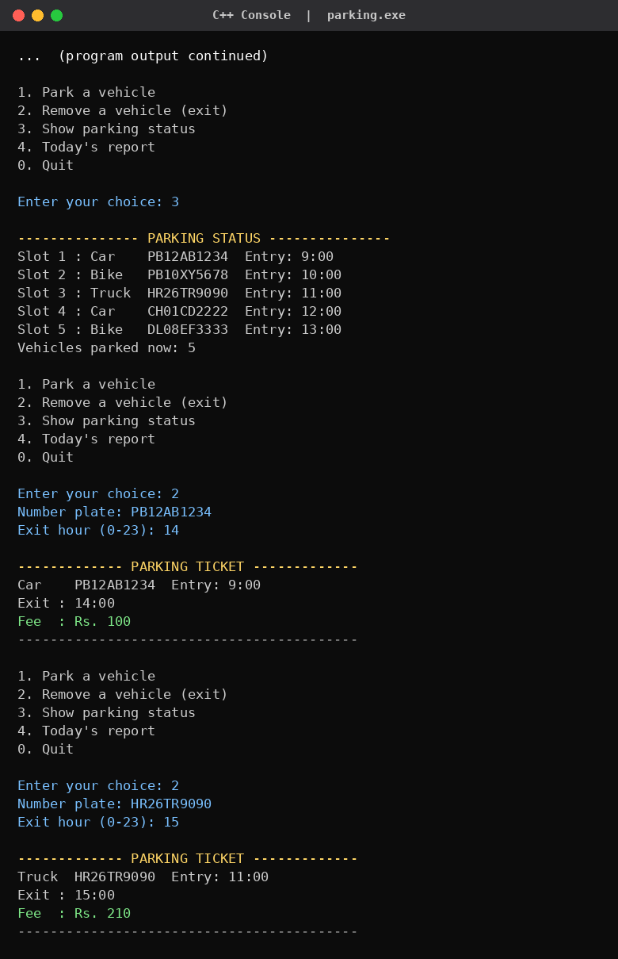  Output 3: Removing vehicles – tickets with fees | 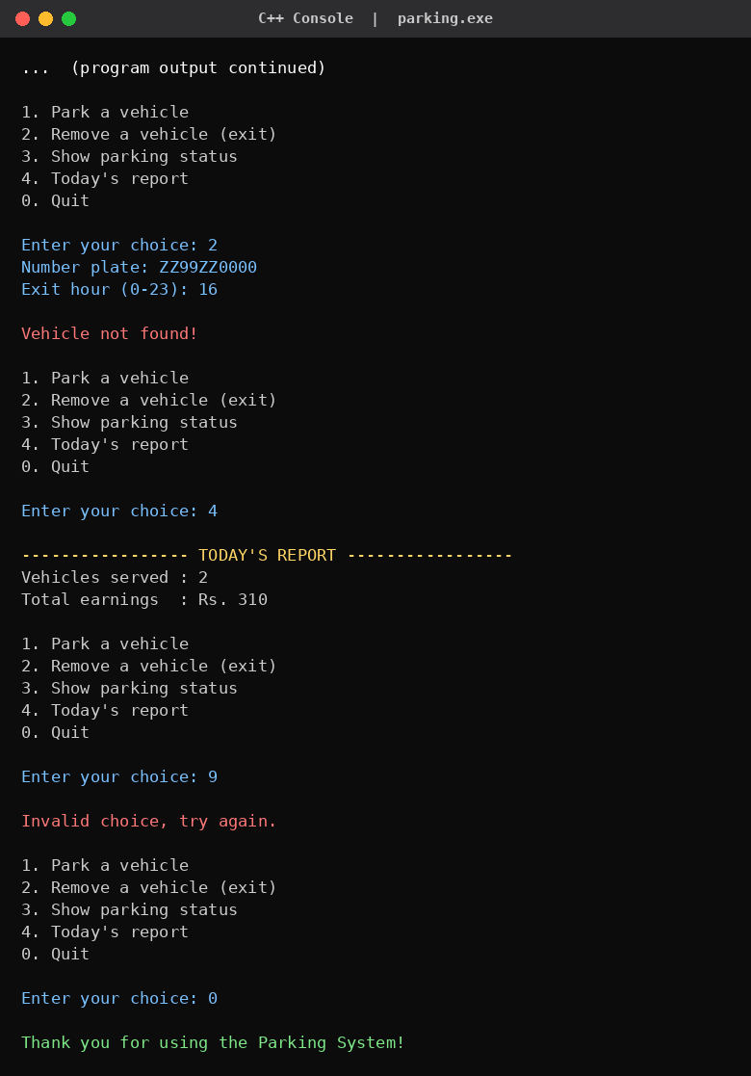  Output 4: Report, invalid choice and quit

Vehicle | Parked time | Calculation | Fee
Car PB12AB1234 | 9:00 to 14:00 (5 hrs) | 5 × 20 | Rs. 100
Truck HR26TR9090 | 11:00 to 15:00 (4 hrs) | 4 × 40 + 50 | Rs. 210
Total earnings |  | 100 + 210 | Rs. 310

6. CONCLUSION
The Smart Parking Management System was successfully implemented in C++ using OOP. It parks and removes vehicles, rejects duplicate and overflow entries, calculates the fee correctly for each vehicle type and reports the day's earnings, as shown in the outputs. I learned how real-world entities become classes, how inheritance avoids repeated code and how virtual functions make one call behave differently for a Car, a Bike and a Truck.

Future Scope
- Save and load records from a file; add more vehicle types by deriving new classes.
- Add a graphical interface and use real date and time for the fee.

7. GITHUB UPLOAD
The project is uploaded to GitHub (parking_system.cpp and README.md).
GitHub repository link:
https://github.com/KeshavSaini124/SMART_PARKING_MANAGEMENT_SYSTEM_c-.git
git init
git add parking_system.cpp README.md
git commit -m "Smart Parking Management System - C++ OOP mini project"
git branch -M main
git remote add origin https://github.com/KeshavSaini124/SMART_PARKING_MANAGEMENT_SYSTEM_c-.git
git push -u origin main

