CASE STUDY
STUDENT PERFORMANCE ANALYSIS
Data Science using Pandas, NumPy, Matplotlib and Seaborn

Submitted by:
Keshav Saini
UID: 25BCD10101

Submitted to:
Faculty Name: Mrs. Preeti
Designation: Assistant Professor

Course: Python Programming (Data Science Mini Project)

Chandigarh University
Date of Submission: 8 October 2026

TABLE OF CONTENTS
Section | Page
1. Problem Statement | 3
2. Dataset Description | 4
3. Data Cleaning Using Pandas | 5
4. Data Analysis Using NumPy and Pandas | 7
5. Data Visualization | 11
6. Findings | 17
7. Conclusion | 17

1. PROBLEM STATEMENT

1.1 Background
Every college and school collects a large amount of data about its students: marks in each subject, attendance, study habits and results. Most of this data is used only to prepare a result sheet at the end of the semester. However, hidden inside the same data are answers to very important questions – why some students score high and others struggle, which subjects are difficult, and which students need help before they fail.
Data Science provides tools to find such answers. Python libraries such as Pandas and NumPy make it easy to clean and calculate on tabular data, and Matplotlib and Seaborn convert numbers into charts that can be understood at a glance. This case study applies these tools to a student record to study academic performance.

1.2 Real-World Problem
The main question investigated in this case study is:
“What factors are associated with students' academic performance?”
A teacher or a department head normally relies on experience and guesses to answer this. If the answer can be shown with data, then decisions such as arranging extra classes, setting an attendance policy or giving special attention to some students can be taken on facts instead of assumptions.

1.3 Objectives of the Case Study
- To load a student dataset and clean it using Pandas (missing values, duplicates, wrong data types and inconsistent values).
- To calculate the mean, median and standard deviation of marks using NumPy and Pandas.
- To compare performance gender-wise, section-wise and subject-wise using grouping and aggregation.
- To find how study hours and attendance are related to marks using correlation.
- To present the results with ten charts using Matplotlib and Seaborn.
- To write clear findings that can help a teacher support students.

1.4 Tools Used
Tool | Use in this case study
Python 3 | Programming language used for the complete analysis
Pandas | Loading the CSV file, cleaning, grouping, sorting and filtering
NumPy | Mean, median, standard deviation and conditional columns (np.where)
Matplotlib | Line chart, bar chart, histogram, pie chart and scatter plot
Seaborn | Box plot, violin plot, heatmap, count plot and pair plot
Git and GitHub | Storing and sharing the project

2. DATASET DESCRIPTION

2.1 About the Dataset
The dataset used is student_data.csv. It contains one row for every student and describes the student's gender, section, daily study hours, attendance percentage and marks in five subjects out of 100. The file has 205 records and 10 columns before cleaning.
The dataset was generated with Python (the script generate_data.py, random seed 42) so that it looks like a typical class record, and the project can be run again by anyone and gives exactly the same result. It was also made slightly “dirty” on purpose – with missing values, repeated rows, a percentage sign inside a number column and gender written in different ways – so that the data cleaning steps of this case study could be practised on realistic problems. Because the data is generated, the results show how the analysis method works and should not be taken as the marks of real students.

2.2 Variables
Column | Data type | Kind | Description
StudentID | int64 | Identifier | Unique roll number from 1 to 200
Gender | text | Categorical | Male or Female
Section | text | Categorical | Class section A, B or C
StudyHours | float64 | Numerical | Average study hours per day (0.5 to 9)
Attendance | text (raw) | Numerical | Attendance percentage, stored as text such as “82%”
Maths | float64 | Numerical | Marks out of 100
Physics | float64 | Numerical | Marks out of 100
Chemistry | float64 | Numerical | Marks out of 100
English | float64 | Numerical | Marks out of 100
Computer | float64 | Numerical | Marks out of 100

2.3 Size of the Data
Property | Value
Records in the raw file | 205
Columns in the raw file | 10
Records after removing duplicates | 200 (100 male and 100 female)
Sections | A: 73 students, B: 61 students, C: 66 students

3. DATA CLEANING USING PANDAS
Real data is rarely perfect. Before any calculation is done, the data must be checked and corrected, otherwise the results can be wrong. The first step is to load the file and look at its shape, first rows and column types.
df = pd.read_csv("student_data.csv")
print("Shape :", df.shape)
print(df.head())
df.info()

The output shows 205 rows and 10 columns. The info() table shows that Attendance and Maths have fewer than 205 non-null values, and that Attendance has the type str (text) instead of a number. These are the first signs of dirty data.
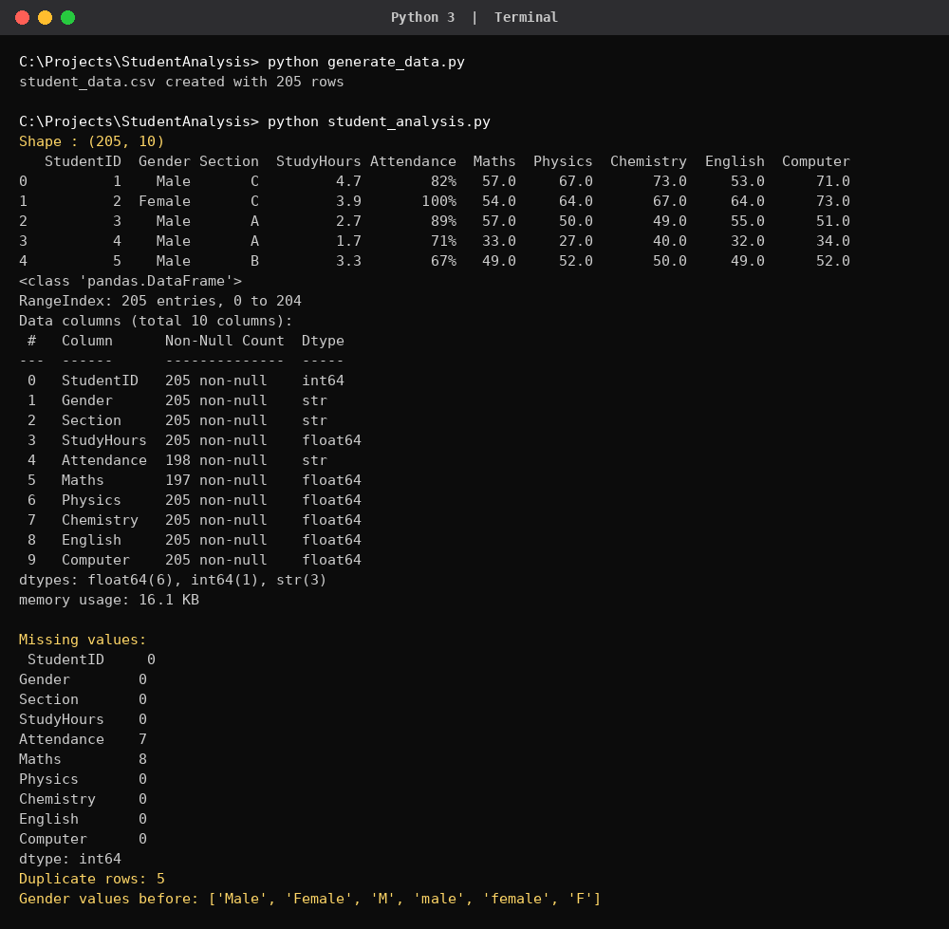
Output 1: Loading the data and checking for missing values and duplicates

3.1 Missing Values
The isnull().sum() command counts the empty cells in every column. Seven values are missing in Attendance and eight in Maths. Dropping those students would waste good data in the other columns, so the missing values were filled with the median of the column. The median is used instead of the mean because it is not affected by extremely high or low marks.
print(df.isnull().sum())
df["Maths"] = df["Maths"].fillna(df["Maths"].median())
df["Attendance"] = df["Attendance"].fillna(df["Attendance"].median())

3.2 Duplicate Records
The duplicated().sum() command found 5 repeated rows. A student counted twice would give his marks extra weight in every average, so the duplicates were removed with drop_duplicates(). The data now has 200 unique students.
print("Duplicate rows:", df.duplicated().sum())
df = df.drop_duplicates()

3.3 Incorrect Data Types
The Attendance column was read as text because every value ends with a percent sign, for example “82%”. Calculations such as mean or correlation cannot be done on text. The % sign was removed with str.replace() and the column was converted to a decimal number with astype(float).
df["Attendance"] = df["Attendance"].str.replace("%", "").astype(float)

3.4 Inconsistent Values
The Gender column contained six different spellings for two categories: Male, Female, M, male, female and F. If used as they are, Pandas would treat them as six different groups. The values were converted to title case and the short forms were replaced with full words.
df["Gender"] = df["Gender"].str.title().replace({"M": "Male", "F": "Female"})

After all four steps the check prints 0 missing values, 0 duplicates and only two gender values (Male and Female), so the data is ready for analysis.

4. DATA ANALYSIS USING NUMPY AND PANDAS

4.1 New Columns
Three new columns were created to measure the performance of each student. np.where() was used to decide Pass or Fail, and pd.cut() was used to divide the percentage into grades. Percentage is the total divided by 5; a student passes only if every subject is 40 or more; and the grades are F (up to 40), D (40–50), C (50–60), B (60–70) and A (above 70).
df["Total"] = df[subjects].sum(axis=1)
df["Percentage"] = df["Total"] / 5
df["Result"] = np.where((df[subjects] >= 40).all(axis=1), "Pass", "Fail")
df["Grade"] = pd.cut(df["Percentage"], [0, 40, 50, 60, 70, 100],
labels=["F", "D", "C", "B", "A"])

4.2 Mean, Median and Standard Deviation
print("Mean :", round(np.mean(df["Percentage"]), 2))
print("Median :", round(np.median(df["Percentage"]), 2))
print("Std dev:", round(np.std(df["Percentage"]), 2))
print(df[subjects].describe().round(2))

Measure | Value | Meaning
Mean percentage | 56.85 | Average performance of the class
Median percentage | 56.30 | Middle student – very close to the mean
Standard deviation | 9.42 | Typical distance of a student from the average
The mean and median are almost equal, which tells us that the marks are spread evenly around the centre without a few extreme values pulling the average. The describe() table gives the subject-wise count, mean, standard deviation, minimum, quartiles and maximum.
Subject | Mean | Std dev | Minimum | Maximum | Median
Maths | 55.92 | 11.26 | 19 | 99 | 56.0
Physics | 56.72 | 11.14 | 26 | 85 | 56.5
Chemistry | 56.88 | 11.68 | 30 | 93 | 58.5
English | 58.05 | 12.45 | 23 | 100 | 56.0
Computer | 56.66 | 12.53 | 26 | 87 | 56.0

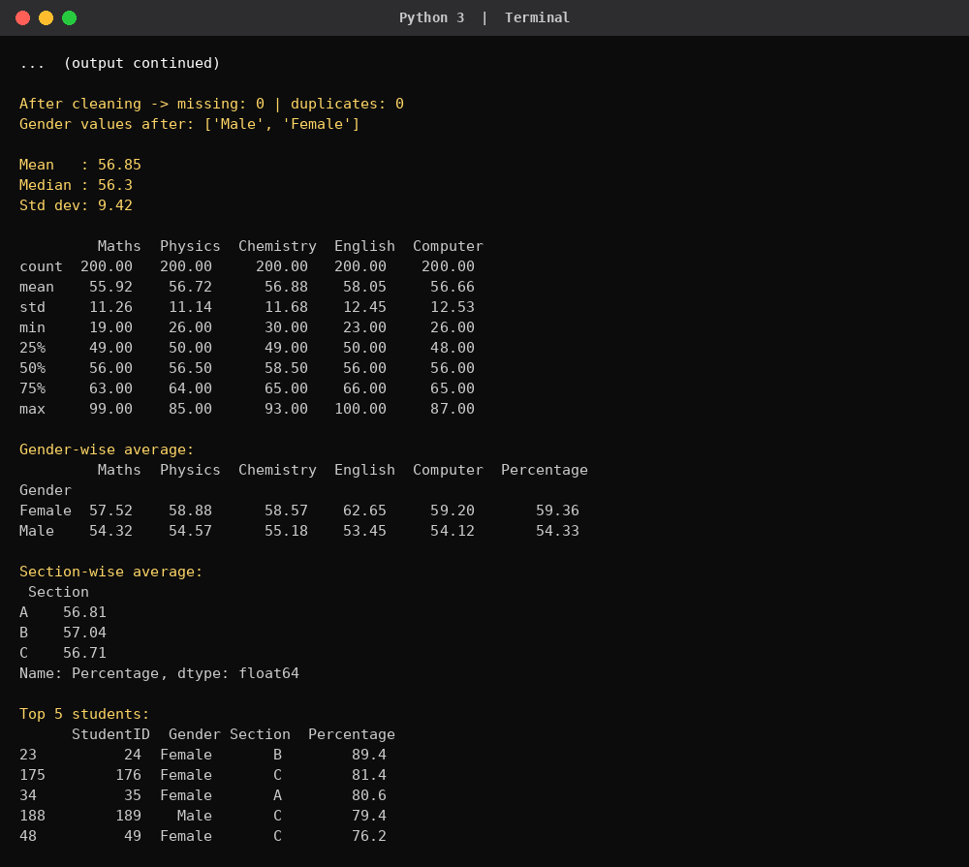
Output 2: Descriptive statistics, grouping and aggregation

4.3 Grouping and Aggregation
The groupby() function divides the data into groups and calculates a value for each group. The data was grouped by gender and by section.
print(df.groupby("Gender")[subjects + ["Percentage"]].mean().round(2))
print(df.groupby("Section")["Percentage"].mean().round(2))

Gender | Maths | Physics | Chemistry | English | Computer
Female | 57.52 | 58.88 | 58.57 | 62.65 | 59.20
Male | 54.32 | 54.57 | 55.18 | 53.45 | 54.12
Female students have a higher average in every subject. The biggest difference is in English, where the average of female students is 62.65 and of male students is 53.45. Section-wise averages are almost the same: A has 56.81, B has 57.04 and C has 56.71, so the section does not affect performance.

4.4 Sorting and Filtering
sort_values() arranges the students by percentage so that the top performers can be seen, and a condition inside square brackets filters the students with low attendance.
print(df.sort_values("Percentage", ascending=False).head(5))
print(len(df[df["Attendance"] < 60]), "students")
print(df["Result"].value_counts())

StudentID | Gender | Section | Percentage
24 | Female | B | 89.4
176 | Female | C | 81.4
35 | Female | A | 80.6
189 | Male | C | 79.4
49 | Female | C | 76.2
Four of the top five students are female. Fifteen students have attendance below 60%. In the result count, 157 students passed and 43 failed, where “fail” means scoring below 40 in at least one subject.

4.5 Correlation
Correlation shows how strongly two numerical columns move together. Its value lies between −1 and +1. A value close to +1 means that when one column increases the other also increases. The corr() function of Pandas was used to find the correlation of every column with the overall percentage.
corr = df[["StudyHours", "Attendance"] + subjects + ["Percentage"]].corr()
print(corr["Percentage"].round(2))

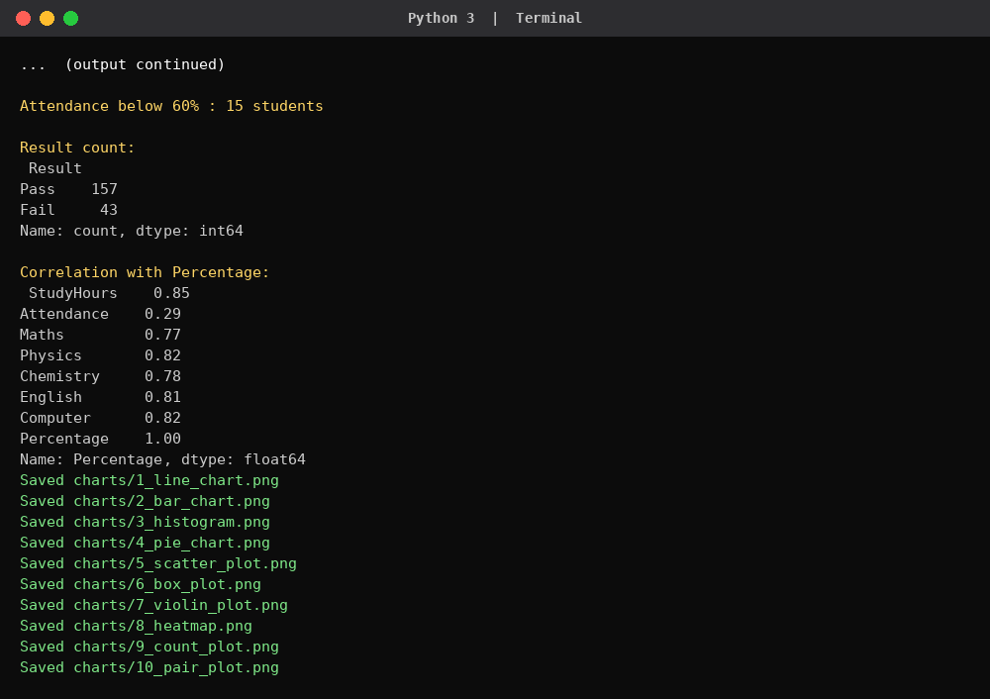
Output 3: Sorting, filtering and correlation, and the saving of the charts
Column | Correlation | Strength
StudyHours | 0.85 | Very strong positive
Physics, Computer | 0.82 | Very strong positive
English | 0.81 | Very strong positive
Chemistry | 0.78 | Strong positive
Maths | 0.77 | Strong positive
Attendance | 0.29 | Weak positive

5. DATA VISUALIZATION
A chart can show a pattern that is difficult to see in a table of numbers. Ten charts were drawn: five with Matplotlib and five with Seaborn. All of them are saved as PNG files in the charts folder of the project. A small helper function is used to save each chart, so the code stays short.
def save(name):
plt.tight_layout()
plt.savefig(f"charts/{name}.png", dpi=110)
plt.close()

5.1 Matplotlib Charts
(a) Line chart – average percentage for each study-hour level
df.groupby(df["StudyHours"].round())["Percentage"].mean().plot(marker="o")

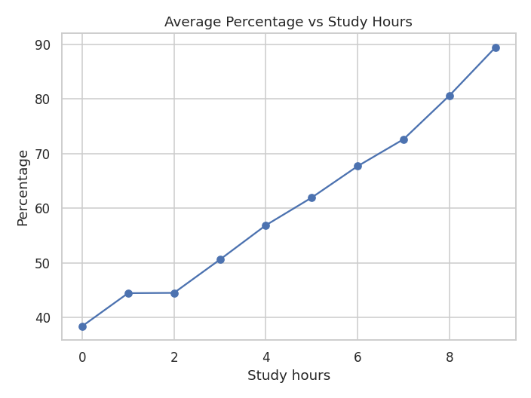
Figure 1: Average percentage vs study hours
The line rises steadily without any fall: students who study about 2 hours a day average 44.5%, those who study 4 hours average 56.9% and those who study 6 hours average 67.7%. The points at 0, 8 and 9 hours are based on only one student each, so they should be read carefully.
(b) Bar chart – average marks in each subject
df[subjects].mean().plot(kind="bar", color="steelblue")

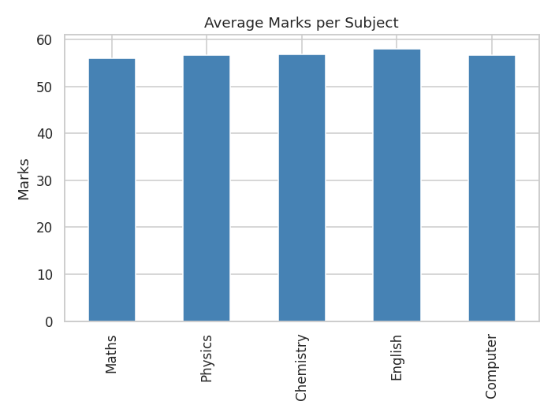
Figure 2: Average marks per subject
All five bars are almost equal. English has the highest average (58.05) and Maths the lowest (55.92), but the gap is only about two marks, so no subject is much harder than the others.
(c) Histogram – distribution of percentage
plt.hist(df["Percentage"], bins=12, color="orange", edgecolor="black")

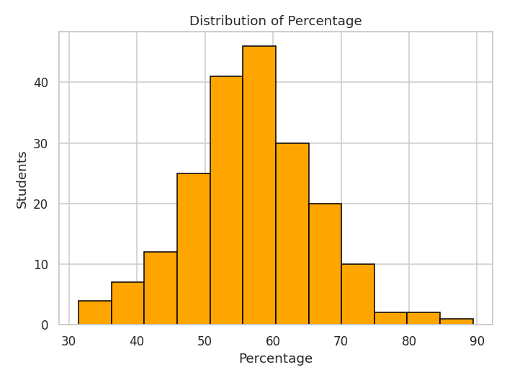
Figure 3: Distribution of percentage
The histogram is bell-shaped with its peak between 50% and 60%. Few students are below 40% or above 75%, which agrees with the mean (56.85) and median (56.3) calculated earlier.
(d) Pie chart – grade distribution
df["Grade"].value_counts().sort_index().plot(kind="pie", autopct="%1.0f%%")

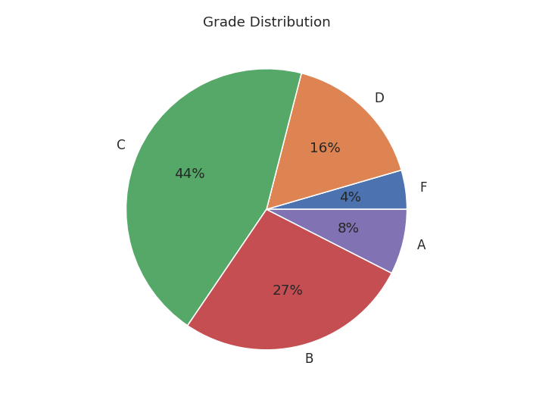
Figure 4: Grade distribution
Grade C is the largest slice with 89 students (about 44%), followed by B with 54 students (27%) and D with 33 students (16%). Only 15 students (about 8%) obtained grade A and 9 students (4%) obtained grade F.
(e) Scatter plot – attendance and percentage
plt.scatter(df["Attendance"], df["Percentage"], alpha=0.6, color="green")

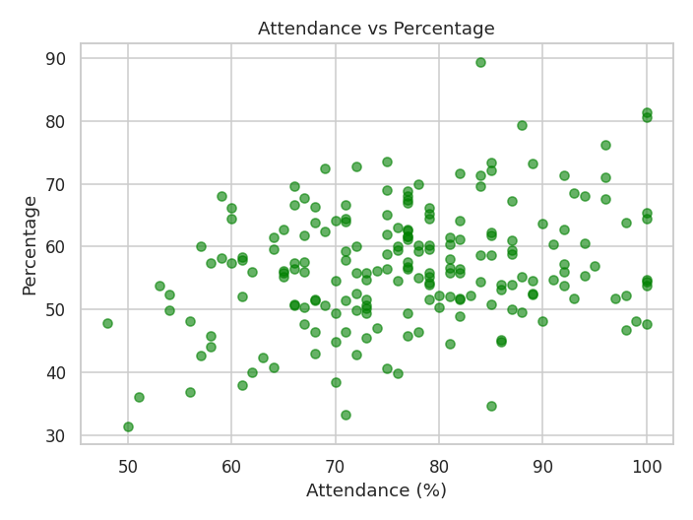
Figure 5: Attendance vs percentage
The points rise slowly from left to right but are widely scattered. This matches the weak correlation of 0.29: higher attendance helps, but many students with high attendance still score only average marks.

5.2 Seaborn Charts
(f) Box plot – subject-wise marks
sns.boxplot(data=df[subjects])

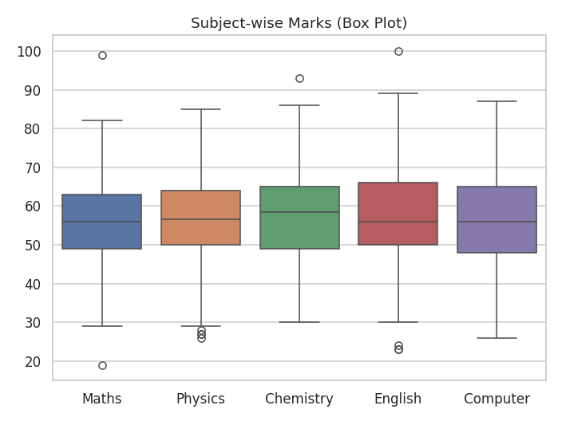
Figure 6: Subject-wise marks
The medians of all subjects are close to 56–58. Computer and English have the largest spread (standard deviation 12.53 and 12.45), and every subject has a few outliers – for example some students scored above 90 in Maths, Chemistry and English while a few scored below 30.
(g) Violin plot – percentage in each section
sns.violinplot(x="Section", y="Percentage", data=df)

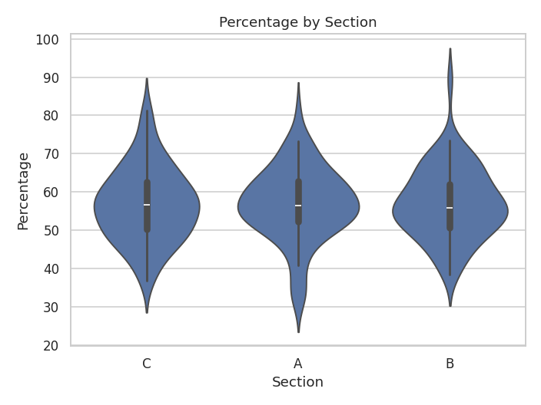
Figure 7: Percentage by section
The three violins have nearly the same shape, width and centre. This confirms that the section a student belongs to makes no real difference to the percentage.
(h) Heatmap – correlation of all numerical columns
sns.heatmap(corr, annot=True, fmt=".2f", cmap="coolwarm")

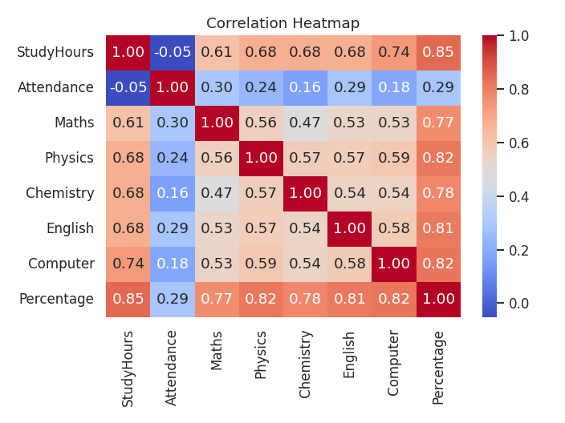
Figure 8: Correlation heatmap
The darkest red squares belong to StudyHours with the subjects and with Percentage (0.85). Attendance is only lightly coloured (0.16 to 0.30). The subjects are moderately related to one another (0.47 to 0.59), which means a student who is good in one subject is usually good in the others.
(i) Count plot – grades of male and female students
sns.countplot(x="Grade", hue="Gender", data=df, order=["F", "D", "C", "B", "A"])

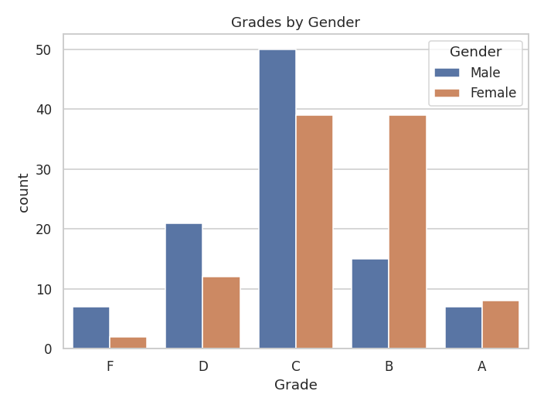
Figure 9: Grades by gender
Female students are far more common in grade B (39 against 15), while male students are more common in grades D (21 against 12) and F (7 against 2). Grade C is the most common for both.
(j) Pair plot – study hours, attendance and percentage
sns.pairplot(df[["StudyHours", "Attendance", "Percentage"]])

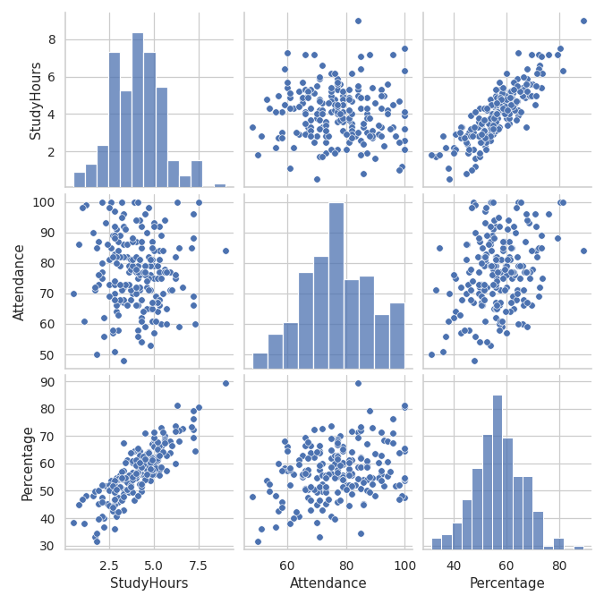
Figure 10: Pair plot
The pair plot shows all relationships together. The StudyHours–Percentage panels show points close to a straight line, while the Attendance panels are spread out. The diagonal histograms show how each variable is distributed.

6. FINDINGS
The following observations are based on the analysis of the 200 cleaned student records:
- Study hours is the strongest factor. Its correlation with percentage is 0.85. Students who study less than 2 hours a day average 42.2%, while students who study 6 hours or more average 73.2% – a difference of more than 30 marks.
- Attendance matters, but much less. The correlation is only 0.29. Students with attendance below 60% average 48.8%, and those with 80% or more average 58.9%. Fifteen students have attendance below 60% and need attention.
- Female students perform better on average. Their overall average is 59.36% against 54.33% for male students, and the gap is largest in English (62.65 against 53.45).
- The pass rate is 78.5%. 157 of 200 students passed all five subjects and 43 failed at least one. The pass rate of female students is 85% compared with 72% for male students.
- No subject is much harder than the others. Subject averages lie between 55.9 (Maths) and 58.1 (English). Computer and English show the largest differences between students.
- Section does not affect results. Averages are 56.81 (A), 57.04 (B) and 56.71 (C), and the violin plots look almost identical.
- Most students are average performers. Grade C has 89 students (44.5%), only 15 students (7.5%) reached grade A, and 42 students (21%) are in grades D and F.
- Good data cleaning was necessary. The raw file had 15 missing values, 5 duplicate rows, a text column that should have been numeric and six spellings for two genders. Without cleaning, the averages and group comparisons would have been wrong.

7. CONCLUSION
This case study analysed a student performance dataset using Pandas, NumPy, Matplotlib and Seaborn. The raw file was first cleaned by filling missing values, removing duplicates, converting the attendance column to numbers and correcting the gender spellings. After that, statistics, grouping, sorting, filtering and correlation were used to find patterns, and ten charts were drawn to present them.
The analysis shows that the amount of time a student spends studying each day is the single most important factor linked with marks, far ahead of attendance, section or subject. Attendance has a smaller but positive effect, and female students scored higher than male students in this dataset, especially in English. Most students are in the middle grades, and about one in five students is in grade D or F.

7.1 Suggestions
- Encourage regular daily study and set up supervised study hours for students who study less than two hours a day.
- Identify students with attendance below 60% early in the semester and counsel them.
- Give extra support in English to male students and in the subjects where the failing students are weak.
- Repeat this analysis every semester so that the effect of such steps can be measured.

7.2 Limitations and Future Work
The dataset is generated, so the relationships are examples of the method and not facts about real students. The study can be repeated with real data from a college, and extended with machine learning, for example a model that predicts a student's result from study hours and attendance.

7.3 Project Files and GitHub
The complete project (generate_data.py, student_analysis.py, student_data.csv and the charts folder) is available on GitHub:
GitHub repository link:
https://github.com/KeshavSaini124/STUDENT_PERFORMANCE_ANALYSIS_Python.git

References
- Pandas documentation – https://pandas.pydata.org/docs/
- NumPy documentation – https://numpy.org/doc/
- Matplotlib documentation – https://matplotlib.org/stable/
- Seaborn documentation – https://seaborn.pydata.org/

