
MINI PROJECT REPORT
STUDENT PERFORMANCE ANALYSIS
Data Science using Pandas, NumPy, Matplotlib and Seaborn

Submitted by:
Keshav Saini
UID: 25BCD10101

Submitted to:
Faculty Name: Mrs. Preeti
Designation: Assistant Professor

Course: Python Programming (Data Science Mini Project)

Chandigarh University
Date of Submission: 8 October 2026

1. INTRODUCTION
Colleges keep a large amount of data about their students – marks, attendance and study habits – but it is usually used only to prepare a result. This mini project uses Python data science libraries to look inside such data and find out what is linked with good and poor academic performance.
The project, Student Performance Analysis, reads a student record file, cleans it with Pandas, calculates statistics with NumPy and Pandas, and shows the results with ten charts drawn using Matplotlib and Seaborn. A detailed case study of the same project is submitted separately.

2. OBJECTIVES / PROBLEM STATEMENT
Problem statement: “What factors are associated with students' academic performance?”
- Clean a real-looking dataset: missing values, duplicates, wrong data types and inconsistent values.
- Find the mean, median and standard deviation of marks, and compare groups (gender, section, subject).
- Measure the effect of study hours and attendance on marks using correlation.
- Present the results using Matplotlib and Seaborn charts and write clear findings.

3. MODULES, TOOLS AND TECHNOLOGIES USED
Library / Tool | Type | Used for
pandas | Third-party | Reading the CSV file, cleaning, grouping, sorting, filtering, correlation
numpy | Third-party | mean, median, standard deviation, np.where for the Pass/Fail column
matplotlib | Third-party | Line chart, bar chart, histogram, pie chart, scatter plot
seaborn | Third-party | Box plot, violin plot, heatmap, count plot, pair plot
Python 3 / VS Code | Language / editor | Writing and running the program
Git and GitHub | Version control | Storing and sharing the project

Dataset: student_data.csv has 205 rows and 10 columns (StudentID, Gender, Section, StudyHours, Attendance and the marks of Maths, Physics, Chemistry, English and Computer). It was generated with a fixed random seed by generate_data.py, with some missing values, duplicates and inconsistent entries added on purpose so that data cleaning could be practised. After cleaning, 200 students remain.

4. CODE WITH OUTPUT
The project has two short files: generate_data.py (creates the dataset) and student_analysis.py (about 100 lines, complete analysis). The important statements of student_analysis.py are shown below; the full code is in the GitHub repository.
df = pd.read_csv("student_data.csv") # load
df = df.drop_duplicates() # 5 duplicates removed
df["Attendance"] = df["Attendance"].str.replace("%", "").astype(float)
df["Maths"] = df["Maths"].fillna(df["Maths"].median())
df["Attendance"] = df["Attendance"].fillna(df["Attendance"].median())
df["Gender"] = df["Gender"].str.title().replace({"M": "Male", "F": "Female"})

df["Total"] = df[subjects].sum(axis=1)
df["Percentage"] = df["Total"] / 5
df["Result"] = np.where((df[subjects] >= 40).all(axis=1), "Pass", "Fail")
df["Grade"] = pd.cut(df["Percentage"], [0, 40, 50, 60, 70, 100],
labels=["F", "D", "C", "B", "A"])

print(df.groupby("Gender")[subjects + ["Percentage"]].mean().round(2))
corr = df[["StudyHours", "Attendance"] + subjects + ["Percentage"]].corr()

df.groupby(df["StudyHours"].round())["Percentage"].mean().plot(marker="o") # line
sns.heatmap(corr, annot=True, fmt=".2f", cmap="coolwarm") # heatmap

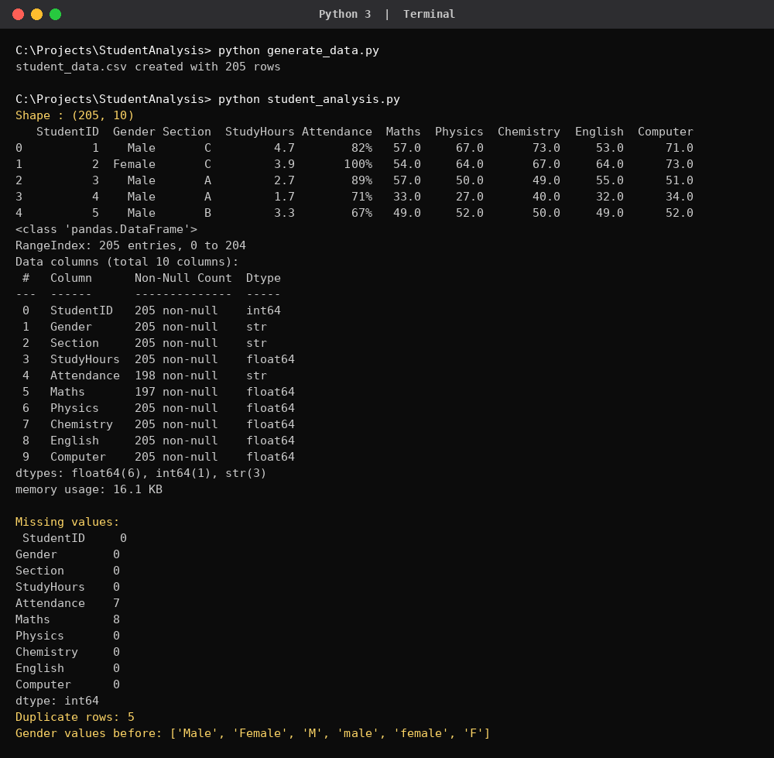
Output 1: Data loading and checking for missing values and duplicates
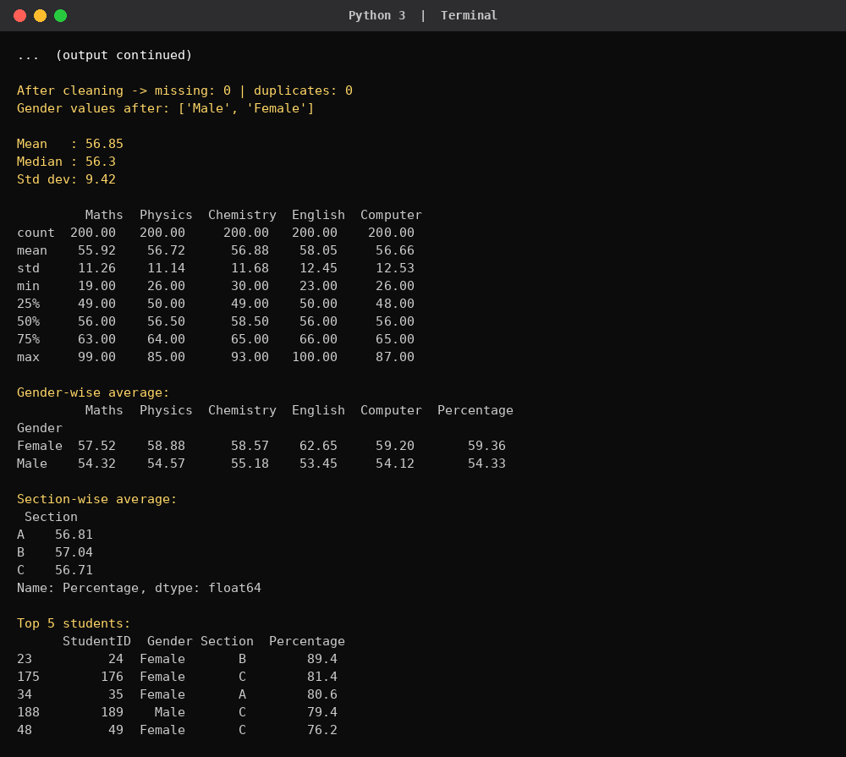
Output 2: Descriptive statistics and gender-wise averages
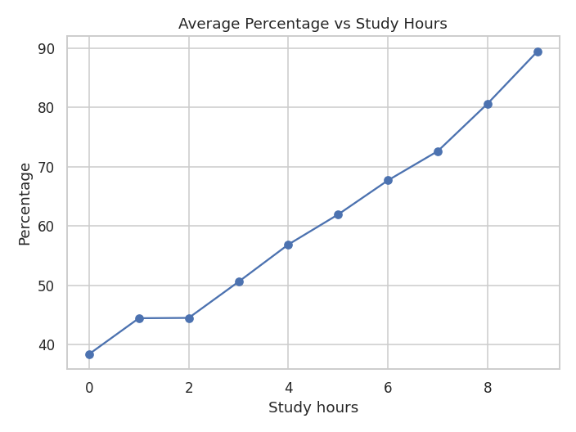  Chart 1: Average percentage vs study hours | 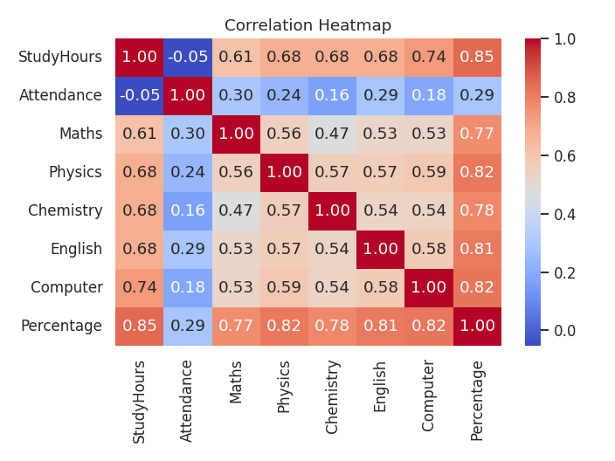  Chart 2: Correlation heatmap

5. FINDINGS
- Study hours is the strongest factor: correlation with percentage is 0.85 (students under 2 hours average 42.2%, 6 hours or more average 73.2%).
- Attendance has a weak effect (correlation 0.29); 15 students have attendance below 60%.
- Female students average 59.36% against 54.33% for male students; the largest gap is in English.
- 157 of 200 students passed all subjects (pass rate 78.5%); grade C is the most common (89 students).
- All subject averages are close (55.9 to 58.1) and section has no real effect on marks.

6. CONCLUSION
The project shows that data analysis with Pandas, NumPy, Matplotlib and Seaborn can turn a simple student record into useful knowledge. After cleaning the data, the analysis found that daily study time is the factor most strongly linked with marks, ahead of attendance, section and subject. Such results can help teachers give extra support to students who study little or attend irregularly. The same code can be reused on real college data.
Github Link :
https://github.com/KeshavSaini124/STUDENT_PERFORMANCE_ANALYSIS_Python.git

