Report
Of
Artificial Intelligence Internship: Machine Learning Based Cardiovascular Disease Prediction and Spotify Songs’ Genre Segmentation
Submitted
To
School of Computer Science and Engineering
IILM University, Greater Noida, U.P.
In partial fulfilment of the requirement of degree of
B.Tech CSE -AI/ML(IBM-ICE)

By
Roll Number of Student: 25SCS1003001691
Name of Student: KESHAV SHANDILYA
Section: 2CSE-22
Batch: 2025-2029

2026-27

TABLE OF CONTENTS
Chapter No. | Chapter Name | Page No.
 | Cover Page | ----
1. | Candidate’s Declaration | ii
2. | Acknowledgement | iii
3. | Internship Completion Certificate | ----
4. | Project Description | 1
 | 4.1 Introduction | 1
 | 4.2 Organization Profile | 1
 | 4.3 Problem Statement | 2
 | 4.4 Project Objectives | 2
 | 4.5 Scope of the Project | 3
 | 4.6 Technologies and Tools Used | 4
 | 4.7 System Architecture | 4
 | 4.8 Methodology | 5
 | 4.9 Expected Outcomes | 18
 | 4.10 Certificates of Completion | 19
5. | Bibliography/References | 20
CANDIDATE’S DECLARATION
I, KESHAV SHANDILYA, do hereby declare that the internship report titled “Artificial Intelligence Internship: Machine Learning Based Cardiovascular Disease Prediction and Spotify Songs’ Genre Segmentation” has been completed by me to fulfil the requirement for the award of the degree of Bachelor of Technology in CSE. All the references have been quoted and I have not taken as such any material from any other source. I affirm to you that this report is my own and has not been submitted to any other institute for any degree/diploma requirement and further I shall be solely responsible for any kind of copyright violation in this regard.
Student Name: Keshav Shandilya
Roll No.: 25SCS1003001691
Section: 2CSE-22
ACKNOWLEDGEMENT
I, Keshav Shandilya, am using this opportunity to express my gratitude to everyone who supported me throughout the Internship Program. I am thankful for their aspiring guidance, invaluably constructive criticism and friendly advice during this work. I am sincerely grateful to them for sharing their truthful and illuminating views on a number of issues related to this work.
I would like to extend my sincere thanks to Corizo and Mr. Hemant Ingle, Academic Head, for giving me the opportunity to undertake this Artificial Intelligence internship and for their guidance and support throughout its duration.
I would also like to thank the School of Computer Science and Engineering, IILM University, Greater Noida, U.P., for providing the platform and encouragement to undertake this internship as part of my academic curriculum.
I express my gratitude to my parents for their blessings.
Student Name: Keshav Shandilya
Roll No.: 25SCS1003001691
Section:2CSE-22
INTERNSHIP COMPLETION CERTIFICATE


PROJECT DESCRIPTION
4.1 Introduction
This report presents the work carried out during a one-month internship in Artificial Intelligence undertaken with Corizo, an ed-tech platform that provides industry-oriented internships and project-based training programs, from 05 December 2025 to 05 January 2026. The internship was completed under the guidance of Mr. Hemant Ingle, Academic Head, and was aimed at providing hands-on exposure to the complete data science and machine learning workflow, starting from raw data and ending in actionable insight.
As part of the internship, two independent projects were undertaken, each based on a real-world, publicly available dataset. The first project, “Cardiovascular Disease Prediction”, applies supervised machine learning to a healthcare dataset of over 68,000 patients in order to classify the presence or absence of cardiovascular disease from routinely recorded clinical and lifestyle attributes. The second project, “Spotify Songs’ Genre Segmentation”, applies unsupervised machine learning to a dataset of over 28,000 tracks from the Spotify platform in order to explore how the audio characteristics of a song relate to its musical genre.
Although the two projects differ in domain and in the class of algorithm used, both were carried out using the same overall methodology: data acquisition, data cleaning and preprocessing, exploratory data analysis, feature scaling, model building, and evaluation of results. This report documents that process for both projects, along with the tools used, the system architecture followed, the outcomes obtained, and the certificate issued on successful completion of the internship.
4.2 Organization Profile
Corizo is an Indian ed-tech platform that provides internships, professional training programs, career guidance and mentorship to engineering and management students. The platform’s stated objective is to bridge the gap between formal classroom education and the practical, fast-changing requirements of industry by pairing learners with experienced mentors and structured, project-based curricula. It offers training across multiple technology domains, including Data Science, Machine Learning, Web Development, Cyber Security and Cloud Computing, and issues an internship completion certificate to interns who successfully complete their assigned project work.
The Artificial Intelligence internship undertaken for this report followed this project-based model, consisting of guided learning modules followed by independent project assignments that were evaluated by the organization’s academic team. The internship completion certificate issued by Corizo on completion of this internship is provided in Chapter 3 of this report.
4.3 Problem Statement
4.3.1 Cardiovascular Disease Prediction
Cardiovascular diseases (CVDs) are, by a wide margin, the leading cause of death worldwide. According to the World Health Organization, CVDs were responsible for an estimated 19.8 million deaths in 2022 alone, accounting for close to a third of all deaths recorded globally that year, with the large majority caused by heart attack and stroke. A substantial share of this burden is preventable, since many of the underlying risk factors, such as high blood pressure, high cholesterol, elevated glucose, smoking, alcohol use and physical inactivity, are measurable well before a cardiac event occurs. This creates a strong motivation for data-driven screening tools that can flag at-risk individuals early, using only the kind of clinical and lifestyle information already collected during a routine health check-up. The problem addressed in this project is to use such attributes, recorded for over 68,000 patients, to build a machine learning model that classifies whether a given individual is likely to have cardiovascular disease.
4.3.2 Spotify Songs’ Genre Segmentation
Modern music streaming platforms such as Spotify curate playlists and recommendations not only from what a listener explicitly chooses, but from the underlying acoustic character of the songs themselves, captured as numerical audio features such as danceability, energy, valence, acousticness and tempo. Two songs from very different artists can be acoustically similar, while two songs shelved under the same genre label can sound quite different, which makes genre a somewhat fuzzy, human-assigned category rather than a strict acoustic boundary. The problem addressed in this project is to explore whether the audio features already computed for a track can, on their own and without using the genre label, be used to group songs into meaningful clusters, and to examine how well those data-driven clusters line up with the genre labels that Spotify’s own playlists assign.
4.4 Project Objectives
4.4.1 Cardiovascular Disease Prediction
- To collect and clean the cardiovascular disease dataset, handling implausible and outlying clinical readings.
- To engineer derived features, namely age in years and Body Mass Index (BMI), from the raw attributes provided.
- To perform exploratory data analysis to understand the distribution of each attribute and its relationship with the target variable.
- To visualize the correlation among clinical and lifestyle attributes using a correlation matrix.
- To build and train five classification algorithms — Logistic Regression, K-Nearest Neighbors, Support Vector Machine, Decision Tree and Random Forest — on the processed dataset.
- To evaluate and compare the five models using accuracy, precision, recall and F1-score, and to identify the best performing model.
4.4.2 Spotify Songs’ Genre Segmentation
- To collect and clean the Spotify dataset, removing duplicate tracks and incomplete records.
- To perform exploratory data analysis on audio features such as danceability, energy, valence and acousticness across the six playlist genres.
- To visualize the correlation among the numerical audio features.
- To scale the audio features and apply K-Means clustering to group tracks with similar acoustic characteristics.
- To reduce the feature space to two dimensions using Principal Component Analysis (PCA) for visualization of the resulting clusters.
- To compare the composition of each cluster against the actual playlist genre labels and interpret the results.
4.5 Scope of the Project
4.5.1 Cardiovascular Disease Prediction
This project is restricted to the publicly available cardiovascular disease dataset of 70,000 anonymized patient records and eleven clinical and lifestyle attributes (age, gender, height, weight, blood pressure, cholesterol, glucose, smoking, alcohol intake and physical activity). The models developed are intended purely for academic demonstration of the classification workflow and are not validated for, nor intended for, real clinical diagnosis or deployment. The scope does not extend to additional medical data such as ECG readings, family history or laboratory blood tests, which could further improve prediction quality in a production setting.
4.5.2 Spotify Songs’ Genre Segmentation
This project is restricted to the publicly available dataset of Spotify tracks, spanning six playlist genres and twenty-four playlist subgenres, described purely by their audio features. The clustering carried out is unsupervised and based solely on acoustic characteristics; it does not use lyrical content, artist metadata or listener behaviour, all of which a production-grade recommendation system would typically incorporate. The scope of this project is limited to identifying and interpreting natural groupings in the audio feature space, and does not extend to building a deployable recommendation engine.
4.6 Technologies and Tools Used
Both projects were implemented in Python, using the standard open-source data science stack. Table 4.1 summarizes the languages, libraries and tools used across the two projects, along with the purpose each one served.
Table 4.1: Technologies and Tools Used
Category | Tool / Library | Purpose
Programming Language | Python 3 | Core language used for data processing, analysis and model building
Data Handling | Pandas, NumPy | Loading, cleaning, transforming and aggregating tabular data
Data Visualization | Matplotlib, Seaborn | Exploratory plots, correlation heatmaps, cluster and PCA visualization
Machine Learning | Scikit-learn | Classification models, K-Means clustering, PCA, feature scaling and evaluation metrics
Development Environment | Jupyter Notebook | Interactive development, iterative analysis and inline visualization
Dataset Source | Kaggle | Public repository hosting both datasets used in this report
4.7 System Architecture
4.7.1 Cardiovascular Disease Prediction
The Cardiovascular Disease Prediction project follows a standard supervised learning pipeline, illustrated in Fig. 4.1. Raw patient records are first collected from the dataset, then passed through a preprocessing stage that removes physiologically implausible readings and engineers new features. The cleaned data is explored visually before being scaled and split into training and testing sets, on which five classification models are trained independently and then evaluated to select the best performer.
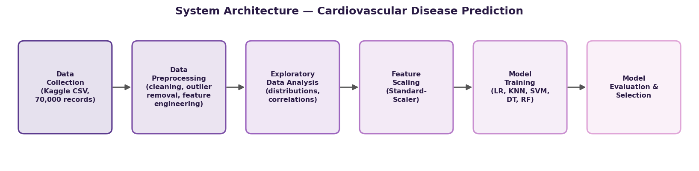
Fig. 4.1: System Architecture — Cardiovascular Disease Prediction
4.7.2 Spotify Songs’ Genre Segmentation
The Spotify Songs’ Genre Segmentation project follows an unsupervised learning pipeline, illustrated in Fig. 4.2. Track-level data is collected and cleaned to remove duplicate and incomplete entries, after which the numerical audio features are explored visually, standardized, and clustered using K-Means. The resulting high-dimensional cluster structure is then projected into two dimensions using PCA so that it can be visualized and interpreted against the actual genre labels.
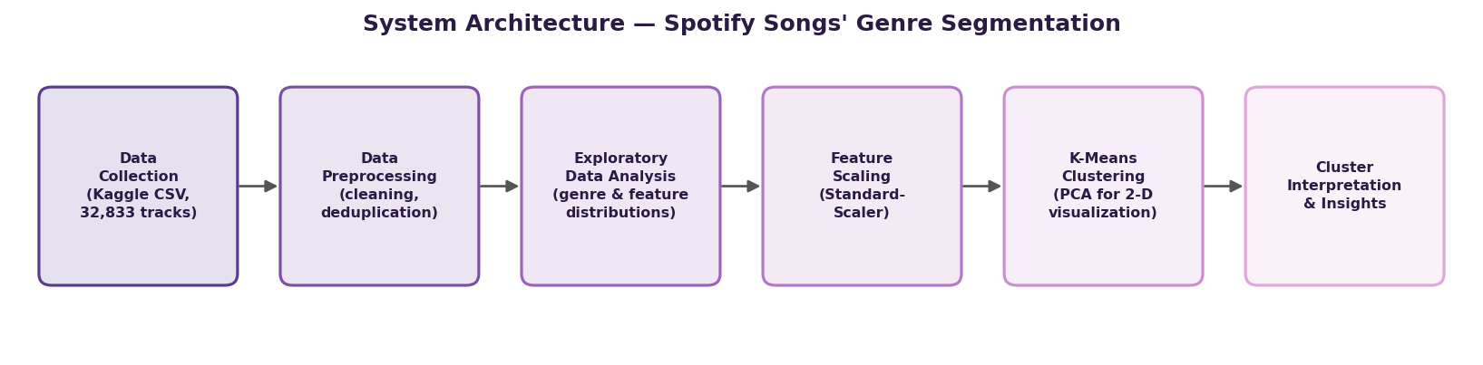
Fig. 4.2: System Architecture — Spotify Songs’ Genre Segmentation
4.8.1 Methodology — Cardiovascular Disease Prediction
Dataset Description
The dataset used for this project is the Cardiovascular Disease dataset, a publicly available collection of 70,000 anonymized patient records with 11 input attributes and a binary target variable, cardio, indicating the presence (1) or absence (0) of cardiovascular disease. The attributes fall into three categories: objective measurements taken at examination time (age, gender, height, weight, systolic blood pressure ‘ap_hi’ and diastolic blood pressure ‘ap_lo’), examination results (cholesterol and glucose level, each recorded on a three-point ordinal scale), and subjective lifestyle information reported by the patient (smoking, alcohol intake and physical activity, each a binary flag). Table 4.2 summarizes both datasets used in this report for comparison.
Table 4.2: Summary of Datasets Used
Attribute | Cardiovascular Disease Dataset | Spotify Dataset
Source | Kaggle (public dataset) | Kaggle (public dataset)
Raw records | 70,000 | 32,833
Records after cleaning | 68,613 | 28,352
Number of features used | 12 (incl. 2 engineered) | 11 audio features
Task type | Binary classification | Unsupervised clustering
Target / validation label | cardio (0 = no disease, 1 = disease) | playlist_genre (used only to validate clusters)
Data Preprocessing
Age, originally recorded in days, was converted to years for interpretability, and Body Mass Index (BMI) was engineered from height and weight using the standard formula BMI = weight (kg) / height (m)². A data-cleaning pass then removed 1,387 records (about 2% of the raw data) with physiologically implausible readings, namely diastolic pressure exceeding systolic pressure, blood pressure values outside a plausible clinical range, and heights or weights far outside plausible adult ranges, leaving 68,613 records for analysis. The resulting cohort has a mean age of 53.3 years (range 29.6–64.9 years) and a mean BMI of 27.5, which falls in the ‘overweight’ category by WHO classification, indicating that the dataset skews toward a middle-aged, somewhat overweight population — consistent with the population most relevant to cardiovascular risk screening.
Exploratory Data Analysis
The target variable is well balanced, with 34,667 patients (50.5%) recorded as not having cardiovascular disease and 33,946 patients (49.5%) recorded as having it, as shown in Fig. 4.3. This balance means accuracy is a meaningful evaluation metric for this dataset, without the class-imbalance distortions that would otherwise call for metrics such as balanced accuracy.
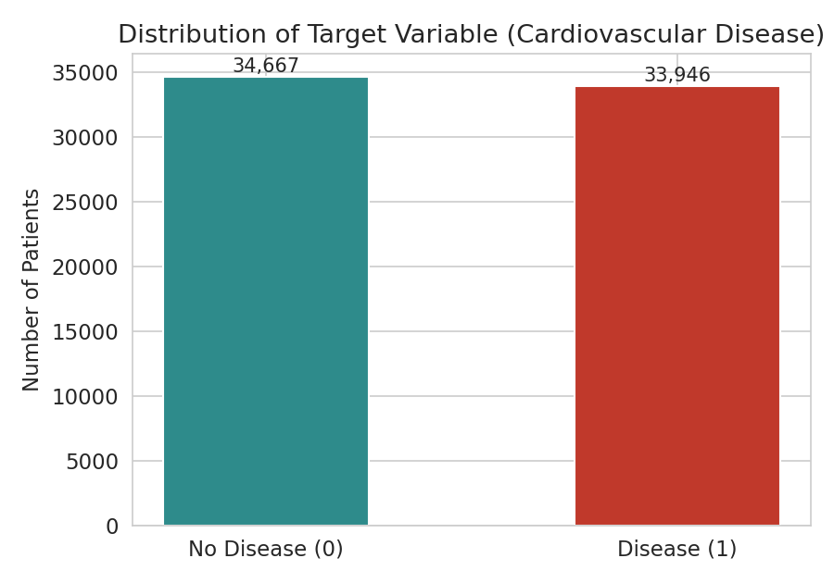
Fig. 4.3: Distribution of Target Variable (Cardiovascular Disease)
Fig. 4.4 shows that disease prevalence rises steadily with age, consistent with cardiovascular risk accumulating over the lifespan. Fig. 4.5 shows the gender split of the cohort: 44,691 records (65.1%) are coded as female and 23,922 (34.9%) as male, verified against the dataset by the fact that the male-coded group has a higher average height and weight, matching general population patterns.
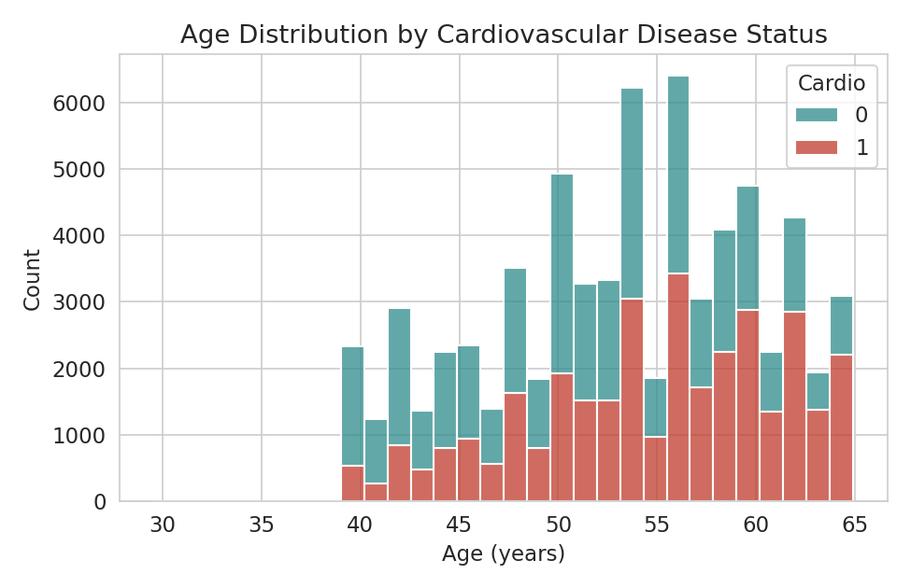
Fig. 4.4: Age Distribution by Cardiovascular Disease Status
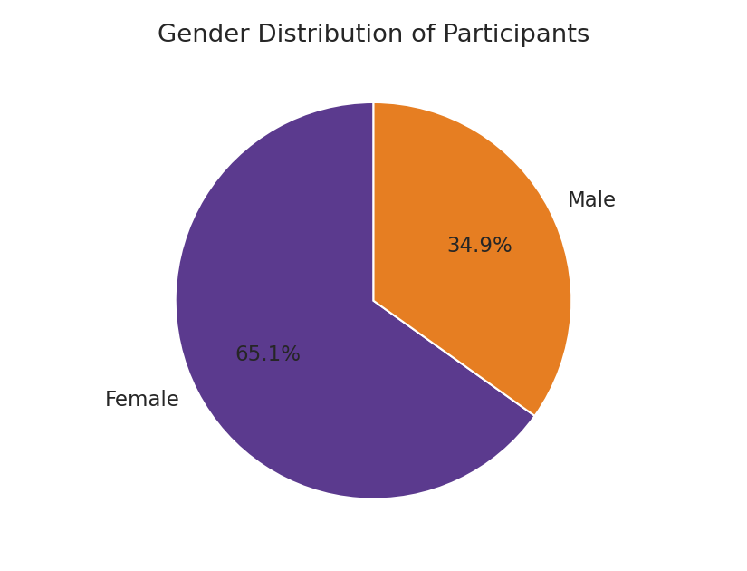
Fig. 4.5: Gender Distribution of Participants
Cholesterol shows one of the clearest relationships with disease status in the dataset: disease prevalence rises from 43.5% among patients with normal cholesterol, to 59.6% among those with above-normal cholesterol, to 76.2% among those with well-above-normal cholesterol (Fig. 4.6). Glucose level shows a similar, though weaker, upward trend.
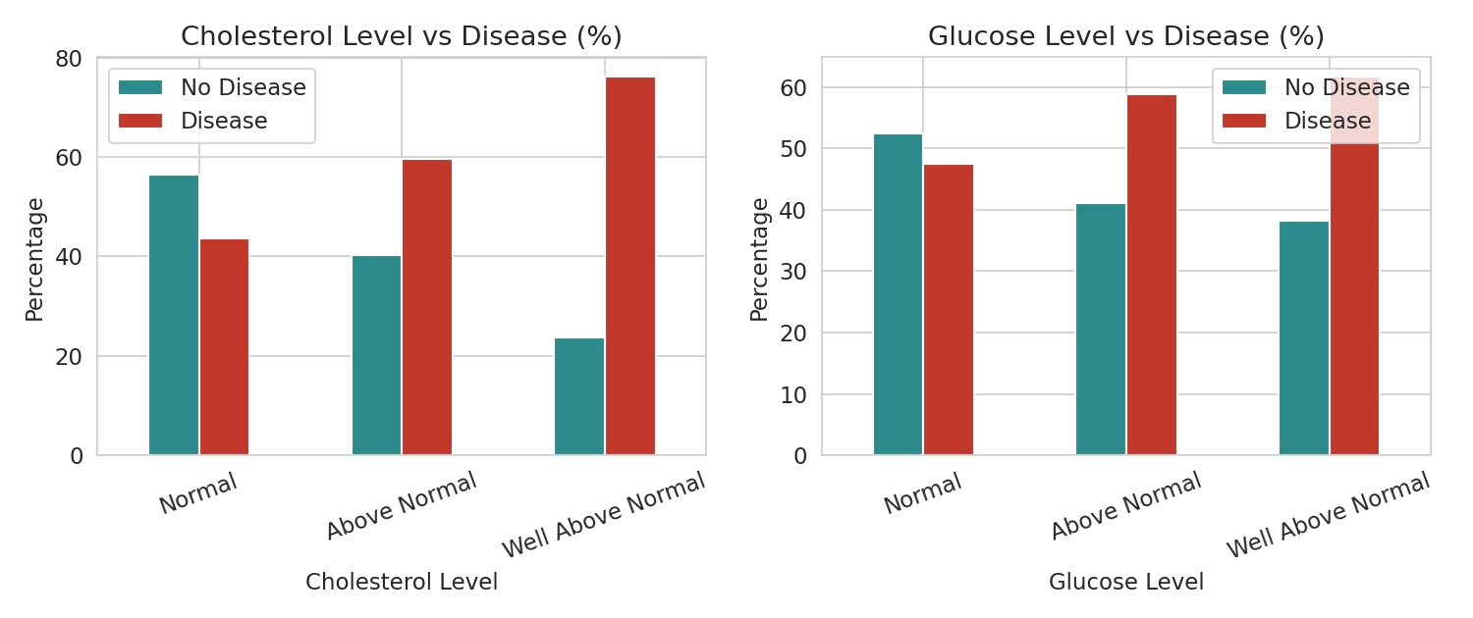
Fig. 4.6: Cholesterol and Glucose Level vs Disease Status
BMI is visibly higher among patients with cardiovascular disease (Fig. 4.7), and disease cases are concentrated at higher systolic and diastolic blood pressure readings (Fig. 4.8), both in line with established clinical risk factors.
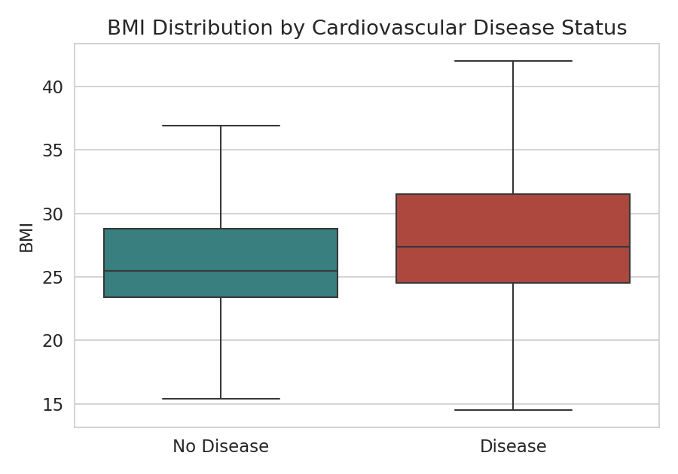
Fig. 4.7: BMI Distribution by Cardiovascular Disease Status
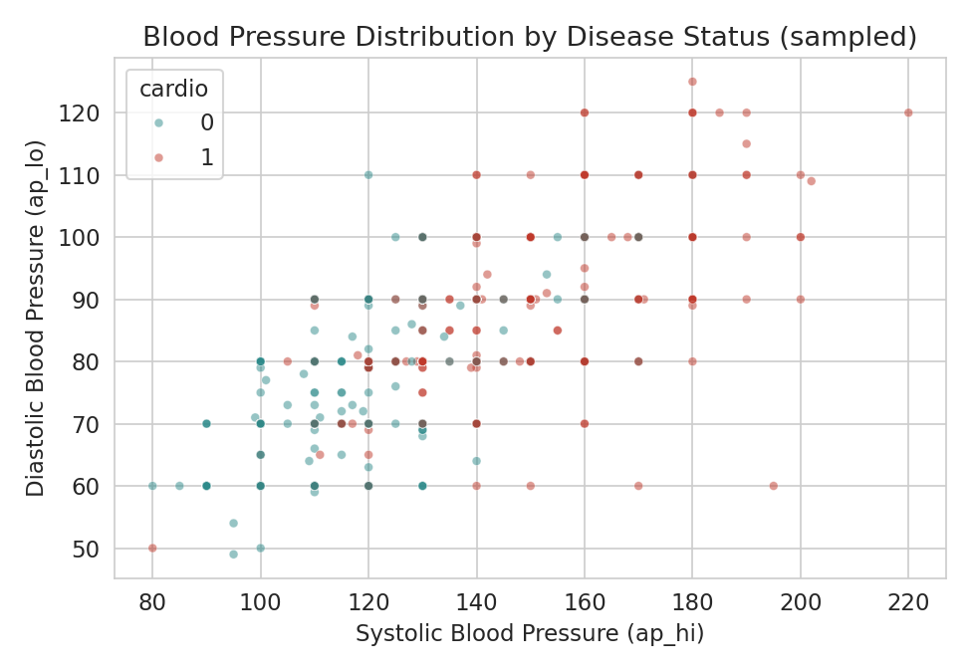
Fig. 4.8: Blood Pressure Distribution by Disease Status (3,000-patient sample)
Interestingly, the raw data shows only a weak and, for smoking and alcohol, counter-intuitive relationship with disease status: patients who reported smoking had a slightly lower disease rate (46.8%) than non-smokers (49.7%), and reported alcohol use shows a similar pattern (Fig. 4.9). Physical activity behaves as expected, with active patients showing a lower disease rate (48.5%) than inactive patients (53.3%). This is a known characteristic of this particular dataset and most likely reflects self-report bias and confounding with other factors such as age, rather than a genuine protective effect of smoking; it is reported here as observed, without adjustment, since correcting for such confounding was outside the scope of this project.
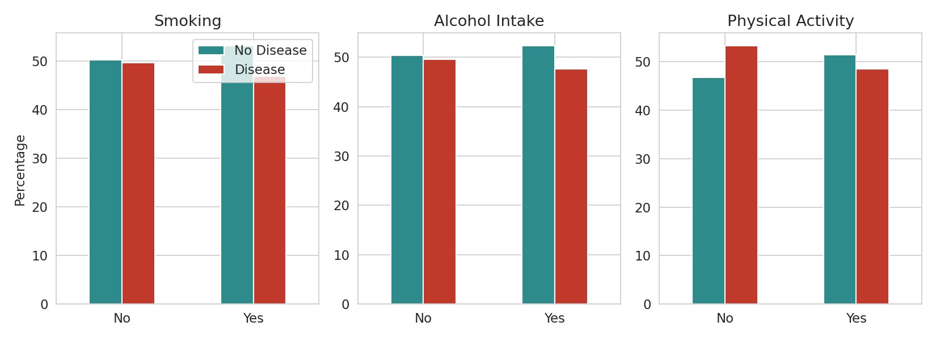
Fig. 4.9: Lifestyle Factors (Smoking, Alcohol, Activity) vs Disease Status
The correlation matrix in Fig. 4.10 confirms these observations quantitatively: systolic blood pressure (0.43) and diastolic blood pressure (0.34) are the two attributes most strongly correlated with cardiovascular disease, followed by cholesterol (0.22), age (0.24), and weight/BMI (0.18–0.19). Smoking, alcohol use and physical activity all show a correlation magnitude below 0.05 with the target, consistent with the weak lifestyle relationships observed above.
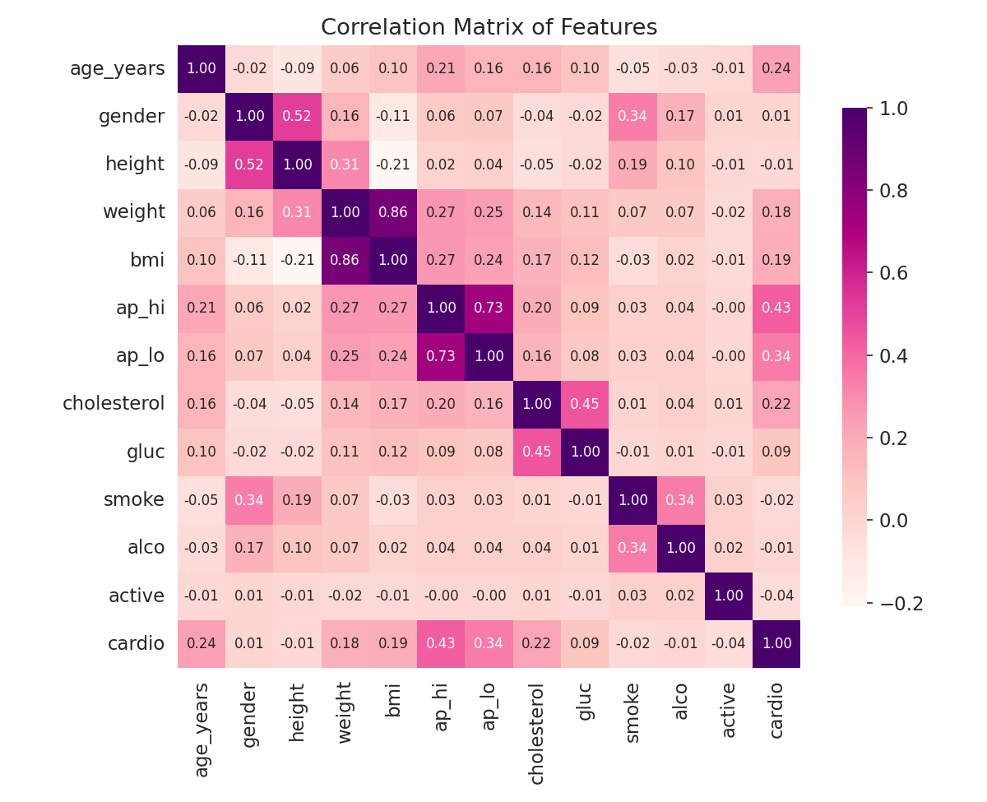
Fig. 4.10: Correlation Matrix of Features
Model Building and Evaluation
The processed dataset was split into training (80%) and testing (20%) sets using stratified sampling to preserve the class balance, and all input features were standardized using a StandardScaler fitted on the training data. Five classification algorithms were trained on the scaled training data and evaluated on the held-out test set: Logistic Regression, K-Nearest Neighbors (k = 15), Support Vector Machine (RBF kernel), Decision Tree (max depth 6) and Random Forest (200 trees, max depth 8). Table 4.3 reports the accuracy, precision, recall and F1-score obtained for each model, and Fig. 4.11 compares their accuracy visually.
Table 4.3: Performance Comparison of Classification Algorithms (all values in %)
Model | Accuracy | Precision | Recall | F1-score
Logistic Regression | 72.79 | 75.26 | 67.03 | 70.91
K-Nearest Neighbors | 71.92 | 72.73 | 69.16 | 70.90
Support Vector Machine | 73.53 | 76.07 | 67.83 | 71.71
Decision Tree | 72.85 | 73.19 | 71.19 | 72.18
Random Forest | 73.17 | 75.45 | 67.83 | 71.44
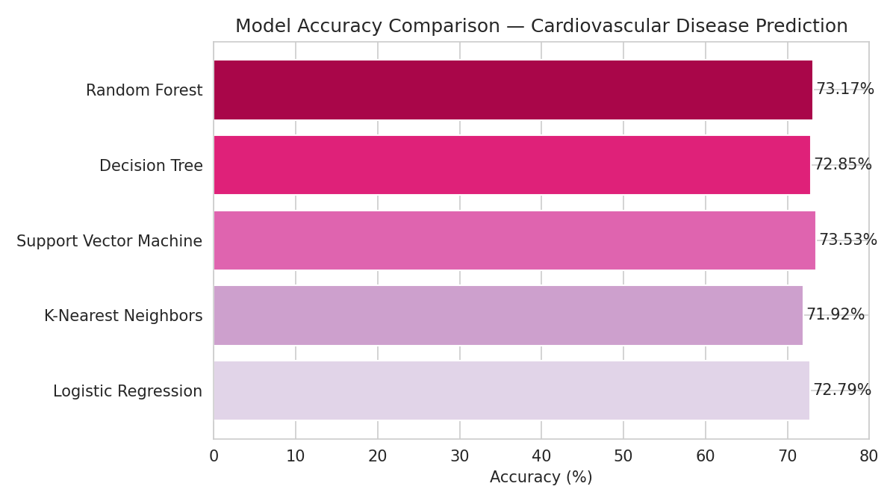
Fig. 4.11: Model Accuracy Comparison — Cardiovascular Disease Prediction
The Support Vector Machine achieved the highest accuracy (73.53%) and the highest precision (76.07%), making it the best-performing model overall on this dataset, closely followed by Random Forest (73.17%) and Decision Tree (72.85%). All five models cluster within a fairly narrow band of 72–74% accuracy, which suggests that the ceiling on predictive performance here is set more by the inherent noise and overlap in the clinical attributes themselves than by the choice of algorithm — a pattern also reported in published work on this dataset. The confusion matrix for the best model, shown in Fig. 4.12, indicates a reasonably balanced error pattern between false positives and false negatives, with no strong bias toward over- or under-predicting disease.
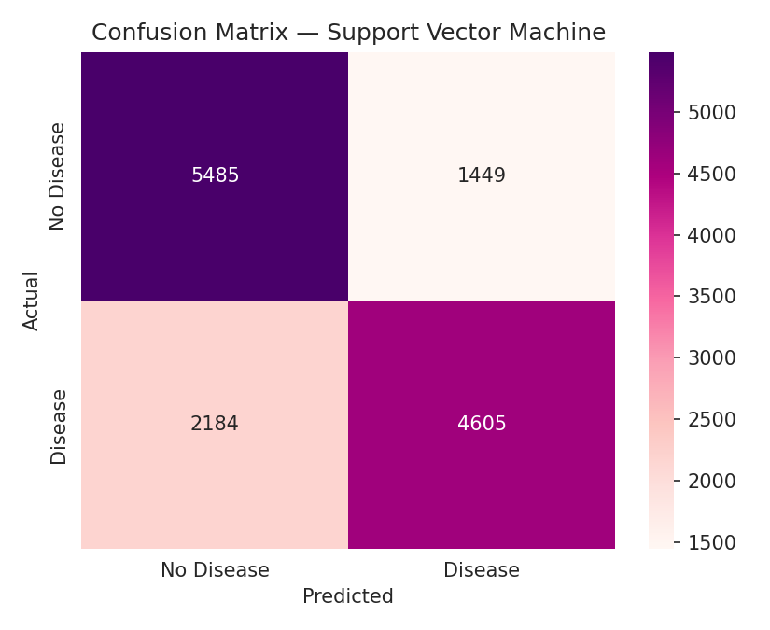
Fig. 4.12: Confusion Matrix — Support Vector Machine (Best Model)
Fig. 4.13 shows feature importance scores extracted from the Random Forest model. Systolic blood pressure, diastolic blood pressure and age emerge as the three most influential predictors, which aligns closely with the correlation analysis in Fig. 4.10 and with established cardiovascular risk factors reported in the clinical literature.
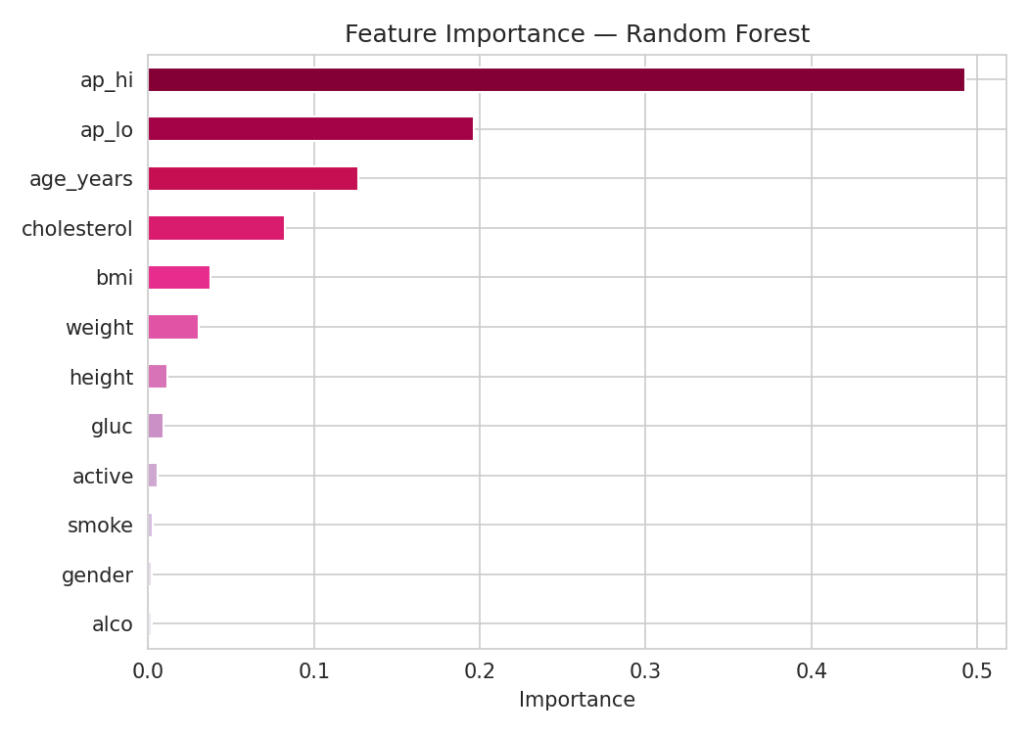
Fig. 4.13: Feature Importance — Random Forest
4.8.2 Methodology — Spotify Songs’ Genre Segmentation
Dataset Description
The dataset used for this project is the Spotify Songs’ Genre Segmentation dataset, containing 32,833 tracks drawn from Spotify playlists across 6 broad playlist genres (pop, rap, rock, latin, r&b and edm) and 24 more specific subgenres. Each track carries 12 numerical audio features computed by Spotify’s own audio analysis, including danceability, energy, key, loudness, mode, speechiness, acousticness, instrumentalness, liveness, valence and tempo, alongside metadata such as track name, artist and popularity score. Table 4.2 in Section 4.8.1 summarizes this dataset alongside the cardiovascular disease dataset.
Data Preprocessing
Five records with missing track, artist or album names were removed, and duplicate entries sharing the same track_id (the same song appearing under more than one playlist) were dropped, together removing 4,481 records and leaving 28,352 unique tracks for analysis. No further imputation was required, as the remaining audio-feature columns had no missing values.
Exploratory Data Analysis
After cleaning, the six genres are fairly evenly represented, ranging from 4,136 tracks (latin) to 5,398 tracks (rap), as shown in Fig. 4.14, which reduces the risk of any one genre dominating the subsequent clustering purely due to sample size.
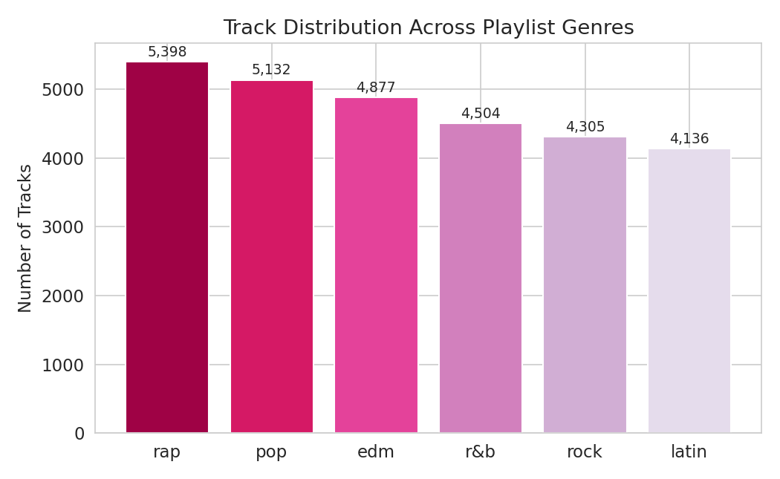
Fig. 4.14: Track Distribution Across Playlist Genres
Fig. 4.15 compares four key audio features across genres. Rock stands out with the lowest median danceability, while R&B shows the widest spread in acousticness, ranging from fully acoustic ballads to heavily produced tracks. EDM shows the highest energy and the lowest acousticness of any genre, reflecting its electronically produced, high-intensity character, while also showing the lowest valence (a measure of musical positivity), which is a less intuitive finding given the genre’s dancefloor associations. Latin tracks show the highest median valence and strong danceability, consistent with the genre’s upbeat, rhythm-driven reputation.
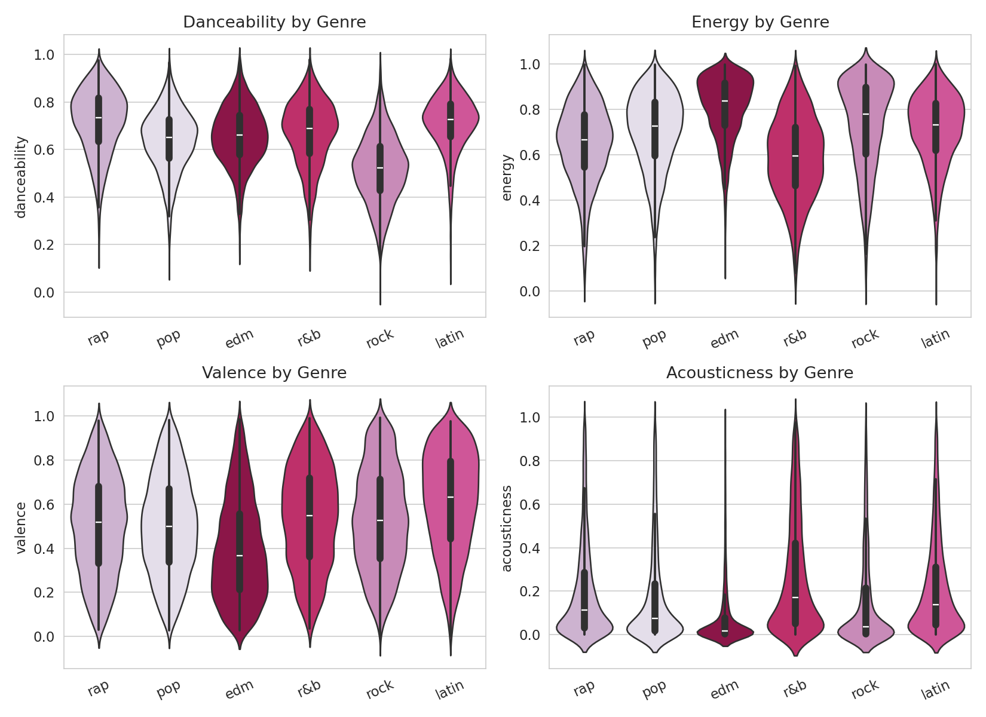
Fig. 4.15: Danceability, Energy, Valence and Acousticness by Genre
Tempo is roughly bell-shaped and centered around 120 beats per minute, a common tempo range for popular music, while loudness clusters tightly around −5 to −6 dB, reflecting the industry-wide practice of mastering commercial tracks to a fairly narrow, loud volume range (Fig. 4.16). Track popularity varies more distinctly by genre (Fig. 4.17): pop tracks skew toward the highest popularity scores in this dataset, rap, latin and rock form a middle band, and EDM and R&B trend lowest.
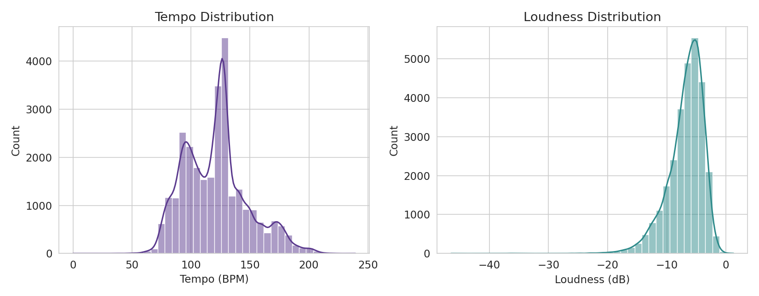
Fig. 4.16: Tempo and Loudness Distribution
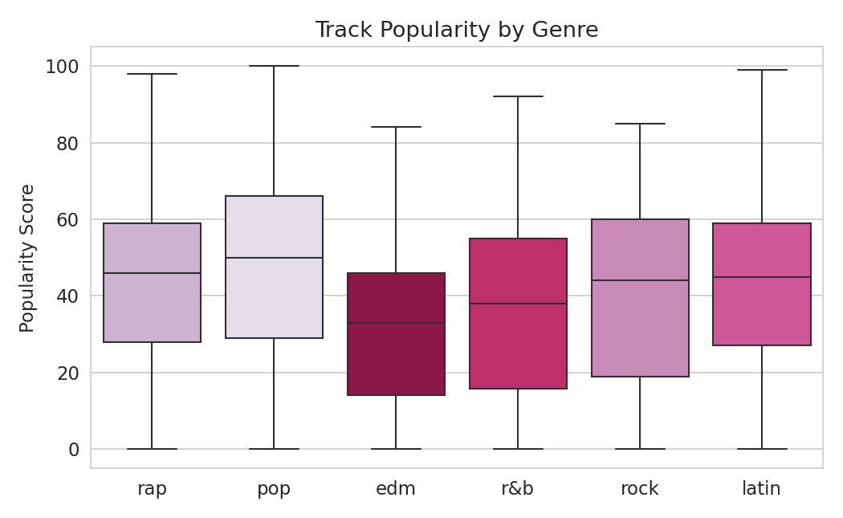
Fig. 4.17: Track Popularity by Genre
The correlation matrix in Fig. 4.18 shows that energy and loudness are strongly positively correlated (a louder mix is generally also a higher-energy one), while energy and acousticness are strongly negatively correlated, as expected, since heavily produced, high-energy tracks tend to rely less on unamplified, acoustic instrumentation. Most other audio features show comparatively weak pairwise correlation, indicating that they each capture a fairly distinct aspect of a track’s character rather than duplicating information already present in another feature.
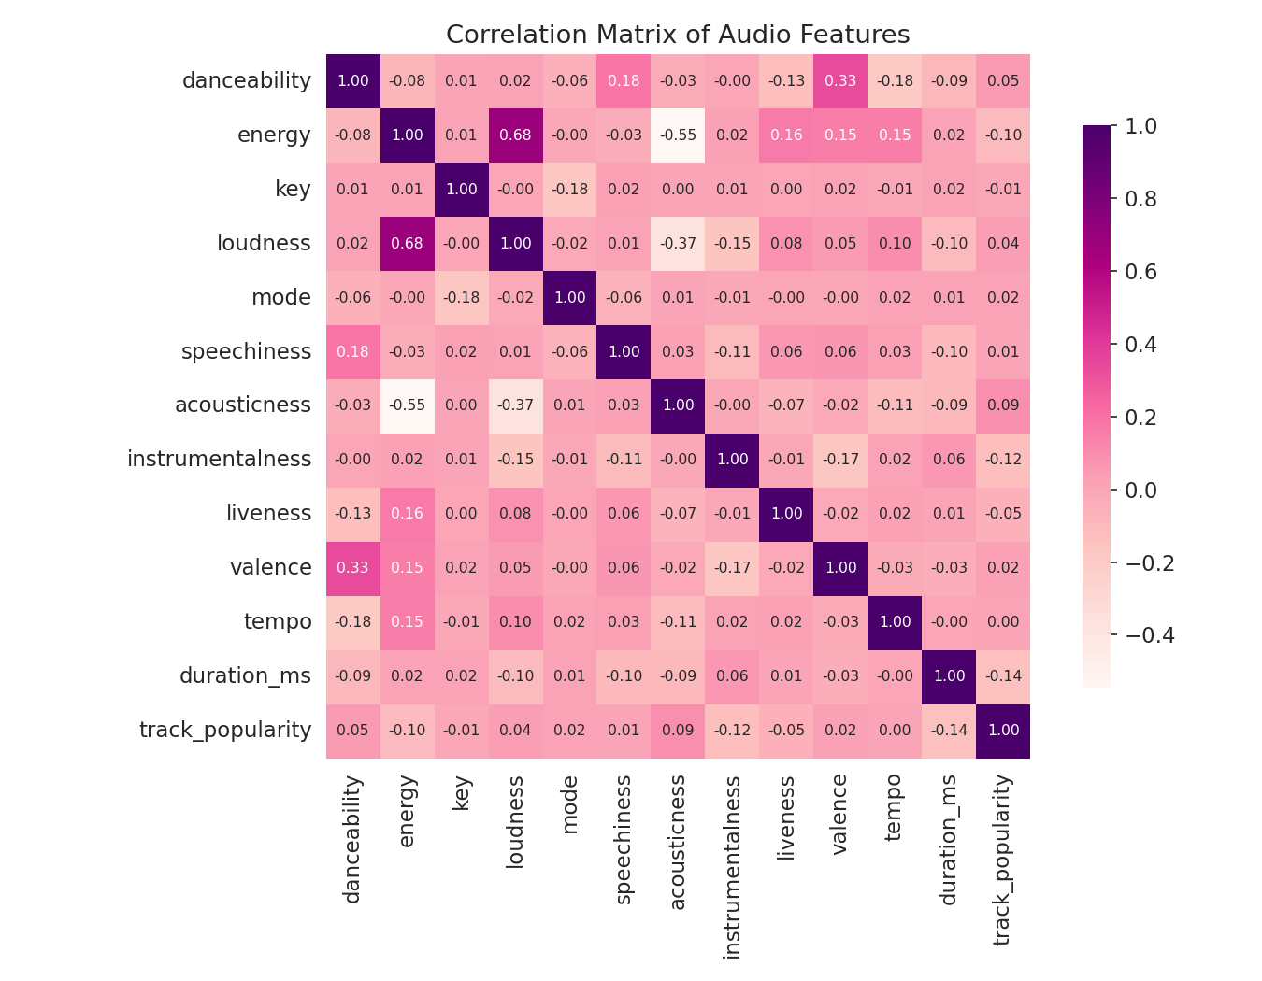
Fig. 4.18: Correlation Matrix of Audio Features
Clustering Analysis
All eleven numerical audio features were standardized using a StandardScaler, and K-Means clustering was applied for a range of k from 2 to 10. Fig. 4.19 shows the resulting elbow curve (inertia) alongside the silhouette score for each value of k. Neither curve shows a sharp, unambiguous elbow, which is itself informative: it suggests that genres in this dataset do not separate into naturally tight, well-isolated clusters in audio-feature space, but instead blend into one another along a continuum. A value of k = 6 was selected to match the number of actual playlist genres, which allows the resulting clusters to be interpreted directly against the genre labels.
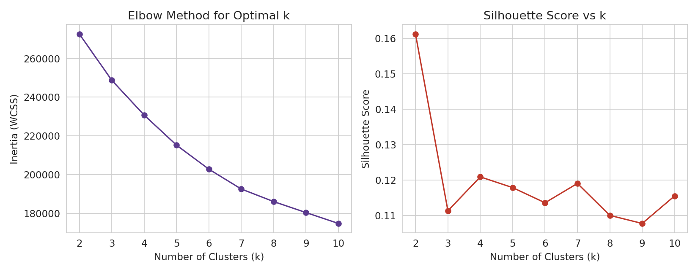
Fig. 4.19: Elbow Method and Silhouette Score for Selecting k
The resulting silhouette score of 0.114 is low in absolute terms, confirming that the six clusters overlap considerably rather than forming compact, well-separated groups — a reasonable outcome given that genre is a human, cultural label layered on top of a continuous space of acoustic characteristics, and not something the audio features alone were ever guaranteed to reproduce exactly. Fig. 4.20 projects the eleven-dimensional feature space onto its first two principal components (explaining 19.7% and 13.8% of total variance respectively, or 33.5% combined) and plots the K-Means clusters side by side with the actual genre labels in this same 2-D space. The two panels show broadly similar large-scale shape, but with visibly blurred boundaries in both, consistent with the low silhouette score.
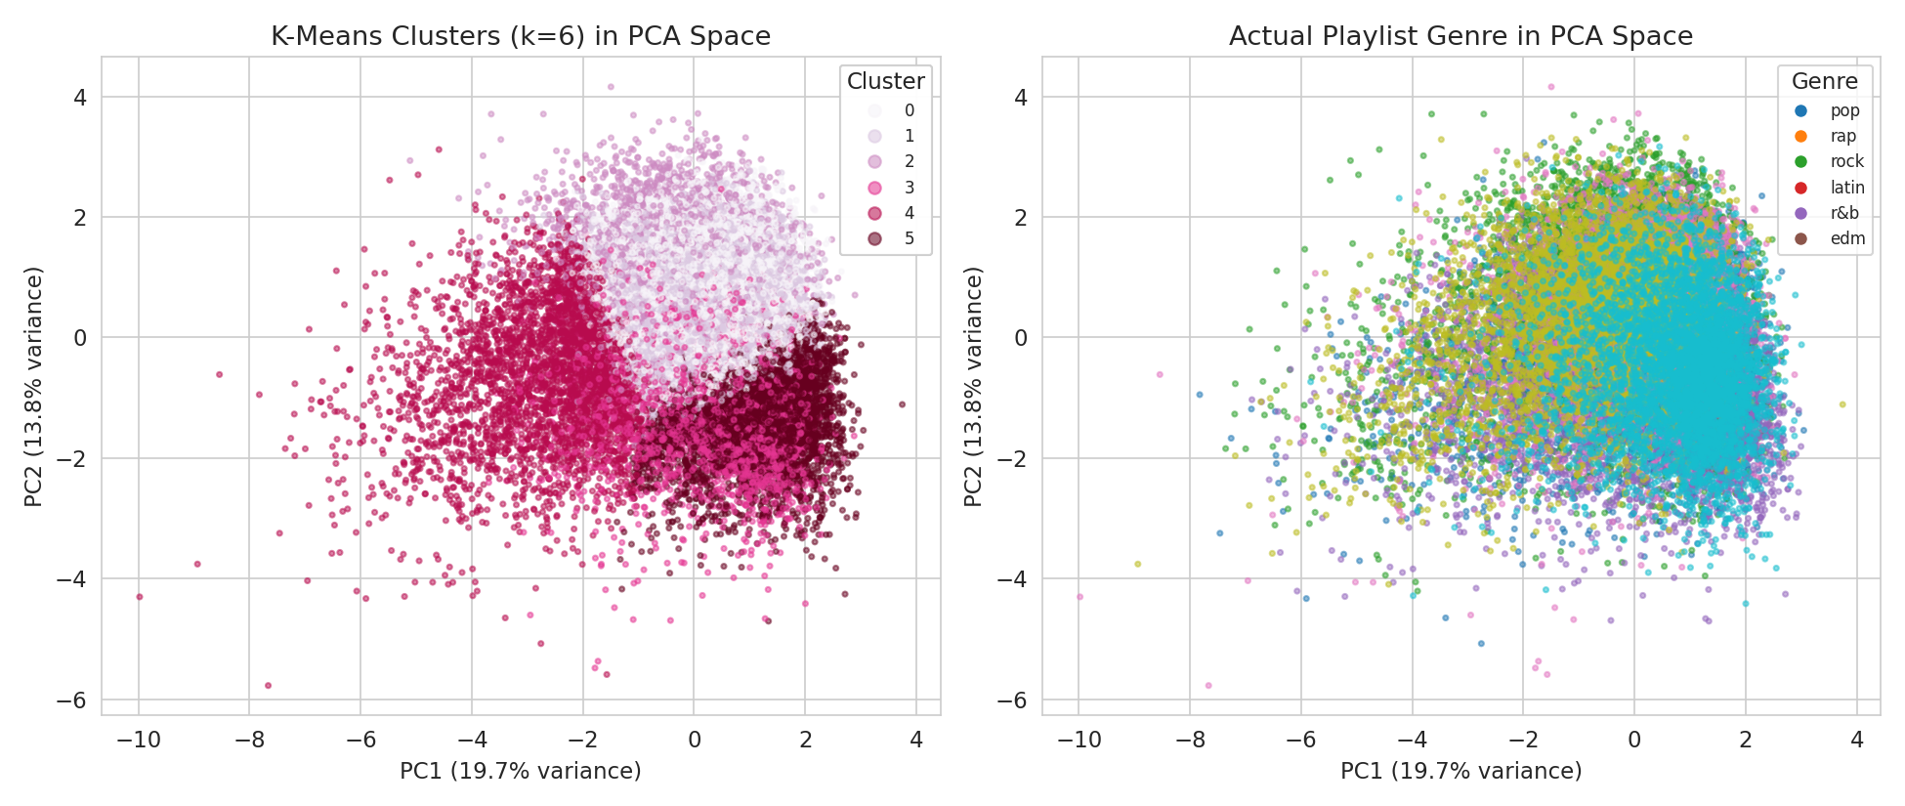
Fig. 4.20: K-Means Clusters vs Actual Playlist Genre in PCA Space
Table 4.4 and Fig. 4.21 quantify how each cluster relates to the six playlist genres. Two clusters are notably ‘pure’: Cluster 2 is 58.0% rap and Cluster 3 is 57.7% edm, showing that rap and EDM each have a fairly distinctive audio-feature signature (high speechiness and rhythmic emphasis for rap; high energy and low acousticness for EDM) that K-Means was able to isolate reasonably well without ever seeing the genre label. The remaining four clusters are considerably more mixed: rock (32.4%), r&b (31.6%), pop (21.8%) and latin (21.2%) are each only a plurality, not a majority, within their respective best-matching cluster, indicating that these four genres overlap substantially with one another in terms of raw audio characteristics and are harder to tell apart using audio features alone.
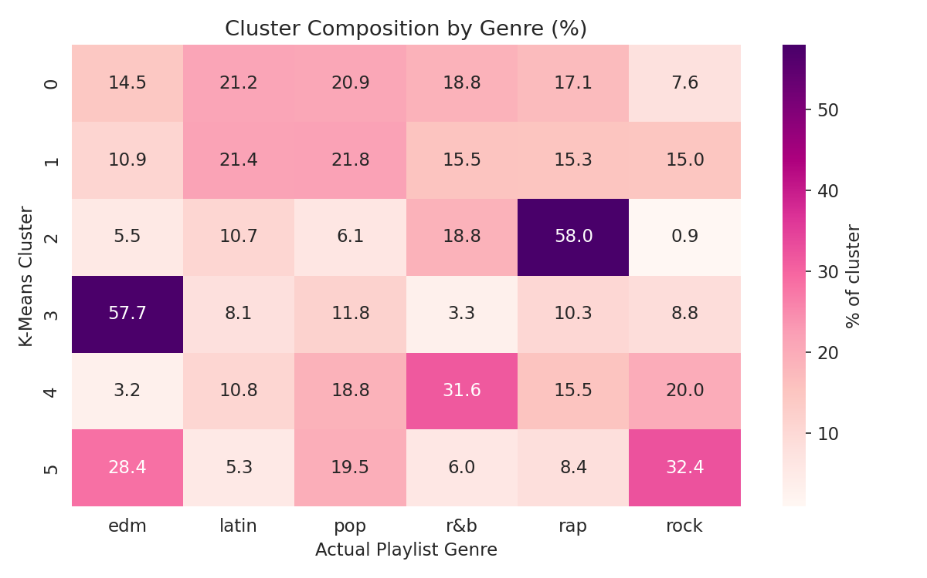
Fig. 4.21: Cluster Composition by Genre (%)
Table 4.4: Cluster Size and Dominant Genre Summary
Cluster | Size (tracks) | Dominant Genre | % of Cluster
0 | 6,262 | Latin | 21.2
1 | 7,382 | Pop | 21.8
2 | 3,353 | Rap | 58.0
3 | 2,284 | EDM | 57.7
4 | 3,641 | R&B | 31.6
5 | 5,430 | Rock | 32.4
Fig. 4.22 shows the mean value of each audio feature within every cluster, which helps characterize what distinguishes them acoustically. Cluster 5 (rock-leaning) has by far the highest energy (0.82) and the lowest acousticness and danceability of any cluster, an intensely energetic, guitar-driven profile consistent with rock’s plurality there. Cluster 2 (rap-dominant) has a markedly higher speechiness (0.33) than any other cluster, consistent with rap’s vocal-forward, rhythmic delivery, while Cluster 3 (edm-dominant) stands out for its high instrumentalness (0.76), well above every other cluster, reflecting the prevalence of vocal-light production in electronic dance tracks.
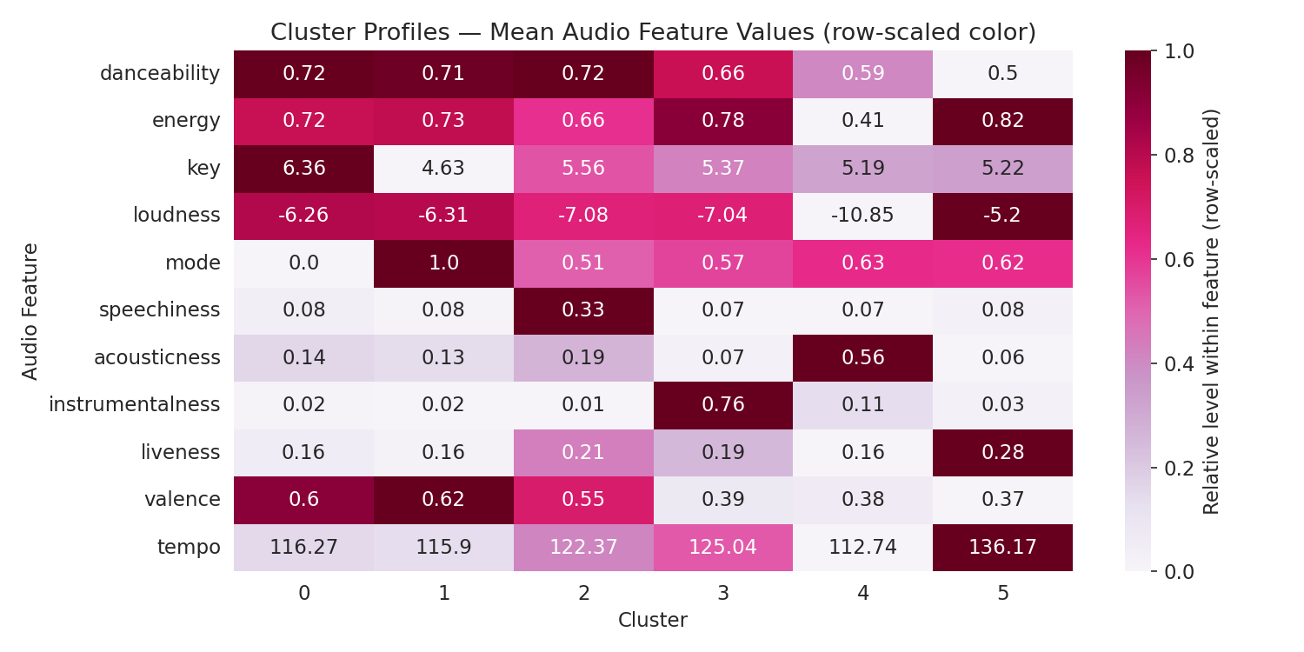
Fig. 4.22: Cluster Profiles — Mean Audio Feature Values
4.9 Expected Outcomes
4.9.1 Cardiovascular Disease Prediction
- A cleaned, analysis-ready dataset of 68,613 patient records with two additional engineered features (age in years and BMI).
- A clear visual and statistical understanding of which clinical and lifestyle attributes are most associated with cardiovascular disease, with systolic blood pressure, cholesterol, age and BMI emerging as the strongest indicators.
- Five trained classification models, with the Support Vector Machine identified as the best performer at 73.53% test accuracy and 76.07% precision.
- A demonstration that model choice has a comparatively small effect on this dataset (72–74% accuracy across all five algorithms), with data quality and feature relevance mattering more than algorithm selection alone.
- A reusable, documented pipeline (cleaning → EDA → scaling → modeling → evaluation) that could be extended with additional health attributes in future work.
4.9.2 Spotify Songs’ Genre Segmentation
- A cleaned dataset of 28,352 unique tracks with duplicate playlist entries removed.
- A visual and statistical profile of how audio features such as danceability, energy, valence and acousticness vary across genres.
- Six K-Means clusters derived purely from audio features, two of which (rap and edm) align closely with actual genre labels (58.0% and 57.7% purity respectively), showing that these genres have a distinctive acoustic signature.
- Evidence that pop, latin, r&b and rock overlap considerably in audio-feature space (21–32% cluster purity), indicating that genre, as applied by humans, only partly follows sonic characteristics.
- A PCA-based visualization technique for inspecting cluster quality that can be reused for other audio-feature datasets or extended into a content-based recommendation prototype.
4.10 Certificates of Completion and Other Communication/Mail Proof
The Internship Completion Certificate issued by Corizo on successful completion of the Artificial Intelligence internship (05 December 2025 to 05 January 2026), bearing Corizo Dice ID CRZ140452 and signed by Mr. Hemant Ingle, Academic Head, is attached in Chapter 3 of this report.
BIBLIOGRAPHY/REFERENCES
[1] Ulianova, S., “Cardiovascular Disease Dataset,” Kaggle. [Online]. Available: https://www.kaggle.com/datasets/sulianova/cardiovascular-disease-dataset
[2] “Spotify Songs’ Genre Segmentation,” Kaggle. [Online]. Available: https://www.kaggle.com/datasets/joebeachcapital/30000-spotify-songs
[3] World Health Organization, “Cardiovascular diseases (CVDs) — Fact Sheet,” who.int, 2025. [Online]. Available: https://www.who.int/news-room/fact-sheets/detail/cardiovascular-diseases-(cvds)
[4] Pedregosa, F. et al., “Scikit-learn: Machine Learning in Python,” Journal of Machine Learning Research, vol. 12, pp. 2825–2830, 2011.
[5] McKinney, W., “Data Structures for Statistical Computing in Python,” Proceedings of the 9th Python in Science Conference, pp. 56–61, 2010.
[6] Hunter, J. D., “Matplotlib: A 2D Graphics Environment,” Computing in Science & Engineering, vol. 9, no. 3, pp. 90–95, 2007.
[7] Waskom, M., “seaborn: Statistical Data Visualization,” Journal of Open Source Software, vol. 6, no. 60, p. 3021, 2021.
[8] Jolliffe, I. T., Principal Component Analysis, 2nd ed., Springer Series in Statistics, 2002.
[9] Corizo, “About Us,” corizo.in. [Online]. Available: https://www.corizo.in

