**Practical-1**

**Write a program for traversing array elements.**

#include<stdio.h>

void main()

{

int i,n;

printf(“KOMAL BHARDWAJ/n”);

printf(“2100320120093/n”);

printf("Enter size of array:");

scanf("%d",&n);

int a[n];

printf("Enter array elements:\n");

for(i=0;i<n;i++)

{

scanf("%d",&a[i]);

}

printf("\nEntered array is:\n");

for(i=0;i<n;i++)

{

printf("%d\n",a[i]);

}

}

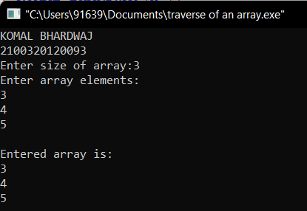

**Practical-2**

**Write a program to insert the given element into an array.**

#include<stdio.h>

void main()

{

int i,n,x,p;

printf(“KOMAL BHARDWAJ/n”);

printf(“2100320120093/n”);

printf("Enter size of array:");

scanf("%d",&n);

int a[100];

printf("Enter elements:");

for(i=0;i<n;i++)

scanf("%d",&a[i]);

printf("Enter position:");

scanf("%d",&p);

printf("Enter element to be inserted:");

scanf("%d",&x);

for(i=n-1;i>=p-1;i--)

a[i+1]=a[i];

a[p-1]=x;

for(i=0;i<n+1;i++)

printf("%d\t",a[i]);

}

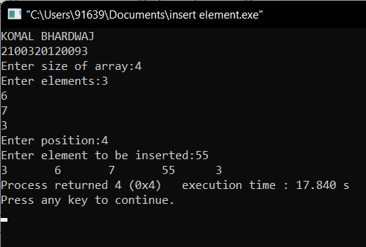

**Practical-3**

**Write a program for insertion in the sorted array.**

#include<stdio.h>

void main()

{

int i,n,x;

printf(“KOMAL BHARDWAJ/n”);

printf(“2100320120093/n”);

printf("Enter size of array:");

scanf("%d",&n);

int a[n];

printf("Enter sorted array elements:\n");

for(i=0;i<n;i++)

scanf("%d",&a[i]);

printf("Enter element to be inserted:");

scanf("%d",&x);

i=n-1;

while(x<a[i]&&x>=0){

a[i+1]=a[i];

i--;}

a[i+1]=x;

n++;

printf("New array:");

for(i=0;i<n;i++)

printf("\n%d",a[i]);}

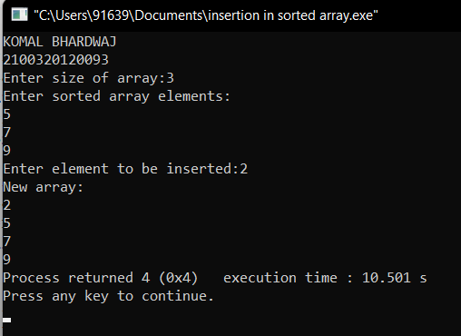

**Practical-4**

**Write a program to delete the given element in the array.**

#include<stdio.h>

void main()

{

int i,n,x;

printf(“KOMAL BHARDWAJ/n”);

printf(“2100320120093/n”);

printf("Enter size of array:");

scanf("%d",&n);

int a[n];

printf("Enter array elements:\n");

for(i=0;i<n;i++)

scanf("%d",&a[i]);

printf("Enter number to be deleted:");

scanf("%d",&x);

printf("New array:");

for(i=0;i<n;i++){

if(a[i]==x)

continue;

else

printf("\n%d",a[i]);

}

}

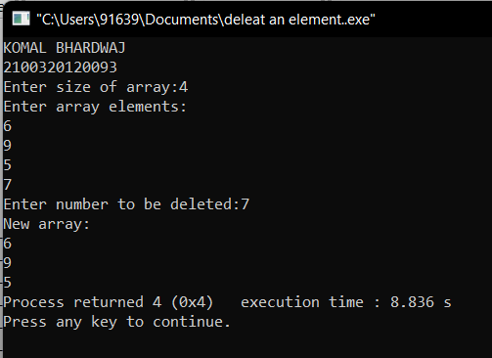

**Practical-5**

**Write a program for missing number in an array.**

#include<stdio.h>

void main()

{

int i,n,x,flag=0;

printf(“KOMAL BHARDWAJ\n”);

printf(“2100320120093\n”);

printf("Enter size of array:");

scanf("%d",&n);

int a[n];

printf("Enter array elements:\n");

for(i=0;i<n;i++)

scanf("%d",&a[i]);

printf("Enter number:");

scanf("%d",&x);

for(i=0;i<n;i++){

if(a[i]==x){

flag=1;

continue;} }

if(flag==0)

printf("Number Missing");

else

printf("Number Found");}

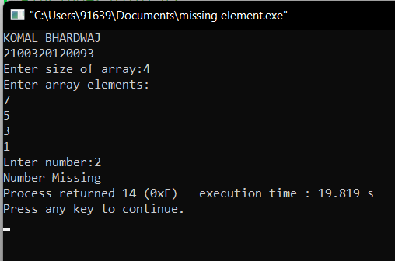

**Practical-6**

**Write a program to find which elements is repeated in the array and which is not.**

**#include <stdio.h>**

**int main()**

**{**

**int A[20], I, J, M, N;**

**printf("Enter The No. Of Elements You Want In Array ");**

**scanf("%d", &N);**

**for (I = 0; I < N; I++)**

**{**

**printf("Enter The Value Of A[%d] ", I);**

**scanf("%d", &A[I]);**

**}**

**M=A[0];**

**for(I=0;I<N;I++)**

**{**

**if(M<A[I])**

**{**

**M=A[I];**

**}**

**}**

**int B[M];**

**for(I=0;I<=M;I++)**

**{**

**B[I]=0;**

**}**

**for (I = 0; I < N; I++)**

**{**

**B[A[I]]=B[A[I]]+1;**

**}**

**for(I=1;I<=M;I++)**

**{**

**if(B[I]==1)**

**{**

**printf("Non Repeated Element :%d\n",I);**

**}**

**else if(B[I]>1)**

**{**

**printf("Repeated element : %d\n",I);**

**}**

**}**

**}**

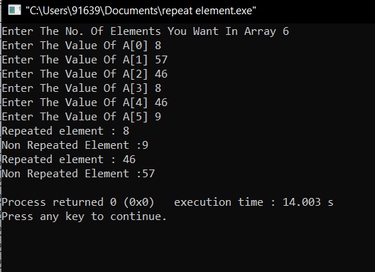

**Practical-7**

**Write a program for reversal of an array.**

#include<stdio.h>

void main()

{

int i,n;

printf(“KOMAL BHARDWAJ/n”);

printf(“2100320120093/n”);

printf("Enter size of array:");

scanf("%d",&n);

int a[n];

printf("Enter array elements:\n");

for(i=0;i<n;i++)

{

scanf("%d",&a[i]);

}

printf("\nReverse array is:\n");

for(i=n-1;i>=0;i--)

{

printf("%d\n",a[i]);

}

}

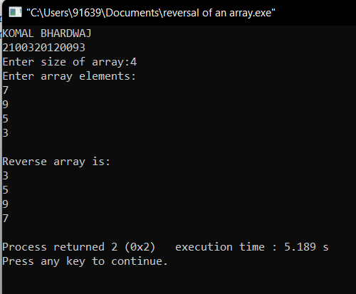

**Prractical-8**

**Write a program for merging two sorted arrays.**

#include<stdio.h>

void main()

{

int m,n,i=0,j=0,k=0;

printf(“KOMAL BHARDWAJ/n”);

printf(“2100320120093/n”);

int a[5]={1,3,5,7,10};

int b[4]={2,3,5,9};

m=sizeof(a)/sizeof(a[0]);

n=sizeof(b)/sizeof(b[0]);

int c[m+n];

while(i<m && j<n)

{

if(a[i]<b[j])

{

c[k]=a[i];

i++;

k++;

}

else

{

c[k]=b[j];

j++;

k++;

}

}

while(j<n)

{

c[k]=b[j];

j++;

k++;

}

while(i<m)

{

c[k]=a[i];

k++;

i++;

}

printf("Sorted array:\n");

for(i=0;i<(m+n);i++)

{

printf("%d\t",c[i]);

}

printf("\n");

}

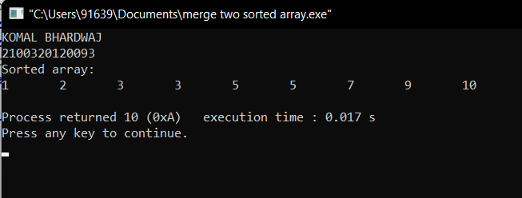

**Practical-9**

**Write a program for set union.**

#include <stdio.h>

int main(void)

{

int m,n,i,j,k=0,l;

printf(“KOMAL BHARDWAJ/n”);

printf(“2100320120093/n”);

printf("Enter value of m and n:");

scanf("%d%d",&m,&n);

int a[m],b[n];

printf("\nEnter first set:");

for(i=0;i<m;i++)

{

scanf("%d",&a[i]);

}

printf("\nEnter second set:");

for(i=0;i<n;i++)

{

scanf("%d",&b[i]);

}

l=m+n;

int c[l];

for(i=0;i<m;i++)

{

c[k]=a[i];

k++;

}

for(i=0;i<n;i++)

{

int count=0;

for(j=0;j<m;j++)

{

if(b[i]==c[j])

{

count=1;

}

}

if(count==0)

{

c[k]=b[i];

k++;

}

}

printf("\nUnion:");

for(i=0;i<k;i++)

{

printf("\n%d",c[i]);

}

}

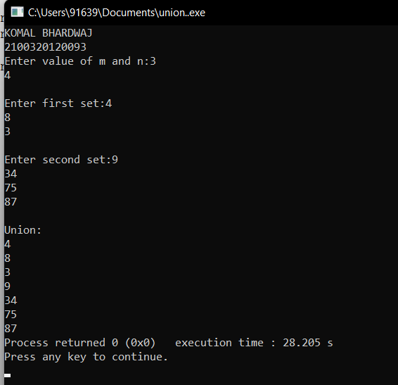

**Practical-10**

**Write a program for set intersection.**

#include<stdio.h>

void main(){

int m,n,l,i,j,k;

printf(“KOMAL BHARDWAJ/n”);

printf(“2100320120093/n”);

printf("Enter size of first set:");

scanf("%d",&m);

int a[m];

printf("Enter first set:");

for(i=0;i<m;i++)

scanf("%d",&a[i]);

printf("\nEnter size of second set:");

scanf("%d",&n);

int b[n];

printf("Enter second set:");

for(j=0;j<n;j++)

scanf("%d",&b[j]);

l=m+n;

int c[l];

for(i=0;i<m;i++) {

for(j=0;j<n;j++){

if(a[i]==b[j]){

c[k]=a[i];

k++; } } }

printf("\nIntersection:");

for(i=0;i<k;i++)

printf("\n%d",c[i]);}

