**ACTIVITY DIAGRAM**

**Ex No :**

**Date :**

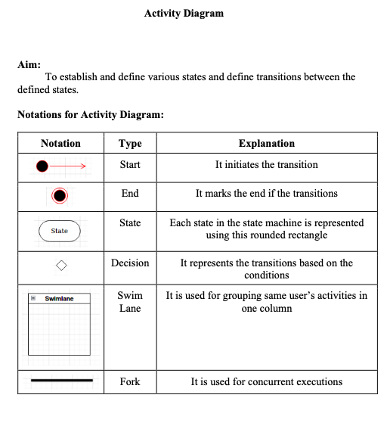

**Activity Diagram :**

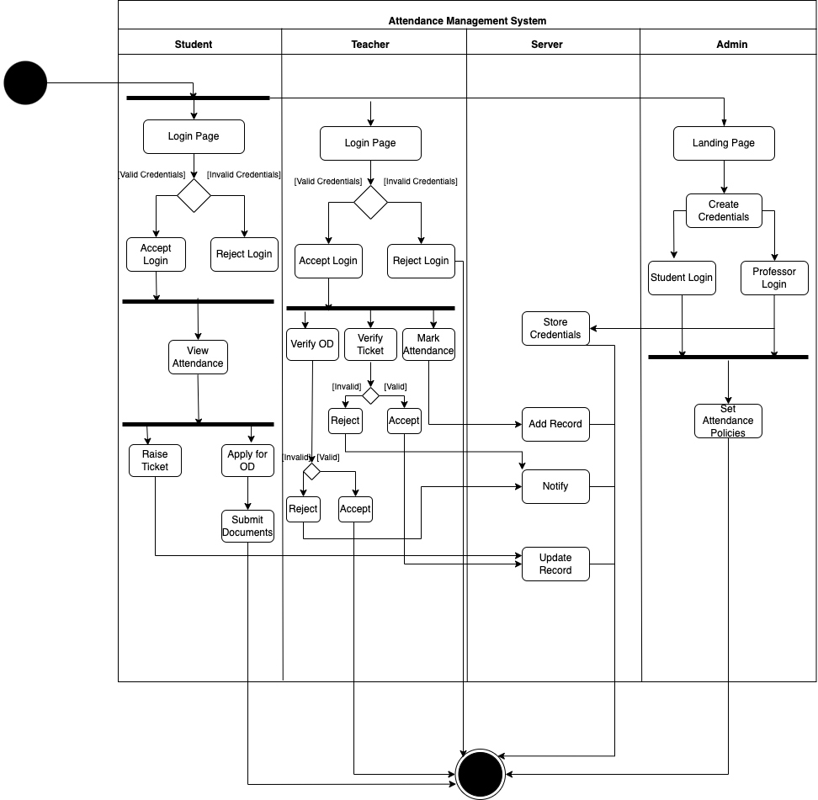

**Registration and Policies Setup:**

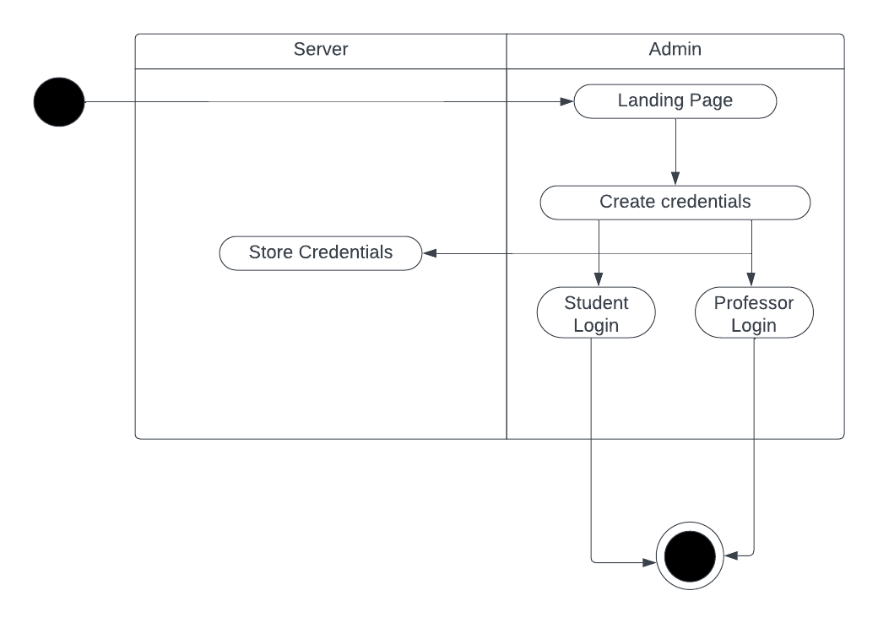

**Login:**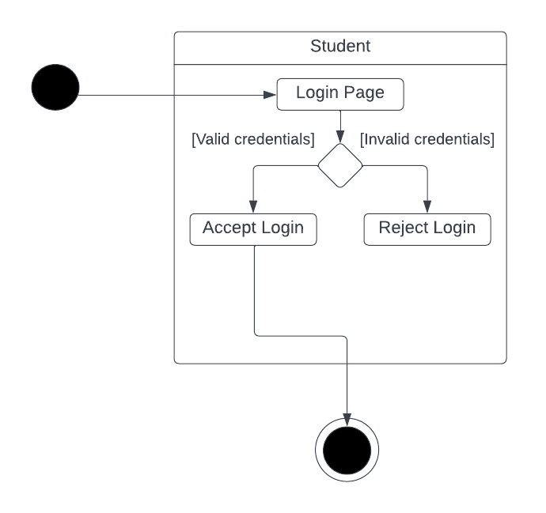

**Raise Ticket and Verification:**

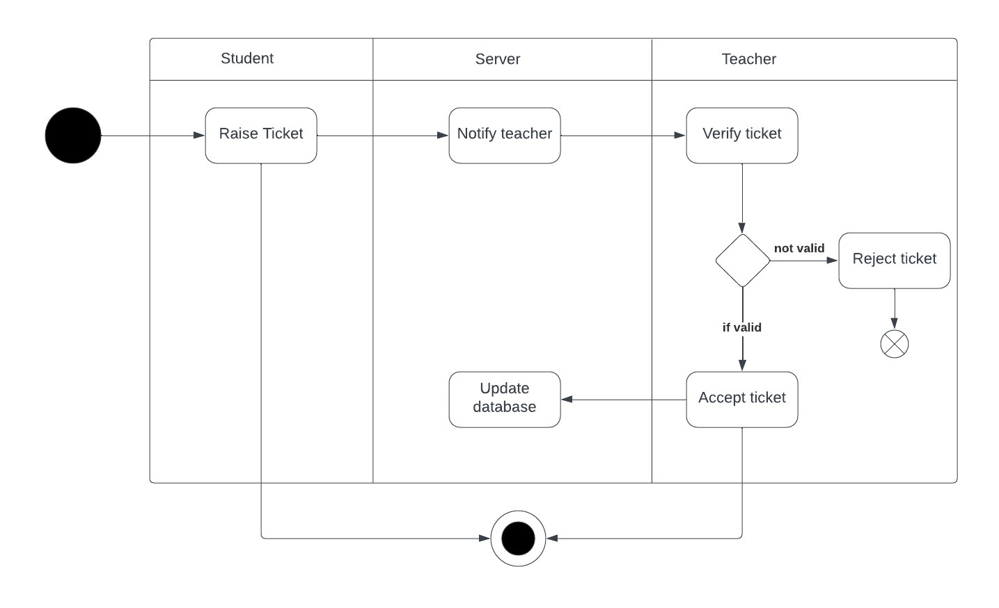

**OD application and Acceptance:**

