**Package Diagram, Deployment Diagram and Component Diagram**

**Ex No :**

**Date :**

**Package Diagram**

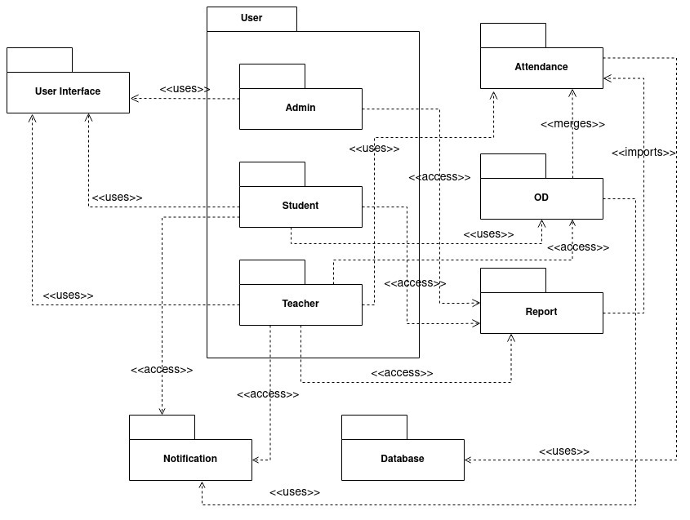

**Deployment Diagram**

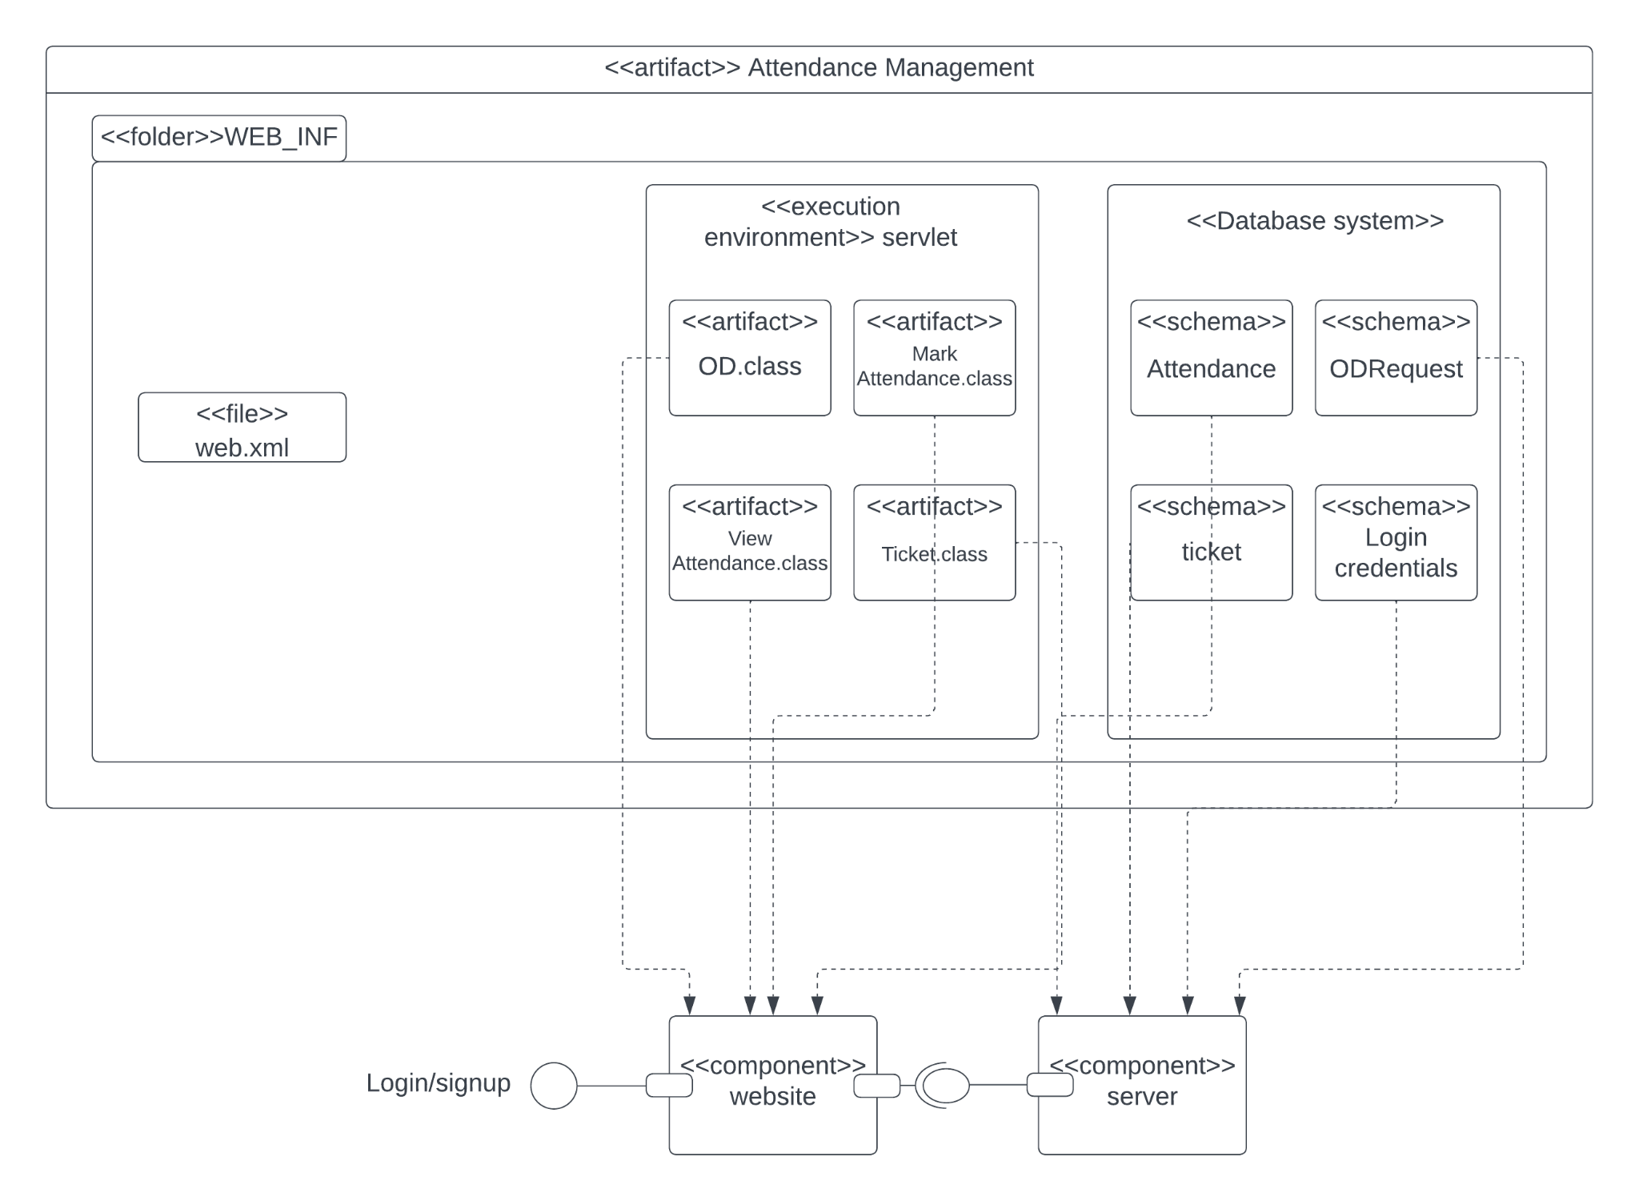

**Component Diagram**

