**STATE MACHINE DIAGRAM**

**Ex No :**

**Date :**

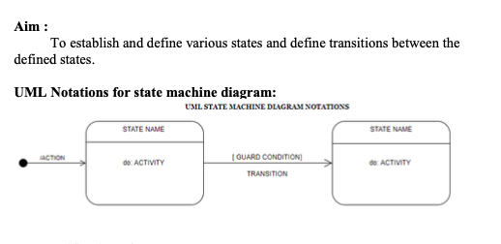

**VALIDATE LOGIN**

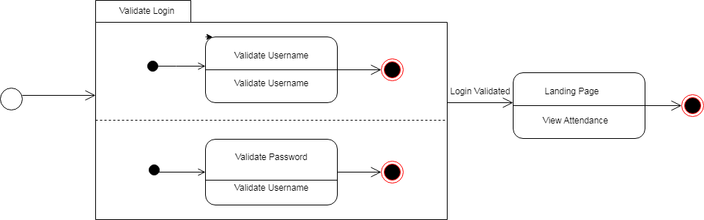

**SET POLICIES**

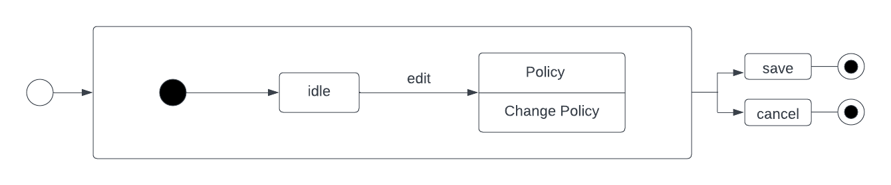

**VERIFY OD**

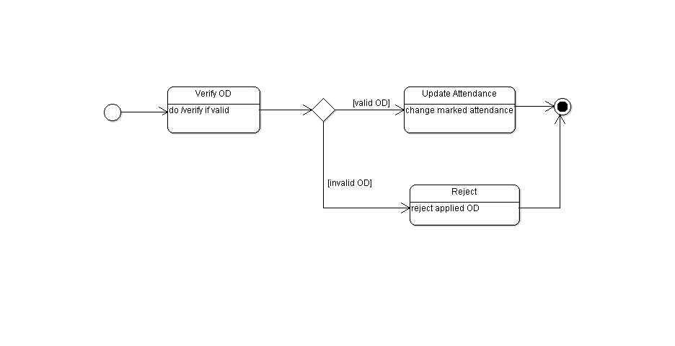

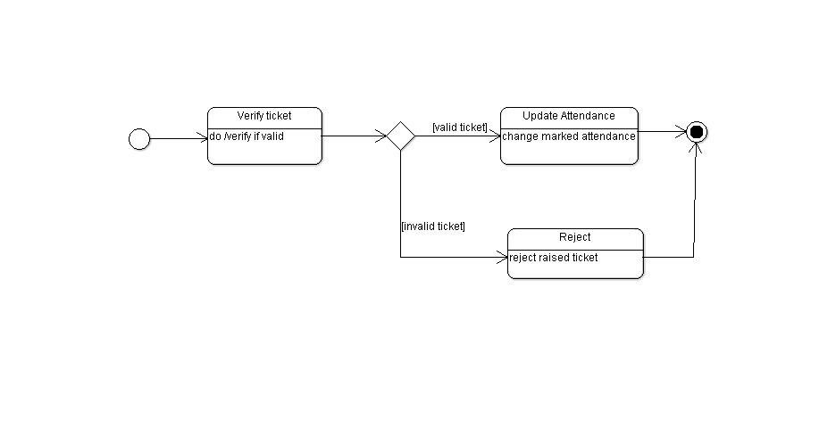

**VERIFY TICKET**